Dear Parent/Guardian,

Anti-bullying Week 12th – 16th November

As part of our Health and Wellbeing, we are having a particular focus on anti-bullying next week.

On Thursday 15th November, we are having an Odd Socks Day and children are encouraged to come to school wearing odd socks. This is to celebrate that we are all different and equal. Article 2 of the UNCRC sets down that no child should be treated unfairly on any basis. We encourage the children of Abronhill Primary to embrace their own uniqueness and to be respectful of others too. Children can also take part in a Design Some Odd Socks Competition and we have some small prizes for the most creative design.

Please note that there is no cost for any of these activities, they are just for fun!

Yours sincerely,

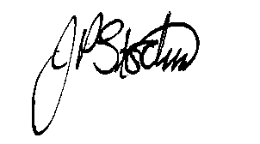
JANE STOCKS
Head Teacher

