:

Our Ref: JS/AM
Your Ref:
Contact:
Tel: 01236 794870
Date: 3rd October 2018

Head Teacher
Jane Stocks
Abronhill Primary School and Nursery Class
Medlar Road
Abronhill
G67 3AJ
Dear Parent/Guardian

CHOIR

Mrs Wright and Mrs McCarron will be starting a choir with a view to singing at Christmas events in November and December.

Rehearsals will commence on Tuesday lunchtimes in school from the 23rd of October and after school from Wednesday 31st of October – Wednesday 28th November at 3.15-4pm. Places are restricted to P4-7 and will be open to all who would like to join.

If you wish your child to take part, please complete and return the consent form below and return to the school office before Monday 22nd October 2018.

Please note that the children must be able to commit to both the Tuesday and Wednesday clubs.

Yours sincerely
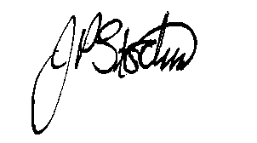
JANE STOCKS
Head Teacher

TO: ABRONHILL PRIMARY SCHOOL – CHIOR

I give my child ____________________ class _____________permission to attend the choir.

I will collect my child from school at 4.00pm. / My child will walk home from school at 4.00pm.
(Please delete as appropriate).

Signed ………………………………………………………………Dated …………………..…….

