:

Our Ref: JS /AM
Your Ref:
Contact:
Tel: 01236 794870
Date: 13th September 2018
Head Teacher
Jane Stocks
Abronhill Primary School and Nursery Class
Medlar Road
Abronhill
G67 3AJ

Dear Parent/Guardian

SCHOOL BOOK FAIR

The Book Fair will take place in the dining hall from Wednesday 31st October to Monday 5th November during school hours. A selection of books suitable for all ages will be available for you to view and purchase if you wish.

The timetable below indicates the visits individual classes will make to the Book Fair. Parents are invited to come along at the appropriate times to assist their child to make a choice. If you are unable to come, the class teacher will assist your child

The Book Fair has been welcomed by parents in past years as an opportunity to see books that interest their children and promote an interest in reading. The school will receive a percentage of all books sold.

Yours sincerely
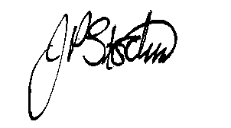
JANE STOCKS
Head Teacher
Wednesday 31st October 2018
9.15am  Primary1 Room 1 |  | 9.30am  Primary 2 Room 2 |  |  | 11.30am  Nursery |  | 1.00pm  Nursery
Friday 2nd November 2018
9.15am  Primary 4 Room 9 | 9.30am  Primary 3 Room 6
Monday 5th November 2018
9.15am  Primary 7 Room 16 |  |  | 9.30am  Primary 6 Room 15 |  |  | 9.45am  Primary 5 Room 12

