:

Our Ref: JS/AM
Your Ref:
Contact:
Tel: 01236 794870
Date: 7th June 2018

Head Teacher
Jane Stocks
Abronhill Primary School and Nursery Class
Medlar Road
Abronhill
G67 3AJ
Dear Parents/guardian

SPORTS DAY

The school will be holding their sports day on Monday 18th June 2018 at 1.30pm. Can all children please make sure that they have a P.E. kit with them on this day.

This event will take place in the school playground (weather permitting) and all parents/guardians are welcome to attend.

Yours sincerely

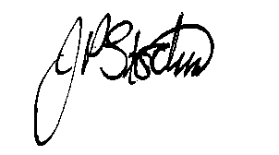
Jane Stocks
Head Teacher

