:

Our Ref: JS/AM
Your Ref:
Contact:
Tel: 01236 794870
Date: 11th June 2018
Head Teacher
Jane Stocks
Abronhill Primary School and Nursery Class
Medlar Road
Abronhill
G67 3AJ

Dear Parent/Guardian

BREAKFAST SERVICE PROVISION FROM AUGUST 2018

Following on from my letter dated 18th May, I can now advise that for pupils who have more than one sibling at the same school, a price structure has been agreed as long as all siblings arrive at the service point at the same time.

The cost for one child will be £1.00

The cost for 2 siblings will be £1.50

The cost for 3 siblings will be £1.80.

Yours sincerely

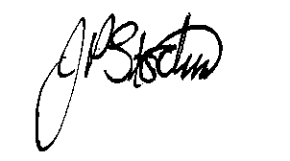
JANE STOCKS
Head Teacher

