:

Our Ref: JS/AM
Your Ref:
Contact:
Tel: 01236 794870
Date: 15th February 2018

Head Teacher
Jane Stocks
Abronhill Primary School and Nursery Class
Medlar Road
Abronhill
G67 3AJ
Dear Parent/guardian

PRIMARY 2 - HOUSE FOR AN ART LOVER, GLASGOW

Primary 2 have been looking at Charles Rennie Mackintosh as part of their Scotland topic and are going to visit House for an Art Lover which will include a tour of the house, a drawing activity followed by a practical art activity.

The date for the trip is Thursday 22nd March 2018. The bus will pick up from the school at 9am and return for around 1pm travelling by coach.

Pupils should bring a packed lunch (no glass bottles) and those entitled to a free school meal will have a packed lunch provided for them by the school cafeteria. School uniform should be worn for safety identification purposes as there will be children from many other schools.

If you are agreeable to your child participating in this outing, please complete the attached parental consent form and return it to your child’s class teacher by Monday 18th January 2018.

Yours sincerely
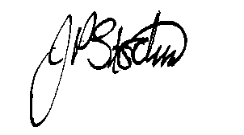
JANE STOCKS
Head Teacher

TO: Abronhill Primary School – Primary 2 - House for an Art Lover, Glasgow

I give my child ____________________ class P2/5 permission to attend the above trip.

Signed ______________________________Dated _________________________
(Parent/Guardian)

