:

Our Ref: JS/AM
Your Ref:
Contact:
Tel: 01236 794870
Date: 7th February 2018

Head Teacher
Jane Stocks
Abronhill Primary School and Nursery Class
Medlar Road
Abronhill
G67 3AJ
Dear Parent/Guardian

AFTER SCHOOL BADMINTON – PRIMARY 4

Active Schools will be taking a badminton club in the school starting Tuesday 20th February 2018 for 5 weeks. (20th Feb till 20th March).

This activity is open to pupils in Primary 4 and places will be allocated on a 1st come 1st serve basis.

Please note that you are required to make appropriate arrangements for your child’s safe homecoming on a Tuesday at 4.00pm, and in the event of any unforeseen cancellation of the club. Pupils will need to ensure that they have a gym kit with them on Tuesdays to change into for the club.

If you are agreeable to your child taking part in this after school activity, please complete and return the tear-off slip below and parental consent form to the school office by Friday 16th February 2018. You will be advised if your child has secured a place.
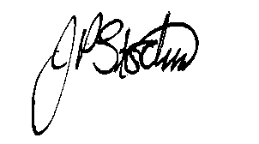
JANE STOCKS
Head Teacher
-----------------------------------------------------------------

TO: ABRONHILL PRIMARY SCHOOL – AFTER SCHOOL BADMINGTON – PRIMARY 4

I give my child ____________________ class _____________permission to attend the after school badminton club.

I will collect my child from school at 4.00pm. / My child will walk home from school at 4.00pm.
(Please delete as appropriate).

Signed ………………………………………………………………Dated …………………..…….
(Parent/Guardian)

