
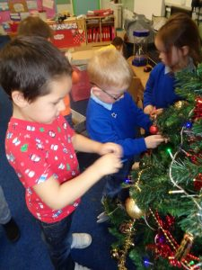
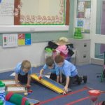

Abronhill Primary School
and Nursery Class

Handbook
2018/2019


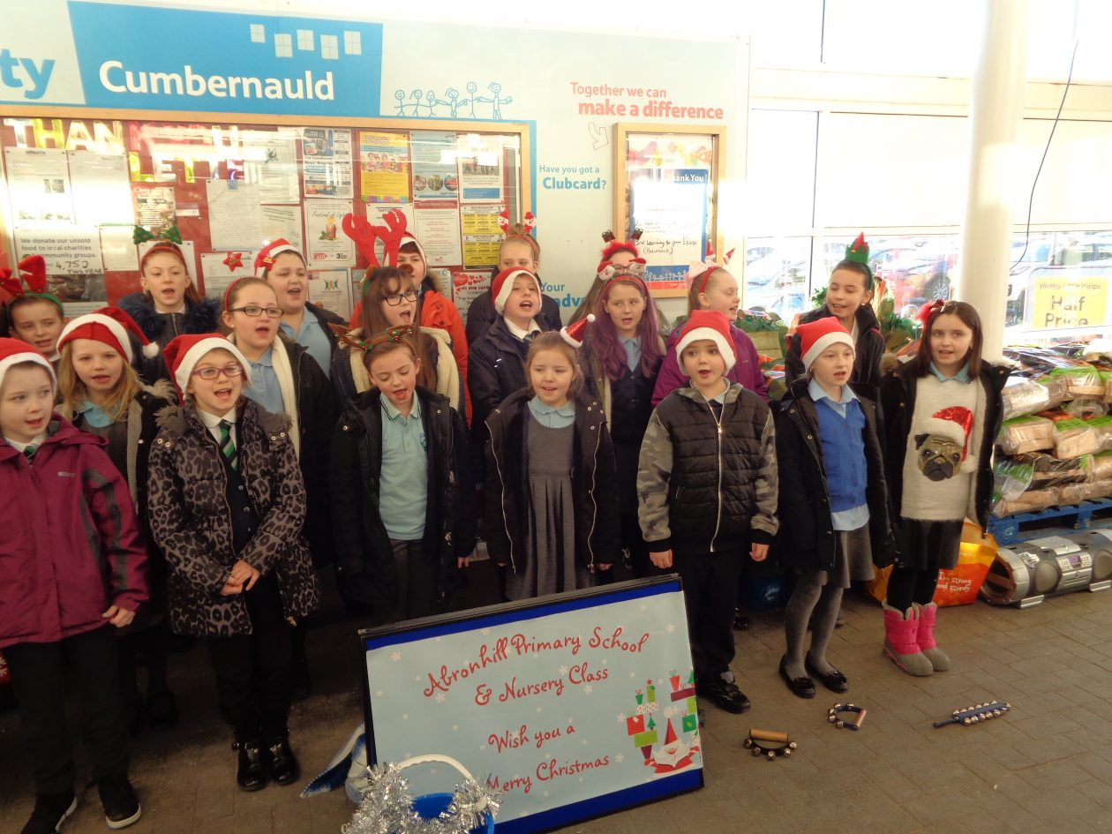
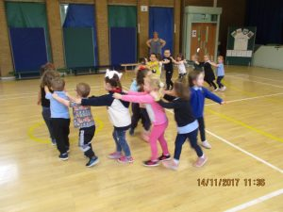




Abronhill Primary School and Nursery Class
Dear Parent/Carer,

As Head Teacher of Abronhill Primary School and Nursery Class, I wish to extend a warm welcome to everyone in our community.

Our handbook has been created to provide you with:

- general information about the school
- a brief outline of our educational and pastoral aims for our children
- statements on our curricular content

In partnership with parents/carers, we aim to provide high quality experiences for every child in a learning environment that is nurturing, safe, active and fun. We provide children with opportunities to develop a wide range of skills across the curriculum, taking account of appropriate support and challenge, and we encourage everyone to approach new learning and experiences with a positive attitude. These experiences and opportunities enable our children to take responsibility for their choices and we support them in making decisions about their own learning. As a result, every child can be confident that he/she will experience success in Abronhill Primary School and Nursery Class.

As a parent/carer, you have been your child’s first teacher and we value you as a member of our school community. We have high expectations for everyone and believe that by developing strong links between school and home we can work together to ensure that every child reaches his/her full potential. I encourage you to become involved in the life of our school community in any way you can and welcome your contributions.

In Abronhill Primary School and Nursery Class we ASPIRE to be the best we can be.
We are:
Achieving
Supportive
Persistent
Inspirational
Responsible
Excellent

I am very proud of the positive ethos we have in Abronhill Primary School and Nursery Class, the wonderful children who belong to our community and the dedication and commitment of the staff.

Yours faithfully
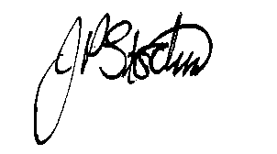
Mrs. Jane Stocks
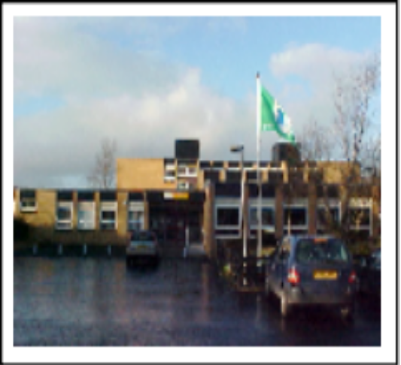
SCHOOL INFORMATION

Abronhill Primary School and Nursery Class
Medlar Road
Abronhill
Cumbernauld
G67 3AJ

Telephone: 01236 794870
E-mail: ht@abronhill-pri.n-lanark.sch.uk
Website: https://blogs.glowscotland.org.uk/nl/abronhillps/

Abronhill Primary School is a non-denominational primary school covering the stages P1 to P7

Planning Capacity: 367
Current Working Capacity: 367

Class Structure
There are currently 8 classes:
P1, P1/2, P2, P3, P4, P5, P6 & P7

Present Roll: 199 (school) and 37 (nursery)

In addition, Abronhill Primary Nursery Class has a 30/20 capacity, i.e., 30 children in the morning session and 20 children in the afternoon session. The nursery class is non-denominational.

At the time of printing, the recommendation is that the maximum number of children in classes is as follows:
Primary 1 25
Primaries 2 and 3 30
Primaries 4-7 33
Composite Classes 25

When deciding on the classes that children are placed in, account is taken of personnel resources within the school and the needs of the children.

Secondary School
Our pupils generally transfer to Cumbernauld Academy, South Kildrum Ring Rd, Cumbernauld, Glasgow G67 2UF. Tel: 01236 794864

Community Facilities
The school building is available for let. Applications should be made to: Culture NLC Ltd, Coatbridge Community Centre, Old Monklands Road, Coatbridge. ML5 5EA – 01236 632802

Associated Secondary
Cumbernauld Academy, South Kildrum Ring Rd, Cumbernauld, Glasgow G67 2UF. Tel: 01236 794864

Parent Council
We have a very active Parent Council that works hard to support the school. You can contact them by email: apnparents@gmail.com

TEACHING STAFF

Head Teacher Mrs Jane Stocks
Principal Teacher Miss Kirsty Crawford
Principal Teacher Mrs Clare McCarron
Acting Principal Teacher Mrs Laura Black

Class Teachers
Miss Stewart Primary 1
Mrs McCormack Primary 1/2

Mrs Hannah/Mrs McCarron Primary 2
Miss McPhail Primary 3
Mrs Saeed/Mrs Gilchrist Primary 4
Miss Stewart Primary 5
Miss Morrison Primary 6
Mrs Black Primary 7
Mrs Wright Non-class contact time
Teacher

TOTAL NUMBER OF TEACHING STAFF:

Nursery Staff
Mrs Martin Nursery Teacher
Miss McGurk Early Learning Practitioner
Mrs McCammon Early Learning Practitioner
Miss Barbour Early Learning Practitioner

TOTAL NUMBER OF NURSERY STAFF:

Support Staff
Mrs Mulholland Senior Clerical Assistant
Mrs Donnelly Clerical Assistant
Mrs McKenna Classroom Assistant
Ms Brannigan Additional Support Needs Assistant
Mrs Scholefield Additional Support Needs Assistant
Mrs Cordiner Additional Support Needs Assistant (Early Years)
Ms Stewart Additional Support Needs Assistant (Early Years
Mr McDowall Janitor

Catering Staff Cleaning Staff
Ms Carchrie Catering Supervisor Mrs McMillan Cleaning Supervisor
Mrs Finlyson Catering Assistant Ms Carchrie Cleaner
Mrs Devlin Catering Assistant Mrs Kirkwood Cleaner
Mrs Gibb Cleaner
Mrs Fern Cleaner


SCHOOL HOURS
School Hours: 9:00am – 3:00pm
Morning Interval: 10:30am – 10:45am
Lunch: 12:15pm – 1:00pm

All primary 1 children will attend full-time from the first day of the session.

OUT OF SCHOOL CARE
POMP 01236 721382

Please note, that it is parents/carers responsibility to arrange for children to be collected at 3pm when the school day ends. Out of school care providers must be made aware of this.

NURSERY HOURS
Morning Session: 8:40am – 11:50am
Afternoon Session: 1:00pm – 4:10pm

The nursery class session times may be extended by arrangement and a charge is made for additional time taken.

SCHOOL HOLIDAY ARRANGEMENTS 2018/2019

August 2018
In-service day: Tuesday 14 August 2018
In-service day: Wednesday 15 August 2018
Pupils return to school: Thursday 16 August 2018

September 2018
September weekend holidays: Friday 21 September 2018 to Monday 24 September 2018

October 2018
October break: Monday 15 October 2018 to Friday 19 October 2018

November 2018
In-service day: 19 Nov 2018

December 2018 – January 2019
Christmas and New Year Holidays: Monday 24 December 2018 – Friday 4 January 2019
(inclusive)

February 2019
Mid-term break: Monday 11 February 2019 and Tuesday 12 February 2019
In-service day: Wednesday 13 February 2019

March/April 2019
Spring break: Monday 1 April to Friday 12 April 2019 (inclusive)
Good Friday 19 April 2019 and Easter Monday 22 April 2019

May 2019
May Day holiday: Monday 6 May 2019
In-service day: 7 May 2019
Mid-term break: Friday 24 May 2019 and Monday 27 May 2019

June 2019
School closes: Friday 28 June 2019

TRANSFER/ENROLMENT
Registration for infant beginners normally take place the second week in January.

The following advertisement regarding registration will appear in the local newspapers: -

Children who attain the age of 5 years between 1 March that year and 28 February the following year must be registered at their local primary school.

Parents/Carers concerned should contact their local school to confirm arrangements for registration. Due to difficulties in the past, each child's birth certificate and proof of address in the form of the current council tax bill must be produced.

The designated catchment area of Abronhill Primary School includes the following roads:

Alder Road Lime Crescent Cedar Road
Medlar Road Hazel Road Rowan Road
Laburnum Road Spruce Road Gean Court
Hawthorn Road Birch Road Elm Drive
Oak Road Larch Court Larch Grove
Larch Road

The streets in bold are eligible for free transport.

We welcome new families to our catchment area. For families who live outside this catchment area, further information about seeking a place in our school is available from the school office.

EQUAL OPPORTUNITIES
In Abronhill Primary School and Nursery Class, we emphasise the need for respect and are committed to providing an environment which values everyone. We encourage all children to ‘have a go’ and to always try their best, while ensuring that they are appropriately supported and challenged according to individual needs. We believe that this will enable every child to access the curriculum and to experience success.

The school is committed to assessing all policies and practices to ensure there are no negative impacts on any group of people.

Implementation of the Education, Youth and Communities Equality Policy including The Equality and Human Rights Commission’s Technical Guidance for Schools in Scotland is the essential guide for the school community to promote equality. This information can be accessed at:
https://www.equalityhumanrights.com/en/publication-download/technical-guidance-schools-scotland

CURRICULUM

What is Curriculum for Excellence?

Curriculum for Excellence aims to achieve a transformation in education in Scotland by providing an improved, more flexible and enriched curriculum for all children and young people from 3 – 18. The curriculum includes all of the experiences which are planned for children and young people through their education, wherever they are being educated.

All schools and nurseries in North Lanarkshire are working hard to raise standards so that children and young people will develop all of the skills necessary to continue to be successful when leaving school and entering the world of higher education, training or work.

Curriculum for Excellence is underpinned by the values inscribed on the mace of the Scottish Parliament – wisdom, justice, compassion and integrity.

The purpose of Curriculum for Excellence is encapsulated in the four capacities – to enable each child or young person to be a successful learner, a confident individual, a responsible citizen and an effective contributor.

What are the curriculum areas in Curriculum for Excellence?

There are eight curriculum areas:-

Expressive Arts Religious and Moral Education
Health and Well Being Sciences
Languages (literacy) Social Studies
Mathematics (numeracy) Technologies

Importantly, literacy and numeracy are given added importance because these skills are so vital in everyday life. All teachers will have responsibility to teach literacy and numeracy.

We provide children with opportunities to demonstrate and further develop their learning in a range of contexts, including, using active and co-operative learning, interdisciplinary approaches and outdoor learning. We work in partnership with visiting specialists and organisations who support and extend the rich experiences we provide through cross curricular approaches, ensuring that our children are able to develop skills for life.

Learning is divided into two phases.

The Broad Education (BGE) is from nursery to the end of Secondary School Year 3. Learning is divided into levels. The levels are as follows:

LEVEL STAGE
Early the pre-school years and P1 or later for some
First to the end of P4 but earlier or later for some
Second to the end of P7 but earlier or later for some
Third and Fourth S1-S3 but earlier for some
Senior Phase S4 – S6 and college or other means of study
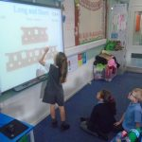
How will my child’s learning be assessed?
The school and nursery class use a range of approaches to ensure that every child’s progress is effectively tracked, assessed and monitored. Staff engage in observations, discussions with children and monitor work being produced. We use a range of ongoing assessments and take account of the views of children, aiming to ensure that every child can reach his/her full potential.

We have produced target books so that children can work with their teachers in identifying suitable targets to focus on in literacy, maths and health and wellbeing. These books also contain feedback from teachers and comments from parents and are sent home each term. Parents/Carers are welcomed to progress/target setting meetings twice a year, as well as other events where evidence of children’s learning can be shared. Written reports are also provided twice a year. By ensuring that we share details of children’s progress and next steps we are able to work together with families to effectively plan future learning opportunities.

At secondary school, National 4 and 5 qualifications were introduced in 2013/2014.

Access, Highers and Advanced Highers are being updated to reflect Curriculum for Excellence.

New Highers in most subjects were introduced in almost all North Lanarkshire schools in August 2014.

In playrooms and classrooms staff will be using improved ways of assessing children’s learning taking account of national and local advice and guidance. Your child’s progress will be reported to you so that you know how well your child is doing.

Each year your nursery/school will let you know what is being done to continue to implement Curriculum for Excellence so that you can be confident that your child is receiving a high quality education.

CURRICULUM FOR EXCELLENCE IN ABRONHILL PRIMARY SCHOOL AND NURSERY CLASS
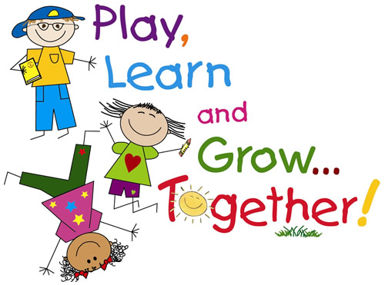
In Abronhill Primary School and Nursery Class, the curriculum takes account of school improvement priorities and local and national guidelines. We aim to make learning for our children challenging, engaging and motivating, and to encourage everyone to have ambition and high aspirations. At all stages, learners of all aptitudes and abilities experience an appropriate level of support and challenge, enabling every child to achieve his/her potential. Children are active in their learning and have opportunities to develop and demonstrate their creativity.

Teachers continually assess children’s work to obtain information that enables them to make professional judgements regarding pupils' progress. This will inform the planning and next steps for learning and teaching in the classroom. We use a range of summative and formative assessment strategies and ensure that all children are involved in the assessment process.

Learners learn best when they:
- understand clearly what the intended learning is, what is expected of them and how they can demonstrate this learning
- are given quality feedback about their work, what they have done well and what they can do to improve it
- participate in self- and peer-assessments
- are fully involved in identifying and understanding next steps in learning
- know how to access support to assist their learning when they require it

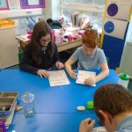
LANGUAGES
Literacy and English
In line with national guidelines and through the use of North Lanarkshire Council’s active literacy approaches, Abronhill Primary School and Nursery Class places great emphasis on promoting the development of critical and creative thinking, as well as developing children’s abilities to listen and talk, read and write to the best of their abilities. Children are encouraged to explore language by engaging with a wide range of reading materials, both fiction and non-fiction. They create their own texts by writing for a variety of purposes, and develop their abilities to accurately use appropriate grammar, punctuation and spelling strategies. A high standard of presentation is encouraged and expected at all times. Consistent development of listening and talking skills enables the children to communicate information and opinions effectively and confidently.

Children are provided with opportunities to use relevant, meaningful contexts across the curriculum to explore the skills they have developed and to deepen their knowledge and understanding of all aspects of literacy.

Parents/Carers continue to play a vital role in further developing children’s language skills by reading together, and by taking advantage of the daily opportunities they have to talk with their children about a wide range of experiences, interests and thoughts and feelings.

Modern Languages
We have worked closely with Cumbernauld Academy and our cluster primaries to develop a progressive and coherent French programme for pupils throughout the school from primary 1 to 7. We will be introducing Spanish to pupils in the upper stages this session.

MATHEMATICS

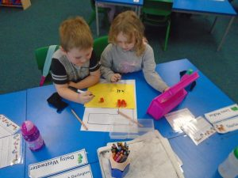
Mathematics is important in allowing us to make sense of the world around us and to manage our everyday lives. Using mathematics enables us to understand real-life situations and to make informed choices. It equips us with the skills we need to interpret and analyse information, simplify and solve problems and to assess risk.

In Abronhill Primary School and Nursery Class we take account of national and local guidelines to provide all children with a mathematics curriculum that will develop their skills, knowledge and understanding of number, money and measure; shape, position and movement; and information handling. Great emphasis is placed on providing all children with experiences that enable them to explore and apply mathematical concepts to understand and solve problems, ask questions, and to explain their thinking and present solutions in a variety of ways. At all stages, children have opportunities to learn actively and collaboratively, allowing them to reason logically and creatively through discussing their ideas with others.

A wide range of concrete materials and real-life contexts are used to enable children to explore mathematics in a meaningful way, helping them to better understand a range of processes and concepts. Children focus on developing their mental agility through the use of the Number Talks programme which encourages the use of a wide range of strategies and methods to support them in improving speed, accuracy and problem solving skills.

Children are provided with opportunities to make links across the curriculum to show how mathematical concepts are applied in a wide range of contexts, such as those provided by science, technology and social studies.

Parents/Carers can further develop children’s awareness, knowledge and understanding of many concepts by providing them with opportunities to use skills in everyday life. Parents/Carers should also encourage children to practise their addition, subtraction, multiplication and division facts regularly at home, enabling them to further develop speed and accuracy. It is important that consistent approaches are used in school and at home to avoid children becoming confused and parents/carers are encouraged to speak to class teachers about the maths language and methods being used.

HEALTH AND WELLBEING
Learning in health and wellbeing ensures that children develop the knowledge and understanding, skills, capabilities and attributes they need for mental, emotional, social and physical wellbeing now and in the future.

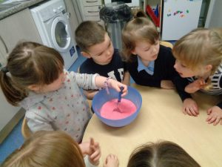
Mental, Emotional, Social and Physical Wellbeing
In Abronhill Primary School and Nursery Class we have a very positive ethos and aim to provide children with an environment that enables them to feel safe, happy, respected and included. We place great emphasis on developing their knowledge and understanding of what it means to be healthy and we encourage them to make informed choices. Children are provided with opportunities to be active and to achieve to the best of their abilities in all areas of school life. We encourage them and provide them with opportunities to develop as successful learners, confident individuals, responsible citizens and effective contributors.

Our health and wellbeing programme focuses on all children making positive contributions as they learn about self-awareness, self-worth, relationships and respect for others. Children are supported in understanding how they develop physically, socially and emotionally, and we ensure that lessons on subjects such as puberty and substance misuse are handled sensitively. We encourage children to develop a healthy attitude towards food and provide them with opportunities to prepare and cook a range of healthy meals and snacks in our cooking room. We have received national recognition for promoting healthy eating. We also encourage our children to make positive contributions to their local environment and the wider world. The children are regularly involved in activities relating to sustainability and we often work in partnership with The Scottish Wildlife Trust and Cumbernauld Living Landscape, with our efforts being recognised when the school received a Community Education Award for sustainability awareness.

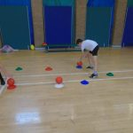
Physical Education
Each class participates in two P.E. sessions a week. Children are required to wear appropriate clothing for P.E., black shorts, white t-shirt and soft-soled shoes. Football strips are unacceptable. We encourage all children to develop a positive attitude towards exercise and to see daily activity as an essential part of a healthy lifestyle. As well as P.E., we work with our active schools coordinator to provide extra curricular sports activities, including football, basketball, dance and athletics. We also have taster sessions from local clubs, such as tae kwon do, to encourage children to access the activities available in our local community. Our senior pupils often provide lunch time clubs for the younger children in the school.
Social Studies
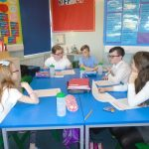
Through focusing on social subjects we aim to provide children with experiences than enhance their knowledge and understanding of their local area and the wider world. Our local environment provides us with a very rich learning context which we utilise through our outdoor learning programme. Educational visits, the use of ICT and a range of texts support the children’s learning experience and enhances their understanding of the diverse world in which we live. Children develop informed attitudes about the past and present through focusing on social subjects which we hope they will further develop in the future.
The Experiences and Outcomes are grouped as follows:
- People, Past Events and Societies
- People, Place and the Environment
- People in Society, Economy and Business
Sciences
We provide children with opportunities to work collaboratively on a range of investigative tasks. This develops their curiosity and understanding of their environment and the wider world, as well as developing their skills in scientific inquiry and the accurate use of scientific language. The Experiences and Outcomes for science cover the following:
- Planet Earth
- Forces, Electricity and Waves
- Biological Systems
- Materials
- Topical Science
Technologies
Learning through technologies allows children to be informed, skilled, thoughtful, adaptable and enterprising citizens. Children are supported in gaining skills and confidence in using technologies to support and enhance their learning. They are provided with opportunities to use ICT in a wide variety of contexts, and are encouraged to be creative and innovative.
Religious And Moral Education
Through religious and moral education, children develop an awareness and appreciation of the value of all individuals and the importance of having a responsible attitude towards others. We aim to teach the children to respect the beliefs, practices, values and religious traditions of everyone. We study different religions so that children may become more aware of the similarities and differences between them and focus on the importance of respect and tolerance.
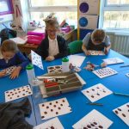
Expressive Arts

Learning through expressive arts enables children to be creative and to express themselves in different ways. In Abronhill Primary School and Nursery Class all children are supported and encouraged in developing their abilities, knowledge and understanding of art and design, music, dance and drama. Developing skills through different aspects of expressive arts is enjoyable for the children and allows them to explore different ways of communicating their ideas, thoughts and feelings, as well as learning to evaluate and appreciate their own and others’ contributions.
There are opportunities for children in the upper stages of the school to receive music instruction from visiting specialists, and we are also able to utilise our links with Cumbernauld Academy to provide the children with a range of interesting activities and experiences. All children have opportunities to perform and present their work in a wide range of contexts in class lessons, assemblies and whole school shows, which are well supported by families and the local community.

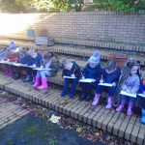
OUTDOOR LEARNING
A range of approaches are used in Abronhill Primary School and Nursery Class to provide children with opportunities to investigate and explore their learning in a variety of contexts. We have an excellent outdoor learning programme throughout the year which enables them to work on all curricular areas within their local environment. This allows children to develop new skills, to work with children from other classes and to have lots of fun.

ADDITIONAL SUPPORT NEEDS
Abronhill Primary School and Nursery Class complies with Learning (Scotland) Act 2004 as amended by the Education (Additional Support for Learning) (Scotland) Act 2009.

North Lanarkshire Council’s policy is contained within “Support for Learning Policy into Practice 2”, a copy of which is available in the School. The school has a Support for Learning Policy, available from the school on request, which is consistent with North Lanarkshire Council guidelines.

Children with additional support needs are identified using a variety of approaches, including observations, examining class work, assessments, and taking account of the views of the children and their families. Where possible, support is provided within the class setting. If further support is required from specialist practitioners from out with the school, this will be requested by the Principal Teacher. Specialists who may support children include the school nurse, educational psychologist and speech and language therapists. When required, further advice and guidance is provided to the school by the additional support manager.

If you require additional information on Support for Learning or would like to refer your child for assessment, please contact Miss Crawford, who is our school and nursery’s Support for Learning Co-ordinator. Parents/carers are always informed of any concerns regarding children’s progress, care and welfare, and we strive to work in partnership with families to ensure we are providing the most appropriate support. Parents/carers and pupils are an essential part of the assessment, planning and review processes and we will always seek your views.

Parents/Carers can request an assessment at any time to establish whether a child has additional needs and/or requires a Co-ordinated Support Plan.

Staged Intervention
There are four levels in the staged intervention process to identify and provide support to meet children’s needs:

Level 1 – Internal support, where education staff identify that a child or young person needs support or planning which can be met within the existing classroom or playroom setting.

Level 2 – Requesting support from within Education, Youth and Communities from practitioners who can provide a range of services and resources, e.g. Educational Psychologist, Community Learning and Development.

Level 3 – When further planning is required to further develop the wellbeing of a child then a request for assistance may be made by the Named Person from colleagues in partner agencies. These professionals will work with the child, school staff and families to provide appropriate support, e.g. Speech and Language Therapy.

Level 4 – Targeted interventions may be required to promote the wellbeing of a child and relevant agencies would be identified and contacted, possibly on a compulsory basis. It would be the expectation that, at this level, a child have a statutory Child’s Plan with integrated assessment, integrated chronology and a Lead Professional in place.

The services of North Lanarkshire’s bilingual support staff are made available, where necessary, for children whose first language is not English.

Looked After Children i.e. children who are cared for directly or whose care is supervised by the local authority, are deemed to have Additional Support Needs unless assessment determines otherwise. Mrs Stocks, the Head Teacher, is the Named Person and can be contacted for further information or support. In the event that Mrs Stocks is unavailable, the principal teachers, Miss Crawford or Mrs McCarron, should be contacted.

Parents and young people can request an assessment at any time to establish whether a child or young person has additional needs and/or requires a Co-ordinated Support Plan. Parents and pupils are an essential part of the assessment, planning and review processes and your views will be actively sought.

PLANNING
Additional Support Plans (ASPs) enable staff to plan effectively for children and young people with Additional Support Needs.

Some children and young people may require significant support from education and at least one other agency, such as health, social work and/or voluntary agency to help them meet their learning targets. Where this support requires a high level of co-ordination, the opening of a Co-ordinated Support Plan (CSP) may be considered. A CSP may be initiated by the school or another agency.

Parents and young people can, if they wish, request that a CSP be considered and would be involved in the process. Parents will receive letters from the Education Authority throughout the CSP process. Parents and young people will be invited to take part in multi-agency meetings and their views will be recorded in the plan.

DISPUTE RESOLUTION
North Lanarkshire Council is committed to resolving any differences of views through discussion, dialogue and building on common ground.

If the matter cannot be resolved with the Education Authority you have the right to request mediation. An independent mediation service is available to parents and young people through Resolve (see contact details at the back of this handbook). Mediation is free and independent of the Education Authority.

In the event that a disagreement cannot be resolved through mediation, then an application for Independent Adjudication (see contact details at the back of this handbook) can be made by parents free of charge. The Independent Adjudicator will make recommendations to the Education Authority about how the dispute should be resolved.

The Additional Support Needs Tribunal has been set up to hear appeals made by parents or young people on the decisions made by the Education Authority relating to Co-ordinated Support Plans, placing requests and post school transition. If you disagree with any decision relating to your child’s Co-ordinated Support Plan, either the creation of a CSP, or the content of it, you may be entitled to refer to the Tribunal.

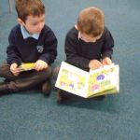
SCHOOL IMPROVEMENT PLAN
Every year the school has to evaluate its practice and from this we produce a School Improvement Report that informs the School Improvement Plan for the following session. The School Improvement Plan outlines developments in which all staff will be involved to further develop the curriculum and to enhance opportunities and experiences for the children. When deciding on school improvement priorities we take account of local and national priorities, the school curriculum, and the results of audit exercises carried out in the school and nursery class. Consideration is also given to how we can further improve standards in relation to literacy, numeracy and health and wellbeing.

2018-19 School Improvement Priorities:

- Develop consistent approaches to planning, assessment and evaluation, and reporting with a focus on improving attainment and achievement for all, particularly in literacy and numeracy.
- Continue to further develop the writing programme, focusing on increasing skills and attainment levels across all genres. This will incorporate targeted supports for identified children, including those from SIMD 1-3.
- Further develop the physical, emotional and social well-being of all learners through a number of approaches and targeted interventions, with particular focus on lessening the attainment gap between the most and least disadvantaged children.

The current priorities will be reviewed at the end of the school year and the new School Improvement Plan for 2019-2020 will be available in August 2019.

To access our most recent inspection, please log on to:
http://www.northlanarkshire.gov.uk/CHttpHandler.ashx?id=11091&p=0

HOMEWORK
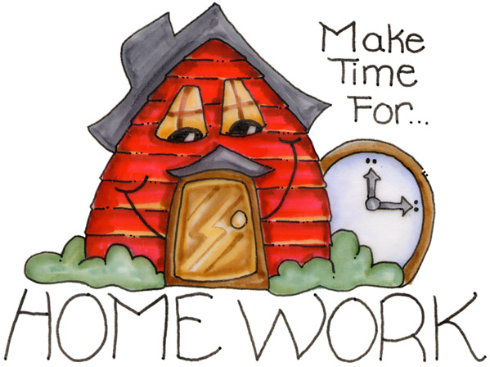
Homework will be issued in all classes on a weekly basis. A focus on reading will always be included. Other aspects of literacy and mathematics will also be included, as well as work on other curricular areas. Through completing homework, children are able to extend and consolidate their learning outside the school environment, and families can become more involved in supporting children. The expectation is that homework will be completed to a high standard and returned to school on time. If parents/carers have any questions regarding homework they should speak to class teachers or a member of the senior management team as soon as possible.

SCHOOL ETHOS
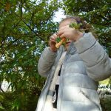
In Abronhill Primary School and Nursery Class, we aspire to have a learning community that is caring, welcoming and stimulating. Through high quality teaching and learning, children work to their full potential to develop their talents, self-esteem and life-long learning skills, in a safe and happy environment. Positive partnerships with families and the wider community will ensure children’s ongoing success in attainment and achievement. We aim to promote and support our local community as much as possible and have done so through many initiatives, e.g. supporting the local food bank, working with the Scottish Wildlife Trust and Cumbernauld Living Landscape on various environmental projects and attending events with our choir.

AIMS OF THE SCHOOL AND NURSERY CLASS
- To teach children life skills and to encourage children to be confident, independent learners.

- To encourage all children to work to their full potential and to develop their skills and talents.

- To recognise and celebrate both academic and non-academic achievements.

- To encourage friendship, understanding and harmony among all children.
- To promote a sense of self-respect and self-esteem.

- To foster good relationships among all those who work in, or visit, the school.

- To establish a sense of community and participate in activities
involving other schools and agencies.

- To develop the four capacities of a Curriculum for Excellence:
Successful Learners, Effective Contributors, Responsible Citizens and
Confident Individuals.

SPIRITUAL, SOCIAL, MORAL AND CULTURAL VALUES
The spiritual, social, moral and cultural values we wish to develop in our children permeate the life of Abronhill Primary and Nursery Class and are not confined to religious education lessons. Our school and nursery class are non-denominational and we aim to teach the children to respect the beliefs, practices, values and religious traditions within their own community and also those of people from other faith communities. If parents/carers would like to discuss any aspect of the school’s religious education programme they should speak to the head teacher.

Parents/Guardians from ethnic minority religious communities may request that their children be permitted to be absent from school in order to celebrate recognised religious events. Only written requests will be considered. Appropriate requests will be granted on not more than three occasions in any one school session and the pupil noted as an authorised absentee in the register.

EXTRA CURRICULAR ACTIVITIES
The school offers a variety of clubs and activities which are run by members of staff and visiting specialists throughout the school year. Our Active Sports Co-ordinator is a valued member of our school community and organises many of the active clubs we offer. After school and lunch time clubs are introduced in blocks throughout the school year and we strive to ensure that all year groups have opportunities to participate. We are very grateful for the considerable support received from parents, friends and staff for the training and practical help given.

We are extremely fortunate at Abronhill Primary School and Nursery Class to have excellent indoor and outdoor facilities to enable our children to have additional experiences beyond the classroom. This includes the woodland walk around the school grounds which is used as part of our outdoor learning programme throughout the year. Our senior pupils are trained by our Active Schools Co-ordinator in delivering a range of playground activities to our younger pupils.

FREEDOM OF INFORMATION
The Freedom of Information Act (Scotland) Act 2002 came into force in January 2005. The Act allows anyone to ask for information held by the Council and imposes a time-scale of 20 working days for the Council to respond. To deal with Freedom of Information requests, this Council has appointed a Corporate Freedom of Information Officer with the support of an officer in each Service. The Freedom of Information and Records Management Officer can be contacted by telephone on 01698 524712.

DATA PROTECTION
The processing of your personal information by North Lanarkshire Council is carried out in accordance with the Data Protection Act 1998. The information you give is held securely, treated confidentially and only used for statutory educational purposes or to improve the quality of the service. Under the Data Protection Act 1998 you are entitled to access the information held. In terms of section 7 of the Act such requests should be sent to Freedom of Information and Records Management Officer.

TRANSFERRING EDUCATIONAL DATA ABOUT PUPILS
Education authorities and the Scottish Government Education Portfolio (SGEP) exchange data about pupils either on paper or electronically through the ScotXed programme.

The data collected and transferred covers areas such as date of birth, post code, registration for free school meals, whether a pupil is looked after by his/her local authority, additional support needs including disability, attendance, absence and exclusions from school. Pupil names and addresses are collected by the school and the council but they are not passed to SGEP. The postcode is the only part of the address that is transferred. Data is held securely and no information on individual pupils can be published by SGEP.
Providing national identity and ethnic background data is entirely voluntary. You can choose the ‘not disclosed’ option if you do not want to provide this data. However, we hope that the explanations contained in this message and on our website will help you understand the importance of providing the data.

Why do we need your data?
In order to make the best decisions about how to improve our education service, SGEP and education authorities need accurate, up-to-date data about our pupils. We are keen to help all our pupils do well in all aspects of school life and achieve better educational outcomes. Accurate and up-to-date data allows SGEP, education authorities and schools to:

- plan and deliver better policies for the benefit of all pupils,

- plan and deliver better policies for the benefit of specific groups of pupils,

- better understand some of the factors that influence pupil attainment and achievement,

- target resources better.

Your Data Protection Rights
The collection, transfer, processing and sharing of ScotXed data is done in accordance with the Data Protection Act 1998. We also comply with the National Statistics Code of Practice requirements and other legislation related to safeguarding the confidentiality of data. The Data Protection Act gives you the right to know how we will use your data. This message can give only a brief description of how we use data. Fuller details of the uses of pupil data can be found on the ScotXed website (www.scotxed.net).
SGEP works with a range of partners including Education Scotland and the Scottish Qualifications Authority. On occasion, we will make individual data available to partners and also academic institutions to carry out research and statistical analysis. In addition, we will provide our partners with information they need in order to fulfil their official responsibilities. Any sharing of data will be done under the strict control and prior agreement of the Data Access Panel in SGEP, which will ensure that no subject specific data will be made public as a result of the data sharing and that such data will not be used to take any actions in respect of an individual.

Concerns
If you have any concerns about the ScotXed data collections you can email school.stats@scotland.gsi.gov.uk or write to The ScotXed Support Office, SEGP, Area 1B, Victoria Quay, Leith, EH6 6QQ. Alternative versions of this page are available, on request from the ScotXed Support Office, in other languages, audio tape, braille and large print.

Want more information?

Further details about ScotXed data exchanges are available on the ScotXed website: www.scotxed.net.

CHILD PROTECTION
Every adult in Scotland has a role in ensuring all our children and young people are safe and protected from harm at all times.

The Head Teacher is responsible for the school’s actions in response to Child Protection concerns.

If there are any Child Protection concerns the Head Teacher, who is the Child Protection Co-ordinator, will follow North Lanarkshire Child Protection Procedures and Guidelines.

Child Protection Co-ordinator is: Mrs. Jane Stocks

Telephone Number: 01236 794870.

ADULT PROTECTION
The Council has responsibility under the Adult Support and Protection (Scotland) Act 2007 for the protection and support of adults at risk of harm within North Lanarkshire. Its employees therefore have the responsibility to ensure the welfare of all adults at risk of harm with whom they come into contact, as well as providing the highest possible standard of care for some of the most vulnerable members of our society.

The Head Teacher is responsible for the schools actions in response to Adult Protection concerns.

If there are any Adult Protection concerns the Head Teacher or the Adult Protection Co-ordinator will follow North Lanarkshire Adult Protection Procedures and Guidelines.

Adult Protection Co-ordinator is: Mrs. Jane Stocks

Telephone Number: 01236 794870

SCHOOL DISCIPLINE

Good school discipline is necessary to create the right conditions for learning. It is a joint responsibility of home and school. In partnership with the children we designed a new behaviour management system called ‘Emoji Magic’. In our classrooms we have Emoji Magic charts with our Happy, Last Chance and Disappointed faces on them. If children follow the school rules and consistently stay on Happy throughout each month they may receive an ‘Emoji Magic’ ASPIRE certificate. If a child is not following the school rules they will receive a verbal warning, if they continue to not follow the school rules they will be given a warning card and if there is no improvement their name will be moved on the Emoji Magic chart. Children are able to have their name moved back to Happy at any time if they show that they are making an effort and not breaking school rules.

It is school policy to inform parents of any concerns regarding behaviour or attitude to work as soon as possible. If there is no significant response or improvement, and behaviour continues to be a concern, parents/carers will be asked to come to the school to discuss possible solutions. Parental co-operation at this stage is vital. Your role as parent/carer, your approval of the necessity for rules and discipline within the school, and the way you express this to your child is important. You are asked to talk with your child about the importance of self-discipline and how responsibility for his/her own actions increases as he/she grows older.

Personal and Social Development is addressed in the curriculum at all stages and has a great bearing on how a child accepts him/herself and relates to other people. Parents/Carers are asked to bring concerns about behaviour, or relationships with others, to the school as a matter of urgency. There is more chance of resolving difficulties when home and school communicate well with each other.

In school we encourage all children to be the best they can be at all times, showing a respectful and caring attitude towards others and demonstrating responsibility for their own actions. We have high expectations of all children and we use a range of positive approaches and praise to encourage everyone to try their best.

Our School Rules
We work hard and always try our best.
We treat other people the way we want to be treated.
We are kind, honest and polite.
We listen well and try to help others.
We are proud of our school and look after it.

ASPIRE
In Abronhill Primary School, we ASPIRE to be the best we can be.
We are…
Achieving
Supportive
Persistent
Inspirational
Responsible
Excellent

ANTI-BULLYING

At all times we strive to promote positive behaviour in Abronhill Primary School and Nursery Class. We operate a zero tolerance policy towards bullying and address this through assemblies and in our Health and Wellbeing programme in classes. The children’s awareness is raised regarding the different kinds of bullying that exist and the actions they should take if they encounter it. We are committed to challenging bullying and dealing with it when it arises. Your support with this is very much appreciated.
An adult presence is provided in playgrounds at break times in terms of the Schools (Safety and Supervision of Pupils) (Scotland) Regulations 1990.

HOME AND SCHOOL/NURSERY LINKS
We view parents/carers as partners in their child’s learning. We encourage parents/carers to be involved in the life of the school and nursery class and to update them on their child’s progress throughout the school year. We welcome parents/carers to volunteer in the school, e.g. reading with younger pupils and supporting classes with a range of activities.
We have an active parent council who are committed to supporting the school by co-ordinating regular events to raise additional funds for the school. Parents/Carers may also volunteer to assist at particular events or to accompany groups of children on trips.
Parents/Carers are always welcome to arrange an appointment to speak to their child’s class teacher or to a member of the senior management team if there have any concerns.

Each year, staff will report to parents/carers via written reports and parents’ appointments. All parents/carers are invited into school throughout the school year to share children’s learning and their achievements and to be involved in plans for future learning. The school and nursery welcome families and friends to attend a range of performances, including assemblies, seasonal events and shows. We aim to keep parents/carers informed through the use of our annual calendar, blog, text messaging, newsletters and homework links.

ATTENDANCE AT SCHOOL
Section 30 of the 1980 Education Act lays a duty on every parent of a child of ‘school age’ to ensure that their child attends school regularly. Attendance must be recorded twice a day, morning and afternoon.

Regulation 7 of the Education (School and Placing Information) (Scotland) Amendment, Etc., Regulations 1993 requires each child’s absence from school to be recorded in the school register as authorised or unauthorised, as defined by the Scottish Government.

At the start of each school session, parents/carers will be asked to provide contact details, including at least one emergency contact number. Parents/Carers are required to inform the school if these contact details change during the course of the year.

Parents and carers are asked to inform the school by telephone if a pupil is unable to attend from the start of the school day on the first day of absence. Failure to do so will result in school staff accessing all contact numbers provided. In the interests of child safety the police will be contacted if all attempts to locate the child have been exhausted. Parents/guardians must inform the school by letter or telephone if their child is likely to be absent for some time, and to give the child a note on his or her return to school, confirming the reason for absence.

ATTENDANCE AT NURSERY
Children are expected to attend during the sessions as arranged with parents.
If your child is sick, or likely to be off Nursery for any length of time, you should inform the school clerical staff who will then inform the Nursery staff.
If a child is absent from nursery for more than two days and the parent/guardian has not contacted the school, clerical staff will telephone the parent/guardian on the 3rd day and enquire as to the reason for the child’s absence. At this stage if contact cannot be made by telephone with the parent/guardian and a reason for the absence cannot be confirmed, a letter will be sent to the parent/guardian on the 5th day that the child is absent. If a reply to this letter is not received by the 10th day of absence a further letter will be sent by recorded delivery to the parent/guardian. Parents/guardians will be given 5 days to reply. Should all of the above attempts to contact the parent/guardian regarding the absence be fruitless, then a final letter will be sent on the 15th day of the absence. If no contact is made with the nursery thereafter, the place will be withdrawn and reallocated if necessary after the 20th day of absence.

NON-ATTENDANCE
Continued or serious non-attendance may result in the child losing their placement.

The procedures are in accordance with North Lanarkshire Council Policy.

Family Holidays During Term Time
Every effort should be made to avoid family holidays during term time as this both disrupts the child’s education and reduces learning time.

Parents/Guardians should inform the school by letter of the dates before going on holiday. Absences will be classified as authorised only in exceptional circumstances. Such circumstances may include:

A family holiday judged to be important to the wellbeing and cohesion of the family, following serious or terminal illness, bereavement or other traumatic events.

A family holiday classified under the ‘authorised absence’ category will not include such reasons as:

- The availability of cheap holidays
- The availability of desired accommodation
- Poor weather experience during school holidays
- Holidays which overlap the beginning or end of term
- Parental difficulty obtaining leave (except in cases where evidence is provided by the employer that it cannot accommodate leave during school holidays without serious consequences)

Family holidays with the above similar characteristics will be classified as unauthorised absence. Where the head teacher’s prior agreement has not been sought the absence will automatically be classed as unauthorised.

EXTENDED LEAVE WITH PARENTAL CONSENT
Where most family holidays will be recorded as unauthorised absence (see above) extended leave with parental consent will not be considered the same as a family holiday. Leave in such circumstances will be authorised under circumstances such as:
- Extended overseas educational trips not organised by the school
- Short-term parental placement abroad
- Family returning to its country of origin (to care for a relative, or for cultural reasons)
- Leave in relation to the children of travelling families

EXCEPTIONAL DOMESTIC CIRCUMSTANCES
Parents may request permission for such leave in writing and the school may authorise such requests under the following circumstances:
- The period immediately after an accident or illness
- A period of serious or critical illness of a close relative
- A domestic crisis, which causes serious disruption to the family home, causing temporary relocation.

All schools in North Lanarkshire Council investigate unexplained absence and the authority has the power to write to, interview or prosecute parents, or to refer pupils to the Reporter of the Children’s Panel, if necessary.
At Abronhill Primary School, the Head Teacher will review absences termly and write to parents/carers when the absence rate is below 85% and gives cause for concern. If absence rates do not improve parents/carers may be invited to a meeting to discuss the issue further.

CLOTHING AND UNIFORM
All North Lanarkshire schools must have a dress code, which encourages pupils to dress in a way which is appropriate to attendance at school. This dress code must not lead to direct or indirect discrimination on the grounds of race, religion, gender or disability. Prior to drawing up the dress code the parents, pupils and staff were fully consulted. It is the expectation of the education authority that parents will be keen to support the dress code and written agreement may be sought.
Clothing which is unacceptable in school under any circumstances includes items which:
- could potentially encourage factions (e.g. football colours)
- could cause offence (e.g. anti-religious symbolism or political slogans)
- could cause health and safety difficulties such as loose fitting clothing, dangling earrings and other potentially dangerous jewellery.
- are of flammable materials which may be a danger in certain classes (e.g. shell suits)
- could cause damage to flooring
- carry advertising, in particular for alcohol or tobacco
- could be used to inflict injury to other pupils or to be used by others to do so.

Parents in receipt of a clothing grant from the Council will be encouraged to purchase items which are in accordance with the school dress code. Approval of any requests for such grants in other circumstances is at the discretion of the Assistant Chief Executive, Education, Youth and Communities. Information and application forms may be obtained from any school or First Stop Shop. Parents are entitled to receive a clothing grant if they are in receipt of any of the following benefits: Income Support, Job Seeker’s Allowance (income based), Employment and Support Allowance (income related), Universal Credit, housing benefit, council tax rebate.

Whilst in general terms it would not normally be the policy of the authority to exclude a pupil from school solely on the basis of his/her dress, persistent refusal to respond to a reasonable dress code may be deemed to be a serious challenge to the head teacher’s authority and to be detrimental to the well being of the whole school community. In such circumstances a head teacher may justify the use of the school discipline procedure.
The Council wishes to minimise claims arising from the loss of pupils’ clothing and/or personal belongings. Parents/Guardians are asked to assist in this area by ensuring that valuable items and unnecessarily expensive items of clothing, jewellery, etc., are not brought to school. Parents should note that any claims submitted to cover the loss of such things are likely to be met only where the authority can be shown to have been negligent.
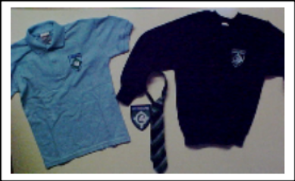
Abronhill Primary School’s uniform consists of:
- Navy blue sweatshirt with embroidered school logo
- Blue polo shirt with embroidered school name
- Grey trousers /skirt
- White shirt and school tie
- School blazer/fleece
- Black shoes
- PE: black shorts, white t-shirt and indoor gym shoes

You are able to buy your child’s school uniform online direct from Gilmour Sports Uniform made easy.

The school has a small stock of school/nursery uniform items and can be purchased in an emergency from the school office.

SCHOOL MEAL ARRANGEMENTS
Lunches
We operate a cashless cafeteria system. Children can add money to their cards either before 9am or during interval using the machine in the dining hall. It is preferred that parents/carers add funds to the cards using online banking. Further information can be obtained at: www.northlanarkshire.gov.uk/schooolpayments. Children in receipt of free school meals automatically have funds credited to their cards. Information and application forms for free school meals may be obtained from schools, First Stop Shops and Municipal Buildings, Coatbridge. All children in primaries 1, 2 and 3 receive free school meals. Only school children who receive a free school meal are entitled to free milk at lunchtime. Milk is available for purchase at lunch time.

During registration time in the mornings children choose which meal they would like from the menu options. There is always an option of two hot meals, sandwiches and baked potatoes. Children are then allocated a corresponding coloured band which they take to the dining hall. This ensures that all children receive the meal they have chosen. Menus are sent home throughout the year and parents/carers can check online to see what their child has chosen each day.
Further information available at: northlanarkshire.gov.uk/primaryschoolmeals

Special Dietary Needs
Diets required as a result of a medical condition (a medically prescribed diet, e.g. coeliac disease, diabetes, food allergy or intolerance) can be provided in school. A medically prescribed diet form, must be completed by the child’s Registered Dietician or General Practitioner. Procedures and forms can be accessed from the child’s school or dietician, or from North Lanarkshire’s Catering Service. Occasionally, parents/carers may be asked to supply prescription foods or attend a meeting to discuss the child’s dietary requirements.
Some children with additional support needs may require food to be adapted to an appropriate texture and consistency. In this instance the child’s Registered Dietician or Speech and Language Therapist will liaise with the Head Teacher and school catering service to ensure appropriate food provision.
Special diets required for ethical, religious or cultural reasons should be requested in writing to the head teacher, who will liaise with the school catering service.

Packed Lunches

Packed lunches may be eaten in the school lunch hall or, in good weather, children may be given permission to eat packed lunches outside, in designated areas. We request that parents support our Health Promoting School by only providing healthy lunches and snacks for children. Children should not bring sugary or fizzy drinks or sweets for their packed lunch. It is important that children learn in school and at home about the importance of healthy eating.

Breakfast Club
A breakfast club operates within the school and is open is from 8.15am and closes at 8.50am each morning. Children coming to the Breakfast Club should enter via the main school entrance and make their way to the dinner hall. Breakfast is served at a cost of 20p per child.

Playtime Snacks
As a Health Promoting School, we strive to encourage children to make healthy choices. We ask that children bring a healthy snack and drink to school for playtime, such as fruit, and that sweets and crisps be given as an occasional treat.
Drinks
We have provided every child with an Abronhill Primary School water bottle and have recently had new water coolers installed throughout the school. All children should bring their water bottle to school every day filled with fresh water. This can then be refilled during the day at designated times, if required. It has been proven that drinking water helps children to focus and learn so we encourage them to do so. We only allow water to be consumed in the classrooms so please do not provide your child with any other drinks as they will not be allowed to have them.

Children may purchase milk to have every day in school. This costs 50p a week and money is paid in class every Monday.

Nursery Snacks
Healthy snacks are provided each day for our nursery children. Children are supported to develop their independent skills by helping to prepare, select and tidy at snack time. Details of snacks provided are listed on the nursery information board, including details of possible allergens. Nursery children are entitled to free milk.

PLACING REQUESTS
You have the right to make a placing request for your child to be educated in a school other than the local school. In December each year, the authority will advertise its arrangements for placing requests.

There are sound educational reasons for trying to ensure that the transfer or admission of children to a school takes place at the start of a school session. Other than those who are moving home to a new area, parents are advised to time any placing requests so that they take effect from the beginning of the new school session.

Every effort will be made to try to meet the parental wishes, but you should note that it is not always possible to grant every placing request to a particular school.

Placing requests to Primary School does not necessarily ensure that your child will have a direct entry into the associated secondary. Advice on this must be sought from the Primary School Head Teacher.

Further information on placing requests and procedures is available from the school or the council’s website.

Parents and Young People have a right under the Additional Support for Learning Act 2009 to make a placing request for their child or young person to attend a nursery (including partnership nursery), special school or special class managed by the home authority. In the event of a successful placing request the authority are not required to provide transport. The Act also enables parents and young people to make a placing request to attend a school/establishment belonging to another authority.

TRANSPORT

The Council has a policy of providing free transport to all primary pupils who live more than one mile from their local school by the shortest suitable walking route. This policy is more generous than the law requires. This provision may be reviewed at any time.

Parents who consider they are eligible should obtain an application form from the school or from Education, Youth and Communities. These forms should be completed and returned before the end of February for those pupils beginning school in August to enable the appropriate arrangements to be made.

Applications may be submitted at any time throughout the year but may be subject to delay whilst arrangements are made.

There is discretion in certain circumstances to grant privilege transport for pupils to travel in transport provided by the authority, where spare places are available and no additional costs are incurred.

PICK UP POINTS
While free transport is provided it may be necessary for pupils to walk a certain distance to the vehicle pick-up point.

Walking distance in total, including the distance from home to the pick-up point and from the drop-off point to the school in any one direction, will not exceed the authority’s limits (see above paragraph).

It is the parent’s responsibility to ensure their child arrives at the pick-up point in time. It is also the parent’s responsibility to ensure the child behaves in a safe and acceptable manner while boarding, travelling in and alighting from the vehicle. Misbehaviour could result in a loss of the right to free transport.

PLACING REQUESTS
The Council does not provide transport for those pupils in receipt of a placing request other than in exceptional circumstances.

In the case of early entry requests if the child is offered a place in the catchment area school, transport will be provided in accordance with the Council’s policy stated above.

MEDICAL AND HEALTH CARE
Medical examination of children is undertaken during the primary school years, usually in the first year and then selected children in primary 7. Lanarkshire Health Board arranges these with the school. Parents may refer their child at other times to the School Medical Officer for examination or advice. Dental inspections are carried out at various times and parents offered any necessary treatment for their children, although they may choose to go to a dentist of their own choosing instead.

At the start of each school year, parents are requested to provide information, i.e., name, address, emergency contact and relevant health information, about their child so that all records can be kept up to date. This is important for children’s wellbeing. If your child becomes ill at school or nursery, contact will be made as soon as possible with the parent or person nominated by the parent. In the case of a serious accident, the child will be taken to hospital immediately while contact is made with the parent/carer. It is important therefore, that we are aware made of any changes regarding children’s medical requirements or emergency contact information.


If children require medication in school or nursery, parents/carers must complete consent forms which are available at the school office and from nursery staff. Medication cannot be given to children without consent forms and it is the duty of parents/carers to ensure that medication in the school or nursery is in date and that there is enough to treat the child.

If a young person is unable to attend a suitable educational establishment as a result of prolonged ill-health, North Lanarkshire Council must make special arrangements for the pupil to receive education elsewhere, other than at an educational establishment.

In North Lanarkshire, children and young people are treated in the paediatric in-patient unit within Wishaw General Hospital. It is not common for children and young people to have extended stays in Wishaw General, and therefore North Lanarkshire Council does not require a dedicated hospital education service.

Children and young people resident in North Lanarkshire, and in hospital in Glasgow, may access education through the Hospital Education Service (HES). The service is provided by Glasgow City Education Department and Social Work Services. For further information, please contact the school.

INFORMATION IN EMERGENCIES
We make every effort to maintain a full educational service, but on some occasions circumstances arise which lead to disruption. For example, schools may be affected by severe weather, temporary interruption of transport, power failures or difficulties of fuel supply. In such cases we shall do all we can to let you know about the details of closure or re-opening. We shall keep you informed by using letters, notices in local shops and community centres, announcements in local churches and announcements in the press, on local radio and the North Lanarkshire Council’s website and Twitter.
THE PARENT FORUM
As a parent of a child at this school you are automatically a member of the
Parent Forum. The Parent Forum is composed of all the parents and carers of children at the school.

As a member of the Parent Forum you can expect to:

- get information about what your child is learning
- get information about events and activities at the school
- get advice/help on how you can support your child's learning
- be told about opportunities to be involved in the school
- have a say in selecting a Parent Council to work on behalf of all parents at the school
- be invited to identify issues for the Parent Council to work on with the school.

THE PARENT COUNCIL

Parent Councils came into force on 1st August 2007.
The composition of the Parent Council is:

Parent Council Representatives
Ms Carol McMillan Chairperson
Mr David MacLeod Vice Chairperson
Mrs Annabella Stirling Secretary
Ms Kirsty McKinnell Treasurer

Parent Council e-mail: apnparents@gmail.com

Duties
The Parent Council’s rights and duties include:
- Supporting the work of the school
- Representing the views of parents
- Consulting with parents and reporting back to the Parent Forum on matters of interest
- Promoting contact between the school, parents, pupils, providers of nursery education and the wider community
- Fundraising
- Taking part in the selection of senior promoted staff
- Receiving reports from the head teacher and education authority
- Receiving an annual budget for administration, training and other expenses
- Improving home school partnership and facilitating parental involvement

Members of Parent Councils, on a voluntary basis, may also have an advisory role in decisions on placing requests by parents in respect of those situations where the number of placing requests for a particular school, or for a particular stage in a particular school, exceeds the number of places available.

The Head Teacher is the professional adviser to the Parent Council and has a right and duty to attend all meetings of the Parent Council. Parent Council meetings are open to members of the public.

Elections
An electoral roll – a list of the names of parents or guardians of children at the school – is drawn up. All those whose names appear on the list on a date fixed by the Authority, are entitled to vote or be nominated as a representative on the parent council. Notice will be given to each member on the electoral role when vacancies arise. This will state the closing date for nominations. Each nomination must be supported by two proposers who are eligible to vote at the particular election. Nomination papers will be available at the school, also a pro-forma which may be used for submitting a 250 word statement in support of candidature.

PUPIL COUNCIL
Mrs. McCarron co-ordinates our pupil council where we have two members from every class representing the views of all children. The pupil council works together to promote the school and to be involved in shaping its future.

SUPERVISION OF PLAYGROUNDS
An adult presence is provided in playgrounds at break times in terms of the Schools (Safety and Supervision of Pupils) (Scotland) Regulations 1990. In the mornings there is adult presence in the playground from 8:45am. The school operates a ‘wet play’ policy so that when weather is extreme, children may be supervised indoors.



TRANSFER FROM PRIMARY SCHOOL TO SECONDARY SCHOOL
Pupils normally transfer between the ages of 11.5 and 12.5 so that they will have the opportunity to complete at least 4 years of secondary education. Parents will be informed of the arrangements no later than December of the year preceding the date of transfer at the start of the new session.
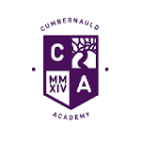
Pupils from Abronhill Primary School generally transfer to Cumbernauld Academy, South Kildrum Ring Rd, Cumbernauld, Glasgow G67 2UF. Tel: 01236 794864.

Transition work with Cumbernauld Academy takes place when children are in primary 6 and 7. Children are involved in a range of activities and visits to the Academy where they become more familiar with the environment, staff and subjects. Abronhill Primary and Cumbernauld Academy staff meet to share information so that the transition between primary and high school is a smooth and enjoyable one for all children. There are also opportunities for parents/carers to attend various events at Cumbernauld Academy in relation to transition. If any children are going to a different secondary school they will also be involved in any transition activities their new school offers.

IMPORTANT NAMES AND ADDRESSES

Education, Youth and Communities,
North Lanarkshire Council,
Municipal Building,
Kildonan Street,
Coatbridge. ML5 3BT.
01236 812222

Councillors - (Cumbernauld East)

Tom Johnston (Scottish National Party) johnstont@northlan.gov.uk
5 Burn View
Cumbernauld G67 2HN. Tel: 01236 738986

Paddy Hogg (Scottish National Party)
C/O Civic Centre
Windmillhill Street
Motherwell ML1 1AB Tel: 07939280060 hoggp@northlan.gov.uk

Gillian Fannan (Scottish Labour Party)
117 McGregor Road
Seafar G67 1JG Tel: 01698 302710/07939280058 fannang@northlan.gov.uk
Chief Executive Area Office
Paul Jukes
Civic Centre
Windmillhill Street
Motherwell ML1 1AB Tel: 01698 403200

Community Learning and Development
Muirfield Community Education Centre
Brown Road
Seafar
Cumbernauld
G67 1AA Tel: 01236 638 383

Continuous Improvement Officers
Irene Pandolfi Tel: 01236 812452
William Collum Tel: 01236 812452
Robert Dalzell Tel: 01236 812226
Education, Skills and Youth Employment,
Municipal Building,
Kildonan Street,
Coatbridge. ML5 3BT.

Contacts in relation to Support for Learning
Help and advice on any matters relating to Support for Learning can be obtained from:

Additional Support Needs Managers:
Carolan Burnet and Lyndsay Malley,
Additional Support Managers,
Baird Memorial Primary,
6 Avonhead Road,
Condorrat,
Cumbernauld. G67 4RA.
01236 632363

You can also obtain more help and advice from:
Enquire
The Scottish advice service for additional support for learning. Operated by Children in Scotland, Enquire offers independent confidential advice and information on additional support for learning. Enquire also provide a range of factsheets.
Tel: 0345 123 2303
info@enquire.org.uk
www.enquire.org.uk for parents and practitioners
www.enquireorg.uk for children and young people

Resolve

0131 313 8844
(Independent Adjudicator)

Scottish Independent Advocacy Alliance
London House,
20-22 East London Street,
Edinburgh.
EH7 4BQ.
0131 524 1975
enquiry@siaa.org.uk
www.siaa.org.uk

Reference to Additional Support Needs Tribunal (Scotland)
ASNTS,
4th Floor,
1 Atlantic Quay,
45 Robertson Street,
Glasgow.
G2 8JB.
Helpline: 0141 302 5860

NHS Lanarkshire (Cumbernauld)
Abronhill Health Centre Tel: 01236 727654
Central Health Centre Tel: 01236 737214
Kildrum Health Centre Tel: 01236 721 354
Cumbernauld Village Tel: 01236 721443

Condorrat Health Centre Tel: 01236 723 383

Kenilworth Health Centre Tel: 01236 727816

Social Work
Cumbernauld/Chryston,
Bron Way,
Town Centre,
Cumbernauld.
G67 1DZ
01236 638700

Although this information is accurate at the time of printing, there could be changes affecting any of the matters dealt within the document –

- before the commencement or during the course of the school year in question.
- In relation to subsequent school years.

Education authorities by law are required to issue a copy of the school handbook to parents in December of each year. It details the current policies and practices of both the council and the school.

