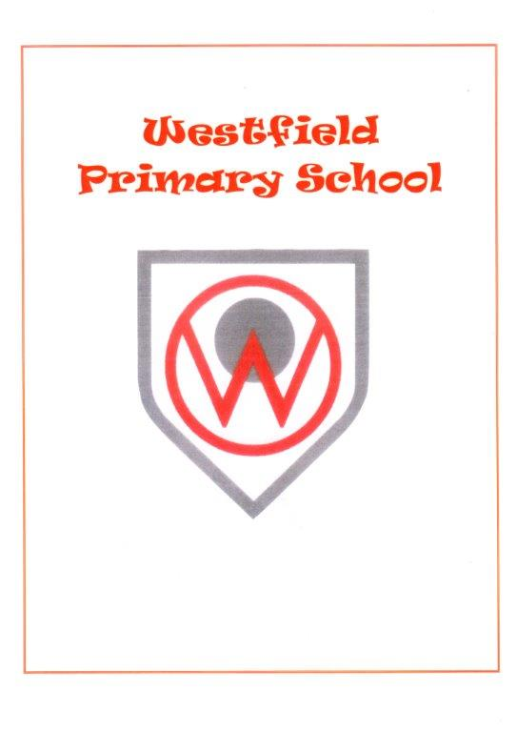
Health and wellbeing policy

Introduction

Improving the health and wellbeing of the people in our school community is a key objective of Westfield Primary and its partner organisations. We work to actively promote health and wellbeing in children and young people in pursuit of this objective.

“Learning and health go hand in hand. Good health of children and young people is a prerequisite for educational achievement.” (Education and Health in Partnership - European Conference report, 2002)

“Good health and wellbeing is central to effective learning and preparation for successful independent living.” (Curriculum for Excellence Health and Wellbeing Principles and Practice, 2009)

A Curriculum for Excellence sets out entitlements for all children and young people. The experiences and outcomes will enable children and young people to develop the knowledge, understanding, skills, capabilities and attributes to live a healthy lifestyle both now and in the future.

“Mental, physical and social wellbeing of young people are essential preconditions for successful learning. These qualities cannot be developed for individuals in isolation from the health and wellbeing of the school community as a whole.”

In addition, the Schools (Health Promotion and Nutrition) (Scotland) Act 2007 imposes duties on Westfield Primary to ensure that we are health promoting and meet the terms of the Act.

Implications of the Health Promotion and Nutrition Act

A. HEALTH PROMOTING SCHOOLS

Westfield Primary is required to be health promoting and we adopt a whole school approach to integrating Health and Wellbeing into every aspect of life in the school. We aim to:

promote the mental, emotional, social and physical health and wellbeing of all children and young people; and work in partnership with partners to identify and meet the health needs of the whole school and its wider community.

B. MEETING NUTRITIONAL REQUIREMENTS

The Schools (Health Promotion and Nutrition) (Scotland) Act 2007 requires that food provided to children and young people is compliant with nutritional requirements specified by government regulations. Westfield Primary actively promotes the availability of school lunches and encourages consumption of these by children and young people, especially those entitled to receive free school lunches. We have also taken steps to minimise any stigma that might be attached to receiving free meals through the use of a cashless card system. Westfield Primary complies with the relevant guidance for nutrition and healthy eating when arranging food and drink for children and young people. This includes school meals, tuck shops, after school clubs and snacks.

Leadership and Quality Assurance for Health and Wellbeing

A. LEADERSHIP

As a health promoting school Westfield Primary aims to cater for the health and wellbeing needs of all of its community. Effective leadership and management at all levels are vital when doing so.

“Within individual establishments positive leadership from the head teacher will encourage contributions from pupils, parents and carers, staff and other partners. Effective leaders look after their own health and wellbeing, model a positive approach to change, and encourage and support well - judged trial and innovation.”

(Health Promotion Guidance (2007) Scottish Government)

At Westfield Primary we strive to create a positive ethos and climate of respect and trust. In this way all individuals can make a positive contribution to health and wellbeing of everyone in the school community.

“Health (and wellbeing) is promoted through positive relationships in a climate that is inclusive, promotes equality, is conducive to learning, and where pupils feel safe, secure, valued and respected.”

(The Journey to Excellence, Part 2, Dimension 9 – HMIE, 2006)

At Westfield Primary we promote health, care and wellbeing and ensure high quality learning and teaching in health and wellbeing. We also provide a safe, supportive, accessible and well-resourced environment for all our pupils and staff, including appropriate provision for children and young people who have additional support needs.

“The whole environment should be conducive to health promotion. Establishments with health promoting environments provide opportunities and space for physical activity, play, eating, socialising and privacy.”

(Health Promotion Guidance (2007) Scottish Government)

B. QUALITY ASSURANCE AND COMMITMENT TO CONTINUOUS IMPROVEMENT

Health and Wellbeing has featured as a key priority on Westfield Primary’s Improvement Plan and procedures for monitoring and evaluation show the impact of Health and Wellbeing initiatives on the lives and learning of everyone in the School.

Regular surveys of pupil, parent and staff perceptions address a range of Health and Wellbeing related issues which help identify improvement targets and provide evidence of progress and overall perceptions.

These surveys together with a range of self-evaluation exercises for Health and Wellbeing provision, based on How Good is Our School Quality Indicators provide robust and valid indicators of progress and the impact of initiatives. These are reported back to the community including through the annual Standards and Quality report.

We also celebrate and publicise our success in promoting Health and Wellbeing through regular school social media accounts, newsletters and journals.

Health and Wellbeing for all in Curriculum for Excellence

“Learning through health and wellbeing promotes confidence, independent thinking and positive attitudes and dispositions. Because of this, it is the responsibility of every teacher to contribute to learning and development in this area.”

(Curriculum for Excellence Health and Wellbeing Principles and Practice, 2009)

The four contexts for learning at the heart of Curriculum for Excellence are particularly significant in health and wellbeing:

- Ethos and life of the school as a community
- Curriculum areas and subjects
- Interdisciplinary learning
- Opportunities for personal achievement

The ethos and life of Westfield Primary as a community supports and nurtures children and young people’s health and wellbeing. This includes the development of positive relationships, and participation in curricular and extra-curricular activities which promote a healthy lifestyle. Everyone within Westfield Primary shares responsibility for creating a positive ethos and climate of respect and trust: a climate in which everyone can make a positive contribution to the wellbeing of each individual within Westfield Primary and the wider community. Our pupils are supported by peer supporters, buddies, classroom assistants, Additional Support Needs Assistants, teachers and senior managers.

The experiences and outcomes for Health and Wellbeing include those aspects of learning which are specifically taught as well as those which are an inherent part of the school environment. Pupils experience certain aspects of health and wellbeing through focused programmes such as PATHS, Healthy Life Styles. A Curriculum for Excellence plays a very important role in the teaching and learning of Health and Wellbeing through the experiences and outcomes for food and health, physical education, physical activity and sport.

Westfield Primary pupils’ learning in Health and Wellbeing benefits strongly from partnership working between teachers and others such as health professionals, educational psychologists and sports coaches who can make complementary contributions through their specialist expertise and knowledge.

The Health and Wellbeing of every child and young person is greatly enhanced through individual support and pastoral care. Pupils receive this through having an identified member of staff from the senior management team – Mrs Alston for P1 to P3 and Mrs Webster for P4-P7 pupils- who knows and understands them and can support them in facing changes and challenges. Members of staff are often best placed to identify even minor changes of mood in a child or young person which could reflect an important emotional, social or mental health issue with which that child or young person needs help or targeted support. It is important that children and young people feel that they can share their anxieties with an appropriate individual who has the skills, rapport, responsibility and the time to listen and to help, or can identify appropriate sources of support.

Learning and Teaching

- Learning in Health and Wellbeing ensures that children and young people develop the knowledge and understanding, skills, capabilities and attributes which they need for mental, emotional, social and physical wellbeing now and in the future. Learning through Health and Wellbeing enables children and young people to: make informed decisions in order to improve their mental, emotional, social and physical wellbeing
- experience challenge and enjoyment
- experience positive aspects of healthy living and activity for themselves
- apply their mental, emotional, social and physical skills to pursue a healthy lifestyle
- make a successful move to the next stage of education or work
- establish a pattern of Health and Wellbeing which will be sustained into adult life, and which will help to promote the health and wellbeing of the next generation of Scottish children.

Westfield Primary staff have a responsibility to support children and young people to achieve all the outcomes at each level in A Curriculum for Excellence in relation to Health and Wellbeing for all.

A. DEVELOPING STAFF SKILLS FOR THE CURRICULUM

The development of staff skills is fundamental to the promotion of Health and Wellbeing. The culture on Westfield Primary is directly influenced by our staff and a whole school approach to health promotion is taken. Staff attend appropriate training opportunities to ensure they can contribute effectively to children and young people’s learning in Health and Wellbeing. Through training, staff develop learning and teaching approaches which suit the aptitudes and needs of our learners, and which are lively and participative and encourage children and young people to learn individually and in groups.

B. FEATURES OF EFFECTIVE LEARNING AND TEACHING IN HEALTH AND WELLBEING

“Effective learning and teaching in health and wellbeing:

- engages children and young people and takes account of their views and experiences, particularly where decisions are to be made that may impact on life choices
- takes account of research and successful practice in supporting the learning and development of children and young people, particularly in sensitive areas such as substance misuse
- uses a variety of approaches including active, cooperative and peer learning and effective use of Technology
- encourages and capitalises on the potential to experience learning an d new challenges in the outdoor environment
- encourages children and young people to act as positive role models for others within the educational community
- leads to a lasting commitment in children and young people to follow a healthy lifestyle by participation in experiences which are varied, relevant, realistic and enjoyable
- helps to foster health in families and communities through work with a range of professions, parents and carers, and children and young people, and enables them to understand the responsibilities of citizenship
- harnesses the experience and expertise of different professions to make specialist contributions, including developing enterprise and employability skills. ”

(Curriculum for Excellence Health and Wellbeing Principles and Practice, 2009)

C. TRANSITIONS

The principles of A Curriculum for Excellence support the importance of cohesion and progression in learning across all stages.

“ While children and young people should feel that the transition from one stage of learning to another is smooth, they should still be able to look forward to the excitement of starting nursery, primary school, secondary school and finally to moving on to positive and sustained destinations. These times in their lives are memorable occasions as well as stepping stones to new experiences and increasing independence. It is therefore important that in planning programmes, schools and establishments provide experiences which are familiar but introduce new aspects which will make each individual phase unique to that time in a young person’s life.”

(Curriculum for Excellence Building the Curriculum 3, 2008)

All transitions are rigorously planned to acknowledge prior learning and experiences. Transitions across year groups and stages within Curriculum for Excellence take account of prior learning in health and wellbeing.

Learning in Health and Wellbeing ensures that children and young people develop the knowledge and understanding, skills, capabilities and attributes which they need for mental, emotional, social and physical wellbeing now and in the future.

D. SKILLS FOR LEARNING, LIFE AND WORK AND HEALTH AND WELLBEING

Teaching good habits associated with Health and Wellbeing is central to effective preparation for life. Teachers in Westfield Primary provide learners with experiences which are relevant, realistic and challenging. At the heart of Health and Wellbeing is the capacity to form and sustain good personal, social and working relationships. When children and young people have good relationships, they are more likely to feel positive self-esteem and confidence with regard to their learning, to show resilience when faced with personal challenges, and to show respect for others.

Staff within Westfield Primary have a vital role to play in supporting children and young people as they develop resilience, the motivation to face and learn from setbacks, and the ability to make mutually supportive relationships. At Westfield Primary an ethos of trust, integrity and democracy is evident, where everyone is valued which in turn fosters an environment of personal, social and emotional development.

E. TRACKING, ASSESSING AND REPORTING PROGRESS IN HEALTH AND WELLBEING

Progression and development in many aspects of Health and Wellbeing depends upon the stage of growth, development and maturity of the learner, upon social issues and upon the community context. From the early years through to the senior stages, children’s and young people’s progress shows how well they are developing and applying their knowledge, understanding and skills in, for example, key features of healthy living and relationships, and in approaches to personal planning, assessing risk and decision making. As pupils progress through the school we monitor and track their mental, emotional, social and physical Health and Wellbeing as well as their learning at all points of transition.

Assessment in Health and Wellbeing links with other areas of the curriculum, within and beyond the classroom. Children and young people have opportunities to apply their knowledge and skills in more complex, demanding or unfamiliar learning or social contexts and they receive regular feedback on their progress in learning.

Reports on children’s and young people’s progress and achievement in Health and Wellbeing are an integral part of the school’s formal reporting systems with Westfield Primary School. Parents are provided with information on their children’s strengths and development needs in relation to Health and Wellbeing. They can also be a basis for discussion on how they can support their children to develop their learning further and for teachers and parents to discuss with learners their progress and next steps in learning.

Partnerships in Health Promotion and Health and Wellbeing

Improving the Health and Wellbeing of pupils at Westfield Primary requires the genuine participation of pupils, parents, staff, community representatives and a range of partner agencies. The importance and benefits of effective partnerships can never be over-stated and partnership working allows enhanced delivery through coordination, consistency and focus, across all stakeholders, including the educational psychologist, school nursing services, speech and language, physiotherapists, dieticians and the Children and Adult Mental Health Services (CAMHS).

School health services provide universal screening of children at various stages to monitor growth and development. Universal screening of children ensures that support needs are identified, and that poor health does not hinder children’s ability to participate in school life and realise their full potential, for example, P1 development checks. In addition, school health services are responsive to public health issues, provide links into primary care services, and carry out routine and mass immunisation programmes.

Review: June 2021

