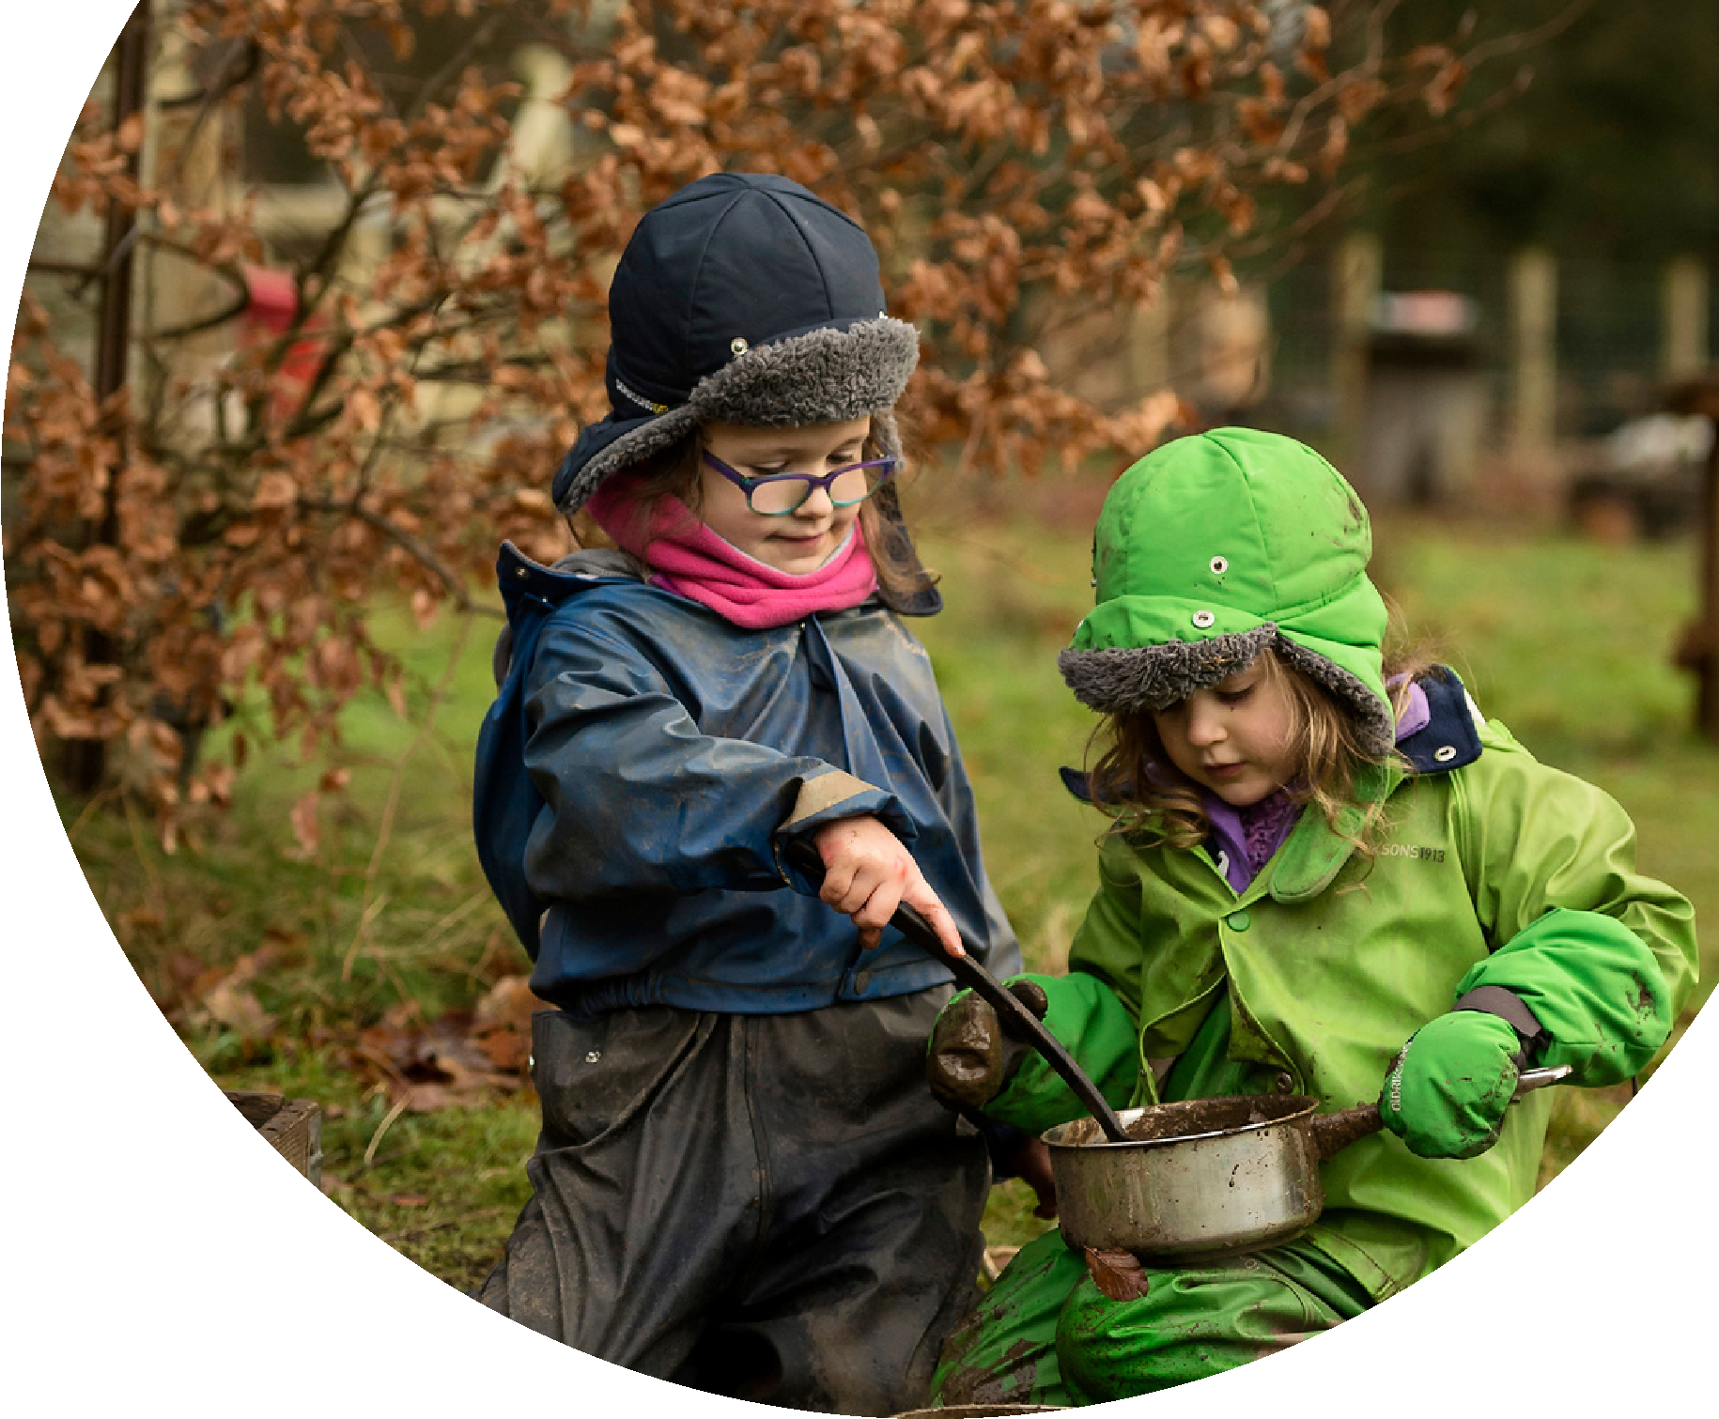
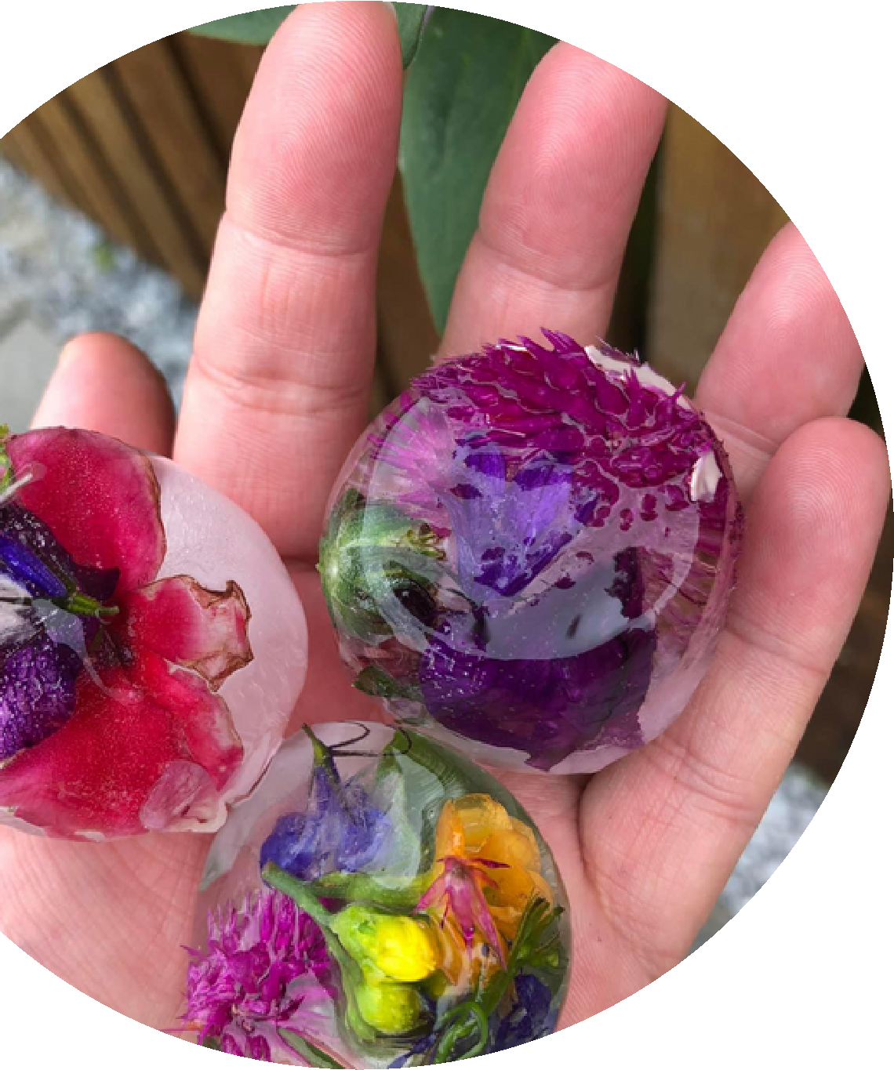
Supporting

outdoor

play

and
learning

at

home

in

the

early

years
.

ww
w
.
virtualnatureschoo
l
.
or
g
Visit our website, or join us on
Facebook, for free outdoor play
resources, ideas and inspiration.
Outdoor play gets children active and
lets their imaginations run wild.

It helps
them develop both mentally and
emotionally, stay healthy, and have fun.
F
r
e
e
R
e
s
o
u
r
c
e
s
Faceboo
k
.
m
co
/
l
vnatureschoo

Outdoor Play and Learning
Young children learn best through play. The outdoors provides a rich environment, full of natural wonders, to peak their curiosity.
The outdoors can be used to explore and learn about all parts of the curriculum; you don't even need any fancy resources!
From literacy and the arts, to maths and science, the natural world might just inspire a life-long love of learning.
Did you know...
Layering is key to staying warm outdoors? You don't need special winter clothes. Simply layer up your normal clothes and pop on a water proof jacket. The colder the weather, the more layers you'll need!
Visit YouTube for videos on dressing for cold weather
Outdoor Learning Example Day
Morning
Have breakfast then watch a Virtual Nature School video. Listen to Dr Claire explain what you'll be exploring that day. Think about where you are going to go, then dress for the weather and head outdoors.
Lunchtime/ Afternoon Have a chat about the morning's adventure whilst you eat your lunch. Then why not write down some notes, film a video or draw some pictures. You can use the nature diary to help you.
Free resources to support home learning

OUTDOOR PLAY IDEAS VIDEOS
We have lots of videos to start you off on your learning journey every day. Simply watch one of the short clips, listen carefully to find out about the day's adventure plans, then head outside to get started.
Find the Virtual Nature School on YouTube

WINTERTIME NATURE PLAY DIARY
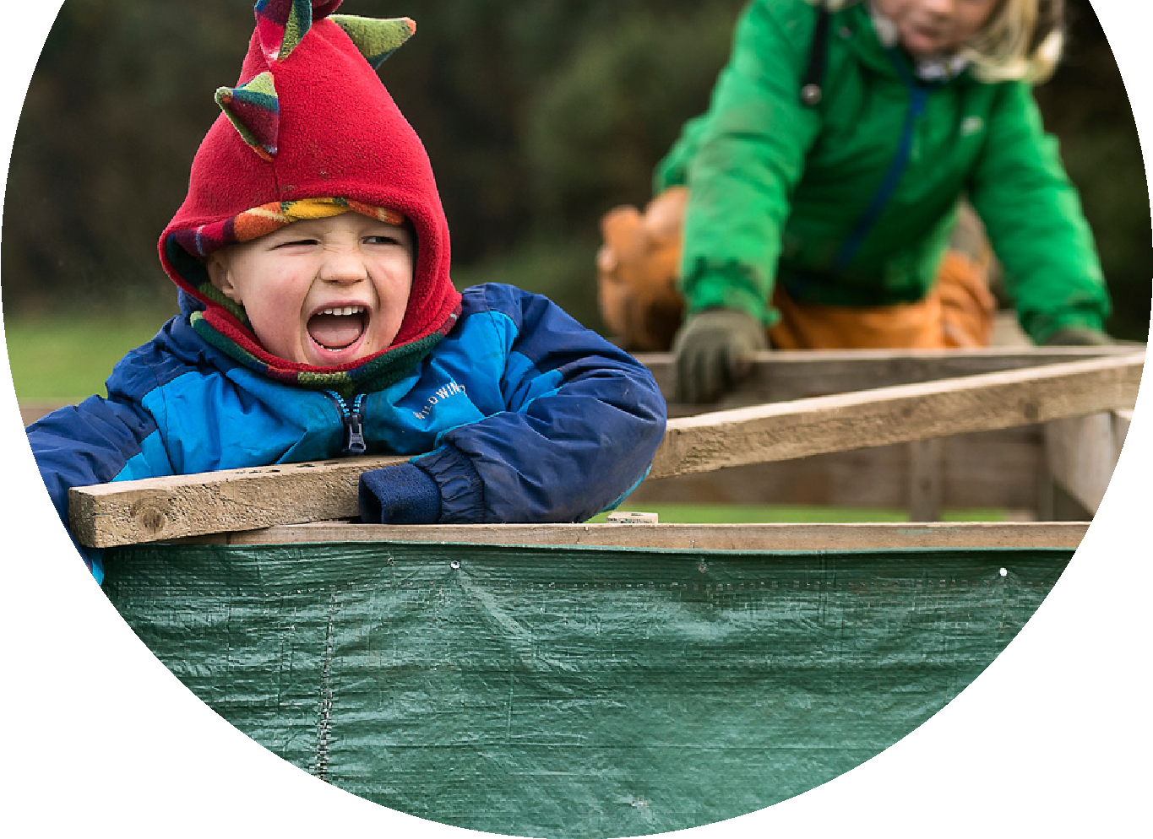
After you've been learning outside, it's great fun to spend some time thinking about what you saw or did. Use the diary to draw pictures or note down ideas. Talking, writing or drawing about your adventures will develop your child's literacy skills.
Download the nature diary at: www.virtualnatureschool.org PARENT PODCASTS
If you are keen to find out more ways to enjoy outdoor play and learning with your children, tune in to our regular podcast for tips, motivation and ideas! Listen at: www.virtualnatureschool.org

