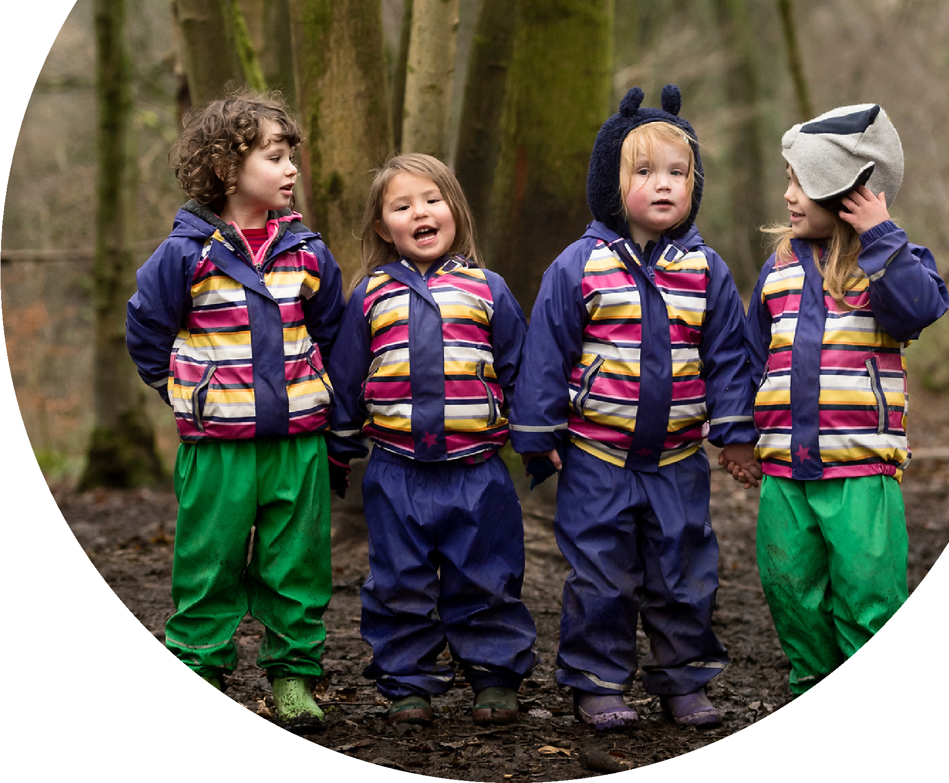
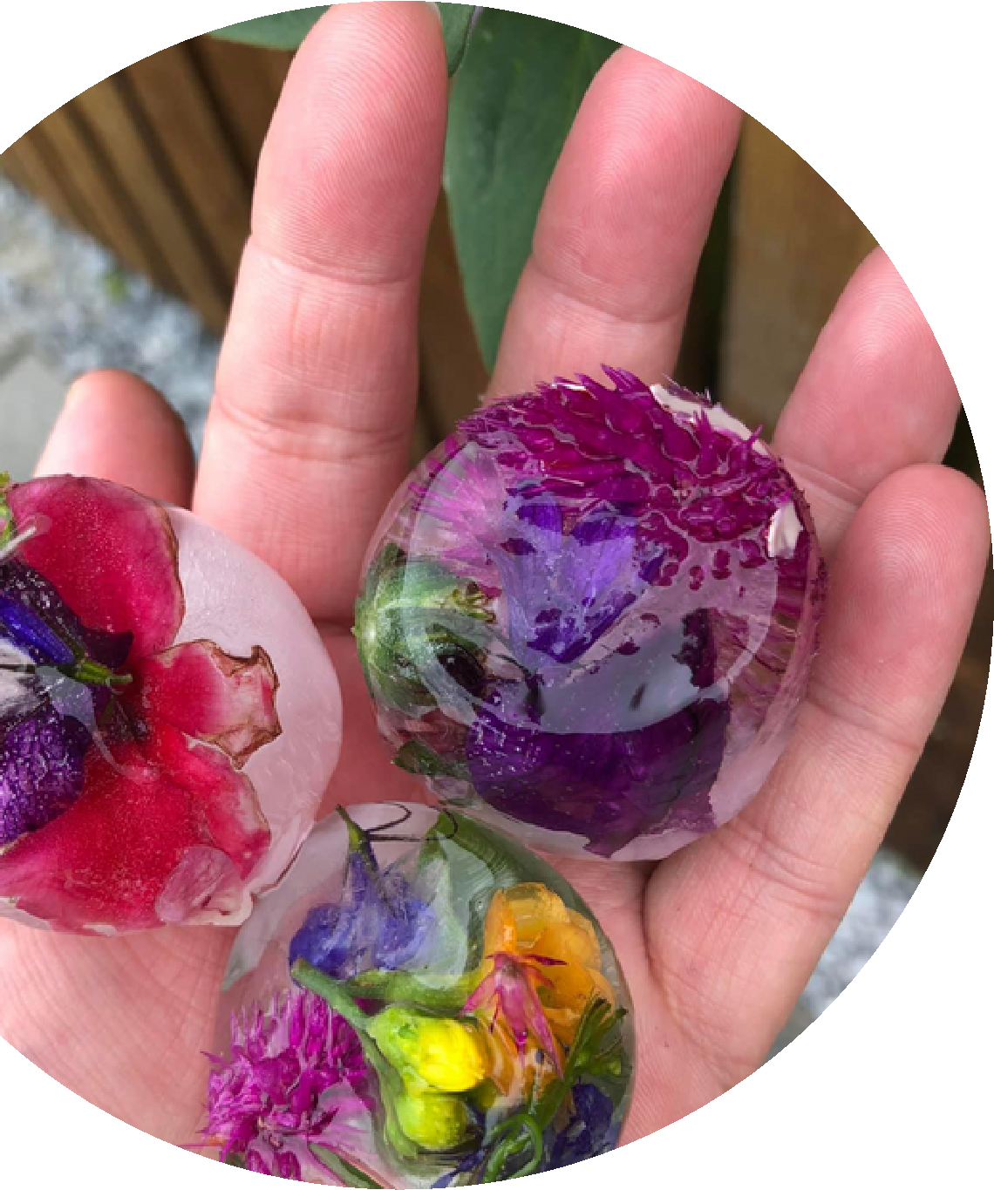
Supporting

outdoor

play

and
learning

at

home

in

the

early

years
.

ww
w
.
virtualnatureschoo
l
.
g
or
Visit our website, or join us on
Facebook, for free outdoor play
resources, ideas and inspiration.
Outdoor play gets children active and
lets their imaginations run wild.

It helps
them develop both mentally and
emotionally, stay healthy, and have fun.
P
r
a
c
t
i
t
i
o
n
e
r
g
u
i
d
e

t
o
h
o
m
e
l
e
a
r
n
i
n
g
k
Faceboo
.
m
co
/
vnatureschoo
l

Free resources to support home learning

OUTDOOR PLAY IDEAS VIDEOS
We have lots of videos to start home learning off each day. Families can simply watch one of the short clips, listen carefully to the learning focus or investigation topic, then get started. Many activities have elements which can be done outside or inside - useful for those days where you can't go out.
Find the Virtual Nature School on YouTube

WINTERTIME NATURE PLAY DIARY
Our nature diary supports parents to talk about, and celebrate, learning with their child. The diary be used to capture the day's learning, supporting the development of literacy skills.
Download the nature diary at: www.virtualnatureschool.org PARENT PODCASTS FOR HOME LEARNING
Parents and practitioners can tune into our podcast series to find out more ways to enjoy outdoor play and learning at home. Share with parents for tips, motivation and ideas!
Listen at: www.virtualnatureschool.org
Outdoor Play and
Learning
We know that young children learn best through play. In ELC the outdoors provides a rich environment for learning, full of natural wonders ready to peak children's curiosity.

When parents support learning at home, they can feel a pressure to carry out typical "learning activities" with their children. Things that they
themselves remember from school; writing, More resources... reading, counting etc.

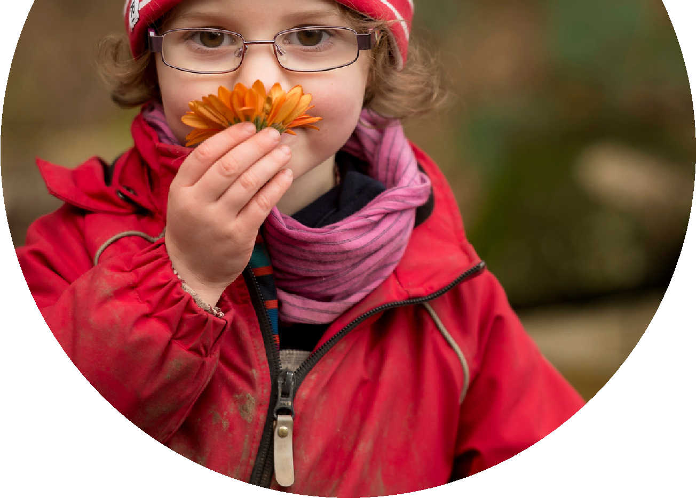
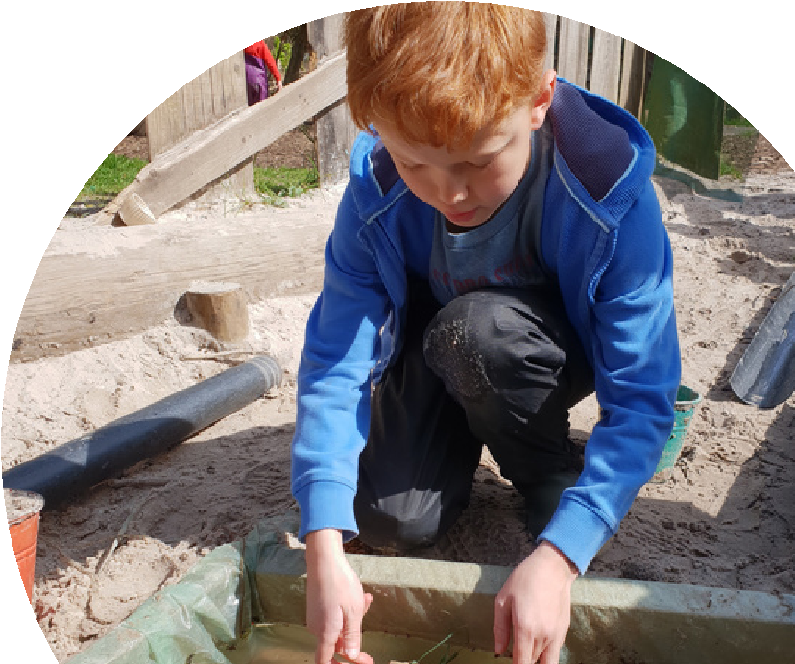
NEWSLETTERS This means that a move to play based learning Our newsletter is designed for can feel like a big step. practitioners and parents to engage children in conversations about nature The Virtual Nature School can be a great based inquiries. Each edition answers a stepping stone in this journey. Providing question that has been posted by a support and structure for parents around child parent or carer; our first newsletter is all led outdoor play experiences. about keeping warm. Share these with
parents as part of your home learning Our videos will show how the outdoors can be package.
used to explore all parts of the curriculum; no
Sign up for our newsletter at: fancy resources needed! www.virtualnatureschool.org

Just for practitioners

PEDGAGOGY PODCAST
Listen back to Dr Claire Warden's weekly outdoor pedagogy discussions with a small group of ELC practitioners each week. Listen at: www.virtualnatureschool.org

