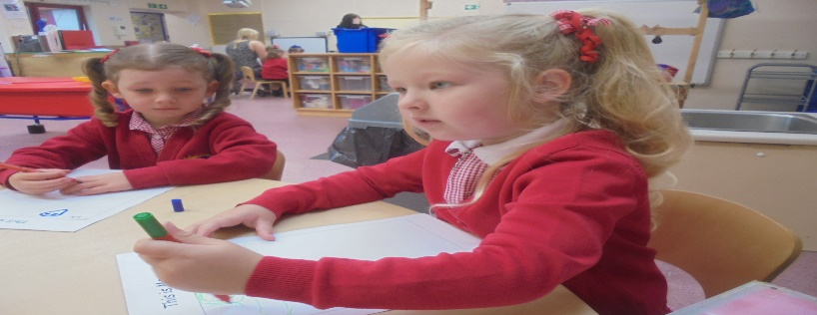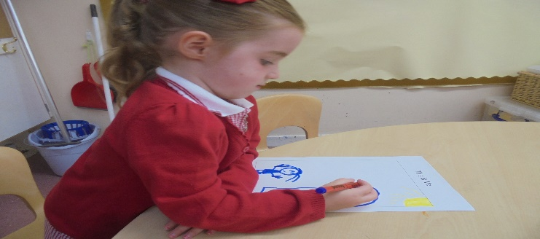

**Session Times**

As of the 2nd of September we are delighted to say that we will be an 1140 hour provider.

The session times are: 8:50 – 14.50 Monday to Friday. Can we ask that all children have an outdoor jacket, footwear/wellies and a change of clothes in case of accidents!

**Nursery Staff**

We are delighted to welcome some new staff to our nursery team to facilitate our expansion to 1140 hours.

Mrs Siobhan Alston – Principal Teacher

Mrs Jane Mitchell (Nursery Lead Practitioner) – Yellow Group

Mrs Bell – Green Group

Mrs Kerr – Red Group

Mrs Simpson/ Miss Gough – Blue Group

Mrs McQuade/ Mrs Crichton – NLC 4 support assistants

**Door Policy**

Please remember if you have any concerns or anything you wish to discuss please do not hesitate to approach your child’s key worker or any other member of staff. Although it is not possible to have close face to face meetings just, now we are able to speak with parents via a phone call. Mrs Ellington, Mrs Alston and Mrs Webster are also available by appointment if there is something you wish to discuss with management. Thank you.

**Suggestions, Concerns and Complaints**

Please remember that you can make suggestions to the nursery staff using the suggestions board and box in the cloakroom, using the slip at the bottom of the newsletters or by speaking to a member of staff. If you have any concerns or complaints you may also report these to nursery staff, Mrs Ellington, Mrs Alston or by following the complaints procedure on the cloakroom notice board. Thank you.

Should you wish to take a complaint further the details for the Care Inspectorate are available at [www.careinspectorate.com](http://www.careinspectorate.com)

**Collection Times**

If your child is going to be collected by a different person to the one who dropped them off please advise the member of staff on the door who is receiving your child into nursery of who the person will be and their relationship to the child. Due to Child Protection procedures if we have not been informed of a change to the adult collecting your child we will not hand over your child until a phone call confirming the change to arrangements has been made.

Welcome Back

Welcome back to all of our returning children and a huge welcome to our new children as they begin their educational journey. The children returning are all settling well and back into our nursery routine. Our new children are learning the ropes and have all generally settled well. Many thanks to our parents and carers for their support in helping the children and staff with this process over the last few weeks.

**Westfield Nursery Class**

September 2020

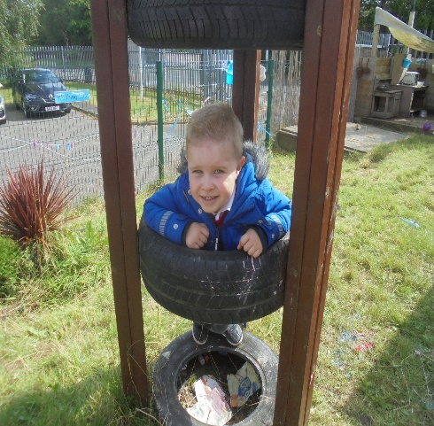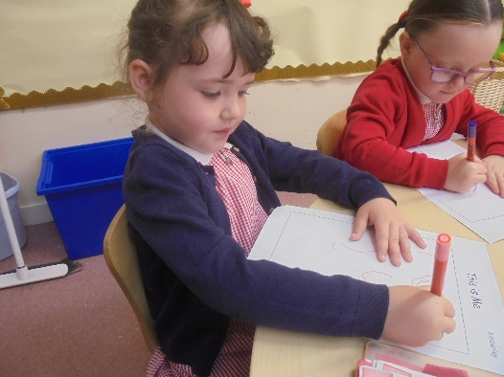

**PTA and Parent Council**

Due to COVID restrictions we are currently unable to hold our normal Parent Council Fund Raising Committee meetings. However, as soon as they resume all nursery parents and carers are welcome to attend.

**Snack Donations**

Although lunch is now provided for all children we still need to purchase biscuits and fruit for daily snacks. Parents are welcome to donate 50p per day towards the nursery fund. The nursery fund is used to purchase daily snack, trips, birthday/Christmas gifts and outings. There are envelopes located on the sign in desk for you to make your donations.

Thank you

**Dates for your Diary**

Holidays and In-service Days

*Nursery closed: Friday 25th September and Monday 28th September re-open Tuesday 29th September at normal times.

*Nursery closed: Monday 12th – Friday 16th October

INSET Day Monday 23rd November to be confirmed

Events

Due to COVID restrictions Parents Evening will not take place in October. Should the guidance change and we are able to have face to face meetings all parents will be informed.

**Topic**

Our new topic is **‘All About Me’**

We will be learning about ourselves, our friends, our families and our nursery.

**Personal Learning Plans and Data Checks**

Staff are currently phoning all parents and carers of returning and new children in connection with their PLPs. Targets set prior to lockdown will be reviewed and new targets discussed and set for our children. If there is a particular target you wish to see included please speak to your child’s keyworker and this will be the focus for the coming few months. The school office are currently compiling the nursery Data Checks. Please check all of the details and return as soon as possible. This ensures that all details are correctly stored on our emergency contacts list. This particularly important if you have changed your mobile phone and have a new number. Thank you.

**Sickness**

In the case that your child is unable to attend nursery please notify the school office by phone before the start of the session. If they have been sick or had diarrhoea they cannot return to nursery until 48 hours after the last period of sickness / diarrhoea. If your child shows any symptoms of COVID then advice should be sought from NHS Inform.

**Suggestions / Comments**: If you have any suggestions or comments please fill in below, tear off and return to a member of staff.

**Birthdays**

The nursery provides a birthday treat for your child on their birthday. We are unable to accept cakes from parents due to allergies.

Thank you for your cooperation and understanding.

**Parking**

We would like to remind parents that the car park is for staff only and children are not permitted at any time. Your support in keeping our children safe and well is much appreciated.