**Westfield Nursery Class** 

December 2018

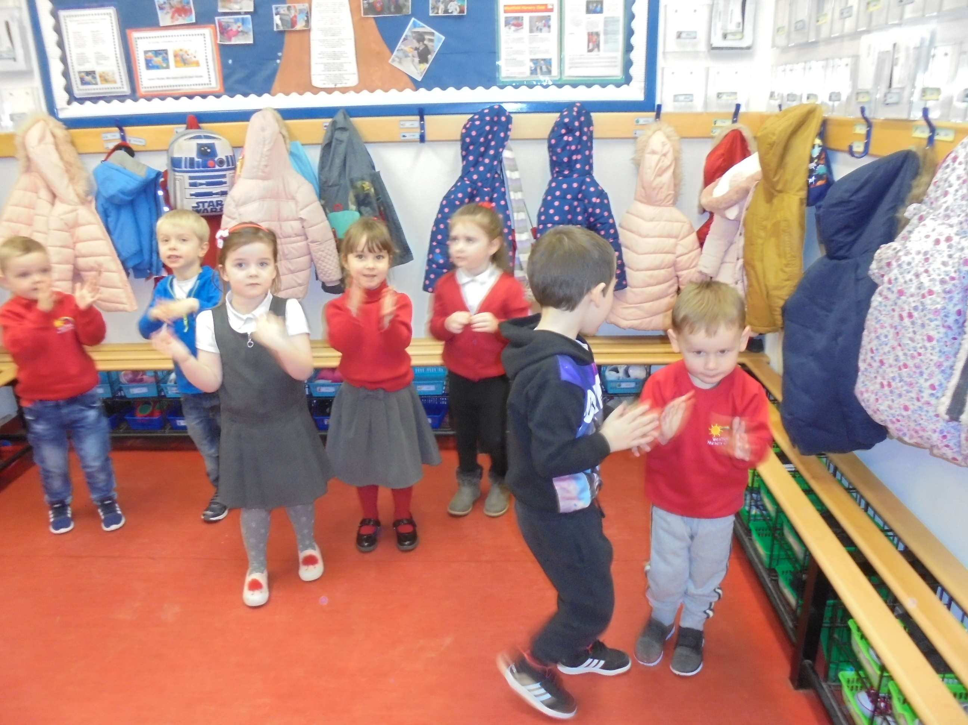

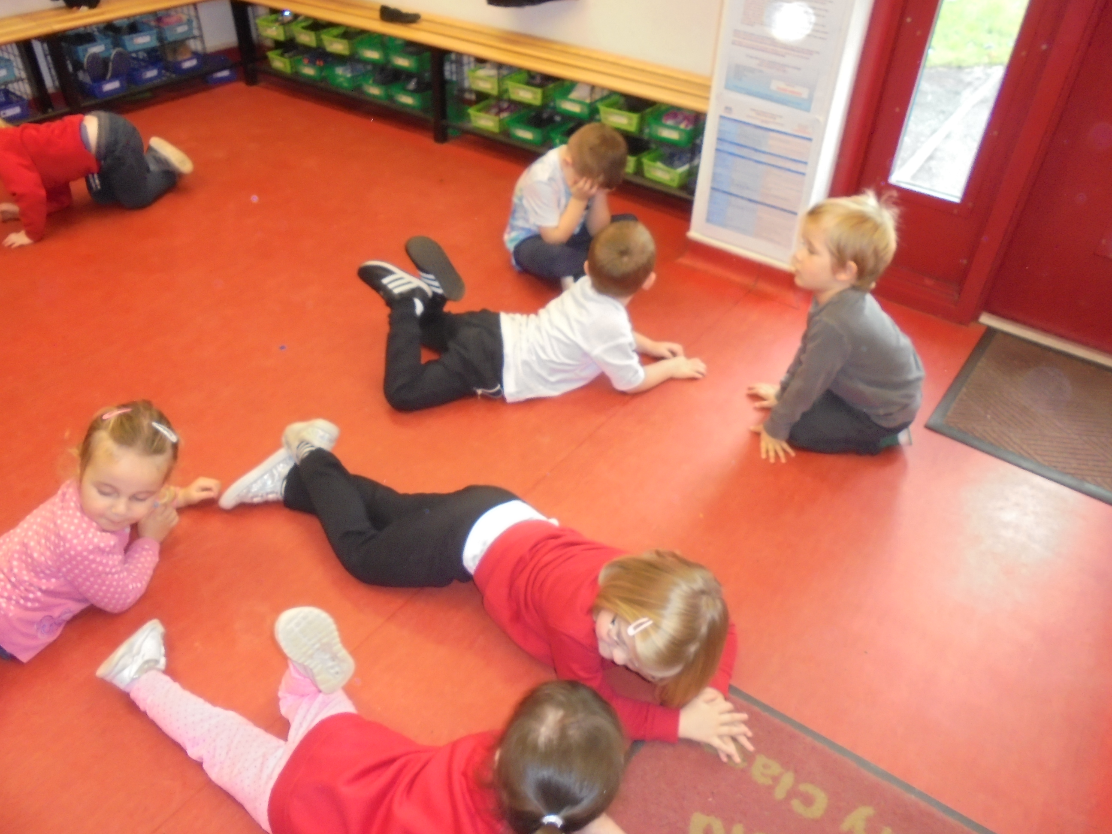

[](http://www.google.co.uk/url?sa=i&rct=j&q=&esrc=s&source=images&cd=&cad=rja&uact=8&ved=0ahUKEwin5dmNyOjXAhUEORQKHT-1DOgQjRwIBw&url=http://unbrokenwarriors.org/product/breakfast-with-santa-13/&psig=AOvVaw3mhLV34dj3AHRFlGj3HF-d&ust=1512209118347913)

**Christmas-Sing-Along**

The children will be performing a Christmas-Sing-Along on Thursday 13th of December, 9:30am and 1:30pm. All children are welcome to attend the Christmas-Sing- Along even if they do not normally attend nursery on a Thursday. We would encourage the children to dress in a Christmas theme (Christmas jumper, Santa hat etc.) for the performance. Parents, grandparents and friends are invited to come along and join the festive fun.  Guests are invited to stay after the performance for tea, coffee and mince pies. We have decided not to sell tickets for this event but donations will be greatly appreciated. All money raised will go towards the nursery Christmas expenses (Christmas party, presents etc). We will have a donations tin at the door on the day. We hope you can come along.

**Snack Money**

All donations from Snack Money are used to support events like Christmas Parties, gifts from Santa, Easter celebrations and any special events throughout the year like our recent St. Andrews Day celebration where the children had shortbread and Irn Bru/ water. Donations should be placed in the envelopes provided and handed to the staff member on the door.

**Parking**

Can we ask that all parents and carers use the car park at the shops as the drop off and pick up for the nursery children. We have had a few near misses recently due to cars not authorised to be in the car park causing congestion. Many thanks for your cooperation with this.

**Condorrat Library**

The nursery will be walking to Condorrat Library on Thursday 6th December for a Christmas storytelling session. If you are available to walk along with us please add your name to the list in the cloakroom area. Thank you.

**Christmas Fayre**

The Christmas Fayre was a great success and we would like to thank all the parents who came along to support the event. If you did not manage along, you are welcome to buy your child’s Christmas Calendar for (£1) and reindeer dust (50p) in the nursery Parent Area.

**Childsmile**

The nursery children had a visit from the Childsmile Team on Thursday the 29th of November. The majority of children had the ‘special’ toothpaste applied. This was a super effort from the children who were happy to show off their beautiful teeth.

**Christmas party**

We will be having a joint Christmas party this year, on Friday 21st December in the morning. Afternoon children are invited to come along to the morning session (8:40am-11-50pm). This is a great opportunity for transition and will ensure the afternoon children get a full session as the school will be closing at early (2.30pm) for the Christmas holidays. Please contact Mrs. Alston if you have any queries or concerns about this arrangement. The party will begin in the nursery then we will move the gym hall for a children’s entertainer, party games and a festive snack. Parents are invited to join the party in the gym hall at 11:10am to see the children get a present from Santa. All children are welcome to attend the Christmas party even if they do not normally attend nursery on a Friday.

**Topic**

In December we will be learning all about

**Christmas**

[](http://www.google.co.uk/url?sa=i&rct=j&q=&esrc=s&source=images&cd=&cad=rja&uact=8&ved=0ahUKEwjmiua80OjXAhVKXBQKHb9aDO0QjRwIBw&url=http://homestart-meonvalley.org.uk/christmas-tree-event/&psig=AOvVaw3wpXXM0UWdYrIeCTl5JAQM&ust=1512211365386698)

Dates for your Diary

**Holidays**

**Nursery closes: 11:50am Friday 21st of December

**Nursery reopens: 8:40am, Monday 7th January

**Events**

** Condorrat Library visit, Thursday 6th December

**Christmas Show, Thursday 13th December (9:30am/1:30pm)

**Christmas Party, Friday 21st December (Morning for everyone)

**Open Door Policy, Suggestions, Concerns and Complaints**

Please remember if you have any concerns or anything you wish to discuss please do not hesitate to approach your child’s key worker or any other member of staff. Although it is not always possible to enter into discussions when all of the children are entering the nursery, the staff are usually able to discuss concerns once the busy period is over. Mrs Ellington, Miss Reilly and Mrs Alston are also available by appointment if there is something you wish to discuss with management.

Please remember that you can make suggestions to the nursery staff using the suggestions board and box in the cloakroom, using the slip at the bottom of the newsletters or by speaking to a member of staff. If you have any concerns or complaints you may also report these to nursery staff, Mrs Ellington or by following the complaints procedure on the cloakroom notice board. Thank you.

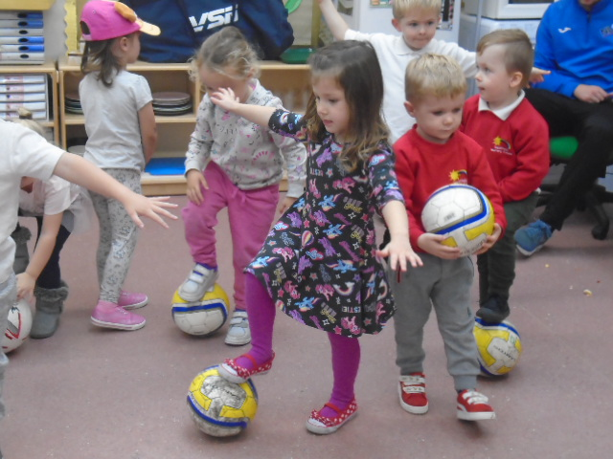

**Nursery Blog**

In response to your requests and suggestions we are trying to include all nursery information on the Nursery Blog. Please check the Blog, and comment if you wish, on any aspect of nursery.

**Suggestions / Comments**: If you have any suggestions or comments please fill in below, tear off and return to a member of staff.