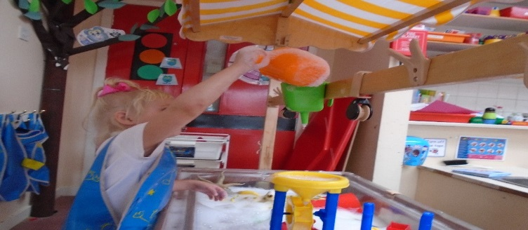

Welcome Back

Welcome back to all of our returning children and a huge welcome to our new children as they begin their educational journey. The children returning are all settling well and back into our nursery routine. Our new children are learning the ropes and have all generally settled well. Many thanks to our parents and carers for their support in helping the children and staff with this process over the last few weeks.

**Collection Times**

Staff would like to remind parents and carers that the children should be collected no later than 11.50 and 3.55. The 10 minutes after the morning session and 20 minutes after the afternoon session are allocated for staff to discuss planning and progress confidentially. Thank You

We would like to remind all afternoon parents and carers to use the whiteboard marker to indicate the time that they will be collecting their child. This helps the nursery staff to structure the day and ensure that the child has the opportunity to attend snack before leaving.

**Suggestions, Concerns and Complaints**

Please remember that you can make suggestions to the nursery staff using the suggestions board and box in the cloakroom, using the slip at the bottom of the newsletters or by speaking to a member of staff. If you have any concerns or complaints you may also report these to nursery staff, Mrs Ellington or by following the complaints procedure on the cloakroom notice board. Thank you.

**Open Door Policy**

Please remember if you have any concerns or anything you wish to discuss please do not hesitate to approach your child’s key worker or any other member of staff. Although it is not always possible to enter into discussions when all of the children are entering the nursery, the staff are usually able to discuss concerns once the busy period is over. Mrs Ellington, Mrs Alston and Miss Reilly are also available by appointment if there is something you wish to discuss with management. Thank you.

**Session Times**

Morning Session: 8.40 – 11.50

Afternoon Session: 12.45 – 3.55

**Nursery Staff**

Miss Copeland – Nursery Teacher

Mrs Kerr – Ladybirds Key Worker

Mrs Simpson – Butterflies Key Worker (M,T)

Miss Gough – Butterflies Key Worker (W, Th, F)

Mrs Bell – Grasshoppers Key Worker

**Westfield Nursery Class**

September 2018



**Sickness**

In the case that your child is unable to attend nursery please notify the school office by phone before the start of the session. If they have been sick or had diarrhoea they cannot return to nursery until 48 hours after the last period of sickness / diarrhoea.

**PTA and Parent Council**

The first PTA and Parent Council meetings will be held on Tuesday 11th September. New members are always welcome to join. Please contact the school office if this is something you are interested in joining. Thank you.

**Snack Donations**

Parents are welcome to donate 50p per day towards the nursery fund. The nursery fund is used to purchase daily snack, trips, birthday/Christmas gifts and outings. There are envelopes located on the sign in desk for you to make your donations.

Thank you

**Topic**

Our new topic is **‘All About Me’**

We will be learning about ourselves, our friends, our families and our nursery.

**PLPs and Data Checks**

PLPs have been handed out to all new children and returning children who set their targets in January and February. Please fill in or check the details, return the PLP to a member of staff and make an appointment using the sheet in the cloakroom to discuss a target for the next 6 months. The school office are currently compiling the nursery Data Checks. Please check all of the details and return as soon as possible. This ensures that all details are correctly stored on our emergency contacts list. This particularly important if you have changed your mobile phone and have a new number. Thank you.

**Suggestions / Comments**: If you have any suggestions or comments please fill in below, tear off and return to a member of staff.

**Dates for your Diary**

Holidays and In-service Days

*Nursery closed: Friday 21st September and Monday 24th September re-open Tuesday 25th September at normal times.

*Nursery closed: Monday 15th – Friday 19th October

INSET Day Monday 19th November

Events

*Parents’ Meeting week: W.C. Monday 8th October, evening appointments available Thursday 11th October

(more information to follow nearer the time.)

**Birthdays**

The nursery provide birthday cakes for your child on their birthday. We are unable to accept cakes from parents due to allergies.

Thank you for your cooperation and understanding.

**Parking**

We would like to remind parents that the car park is for staff only and children are not permitted at any time. Your support in keeping our children safe and well is much appreciated.