**Westfield Nursery Class** 

<https://blogs.glowscotland.org.uk/nl/WestfieldNursery/>June 2018

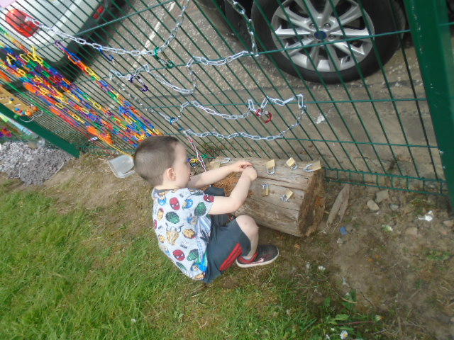



**Sun screen**

Could you please ensure your child has sunscreen on every day. The children do use the nursery garden daily and the weather has been so nice we are concerned the children may get sunburn. There is extra sunscreen in the cloakroom for your use.

Dates for your Diary

**Holidays and In-service Days**

** Thursday 28th June, Nursery closes at 1pm for Summer holidays.

**Events**

* Stay and play days, week beginning 4th June

*Friday 8th June, Coffee Morning/Afternoon

* Monday 11th June, 1pm: Teddy Bears Picnic -Pre-schoolers only

* Thursday 14th June, 6:30pm: Beach Party Disco – Pre-schoolers only

* Summer Trip, Blair Drummond Safari Park Thursday 14th June.

* Nursery Leavers Assembly & Garden Party, Thursday 21st June. 9:30am & 1:30pm

Our topic in June is:

**Animals & Summer**.

**Nursery trip**

The nursery trip to Blair Drummond Safari Park is booked for Thursday 14th June. We will leave nursery around 9:15am and return back for 3pm. As the children are of pre school age we need every child to be accompanied by an adult. There is a sign up sheet in the cloakroom. The sponsor money raised by the beat the goalie fundraiser has helped with the cost of the trip. Therefore the children and the bus will be covered by the funds raised and the adults accompanying the child will only need to pay £11:50 for their admission to the park. All trip money should be paid by Friday 9th June. Please ensure your child has appropriate shoes for walking all day, a jacket with a hood, sunscreen and a packed lunch.

**Leavers assembly/Garden Party**

The leavers assembly will be on Thursday 21st June at 9:30am and 1:30pm. We have decided to host a garden party in our new improved nursery garden straight after the assemblies. We hope you can join us.

**Coffee morning/afternoon**

We will be having our last coffee morning/afternoon on Friday 9th June (rescheduled from 1st June) at 10:45am and 12:45pm. There is a sign up sheet in the cloakroom. We hope you can make it. Our very own mini tour guides are excited to give you a tour of our new improved garden too. We hope you can join us.

**Snack donations**

Could we please remind everyone of the importance of snack donations, we use this towards not only the daily snack but also extra items like birthday presents and cakes, playdough and trips and we are running particularly low at present.

**Homelink bags**

Many thanks to the parent helpers who have been volunteering to give out the ipads, library books and Sid & Shanarri bags every week throughout this term. However we have found it tricky some weeks as the bags were not returned from the previous week. Can we ask that you return all bags on a Tuesday to give us time to get them back out to the children in a Thursday.

**Reduced session**

The nursery will be closing early at 1pm, on the last day of term Thursday 28th June. We will therefore offer two reduced session to give everyone an opportunity to attend nursery on that day.

Morning session 8:40 – 10:30am

Afternoon session 11am – 12:50pm

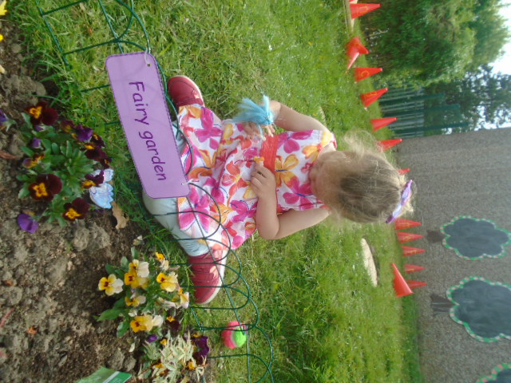

**Beat the goalie**

Our beat the goalie fundraising event was great fun and a huge success. Thank you to the generosity of you, your family and friends we managed to raise an amazing £1039 so far and there is still more donations too come. As you know this has helped subsidise our summer trip to Blair Drummond Safari Park.

**Stay and play days**

You are invited to stay and play with your child and maybe explore our new improved nursery garden, next week 4th - 8th June. There is a sign up sheet in the cloakroom.

**Open Door Policy, Suggestions, Concerns and Complaints**

Please remember if you have any concerns or anything you wish to discuss please do not hesitate to approach your child’s key worker or any other member of staff. Although it is not always possible to enter into discussions when all of the children are entering the nursery, the staff are usually able to discuss concerns once the busy period is over. Mrs Ellington, Miss Reilly and Mrs Alston are also available by appointment if there is something you wish to discuss with management.

Please remember that you can make suggestions to the nursery staff using the suggestions board and box in the cloakroom, using the slip at the bottom of the newsletters or by speaking to a member of staff. If you have any concerns or complaints you may also report these to nursery staff, Mrs Ellington or by following the complaints procedure on the cloakroom notice board. Thank you.

**Suggestions / Comments**: If you have any suggestions or comments please fill in below, tear off and return to a member of staff.