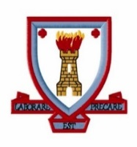
Coatbridge High School
Primary Transition Newsletter June 2021

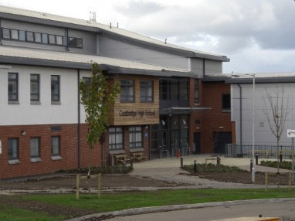

Message from Head Teacher – Mrs Creaney
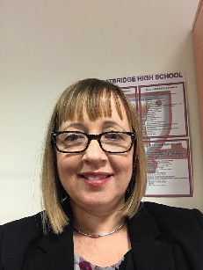
Dear Future Coatbridge High School Pupil

I write to you at an exciting time. Soon, you will no longer be a primary school pupil and you will become a secondary pupil at Coatbridge High School. We are looking forward to welcoming you and helping you become part of the community here.

Moving to secondary school is a big step but don’t be worried about it because there are lots of staff and older pupils who are looking forward to supporting you when you arrive in August. The transitions events will have helped you to find more about what to expect as a pupil at Coatbridge High School. In June you had an opportunity to visit the school and get involved in PE activities. You have left a very good impression on the staff. Well done!

I am sure there are events arranged to celebrate your time at primary school. I hope these events go well and that you make good memories that I am sure you will add to during secondary school.

I hope you are looking forward to starting as a Coatbridge High School pupil in August. Have a lovely summer.

I look forward to meeting you soon.

Mrs Creaney

Message from S1 Depute – Mrs Mills
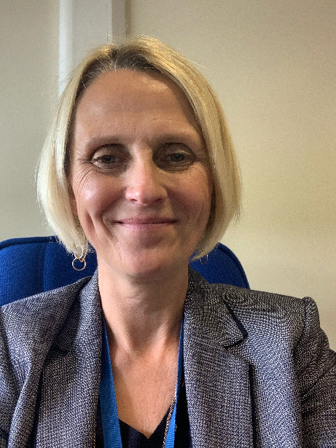
Hello, my name is Mrs Mills and I am a Depute Head Teacher at Coatbridge High School. I am delighted to tell you that I will be the year head for all of our S1 young people joining Coatbridge High School in August. Hopefully I have met most of you already through our transition days and my visits to your primary schools, I am looking forward to getting to know you all much better next year. I would like to take this opportunity to wish you and your families a fantastic summer before our new term starts on Monday 16th August 2021.

Our Transition Year – “P7 Class of 2021”

Our transition programme began this year when pupils had settled in to P7 following lockdown and the summer break. Due to the continued restrictions in place, we set out to ensure that P7 pupils had every opportunity to prepare for their transition to high school. A series of lessons designed by subject specialists across all curricular areas were delivered by primary colleagues.
WW1 Centenary Drama Music P7 Burns Competition Bridge that Gap! Mystery Box of Maths School of Rugby School of Dance Art Science Modern Languages Escape Room-Coatbridge High Library Health & Wellbeing Preparing for High School(Pupil Support)

In addition, video messages have been sent to P7 classes from individuals across the Coatbridge High school community.
- Mrs Dunion, PT Access to Learning & Behaviour – “Welcome to Coatbridge High School”
- School Captains & Vice Captains – “My experiences of coming to Coatbridge High School”
- Jamie Dungavell – “Role of Home School Partnership Officer”
- PC Frew – “Role of Community Police”
- S1 Pupils – “What I like most about Coatbridge High School”

On 26th May all P7 classes participated in a virtual assembly learning about Coatbridge High School’s values and expectations and useful information for starting S1 in August..
Later that day, Mrs Creaney (Head Teacher), Mrs Mills (Year Head for S1) and Mrs Dunion (PT Access to Learning & Behaviour) were delighted to be joined with a large number of P7 pupils and their parents for a virtual information Q&A session.
Highlights of Our Transition Year
Thank you to Primary colleagues for sharing images of some of their transition lessons.
Pupils from Bargeddie Primary enjoyed their WW1 lesson.
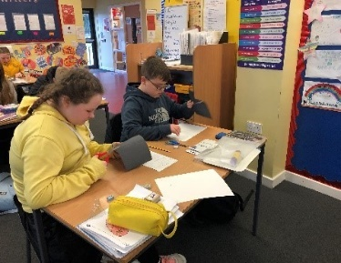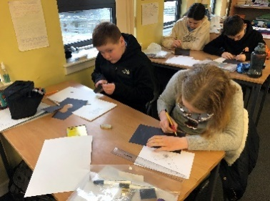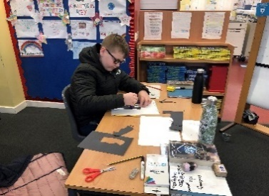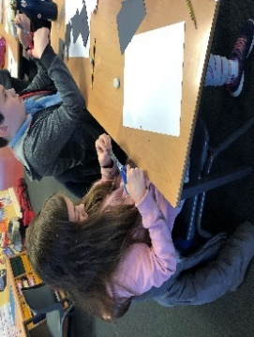
Pupils from Townhead Primary enjoyed the Music lesson, the Centenary lesson and the meeting with Jamie Dungavell (Home School Partership Officer).
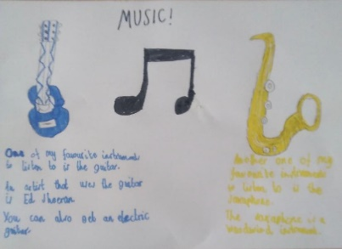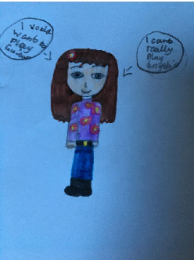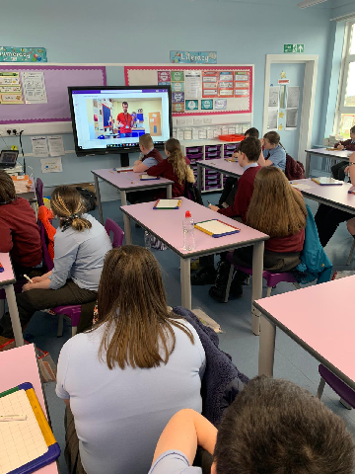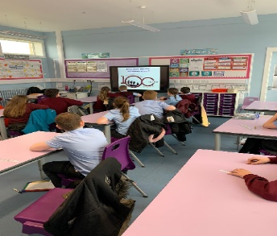
By far the most photographed event was the “Bridge the Gap” lesson provided by our Technical department. Coatbridge cluster is definitely “Developing the Young Workforce!”
Greenhill primary demonstrated excellent team working and problem-solving expertise during the lesson.
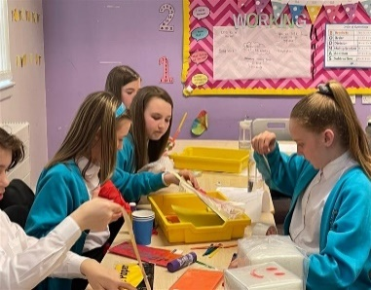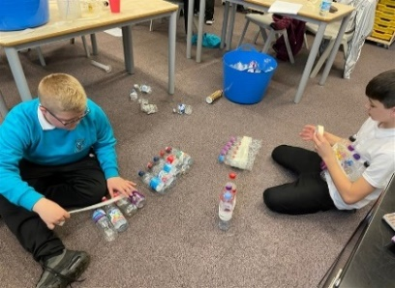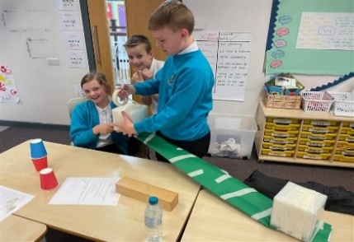
The “Bridge that Gap” lesson was also popular with the budding engineers of Langloan Primary.
. 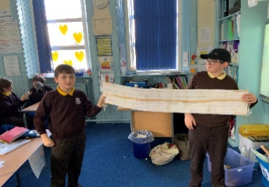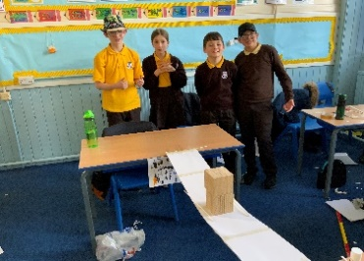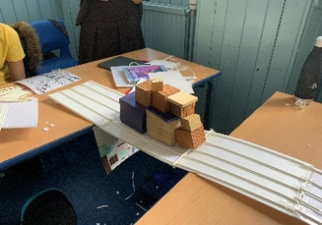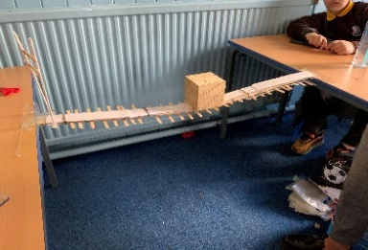
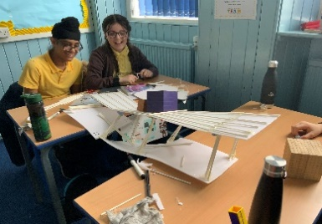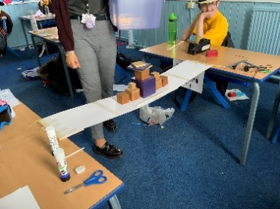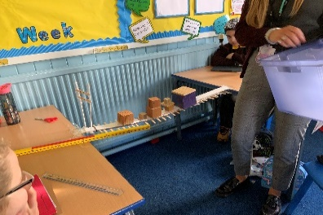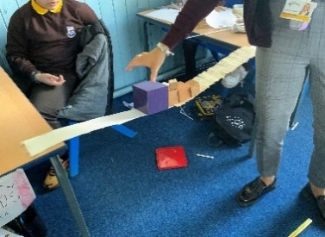

The pupils of Glenboig primary were also keen to show us their outstanding design and bridge building skills.
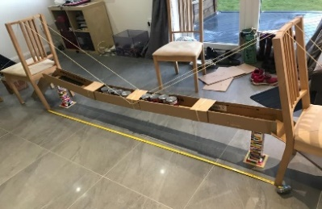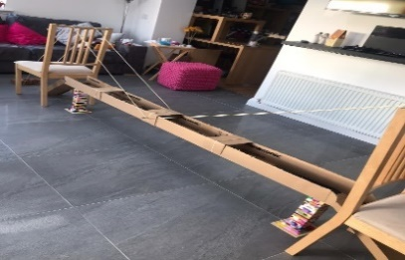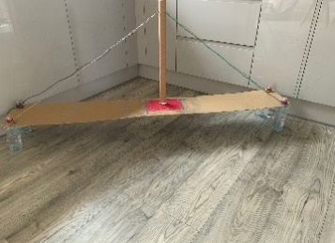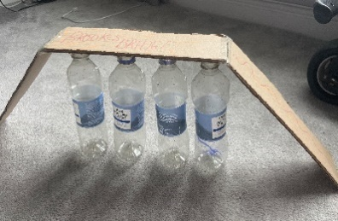
The scientists of tomorrow from Kirkshaws Primary had fun with their Science experiments during our virtual transition week.
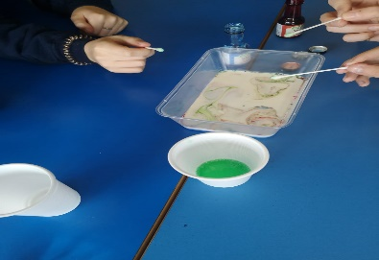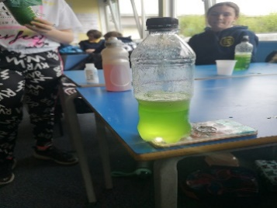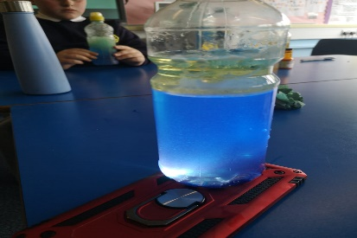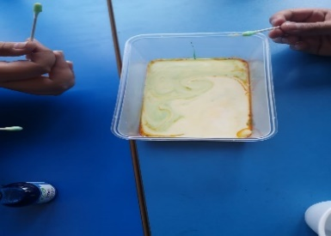
Carnbroe Primary is also home to some enthusiastic Scientists!
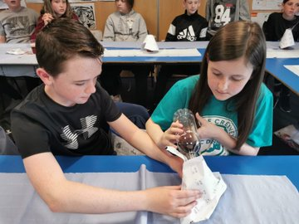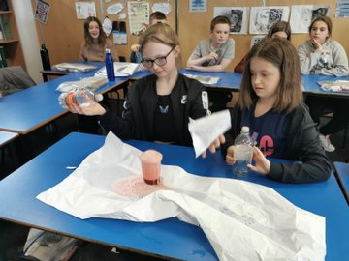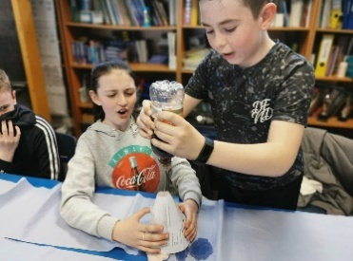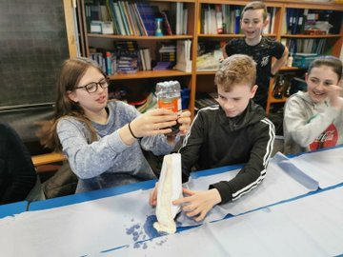
Old Monkland Primary is home to some outstanding artist talent who enjoyed their Art lesson!
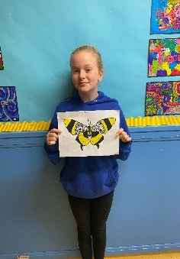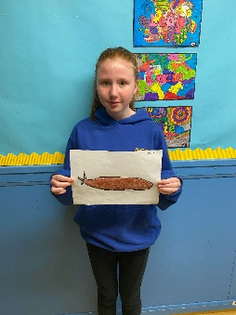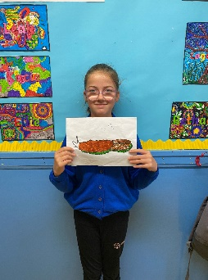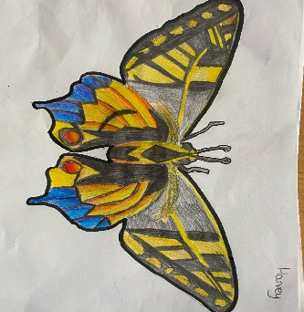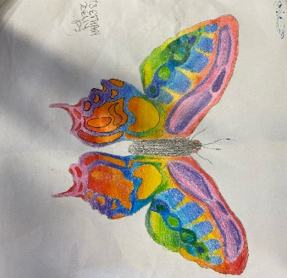

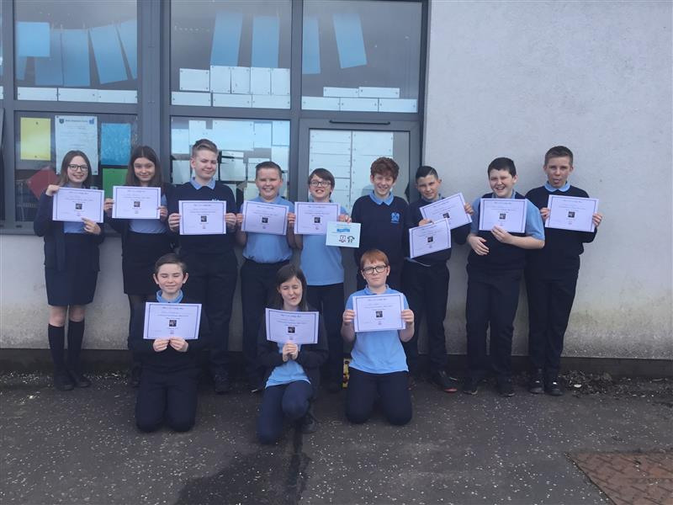
All finalists who participated in the public speaking event were presented with a certificate from the English department due to the high standard of entries this year. Carnbroe primary shared photos of their finalists with us.

Shawhead Primary had fun completing the “Mystery Box of Maths” activities in their dining hall.
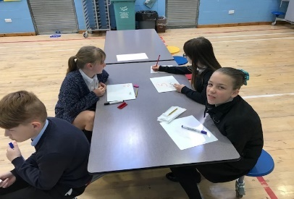
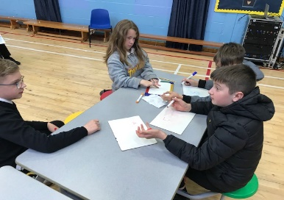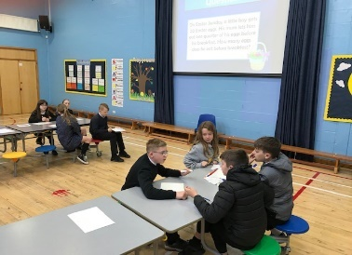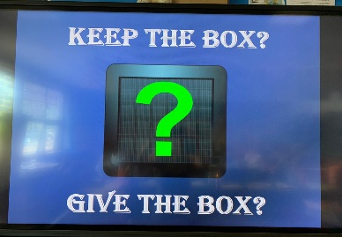

Sikeside Primary pupils enjoyed their Spanish lesson from the Modern Languages department.
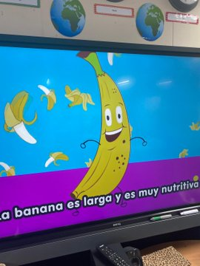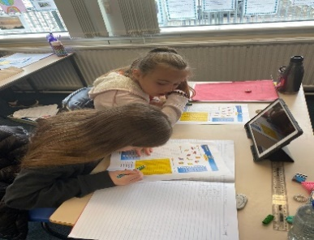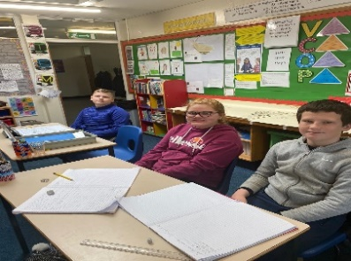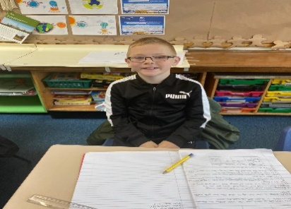
In May we were delighted to provide rugby sessions to all our partner primaries as part of our School of Rugby programme in partnership with Waysiders Drumpellier and Scottish Rugby Union.
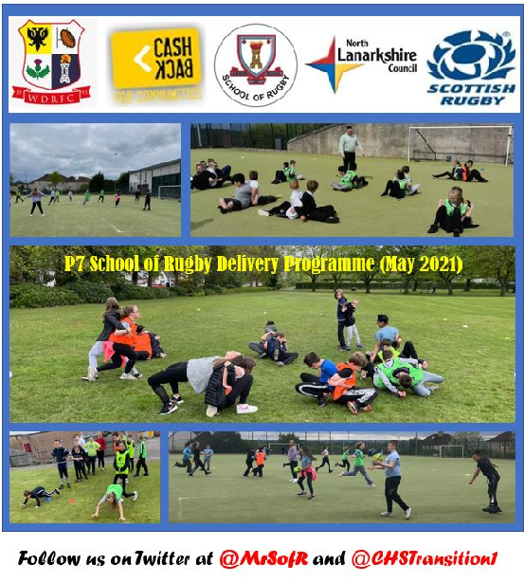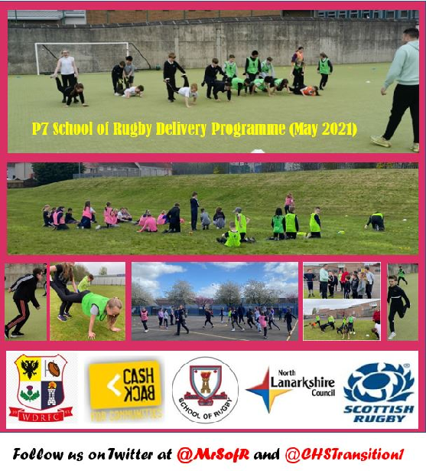
We were also pleased to welcome along applicants for our School of Dance and Aesthetics for auditions.
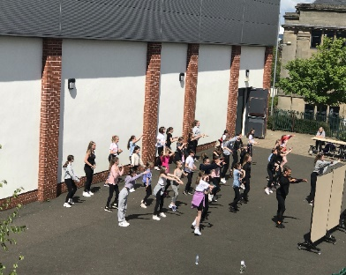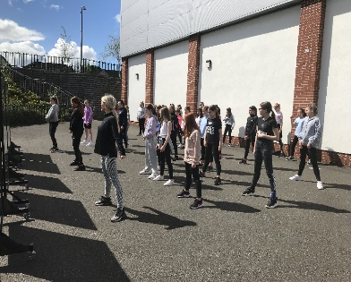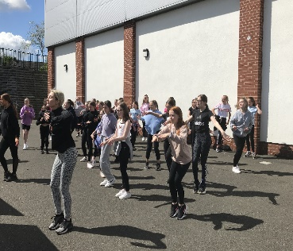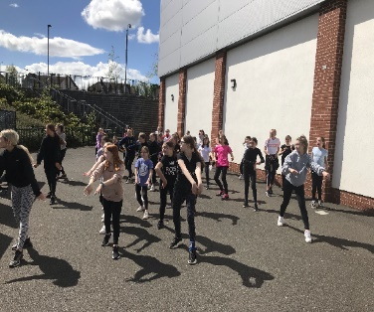

The highlight of our programme however has to be welcoming all P7 pupils to visit Coatbridge High school for a tour of the building and to take part in our PE event hosted by our Senior Sports’ Leaders.
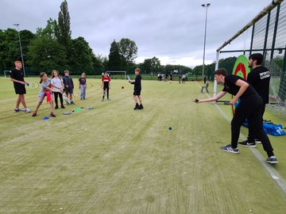
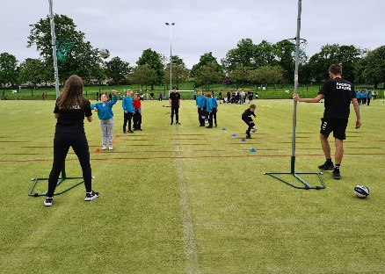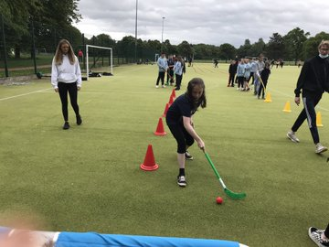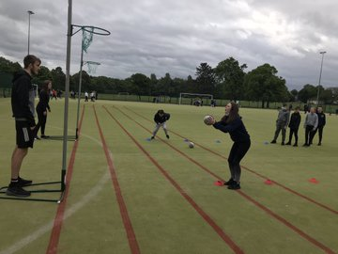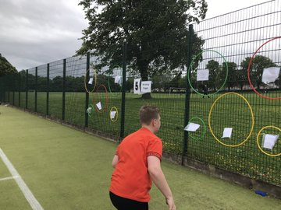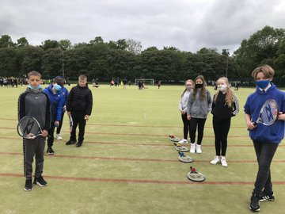
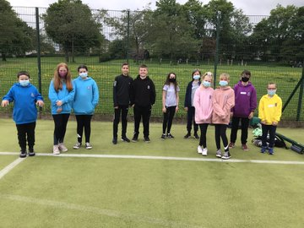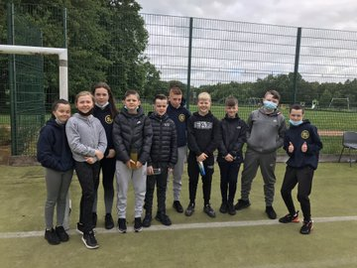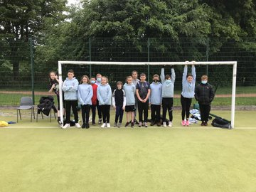
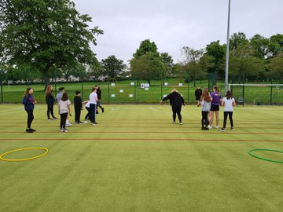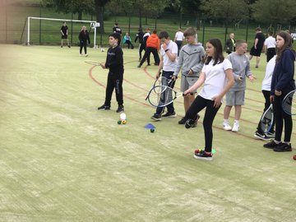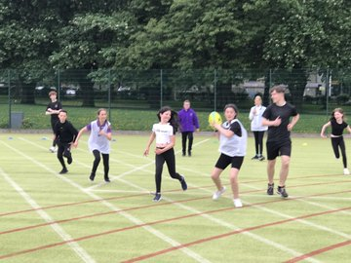
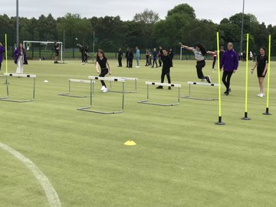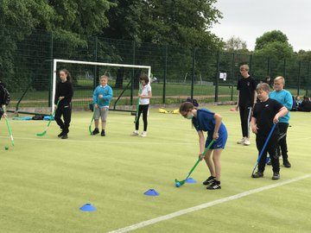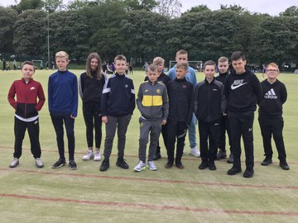
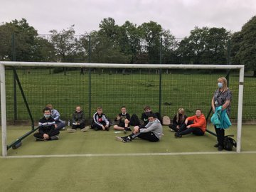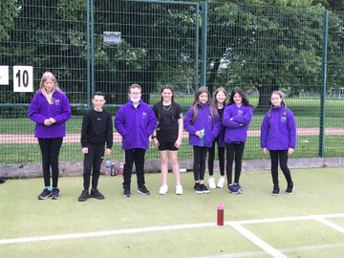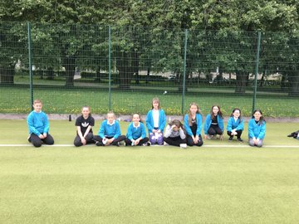
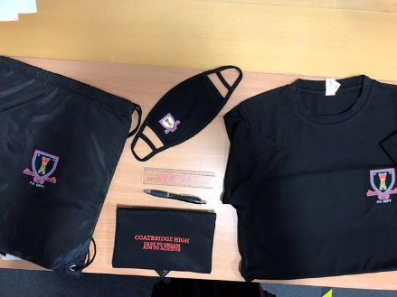

Primary 7 pupils were delighted to receive a goodie bag of Coatbridge High essentials from ourselves to start their preparations for August.

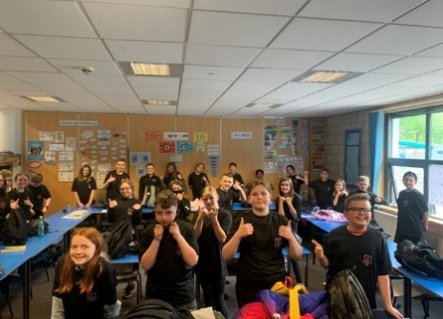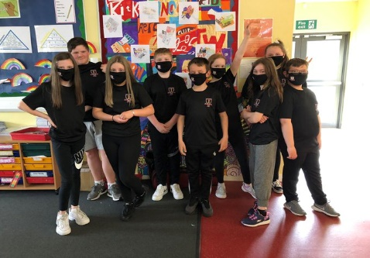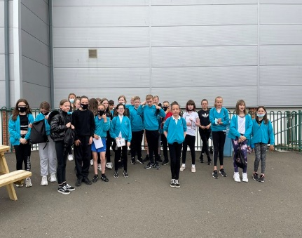

Transition information – have your say
Just to ensure that we have all the information we require, if you have not already done so can we ask that you and your child complete the following surveys:
Parents:
www.forms.office.com/Pages/ResponsePage.aspx?id=oyzTzM4Wj0KVQTctawUZKY3w-8WurXxJm91jhx8xk0ZUQkpTWVk0WTgzWlFLQUlDTklCMFVZM0ZCWS4u
Pupils:
www.forms.office.com/Pages/ResponsePage.aspx?id=oyzTzM4Wj0KVQTctawUZKY3w-8WurXxJm91jhx8xk0ZURVYwTTRBRlU1UVYwQlBBRlRSNDVISU9DQi4u

New House System
From August 2021 we have a new house system starting in Coatbridge High School.

- PTPS | - House Name | - Colour
- Mrs Ballantyne | - Skye | - Red
- Mrs Beaton | - Lewis | - Yellow
- Mrs Fawcett | - Mull | - Purple
- Mrs Hunter | - Arran | - Blue
- Mrs Nicholson | - Islay | - Green

We hope you have enjoyed your P7 Transition year with us and we look forward to welcoming you to join the Coatbridge High school community in August. Enjoy your holidays!
Keep in touch
Parental engagement is very important to us in Coatbridge High school. There are many ways in which you can follow what is happening in Coatbridge High school in order to support your son/daughter during this important transition year and during coming years.
Follow us via Twitter – @CoatbridgeHigh @CHStransition1
Keep up to date with our school website – https://blogs.glowscotland.org.uk/nl/coatbridgehighschool
If you have any concerns regarding your child’s transition and you would rather speak to me in person (Mrs Dunion), please call the school office at (01236) 794848 leaving you and your child’s name, the primary school they currently attend and your contact number. We look forward to working with your child and your family over coming years to ensure they achieve all they can.

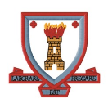

Working in partnership with our partner primary schools.

“Dare to Dream, Aim to Achieve”

