Townhead Nursery Class
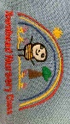TOWNHEAD NURSERY CLASS

May 2021 Newsletter
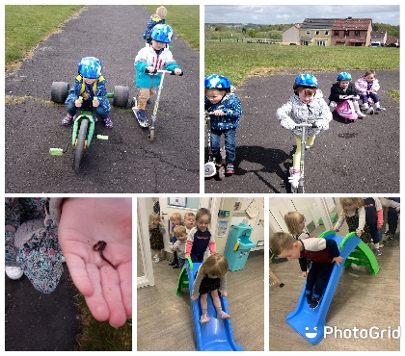
We very much hope you enjoyed the bank holiday weekend. The weather stayed fine up until the very wet and extremely windy start to the week! We seem to be having April showers in May, hopefully it changes before our next long weekend break at the end of May! Our children continue to embrace the routines and exciting play experiences, under the nurturing guidance of our Early Learning Practitioners, pics can be found on Twitter.

COVID-19 Drop Off and Collection Times
We are aware that as we continue on the pathway out of Lockdown, there are still cases of COVID-19 in our local community. In order for us to remain open and protect our staff and children, please continue to follow the Scottish Government guidelines. Should you, your child, or any member of the family you live with develop the symptoms of COVID-19 we request you are tested immediately.
Please continue to adhere to your child’s designated time when entering and exiting the Nursery and maintain social distancing between other adults who are dropping off and picking up their child. Hopefully the Nursery will open fully in the near future and our children will be able to access every area, thank you for continued support and understanding with regard to the situation.

Fundraising - Teddy Bear’s Tea Party – Monday 24th May 2021
Townhead Nursery and Primary 1 are looking forward to a Teddy Bear’s Tea Party in order to raise money for St. Andrew’s Hospice (Lanarkshire)
The children will bring home a sponsor form on Monday 17th. Please send the form and any donations back to us before or on Thursday 27th May. Many thanks for your support. All money raised will be sent to the Hospice to support their amazing work.
We will share our wonderful day with you on Twitter @TPSNurseryNLC.

Snack/Toy Nursery Fund
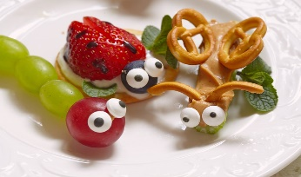
Thank you so much for continuing to contribute to our fund. Your child will be given a small brown money envelope every Monday, if you can please place the money in this to be returned to your child’s Key Worker. We very much appreciate the money received, this enables us to provide a greater choice at snack time and to enhance our learning provision with additional resources.

Learning Fun
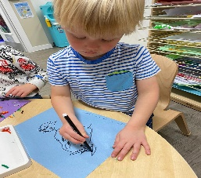
Nursery pupils and Primary 1 are enjoying socially distance partnership learning. They have been reading ‘The Very Hungry Caterpillar’ and are having so much fun finding out what the Hungry Caterpillar has been eating! This topic has certainly sparked their imagination and creativity! All children have experienced healthy eating at snack time, printing symmetrical butterflies, learning about the life cycle of a butterfly and most exciting, growing their own butterflies! This has caused lots of excitement
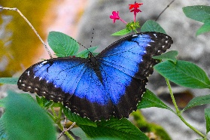
Our caterpillars are due to arrive around the 20th May, watch this space!

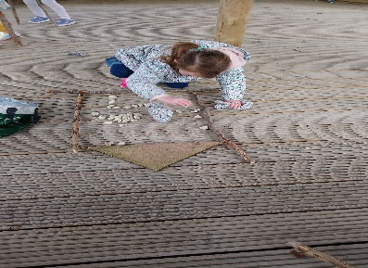
The children have been acting out and retelling the story of ‘The Tiny Seed’ and built up a display to reflect their learning, including naming parts of a plant and what plants need to grow. In Maths they have been counting up and down from 0 to 10 and recognising and describing 2D shapes.
Outdoor numeracy remains a favourite for the children as they explore numbers in their environment,

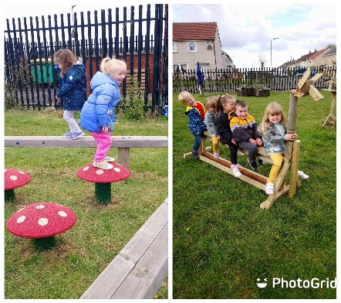
The children continue to love being outdoors, building dens, creating new worlds, exploring, making plenty of mud pies and having fun! The children have demonstrated different ways of being active through their energetic play and can give reasons why being active is good for their health.
Please remember to send in your child’s sun-cream consent form! We are hoping for some sunshine

Donations for ‘Loose Parts’
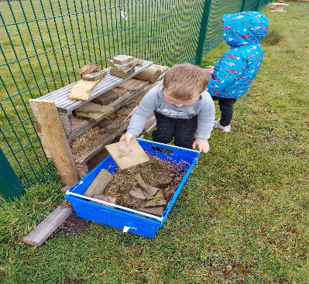
Building and exploring with our loose parts is always a big hit both indoors and outdoors The Nursery are asking for any donations to support the children’s explorations and play; pallets, ladders, big buttons, cotton reels, cable reels, small and large stones and pebbles, wooden and chrome curtain rings, wine corks, children’s suitcases, small gift boxes and bags etc.

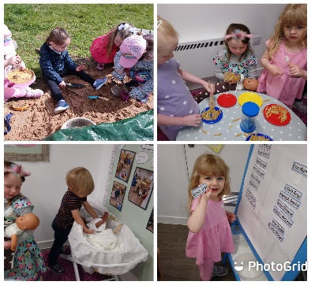
Transitions
We are approaching the time of year when some of our children are preparing to move on to school and new children will be getting ready to join our Nursery. ‘Transition Tuesday’ begins today with a BIG surprise for our own pre-school children. They will share this surprise with you later. As the regulations move in a positive direction, we await updates on parental involvement within the school with regard to visits etc. We will update parents with regard to transition information very soon.

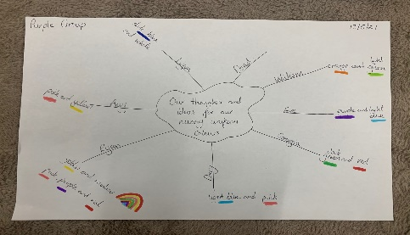
Nursery Uniform
The children are busy discussing and sharing their ideas about their nursery uniform. Super-hero suits, animal masks and dinosaur design have been very popular so far!

Watch this space!

Dates for your Diary
Friday 28th May 2021 – Monday 31st May 2021 (Inclusive) May Weekend Holiday

Contact Us
You are welcome to contact the Nursery on 01236 794873 and a member of staff will answer any questions you may have. You can also follow us on Twitter for up-to-date information and photographs of the children’s learning @TPSNurseryNLC and @townheadps.
Many thanks for your support
Mrs F Ferguson
Head Teacher.

