How to access Glow from home.
Use a search engine like google and type in
RM Unify glow
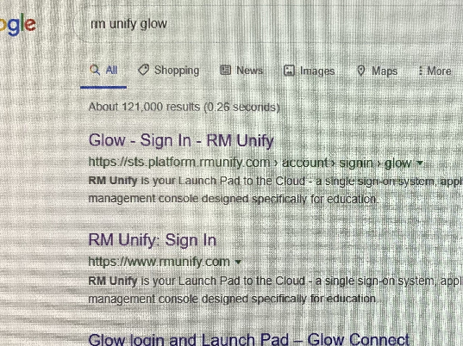
Your username will start with gw
Enter your username and password
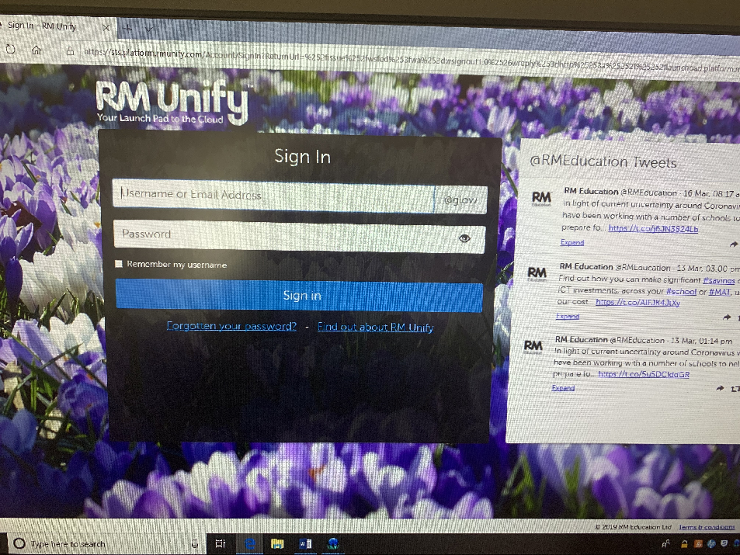
This will take you to your launch pad it looks like this.
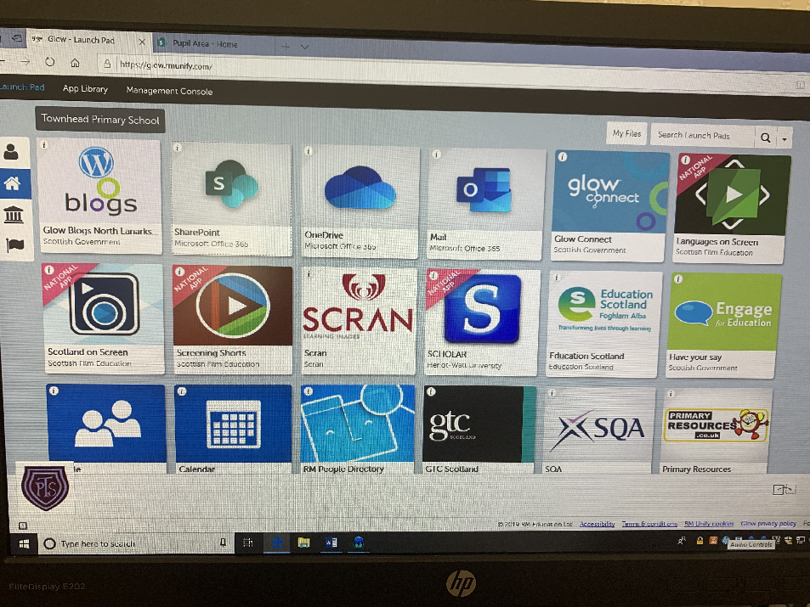
Click on the house icon it will take you to the Townhead Primary page, then click on the tile labelled SharePoint.
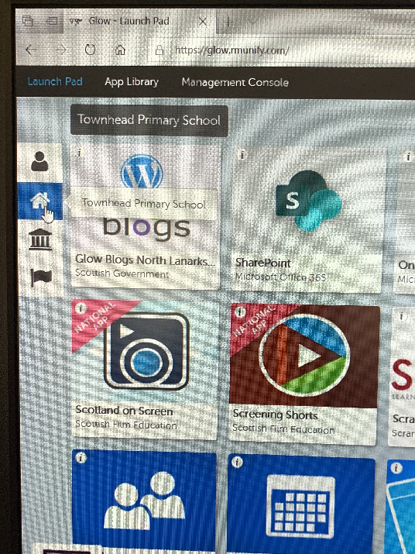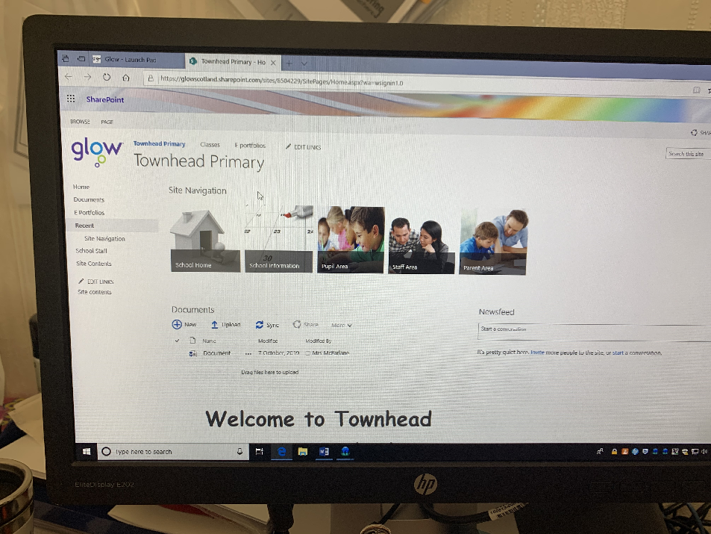
Look for the tile marked with Pupil Area, this will take you to a page with folders for each stage in the school.
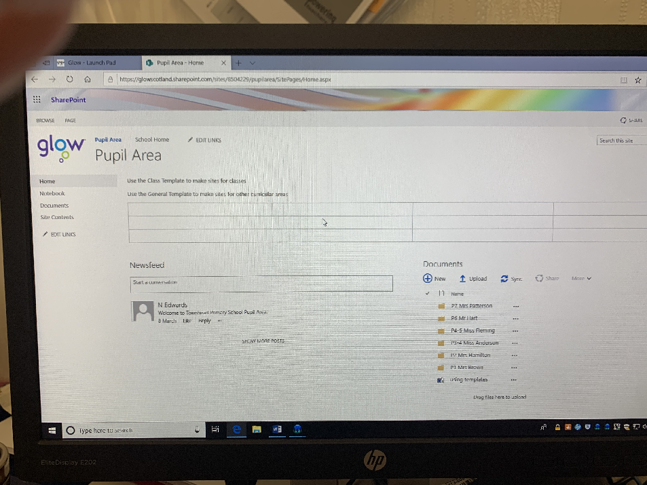

If your child has difficulty logging into GLOW and requires a password reset please contact the school and they will arrange this.

