St Monica’s
Primary School
Craigend Drive, Coatbridge ML5 5TJ
Tel: 01236 632080
P1-P3 Homework Guidelines

Dear Parents,
We would like to provide some guidelines for homework throughout all stages in our school.
We hope you will find this useful. It will let you know what our expectations are and how we can work together to fulfil your child’s homework activities.
All children across the school have been issued with two homework jotters. One is lined for Literacy/IDL tasks. The other is squared for Numeracy tasks.

Here are our set guidelines for homework.
- Homework will consist of tasks from three areas - Literacy, Numeracy and a task from one other subject area e.g. IDL/ Family Engagement/Sacramental Workbook
- All tasks will be given out on a Monday.
- Please aim for homework to be submitted on the Thursday.
- Extra homework tasks, e.g. school projects for upper school will have a clear submission date and there will be no third task during this time
There will be no homework during the first and last week of each new term or when there is a short three day week. When we have whole school activities such as Rights Respecting School tasks or Health Week this will be the third task of the week. Please know we are always available to provide support or answer any questions. Do not hesitate to write a note to your child’s class teacher or phone the school to arrange an appointment.

Thank you.

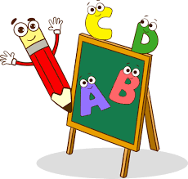
Here are some tips for Literacy…

- Within the early stages of reading, it is important that your child points to each word as it is read, ensuring they are aware of the word on its own and also to prevent repetition or missing out words
- When writing, ensure letters are sitting on the line, that letters are the correct size and that finger spaces are used between words.
- Check all sentences begin with a capital letter and end with a full stop.
- At later stages of P1 and throughout P2 and P3 check for joining words being used in sentences - and, but, so, because, then etc.
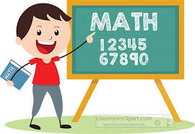

Here are some tips for Numeracy…

- Within P1 children count aloud to numbers 20 in class and focus on instant recognition and formation on 0-10
- From P2 onwards children count aloud to numbers above 20 with a focus on instant recognition and formation of 0-20
- From P3 children work on recognition and formation of numbers to 100
- When counting with your child focus on counting forwards and backwards, what number comes before or after a number, what number is between a set of numbers, e.g. between 31 and 33 etc

We have a weekly Assembly on a Wednesday. During this time the children have an opportunity to share achievements with the whole school. We love to hear about any new skills the children have learned and how they are contributing to the local community.

HWB/Wider Achievements that can be shared at Assembly.

- Medals/Awards/Trophies/Certificates earned at clubs.

- Participation in events e.g. Charity work, Voluntary work, Parish volunteering including altar serving

- Litter Picking (with permission and appropriate equipment)

- Helped a relative with shopping/tasks at home

- Joinedvisited the library and have a book to share

- Learned a new skill e.g., ability to tie your shoelaces.

