

Driving Equity and Excellence

Improvement Action Plans

Session 2026-27

Establishment: | St. Ignatius’ Primary
Empowered Cluster: | Coltness & St. Aidan’s High Schools
Head of Establishment: | Colette Lambie

Improvement Plan Summary
Priority 1: | To improve attainment and consistency in writing across P4–P7 by strengthening learner progress within level and reducing the number of pupils identified as inconsistent or not on track.
Priority 2: | To strengthen learning through play and enquiry by improving the quality of provocations and the use of skilled observation to assess progress and plan next steps.
Nursery Priority: | To improve children’s speech, language and communication skills by providing a rich, language-focused environment that promotes meaningful interactions, extends vocabulary, and supports early conversational skills for all learners.

Key Date | Focus Area
12th June 2026 | Submit AIP to EFM and QISSIP-SIR@northlan.gov.uk
4th December 2026 | Complete RAG status in AIP (Including PEF RAG status)  (No submission, EFM discussion only)
19th March 2027 | Complete RAG status in AIP  (No submission, EFM discussion only)
18th June 2027 | Full submission of AIR: Summary of progress toward priorities, all QIs & PEF update

Establishment Vision and Values

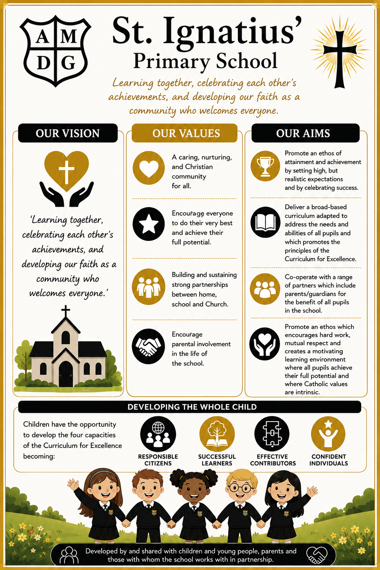 | 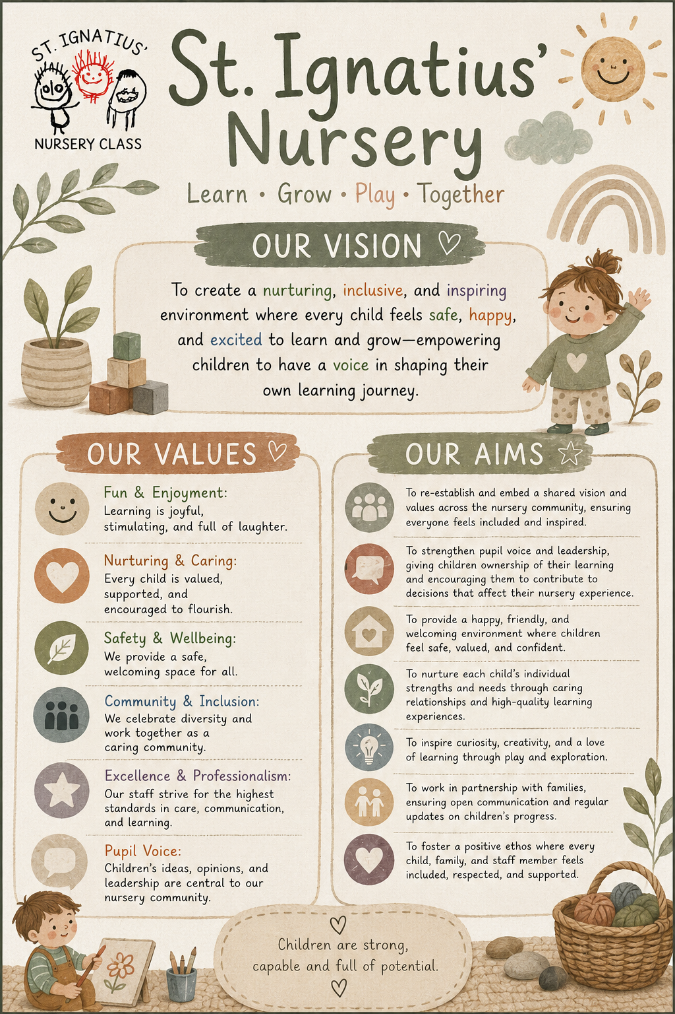

Audit and Consultation

In arriving at our improvement priorities, the establishment has taken account of Education and Families’ priorities, an audit of the previous year’s improvement plan and engagement with parents/carers and learners.

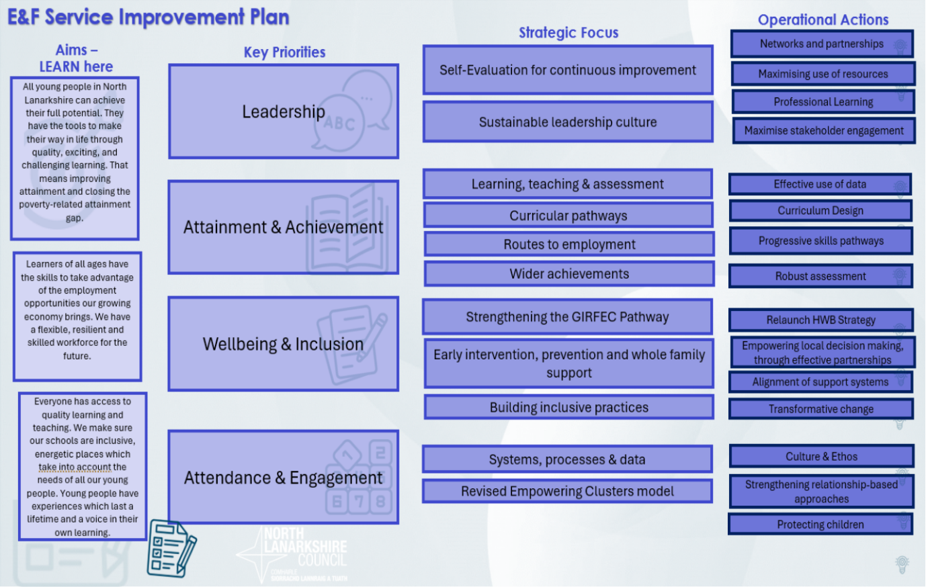
Details of consultation (pupils, parents/carers, partners)
Parents/Partners | Pupils | Staff
- Parent council consultation  - HGIOS survey checkpoints  - Questionnaires  - PEF spend evaluation glow forms  - Intervention evaluation glow forms  - Focus group meetings  - Weekly sway – 5 question surveys. | - Learner conversations  - Target setting  - Pupil led enquiry-based learning  - Wellbeing surveys  - Pupil committees  - Pupil focus group discussions | - HGIOS survey checkpoints and QI evidence gathering  - AIP meetings and evaluations  - Forward planning/ tracking and monitoring meetings  - Analysis of dashboard data to identify the gaps  - PEF evaluations and next steps  - Classroom observations  - Peer observations  - Cluster moderation  - AIP consultation and evaluation of progress  - Weekly 1 hour whole staff collegiate sessions

If your annual improvement priorities are part of a wider, longer term, 3-year strategic plan, please use the template below to outline your longer-term plan. (This overview is optional and does not need to be completed but will provide an overview of your improvement journey.)

 | Priority 1 | Priority 2 | Priority 3
Year 1: Session 2026 - 2027 | Drive for Excellence - Curricular Reform & Pedagogy  All pupils and staff (Stages P4-7) will continue to develop enquiry-based learning (EBL) pedagogy to enhance pupil agency, engagement, and critical thinking.  Through pupil-led investigation supported by high-quality pedagogical approaches all staff will encourage increased motivation and curiosity while continuing to achieve high levels of attainment across the curriculum.
Year 2: Session 2027 - 2028 | To strengthen learning through play and enquiry by improving the quality of provocations and the use of skilled observation to assess progress and plan next steps.
Year 3: Session 2028 - 2029

Guidance for Nursery Classes

When identifying improvement priorities, Head Teachers should ensure that nursery classes are fully and appropriately reflected. This can be achieved either by setting a distinct improvement priority (or priorities) specifically for the nursery class, or, where analysis of data and self-evaluation indicate that the priority applies to the whole establishment, by including at least two expected outcomes that are explicitly focused on early years.

In all cases, improvement planning should be rooted in robust self-evaluation and written to reflect approaches and actions that will deliver the best possible outcomes for children, taking account of developmental stage, pedagogy and the unique context of early learning and childcare. Within the checkpoints, all evaluative statements must also reflect the journey of improvement in early years.

2026-27 Improvement Plan

Priority 1: Long Term Outcome  What do you hope to achieve? What is going to change? For whom? By how much? By when? | By June 2027, writing attainment across P4–P7 will improve by 8 percentage points overall (2 children per class), with the proportion of learners identified as inconsistent or not on track reducing by at least 36%. We will achieve this through consistent implementation of high-quality writing pedagogy, targeted intervention and cluster moderation.
Person(s) Responsible  Who will be leading the improvement? | TBC

(Please insert the relevant codes which can be found in Appendix 1)
NIF Priority: 3, 5 |  | NIF Outcome(s): 4,5
NLC Priority: 2 |  | QI:2.3/3.2
Developing in Faith/UNCRC: 2 – Article 28
Rationale (Why?) Why have you identified this as a priority? What data did you have to support this?
Improving writing attainment in P4–P6 is a key priority based on clear evidence from school ACEL and SSR data, alongside local and national trends.
ACEL data indicates that writing attainment is less secure and more variable than other literacy organisers across the school. While some cohorts show strong attainment, there is inconsistency over time, suggesting that progress in writing is not yet embedded across stages.
SSR progress and achievement data for current P4–P6 learners reinforces this, highlighting:
- High levels of inconsistency in writing
- A group of pupils not on track or making uneven progress within level
This pattern suggests that many learners are not developing writing skills in a consistent, progressive way, which risks limiting attainment as they move through second level.
There is also a clear poverty-related attainment gap, with learners from more deprived SIMD groups achieving less well in writing. This reflects North Lanarkshire and national patterns, where writing is consistently the weakest literacy organiser and shows the greatest inequity.
Given the school context—including significant levels of deprivation, ASN and EAL—there is a need for consistent, high-quality approaches to writing, particularly in the middle and upper stages.
In summary, writing in P4–P6 is prioritised because:
- Attainment is inconsistent and not yet securely embedded
- Progression within level is uneven for a significant group of learners
- There is a clear attainment gap linked to deprivation
- This aligns with local and national concerns about writing outcomes
Focusing on this area will support improved attainment, stronger progression through first and second level, and greater equity for all learners
Resources: Please include costs and, where relevant, state where cost is being met from, specifically if using PEF. Please denote PEF/or colour code if preferred, to indicate where PEF spend aligns with targets.
- NLC Literacy CLPL Sessions
- PEF funding to release PT to support delivery and tracking of targeted interventions
- PEF funded DHT differential to support gathering and analysis of data to evaluate progress
- PEF funded DHT differential to improve attendance of persistent absentees which will directly impact pupil progress.

Expected Impact  (Short Term Outcomes) | Interventions/Actions to Support Improvement: How? |  | How Will You Track Progress?  Measures | Checkpoint 1  December |  |  | Checkpoint 2  March
What will be the benefit for learners (be specific)? | What are you going to do to make the change? What key actions are required? |  | What ongoing information will demonstrate progress? (Qualitative, Quantitative – short/medium/long term data) | RAG Status  Tick progress toward outcomes |  |  | RAG Status  Tick progress toward outcomes
What will be the benefit for learners (be specific)? |  |  |  | ü |  |  | ü
By December, all staff from P4-P7 will implement key components of the NLC Active Literacy programme, including: fiction reading → writing non-fiction reading → writing knowledge about language. As a result, learning and teaching in writing will be more consistent across P4–P7. As a result, learners will experience a more consistent approach to writing with increased opportunities for daily writing, enabling them to apply grammar, vocabulary and writing structures more confidently across different contexts. | Ensure All P4-P7 staff attend CLPL on NLC Active Literacy:  - Linking fiction texts to structured writing outcomes  - Explicit teaching of grammar, sentence structure and vocabulary (knowledge about language)  - Use of non-fiction texts to support writing across the curriculum  Use collegiate time to:  - model practice  - plan together  - share effective approaches  Develop a shared reading into writing annual planning format. |  | Baseline ‘position statement’ gathered by staff to evidence how writing is taught currently/ how/when/contexts/assessment. Repeat in May to evidence change in practice.  Learning walks using Active Literacy monitoring format, will show consistent use of Active Literacy approaches  Planning scrutiny evidences:  - fiction/non-fiction links to writing  - explicit teaching of language  Staff self-evaluation shows increased confidence in teaching writing.
- By March, attainment in writing across P4–P7 will improve by 10–12 percentage points (equivalent to approximately 2–4 learners per stage). This will be achieved through targeted interventions focused on learners identified as inconsistent. | Use Dashboard BI and Tracking And M data identify learners who are inconsistent or not on track.  Deliver targeted interventions, including:  - sentence structure and scaffolding  - spelling and grammar support  - structured writing approaches  Implement regular formative assessment and feedback cycles to support progress.  PT will support literacy interventions for pupils identified as ‘inconsistent’ |  | Tracking data shows:  - increase in on-track learners  - reduction in inconsistency  Samples of pupil writing evidence demonstrate increased quantity and quality.  Tracking data shows more stable progress over time.  Intervention records evidence  progress against targets
- By March, most learners will demonstrate: greater consistency in writing across contexts; improved use of sentence structure, grammar and vocabulary. | Implement consistent modelling and scaffolding approaches:  - shared writing  - guided writing  - use of teacher models  Embed knowledge about language in daily teaching  Provide daily opportunities for extended writing linked to reading  Use literacy sessions to teach skills required prior to writing in IDL contexts. |  | Moderation activities show improved consistency of teacher judgements  Writing samples demonstrate:  - increased accuracy  - improved structure and coherence  Learner work shows transfer of skills across contexts
- By March 2027, most learners will demonstrate increased confidence and independence and motivation in writing. Most learners will be able to talk about their writing and identify next steps. This will be achieved through regular writing conferences between teacher and pupil and the use of structured self- and peer-assessment prompts. | Use high-quality fiction and non- fiction texts as together with engaging contexts for learning to engage learners;  Build in regular opportunities for pupil choice and purpose in writing  Use clear feedback and success criteria to support self-improvement |  | Learner conversations will show:  - increased understanding of writing skills  - ability to identify next steps  Pupil voice will indicates greater engagement in writing  Learners will demonstrate increased completion and quality of written tasks.
Checkpoint 1 Progress Evaluation Statement (December)
Checkpoint 2 Progress Evaluation Statement (March)

2026-27 Improvement Plan

Priority 2: Long Term Outcome  What do you hope to achieve? What is going to change? For whom? By how much? By when? | By June 2027, learning through play and enquiry will be strengthened through a consistent whole-school approach to designing high-quality provocations and using skilled observation to assess learning and plan responsive next steps.
Person(s) Responsible  Who will be leading the improvement? | TBC

(Please insert the relevant codes which can be found in Appendix 1)
NIF Priority: 3,4,5 | NIF Outcome(s):1,3,4,5
NLC Priority: 2,3 | QI: 1.2, 2.2, 2.3, 3.2, 3.3
Developing in Faith/UNCRC: Articles 28 & 29; 2
Rationale (Why?) Self-evaluation evidence demonstrates that learners are highly engaged and motivated during play-based and enquiry-led learning, particularly when experiences are active, creative and offer opportunities for choice and exploration. However, there is inconsistency in the quality of these experiences, with variability in learner agency, depth of thinking, and the use of assessment to support progress. Learners also find it difficult to articulate their progress and next steps within enquiry, highlighting a need for more explicit and responsive assessment approaches. [2.3 Learne...P4-P7 (1) | Word], [2.3 Focus...-P3 - Copy | Word] [2.3 Learne...P4-P7 (1) | Word]
In response, there is a clear need to strengthen pedagogical approaches to learning through play and enquiry by improving the design of rich, purposeful provocations that promote curiosity, challenge and sustained thinking. Alongside this, developing focused and consistent teacher observation will enable practitioners to more effectively capture evidence of learning, assess progress, and plan responsive next steps. This will ensure greater consistency, deepen learning, and support all learners to develop independence and a clearer understanding of their progression.

Resources: Please include costs and, where relevant, state where cost is being met from, specifically if using PEF.
Please denote PEF/or colour code if preferred, to indicate where PEF spend aligns with targets.
- PEF DHT differential to support strategic planning, data gathering and evaluation of impact.
- Professional reading resources linked to play and enquiry-based learning.
- Simon Breakspear -Teaching Sprints Resources
Expected Impact  (Short Term Outcomes) |  | Interventions/Actions to Support Improvement: How? | How Will You Track Progress?  Measures | Checkpoint 1  December |  |  | Checkpoint 2  March
What will be the benefit for learners (be specific)? |  | What are you going to do to make the change? What key actions are required? | What ongoing information will demonstrate progress? (Qualitative, Quantitative – short/medium/long term data) | RAG Status  Tick progress toward outcomes |  |  | RAG Status  Tick progress toward outcomes
By November 2026, all teachers will implement at least one high-quality provocation per enquiry context, resulting in richer learner questioning, sustained engagement and more responsive planning informed by learners' interests and emerging understanding. |  | - Develop a shared whole-school framework for what constitutes an effective provocation  - Engage in professional learning (e.g. Teaching Sprints) focused on designing provocations  - Build provocations into forward planning and interdisciplinary learning contexts  - Build evaluation of provocations into learning walk evidence templates | - Collaborative enquiry evidence.  - Samples of learner questions (showing progression from closed to open-ended questions)  - Forward plans demonstrating evidence of planned provocations  - Floor books – photographic evidence with pupil voiced annotations.  - Leuven Scale Observations  - Learner Conversations  - Staff dialogue/ self-evaluation  - Learning walk records reflect quality of provocation | ü |  |  | ü
- By April 2027, all teachers will consistently use agreed observation approaches to support adaptive teaching, inclusive and challenging practice and development of meta-skills. |  | - Engage in professional learning (focused on observations and assessment of EBL) through teaching sprints model.  - Develop a consistent format for recording pupil observations.  - Update Learning, Teaching and Assessment Policy to reflect shared expectations.  - Build planned observation opportunities into weekly play/enquiry sessions. | - Collaborative enquiry evidence.  - Completed pupil observations  - Learner conversations  - Staff self-evaluation
- By April 2027, 90% of teachers will demonstrate increased confidence and consistent implementation of play and enquiry pedagogy, evidenced through Teaching Sprint reflections, classroom observations, recorded pupil observations, leuven scales, planning scrutiny and learner outcomes. |  | - Implement Teaching Sprints cycles focused on play, enquiry, provocations and observation  - Use peer collaboration, team teaching or observations to share effective practice  - Engage with professional reading and research  - Evaluate impact through learner engagement, pupil voice and quality of evidence gathered | - Teaching Sprint records (plans, reflections, impact statements)  - Staff CLPL logs / evaluations  - Evidence of peer observations or team teaching  - Evaluations showing impact on:  - learner engagement (Leuven scale)  - quality of learner talk
- By October 2026, all staff will introduce the Skills Development Scotland meta-skills framework within play and enquiry contexts, using progression pathways and child-friendly visuals to support understanding. As a result, most learners will begin to recognise and name key meta-skills (e.g. focusing, collaborating, critical thinking) and increasingly reflect on how they learn, make purposeful choices during enquiry, and transfer these skills across different learning contexts. |  | Introduce shared understanding of meta-skills  - Provide professional learning on the SDS meta-skills framework  - Explore progression pathways to build staff awareness of what skills look like at different stages  Introduce meta-skills into planning  - Begin to identify 1–2 key meta-skills within play and enquiry contexts  - Make explicit links between provocations and targeted skills  Introduce child-friendly visuals across the school  - Display and refer to SDS visuals in all classrooms, during assemblies and in play/enquiry zones.  - Create an informative video with pupils to explain what meta-skills are and why they are important to develop. Share with all stakeholders.  - Focus on one aspect of meta skills per term at assembly focus i.e. Self-management Social intelligence Innovation  - Begin using consistent, simple language to help learners recognise skills in action  Introduce observational focus on meta-skills:  - Begin capturing examples of learners demonstrating skills during play and enquiry  - Use simple, consistent recording approaches linked to SDS language  - Introduce termly me  Introduce learner discussion and reflection  - Use SDS to support learners to identify skills they are using  - Model language such as: “We are learning to collaborate” or “You are using your problem-solving skills”  Support through collaboration and moderation  - Share early examples of practice across staff  - Use professional dialogue to build confidence and consistency in introduction phase  Monitor early impact  - Use learning walks, pupil voice, and planning scrutiny to track uptake  - Focus on awareness and consistency, rather than full progression at this stage | - Samples of forward plans showing identified meta-skills (1–2 per context)  - Evidence of links between provocations and targeted skills  - Planning scrutiny highlighting emerging consistency across classes  - Learning environment audits showing SDS visuals displayed and accessible  - Learning walk notes confirming consistent reference to visuals by staff  - Pupil voice (targeted conversations) showing learners can:  - recognise simple meta-skills (e.g. “working together”, “thinking hard”)  - begin to name skills using shared language  - Examples from learning conversations or floor books where skills are discussed  - Samples of observation notes / floor books/social media posts capturing learners demonstrating metaskills.  - Evidence that staff are beginning to use SDS language in observations  - Floor book entries or recorded discussions showing simple reflection prompts:  - “What skill did you use?”  - Examples of learners attempting to talk about their learning in terms of skills  - Feedback from staff indicating growing confidence in using meta-skills language  - Learning walk / SLT observations noting:  - use of shared language  - presence of visuals  - early integration into play and enquiry
Checkpoint 1 Progress Evaluation Statement (December)
Checkpoint 2 Progress Evaluation Statement (March)

2026-27 Improvement Plan

Nursery Priority: Long Term Outcome  What do you hope to achieve? What is going to change? For whom? By how much? By when? | By June 2027, most nursery children will demonstrate improved speech, language and communication skills, with at least 80% of children identified through baseline screening making measurable progress, through consistent language-rich practice and targeted WellComm interventions.
Person(s) Responsible  Who will be leading the improvement? | C. Orr/ C. McIntyre/ C. Lambie

(Please insert the relevant codes which can be found in Appendix 1)
NIF Priority: | NIF Outcome(s):
NLC Priority: | QI:
Developing in Faith/UNCRC: 2/
Rationale (Why?) Why have you identified this as a priority? What data did you have to support this?

Strong speech and language skills underpin all areas of learning and development. Developing these skills early supports children’s confidence, social interaction, and readiness for literacy. Monitoring and tracking data in St. Ignatius’ nursery reflects a significant national concern around early speech and language development.
(Education Scotland- how-can-we-create-a-language-and-communication-supportive-environment-in-elc-settings.pdf Early Years Speech and Language Action Plan - Early years: speech, language and communication action plan - gov.scot Speech, Language and Communication skills matrix - SLC Knowledge and Skills Matrix – National Early Language and Communication Project ). This highlights the need for a strong focus on developing speech, language and communication skills in early years settings to support children’s learning, wellbeing, and future attainment.
Resources: Please include costs and, where relevant, state where cost is being met from.
GL Assessment Wellcomm digital toolkit. (£1000 – 3 year subscription. School budget used as supports children from 6 months to 11 years)
Expected Impact  (Short Term Outcomes) |  | Interventions/Actions to Support Improvement: How? | How Will You Track Progress?  Measures | Checkpoint 1  December |  |  | Checkpoint 2  March
What will be the benefit for learners (be specific)? |  | What are you going to do to make the change? What key actions are required? | What ongoing information will demonstrate progress? (Qualitative, Quantitative – short/medium/long term data) | RAG Status  Tick progress toward outcomes |  |  | RAG Status  Tick progress toward outcomes
- By August 2026, all staff will have engaged in professional dialogue to evaluate their competence and confidence in supporting and developing speech language and communication skills. As a result, practitioners will have a stronger shared understanding of effective SLC practice, enabling earlier identification of children's needs, more responsive interactions, and timely support to strengthen children's communication and participation in learning. |  | - All practitioners will use the SLC Knowledge and Skills Matrix – National Early Language and Communication Project to reflect on their own practice and competency, support supervision conversations and direct their learning journey. | - Recorded evidence from SLC Knowledge and Skills Matrix – National Early Language and Communication Project and ensuing professional dialogue. | ü |  |  | ü
- By September: All staff will engage in CLPL on speech, language and communication, including training in the use of the GL Assessment Screener and Intervention Toolkit, with staff confidently applying at least two agreed language-support strategies (e.g. modelling and extending language) observed consistently in practice. As a result, increased staff confidence and skill in identifying and responding to speech, language and communication (SLC) difficulties will enable earlier intervention, ensuring children receive timely support to strengthen their communication skills and participation in learning. |  | - Deliver CLPL sessions on speech, language and communication and use of the GL Assessment Screener and Intervention Toolkit.  - Model effective strategies (e.g. commenting, questioning, extending language) and agree a shared approach. | - Staff observations and learning walks showing consistent use of at least 2 agreed strategies.  - Staff self-evaluation and feedback indicating increased confidence.
- By August–September: 100% of children will be screened using the GL Assessment tool, with results recorded and analysed to establish a clear baseline of language development across the nursery. As a result, improved staff confidence and skill in identifying and responding to speech, language and communication difficulties will ensure children receive timely early intervention, helping them develop communication skills sooner and participate more confidently in play, learning and interactions with others. |  | - Screen 100% of children using the GL Assessment tool.  - Analyse results to create a baseline overview and identify trends/gaps. | - Completed screening data for all children.  - Baseline summary identifying % of children at/below expected levels.
- By October, children requiring additional support will be identified promptly through screening data, with appropriate targeted group or individual interventions planned using the GL Assessment Toolkit or other appropriate approaches, with clear individual next steps for each child. |  | - Use screening data to identify children requiring support.  - Plan targeted group and individual interventions using the GL toolkit or other relevant resource, with clear next steps. | - Intervention plans in place for all identified children.  - Learning plans showing identified needs and planned outcomes.
- October–March: Staff will deliver regular targeted interventions (minimum 2–3 sessions per week), demonstrating high-quality, responsive interactions that extend vocabulary, promote talk, and support understanding. As a result, at least 80% of children identified through baseline screening will communicate more confidently, extend vocabulary and participate more successfully in play and group learning. |  | - Deliver interventions 2–3 times per week in small groups or individually.  - Ensure high-quality adult interactions that extend language and promote talk. | - Session records and observations showing consistency of delivery.  - Ongoing formative assessment showing progress in targeted skills.
- Ongoing (termly reviews): Children’s progress will be tracked and evaluated, with at least 80% of identified children showing measurable improvement in speech, language and communication and increased confidence in using language. |  | - Review children’s progress using GL assessment data and practitioner observations.  - Adapt interventions based on progress and emerging needs.  - Termly data showing at least 80% of targeted children making measurable progress.  - Case studies demonstrating qualitative improvements (confidence, vocabulary, engagement).
- By June: Practice across the setting will evidence consistent, high-quality adult-child interactions, with most children able to initiate conversations, use a wider vocabulary, and sustain attention during group learning. This will be achieved through a blend of Wellcomm and other interventions such as the 3 read approach. |  | - Ensure a consistent, language-rich environment with high-quality interactions embedded across all practice. | - Observations showing most children can initiate conversations, use wider vocabulary, and sustain attention.  - End-of-year assessment data showing improved attainment in speech and language.
- Ongoing: Parents will be supported through shared strategies and communication, with increasing evidence of home engagement in supporting language development. |  | - Share strategies, resources and updates with parents to support language development at home.  - Parent workshop session – universal offer –  - Targeted stay and play sessions to model strategies.  - Sharing Toolkit activities with parents to replicate practice at home. | - Pre-post parent surveys focused on SLC
Checkpoint 1 Progress Evaluation Statement (December)
Checkpoint 2 Progress Evaluation Statement (March)

PEF ALLOCATION: £49,000

£


nOrth Lanarkshire Council
Education & FAMILIES
Pupil Equity Fund Plan 2026-27
(Random sampling of PEF Plans
will continue throughout the session).

Rationale for PEF plan
Our PEF rationale is based on clear evidence of socio-economic disadvantage and its impact on attendance, attainment and wellbeing. The majority of pupils (82%) live in SIMD Quintiles 1–2, with 23% entitled to Free School Meals and 34% identified as having ASN. This highlights significant barriers to learning, including poverty, additional support needs and language challenges.
Attendance remains a key concern. Overall attendance (91.8%) is below the local authority average and unauthorised absence is higher than average. There is also a high proportion of pupils experiencing persistent absenteeism, particularly those affected by deprivation and additional needs, with a 5.3% attendance gap between Q1 and Q5 learners. This supports the need for the development of strategic approaches to improving attendance, with a focus on targeted families and early intervention.
Attainment data shows that while many learners are on track, there remains a notable group who are inconsistent or not on track, particularly in literacy, alongside a persistent poverty-related attainment gap. This gap is most evident for pupils in SIMD 1–2 and is particularly emerging across the middle stages, especially at P4 and across P3–P5, where tracking data shows inconsistency and risk of learners falling behind. This justifies the provision of targeted interventions to raise attainment in literacy, focusing on these stages and groups.
The high level of ASN and wellbeing-related factors highlights the need to support learners’ emotional and social development. Targeted programmes such as Seasons for Growth and Homunculi interventions will support pupil wellbeing and inclusion, addressing barriers linked to trauma, loss and emotional regulation.
Improvements in engagement are also required. Initiatives such as Forest Club will support engagement and wellbeing, particularly for targeted pupils who benefit from outdoor, nurture-based approaches.
PEF funding has also been strategically used to strengthen leadership and improve capacity across the school. This has enabled the promotion of one Principal Teacher to Depute Head Teacher and the release of both the Depute Head Teacher and Principal Teacher from class commitments to lead targeted interventions, monitor progress and support staff effectively. In addition, increased staffing has allowed for smaller class sizes, providing more personalised support and improved outcomes for learners most at risk of underachievement.
What is Your Poverty Related/Equity Gap? (Q1 v Q5 or other poverty marker)  Select From: attainment & achievement, attendance, inclusion, participation, engagement. | Intended Outcome/Impact  Please describe your planned use of PEF allocation and what you intend to achieve. | Evidence/Measures  Please indicate what pre and post assessment measures you will use to evidence impact. | Detailed Costings | December Checkpoint  RAG Status  Tick progress toward outcomes
Attendance & Inclusion | By June 2027, the % pupils with attendance below 90% will reduce from 32% to 18%, through a blend of universal supports, targeted interventions and a refreshed attendance policy. | - FVRIC Attendance self-evaluation tool data  - Dashboard data – tracking persistent absentees  - Pupil attitude surveys  - Focus group conversations | Depute Head Teacher – Differential Cost  £13,000
Participation & Engagement | Forest Club  (Attendance)  By June 2027:  Whole school attendance on Fridays will increase from a baseline of 90.5% (2025-2026) to 92% through focus on targeted pupils.  (Emotional Regulation)  By June 2027:  Engagement, motivation and emotional regulation will continue to improve for targets pupils in target group.  (Emotional Wellbeing)  By June 2027:  Emotional regulation, confidence and resilience will have increased for target pupils. (Group TBC) | - Power BI Attendance data  - Leuven & Simpson scales  - Recorded Pupil observations  - Pre and post pupil voice evaluations.  - Parent evaluation surveys  - Leuven & Simpson scales  - Recorded Pupil observations  - Pre and post pupil voice evaluations.  - Parent evaluation surveys | Depute Head Teacher – Differential Cost  £13,000
Attainment and Achievement | By June 2027:  Attainment in P5 reading and writing will increase by 10.5% (3 learners) through targeted literacy intervention supports.  Attainment in P6 reading and writing will increase by 8-12% (2/3 learners) through targeted literacy intervention supports.  Attainment in P7 reading and writing will increase by 10.5% (3 learners) through targeted literacy intervention supports. | - Pre/Post YARC Assessment Scores  - ACEL tracking data  - Pre-post intervention pupil writing samples | PEF staffing additionality to release PT and reduce class sizes  £35,000
Inclusion | (Emotional Wellbeing) - Seasons for Growth  By June 2027:  Emotional regulation, confidence and resilience will have increased for target pupils who have experienced loss. (Group TBC)  (Emotional Wellbeing)– Homunculi Group  By June:  Emotional regulation, confidence and resilience will have increased for a target group of neurodiverse pupils. Group TBC. | - Glasgow wellbeing scale pre-post intervention.  - Learner conversations pre post.  - Parent evaluation surveys.  - Glasgow wellbeing scale pre-post intervention.  - Learner conversations pre post.  - Parent evaluation surveys. | PEF staffing additionality to release PT and reduce class sizes  £35,000
 |  | Total PEF Spend | £48,000

Appendix 1:
When considering your School Improvement Priorities, you are asked to provide links to the following, as well as the Quality Indicators within HGIOS4 and HGIOELC:
UNCRC | HGIOS 4 | National Improvement Framework
Article 1 - definition of the child  Article 2 - non-discrimination  Article 3 - best interests of the child  Article 4 - implementation of the Convention  Article 5 - parental guidance and child's evolving capacities  Article 6 - life, survival and development  Article 7 - birth registration, name, nationality, care  Article 8 - protection and preservation of identity  Article 9 - separation from parents  Article 10 - family reunification  Article 11 - abduction and non-return of children  Article 12 - respect for the views of the child  Article 13 - freedom of expression  Article 14 - freedom of thought, belief and religion  Article 15 - freedom of association  Article 16 - right to privacy  Article 17 - access to information from the media  Article 18 - parental responsibilities and state assistance  Article 19 - protection from violence, abuse and neglect  Article 20 - children unable to live with their family  Article 21 – adoption  Article 22 - refugee children  Article 23 - children with a disability  Article 24 - health and health services  Article 25 - review of treatment in care  Article 26 - social security  Article 27 - adequate standard of living  Article 28 - right to education  Article 29 - goals of education  Article 30 - children from minority or indigenous groups  Article 31 - leisure, play and culture  Article 32 - child labour  Article 33 - drug abuse  Article 34 -sexual exploitation  Article 35 - abduction, sale and trafficking  Article 36 - other forms of exploitation  Article 37 - inhumane treatment and detention  Article 38 - war and armed conflicts  Article 39 - recovery from trauma and reintegration  Article 40 - juvenile justice  Article 41 - respect for higher national standards  Article 42 - knowledge of rights  Article 14 - freedom of thought, belief and religion  Article 15 - freedom of association  Article 16 - right to privacy  Article 17 - access to information from the media  Article 18 - parental responsibilities and state assistance | 1.1: Self-evaluation for self-improvement  1.2: Leadership for learning  1.3: Leadership of change  1.4: Leadership and management of staff  1.5: Management of resources to promote equity  2.1: Safeguarding and child protection  2.2: Curriculum  2.3: Learning teaching and assessment  2.4: Personalised support  2.5: Family learning  2.6: Transitions  2.7: Partnerships  3.1: Ensuring wellbeing, equality and inclusion  3.2: Raising attainment and achievement  3.3: Increasing creativity and employability  Quality Improvement Framework for ELC  Leadership  Leadership and management of staff and resources  Staff skills, knowledge, values and deployment  Leadership of continuous improvement  Children thrive and develop in quality spaces  Children experience high quality spaces  Children play and learn  Play and learning  Curriculum  Learning Teaching and Assessment  Children are supported to achieve  Nurturing care and support  Wellbeing, inclusion and equality  Children’s progress  Safeguarding and child protection  PEF INTERVENTIONS  - Early intervention and prevention  - Social and emotional wellbeing  - Promoting healthy lifestyles  - Targeted approaches to literacy and numeracy  - Promoting a high quality learning experience  - Differentiated support  - Using evidence and data  - Employability and skills development  - Engaging beyond the school  - Partnership working  - Professional learning and leadership  - Research and evaluation to monitor impact  EDUCATION AND FAMILIES’ PRIORITIES  1. Leadership  2. Attainment and Achievement  3. Wellbeing and Inclusion  4. Attendance and Engagement | NIF Priorities  - Placing the human rights and needs of every child and young person at the centre of education;  - Improvement in children and young people’s health and wellbeing;  - Closing the attainment gap between the most and least disadvantaged children and young people;  - Improvement in skills and sustained, positive school leaver destinations for all young people ;  - Improvement in attainment, particularly in literacy and numeracy.  NIF Outcomes  - A globally respected, empowered, and responsive education system with clear accountability at every level that supports children, young people, and adult learners to thrive. The system enables the development of their knowledge, skills, values, and attributes that give them the best opportunity to succeed and contribute to Scotland’s society and economy.  - Young people experiencing the benefit of schools and early years settings working in excellent partnerships with wider children’s services and other partners, families, and communities, in line with the GIRFEC approach.  - Inclusive and relevant curriculum and assessment which gives young people the knowledge and skills necessary to contribute to society, and shape a sustainable future, while celebrating and supporting progression for all.  - High levels of achievement across the curriculum for all learners, with action to close the poverty-related attainment gap  - Highly skilled teachers and school-leaders driving excellent learning, teaching and assessment for all, especially those with additional support needs  - Improving relationships and behaviour, and attendance, with increased engagement in learning and a culture of dignity and respect for all.  - An education system engaging in digital technology to enhance all aspects of learning and teaching, supported by a digitally skilled workforce and tackling digital inequality.
Developing In Faith
Roman Catholic Schools are required to provide links within their SIP and SIR to the themes contained within ‘Developing in Faith’, as requested by the Bishops’ Conference of Scotland.
1. Honouring Jesus Christ as the Way, the Truth and the Life
2. Developing as a community of faith and learning
3. Promoting Gospel Values
4. Celebrating and Worshiping
6. Serving the common good.

