
St Ignatius’ Primary School
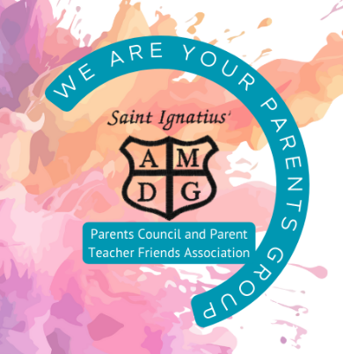
Agenda
Parents Group Meeting 28/05/2026

Present: Tracy Fagan,
Apologies: Rachel B, Lynne T, Lynsay M/ Stacey Ann McConnville, Gilian Kajla, Leslie Burns

Outstanding items from last meeting on 26/03/2026
School Disco  Update | - £100 from takings put to school funds to support P7 Leavers’ Celebrations.  - Increase to three discos per year – suggested Halloween/ Valentines and Summer shorts and shades.  - DJ has become expensive – could we find someone within the community who can
Ties  Action: Leslie leading on this. Any further actions? | - No further action.
P7 Leavers  Action: Hoodies actioned. Party contribution already provided to office staff (disco money) | - All received -
School Trip  Action: Agree contribution | - Tesco grant went to the wrong account – to school as this was on the form. This is now in school funds and has been used short term to cover contribution. Scotland Shirt fundraiser should be able to recoup.
Raffle for Kenny Dalglish Frame  Action: agree strategy and date for draw - 23rd June | - Envelope going home to all family with a £25 pound worth of £5 tickets on Monday.  - Ask Fr. Kevin to put in bulletin.  - To be drawn on 23rd June  - Add to Newsletter
Finances  Cash amount £249.44  Amount in Bank £151.89  Update on new account £859.89  Actions: TF has passed on accounts to be audited, almost signed off.  Timescale: | - Tracy’s friend will audit the accounts for the whole financial year.  - £50 agreed as a thank you
Parent Council Update (Tracy)  Family Fun Night (Tracy)  Actions:  Timescale: NFA until new term | - Meeting on 11th June. Last consultative group meeting.  - Race night – Proposed date – Friday 11th September or Friday 2nd October  - Christmas Fayre either Friday 27th November or Friday 4th December
Tesco blue tokens (Lynsay)  Actions: Devise plan for implementing funding  Timescale: One year | - Planters, soil and vegetable seeds etc to be ordered in new term.
PVGs (Tracy)
Actions:
Timescale: Awaiting PVGs – NFA at this time
Items raised within Parents Group Chat  Communication – replies to emails and calls, short notice for updates, weekly certificates not being posted (raised with class teacher), | - Specific examples of short notice etc will help the school to identify concerns.  - This term there have been a few short weeks,so awards were not given out on those weeks.
Head Teacher Update  - Staffing update  - Improvement Priorities for 2026/2027  - P7 Awards | - Mrs McGinley has been appointed at Principal Teacher in St. Andrew’s Primary  - Mr Eunson has secured a post in Aitkenhead Primary  - Awaiting update from council before confirming classes.  - Consultation regarding P7 awards recognising all pupils’ gifts and talents.
AOB | - Parent group rep to hopefully attend induction afternoon on Wednesday 4th June at 1:30 if possible.
Next Meeting
Next Meeting

