
St Ignatius’ Primary School
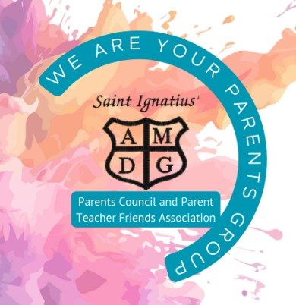
Agenda
Parents Group Meeting 26/03/2026

Present: T Fagan, C Lambie, C McIntyre, N Scott, J McLean, R Byrne.
Apologies: Lynne Totten, Gillian Kajla, T Traynor, L Mackey, SA McConville, S Pew, J Collins.

Outstanding items from last meeting on 26/02/2026
30th April will trial a 6pm start for meeting.
Family Fun Night (Tracy)
Actions: Tracy polled parents – September is preferred date.
Organise Race night after August.
Timescale: NFA until new term
Tesco blue tokens (Lynsay)
Actions: Funding will be used to purchase planting and gardening materials.
Bank Details need to be updated- L Mackey can contact Helen for the details.
Tesco need evidence for how money is spent. School will provide this.
Restorative Justice – benches and planters will be built
Possible organisation of cooking group again round about wintertime.
Timescale: One year

PVGs (Tracy)
Actions: Tracy has met with Lyndsey to complete the necessary paperwork.
Timescale: Awaiting PVGs – NFA at this time

School Disco - support needed
Actions: Helpers & Lead
Timescale: 23rd April 6pm-7:30pm
Help required for supervision of disco:
- Snack Area: 2 people to help serve snacks and 1 person to supervise the snack area.
- Disco Area: 3 people to supervise children, support games, and help manage music/games requests for the DJ
- School staff: will also support with supervision; toilet breaks and organising dismissal at end of evening.

School Improvement Priorities
- School Trips – costings to support school with bringing cost down for kids
- Let PTFA know the cost of buses
- Curriculum Improvement Cycle - curriculum update and refresh.
- School Website Updated – minutes will be added going forward.
- Bluesky - being used well. Mrs Lambie is monitoring this.
- The school app is designed to keep all school communication in one place.
- Planned community connection days in last term
Finances
Cash amount £
Amount in Bank £
Update on new account – nothing new from last time. Cheques sent.
P7 hoodie payments required. £456.39 22
Check with Gillian if invoice has been deducted?
Ties to be purchased for leavers
Actions: TF has passed on accounts to be audited, almost signed off.
Timescale:

Parent Council Update (Tracy)
Parent Consultative Group – 26/03/2026
These are available for parents to attend.
AOB
Kellogg’s Grant – for Breakfast Club - Opening in August again - School will apply with WAPS
Nicole will support Tracy with future grant applications
Next Meeting
30th April 6:00pm(NB time change)
28th May 5:30pm

