
St Ignatius’ Primary School
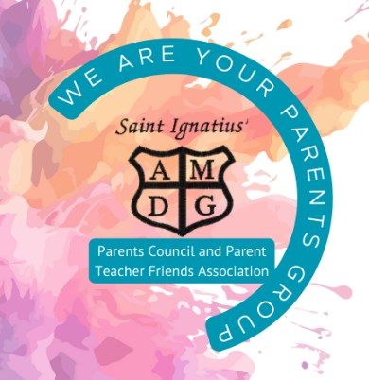
Agenda
Parents Group Meeting 26/03/2026

Present:
Apologies: Lynne Totten, Gillian Kajla

Outstanding items from last meeting on 26/02/2026

Family Fun Night (Tracy)
Actions:
Timescale: NFA until new term

Tesco blue tokens (Lynsay)
Actions: Devise plan for implementing funding
Timescale: One year

PVGs (Tracy)
Actions:
Timescale: Awaiting PVGs – NFA at this time

Head Teacher Update
School Improvement Priorities
- Restorative Justice – Planters and benches related to Tesco Grant
- School Trips
- Curriculum Improvement Cycle
- School Website Updated
- Planned community connection days
Actions: Helpers & Lead
Timescale: 23rd April 6pm-7:30pm

Finances
Cash amount £
Amount in Bank £
Update on new account
Actions: TF has passed on accounts to be audited, almost signed off.
Timescale:

Parent Council Update (Tracy)
Parent Consultative Group – 26/03/2026
AOB

Next Meeting
30th April 5:30pm
28th May 5:30pm

