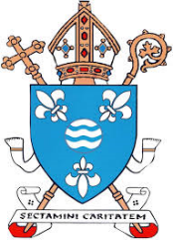
Diocese of Motherwell
Daily Angelus Challenge May 2020
Colour a flower each day you say the Angelus for the first 20 school days of May. On the last day, draw a picture of Our Lady in the centre of the flowers.

If you are able to, take a photo of your completed Angelus Challenge card and tweet to @motherwellre

