St Andrew’s HS

Physical Education Dept

**HIGHER**

**TRAMPOLINING**

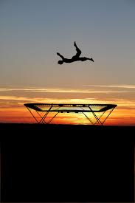

**PHYSICAL FACTORS**

Fitness

Skills

**EMOTIONAL FACTORS**

Confidence

Anxiety

Fear

Determination

**Contents**

**Code of Conduct Page 3**

**Mandatory Knowledge for Exam Page 4**

**Command Words Page 5-8**

**Homework Questions Page 9**

**Physical Factors Impacting Performance Page 10-11**

**Methods of Data Collection for Physical Factors Page 12-15**

**Approaches to Develop Physical (Fitness) Factors Page 16-18**

**Approaches to Develop Physical (Skill) Factors Page 19**

**Principles of Training (SPORT FIT) Page 20-21**

**Emotional Factors Impacting Performance Page 22-23**

**Methods of Data Collection for Emotional Factors Page 24-26**

**Approaches to Develop Emotional Factors Page 27-29**

**Goal Setting Page 30-31**

**Qualitative, Quantitative, Objective & Subjective Information Page 32-33**

**Monitoring and Evaluating Page 34**

**The Use of a Training Diary to Monitor & Evaluate Page 35**

**Steps to Answer Scenario Questions Page 36**

**Appendix Page 37-46**

*Observation Schedule Pg.* 38

*Sit & Reach Test* *(Flexibility)* Pg. 39

*Wall Sit* *(Leg Strength)* Pg. 40

*Standing Vertical Jump* *(Power in Legs)* Pg. 41

*Core Stability Test* *(Core Stability & Core Strength) Pg.* 42

*SCAT Test Pg. 43*

*Performance Profiling Wheel Pg. 44*

*Creating a Voluntary Routine Pg. 45-46*

Higher Code of Conduct

The Higher course is made up of two internally assessed One Off Performances and an external exam -

***2 practical assessments and 1 written***

**ALL ASSESSMENTS MUST BE PASSED AT HIGHER STANDARD IN ORDER FOR YOU TO BE PRESENTED AT HIGHER LEVEL.**

Final results are made up from -

50% - 2 One Off Practical Performances in two different activities

50% - SQA Written Examination *(Lasting 2 hours and 30 minutes)*

**The following are a list of rules which must be adhered to within the Higher class -**

1. Effort and hardworking attitude must be shown at **all times**.
2. Always attend class with PE kit and appropriate theory materials.
3. All homework must be completed properly and on time.
   1. Failing to complete homework will result in no participation in practical.
   2. Using “I don’t understand the homework” is not acceptable for missing deadlines - your teacher is always available for any questions.
   3. Failing to complete homework twice will result in a letter being sent home.
4. Appropriate behaviour must be shown at all times.
   1. Failing to behave appropriately will result in no participation in practical or detention.
   2. Failing to behave properly twice will result in a letter being sent home.

MANDATORY KNOWLEDGE FOR EXAM

* Impact of Mental, Emotional, Social & Physical (MEPS) factors on performance in a variety of activities and on the performance development process.
* Able to name the four main factors impacting on performance and relevant features under each factor.
* Able to give the positive and negative impacts of MEPS factors on performance and performance development in a variety of activities, including individual and team performances.
* Can give the potential impact of one factor upon others(s) during performance and the performance development process.
* Able to give the subsequent impact, both positive and negative, of all four factors on performance at the completion of a PDP.
* Methods to collect information on MEPS factors *(Minimum of 2 per factor)*
  + Use of model performance
  + Application of recognised tests or analytical tools *(Data Collection Methods)*
  + Appropriateness of methods for collecting data
  + Feedback
* Key Planning Information
  + Principles of Training (SPORT FIT)
  + Principles of Effective Practice (SMARTER)
  + Selecting Appropriate Approaches to Develop Performance
  + Performance Development Goals / Target Setting
  + Interpretation of Qualitative and Quantitative Information
* Performance Development Process
  + Approaches to develop performance on MEPS factors *(Minimum of 2 per factor)*
  + Production and implementation of Personal Development Plans (PDP) over a minimum of three sessions for at least two different factors.
* Recording, Monitoring and Evaluating Performance Development
  + Methods, tests or tools used to record, monitor and evaluate
  + Reasons Why We Record, Monitor & Evaluate during performance development
  + Adapting performance development plans
  + Evaluation of the performance development process
  + Future performance development planning

Describe Questions

When answering a Describe question you should always give DETAILS and DESCRIPTIVE POINTS.



**You are *NOT* being asked to give reasons why!!**

You will build a picture in the mind of the marker, by giving details on -

WHAT, WHERE, WHO WITH & HOW



* What exactly did you do?
* Where did it take place? Indoors / Outdoors?
* Who did you play against? What was their ability like in comparison to yours?
* How long did you train / play for?
* What did it look like? The sheet? The drill?
* How was it completed?
* What equipment did you use?
* How was everything set up?
* What did you do with results?



**1 Descriptive point = 1 mark in a Describe Question**

**Read this model answer worth 4 marks…**



**Describe how you gathered data on Physical factors using an analytical tool. *(4 marks)***

[I played a 7 v 7 game of Netball, for 30 minutes, against opponents of similar ability.]**1** A knowledgeable observer completed my Observation Schedule (O.S) specific to Netball while we played. [The O.S had a table with different skills listed across the top row: Passing, Shooting, Dodge and Rebounds etc.]**2** [Down the left hand side there was time periods listed: 0 - 5mins, 6 - 10mins, 11 - 15 mins etc.]**3**

The [observer would place a tick or a cross under the appropriate skill and time period depending on whether or not a skill was successful or unsuccessful. For example a chest pass received a tick when it was passed strong and accurately towards my teammate, this meant is was a successful pass.]**4**



Success Tips for Describing

* You need to give SPECIFIC details!!
* Your answer should help the marker picture exactly what you are talking about, if they can’t see it in their head, they can’t give you a mark.
* No vague statements!!
* Never give reasons why, as this information will be worth nothing in a Describe Question.

Explain Questions

When you are tackling an Explain question you will be looking to give reasons why you have done something or why something has happened.

You might also be asked to talk about **“cause and effect”.** An example of this could be when a Netball player is distracted by the noise of the crowd, they miss being able to catch the ball and lose possession for their team.

The noise of the crowd is the ***“cause”*** and missing being able to catch the ball and losing possession is the ***“effect”.***



To access marks in your Explain answers you will make a POINT, provide an EXAMPLE, and then give the EXPLANATION / IMPACT. *(PEE Paragraph)* You will link these together using LINKING PHRASES.

These phrases will lead you into your explanation and force you to give information on impact…which the SQA are looking for in your answers. Examples of linking phrases are:

* “because…”
* “this allowed…”
* “as a result of this…”
* “to ensure that…”
* “which meant that…”

**Read this model answer worth 4 marks…**

**Bold = Point** *Italics = Impact* Underlined = Linking phrase



**Explain why your chosen method(s) of data collection are appropriate. *(4 marks)***

**I collected this data during pre-season** *as this allowed* me to collect baseline data to enable appropriate targets to be set. *(1 mark)*

**I completed this method before leaving the dressing room**, *this allowed me to* complete the process in private *meaning* I was not distracted and could reduce the possibility of errors. *(1 mark)*

**I carried out this method online**, *meaning that* the information was instantly compared to national norms, helping me to set appropriate targets. *(1 mark)*

**As it was completed straightaway** *it meant that* I did not forget any information and therefore the results were more reliable and could be used to set relevant targets*. (1 mark)*

Success Tips for Explaining

* You need to make a **POINT** then use a *LINKING PHRASE* to give the IMPACT
* You will need to be able to identify cause and effect, e.g. - when this happens, what effect does it have?

Evaluate Questions

The key to success when answering this command word is to make sure that you structure your answer correctly.

When you are Evaluating you are giving YOUR OWN OPINION on something, it can be positive or negative, but **you have to** give a statement of JUDGEMENT.

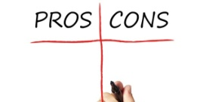You then **have to** back up this judgement with evidence to prove your judgement and then give the impact on training or performance.

**Structure your Evaluate Answer by including the following information:**

* **Judgement** - You need to use a word that shows you have made a judgement. The language you would

use could be - useful, effective, unsuccessful, helpful, good, bad etc.

* **Back It Up!** - You will need to back up your judgement, you can’t give an opinion without backing it up,

so start to explain why this is your opinion. This can come from **qualitative** *(opinions,*

*feedback, personal experience, questionnaires etc)* or **quantitative** sources *(fitness tests,*

*observation schedules, facts & figures etc)*

* **Impact** - You would then use one of your *linking phrases* to lead you into giving details of the impact

caused by what you are evaluating. You should give a clear, specific example with details. Do not be vague here!!

**You will need ALL of this information to access 1 mark** when you are answering an Evaluate question.

So for a four mark answer you would need to give four paragraphs, structured with all the above information, to achieve that number of marks.

**Read this model answer, worth 1 mark…**

**Evaluate how effective one method was in gathering data on the Physical factor. *(4 marks)***

* A method I used to gather data on the Physical factor was the multi stage fitness test (Bleep Test). This method was fairly effective. One benefit of the Bleep Test was that it was easy to interpret my results. **(Judgement)**
* This was because all I had to do was compare my score to the NORMS and easily identify what NORM my score was in. **(Evidence)**
* 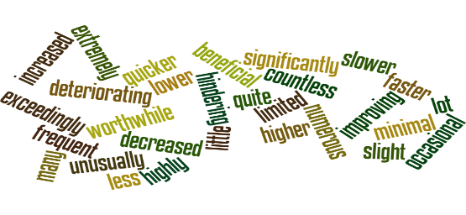This was helpful as it led to me easily identifying if my CRE levels were a strength or a weakness in my performance, so that I could set up a developmentally appropriate training programme, using relevant approaches, at the correct intensities for me to improve. **(Impact)**

Success Tips for Evaluating

* You will need to know **positives and negatives of the method / approach / analytical tool / recognised** **test** **etc.**
* You should draw on your personal experience of using different methods / approaches etc as this will make the evaluation easier to complete.
* Always follow the three point structure, e.g. - ***Judgement, Evidence & Impact***
* Use your linking phrases!! E.g. -

*“This means that…”, “as a result of this..”, “this allowed me to…” etc*

Analyse Questions

When you are asked an Analyse question you are being asked to **break something down into smaller parts** to then look at each part and explain its importance. Your analysis answer can include both positives and negatives.

One of the main tools for success in Analyse questions will be your structure. A well structured answer will stop you writing too much and prevent you from losing your train of thought!!



Firstly you should look at the number of marks available and see if you can break down the subject you are being asked about into that number of ***parts***, e.g. - if it is a four mark answer on a training diary, then you should be looking to break the training diary down into four different parts that will form the basis for each of your paragraphs.



**Structure for your Analyse answers will take this form:**

* **Identify** - This is where you will state what ***part*** you will talk about in your analysis.
* **Explain** - You will talk about why the ***part*** is important, it can be either a positive or a negative and you will

use your linking phrases to help you to give a detailed explanation. Remember to explain & explain further!

* **Impact** - Here you can give details of how the ***part*** has impacted on training, performance, data collection etc.

**Read this model answer worth 2 marks…**  *Italics = part* Underlined = Linking phrase



**Analyse the impact social factors can have on each of the other 3 factors during a performance. *(4 marks)***

*Impact of Social Factor (Gender Issues) on Physical Factor (Strength)*

In Netball, a girl in a mixed team might not be passed to each time she is free, due to her male team mates thinking she lacks skills. This would cause problems as the rest of the team would need to work harder in attack to keep running and create spaces / passing options, which makes them tire more quickly, resulting in their skill level dropping as the game goes on. ***(1 mark)***

*Impact of Social Factor (Cooperation) on Physical Factor (Tactics)*

In Netball cooperating with my team can impact positively on our tactics as I understand my role as WA within my team. If I run ahead of the ball, close to the semi-circle, I can receive the ball as I am a passing option for the ball carrier, which can result in us scoring a goal as I am able to quickly pass to the shooter before the defenders can get into position. ***(1 mark****)*



Success tips for Analysing

* You need to break down what you are going to talk about into the number of ***parts*** required for the marks available in the question.
* Your structure should always follow: ***Identify, Explain (Implication) & Impact***!!
* Use your linking phrases, as this will help you give detailed explanations in your impact!! E.g. -

*“This means that…”, “as a result of this..”, “this allowed me to…”, “ this resulted...” etc*

* Explain, explain, explain!!!

Homework Questions

PHYSICAL FACTORS IN TRAMPOLINING

1. Describe the impact of physical factors on performance. *(4 marks)*
2. Explain the positive and negative impact of physical factors on performance. *(4 marks)*
3. (a) Describe an analytical tool or recognised test you have used to gather data on a physical factors. *(4 marks)*

(b) Explain why the method chosen in part (a) was appropriate to gather data on physical factors. *(4 marks)*

1. (a) Describe two approaches that can be used to develop physical factors in your performance. *(6 marks)*

(b) Evaluate the use of the two approaches chosen in part (a) to develop physical factors. *(6 marks)*

1. Describe how the Principles of Training were applied to your Personal Development Plan. *(6 marks)*
2. (a) Identify a short term and long term goal for physical factors. *(2 marks)*

(b) Explain why you set these goals. *(2 marks)*

1. Evaluate the effectiveness of your Personal Development Plan. *(4 marks)*
2. Describe how you monitored performance when working through your PDP. *(4 marks)*
3. Analyse the method(s) you used to monitor your development when carrying out your PDP. *(4 marks)*
4. Explain why it is important to monitor / review performance when working through a PDP. *(4 marks)*
5. (a) Describe the adaptations / changes that may need to be made to a PDP plan for physical factors. *(4 marks)*

(b) Explain why the adaptations / changes described in part (a) might be necessary. *(4 marks)*

1. Analyse the effective of the changes to your PDP on your level of motivation. *(4 marks)*
2. Describe your strengths and development needs in comparison to a model performer. *(4 marks)*
3. Explain possible future development needs within physical factors which impact on performance. *(4 marks)*

EMOTIONAL FACTORS IN TRAMPOLINING

1. Describe the impact of emotional factors on performance. *(4 marks)*
2. Explain the positive and negative impact of emotional factors on performance. *(4 marks)*
3. (a) Describe two different analytical tools you have used to gather data on emotional factors. *(4 marks)*

(b) Explain the benefits and limitations of using the methods chosen in part (a) to gather data. *(4 marks)*

1. (a) Describe two approaches that can be used to develop emotional factors. *(6 marks)*

(b) Evaluate the use of one approach described in part (a) to develop emotional factors. *(4 marks)*

1. Describe how you applied the Principles of Effective Practice to a personal development plan (PDP)

to develop emotional factors. *(6 marks)*

1. Describe one short term goal and one long term goal for emotional factors.  *(2 marks)*
2. Explain three considerations a performer will have when setting goals to develop emotional factors. *(6 marks)*
3. Explain the impact any improvements in emotional factors can have on performance development. *(4 marks)*
4. (a) Identify one way you have monitored the effectiveness of your plan to develop emotional factors. *(1 mark)*

(b) Explain why you have chosen this method of monitoring. *(4 marks)*

Explain the difficulties that may arise when monitoring emotional factors in your performance. *(4 marks)*

1. Evaluate the effectiveness of your Personal Development Plan to improve emotional factors. *(4 marks)*
2. Explain four reasons why a performer may re-prioritise the focus of their PDP for emotional factors. *(4 marks)*
3. Evaluate your emotional strengths and development needs in comparison to a model performer. *(4 marks)*
4. Explain possible future development needs within emotional factors which impact on performance. *(4 marks)*

PHYSICAL FACTORS (FITNESS) FOR TRAMPOLINING

There are a number of aspects of fitness that impact on a Trampolining performance. You will look at the impact these aspects can have on a performance, both positively and negatively. We will consider the following -

FLEXIBILITY

CORE STABILITY & STRENGTH

LEG STRENGTH

EXPLOSIVE POWER IN THE LEGS

FLEXIBILITY

**MC900318738[1]Flexibility** is defined as the range of movement around a joint.

While Trampolinists do not require the same levels of Flexibility as those competing in other Gymnastic disciplines, they do need good flexibility at the hips, shoulders, ankles and feet. Skills such as Pike jumps and Straddle jumps require good hip flexibility in order for the performer to get into the shape correctly.

Good flexibility reduces the chance of injury and also improves the look and quality of skills in a performance.

CORE STABILITY

**MC900298639[1]Core stability** is the strength or ability to control the position and movement of the central section of the body such as, the abdominals, spine and pelvis. This central section of the body assists in the maintenance of good posture and also provides the foundation for all arm and leg movements.

In Trampolining good Core Strength is an essential aspect of fitness in order for the performer to control their body shape and position whilst in mid-air. Good control is vital in a Trampolining routine for not only how aesthetically pleasing the performance looks to others, but also for safety

reasons, as being able to control your body in the air helps prevent travelling and keeps the

performer over the cross, incurring less deductions in the competition.

STRENGTH

**MC900310176[1]Strength** is defined as the maximum force a muscle or group of muscles can exert in a single movement.

In Trampolining you will require good Static Strength particularly in the legs. Many of the moves in Trampolining call for holding the legs in a straight position and you need good body tension or Static Leg Strength in order to hold and control these positions whilst travelling up and down in the air. Being able to hold shapes steady in the air is vital to the performer if they wish to be awarded a high score from the judges.

POWER

**MC900242191[1]**

**Explosive Power** is a combination of strength and speed, or strength applied quickly.

In Trampolining the repetitive jumping action requires good explosive power in the legs in order

for the performer to get high, so they have enough time in the air to complete the movement and

complete it safely. If a trampolinist can bounce high quickly then they can be identified as an

efficient performer as they are likely to expend less energy completing routines. Ultimately, their

performance will be of a higher quality than someone who takes lots of bounces to gain height or

struggles to gain height again after a landing. This enables the performer to achieve enough

height to execute the skill at the top of the bounce, which gives them enough time to prepare for

the next action.

PHYSICAL FACTORS (SKILLS) FOR TRAMPOLINING

Within Trampolining, there is a range of different skills that can be used, such as basic shapes *(star, tuck, straddle, pike etc)*, as well as more complex skills. *(Back Landing, Front Somersault etc)*

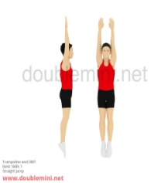BASIC SHAPES

Straight Jump

A vertical jump with the body held straight and arms in a straight line above the body at take off.

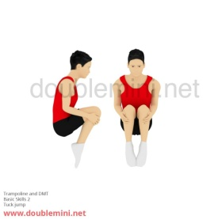

Tuck Jump

From a straight jump start, the knees are pulled up to the chest and the hands must at least briefly grasp the legs between the knees and ankle.

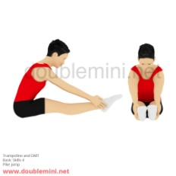Pike Jump

Again from a straight jump start, the legs are straight, held together and lifted parallel to the

trampoline and the arms and body reach forwards towards the pointed toes.

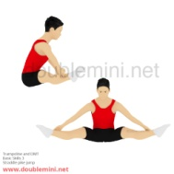

Straddle Jump

Similar to the pike jump except the legs are spread sideways approximately 90 degrees apart and the arms reach forward towards the pointed toes.

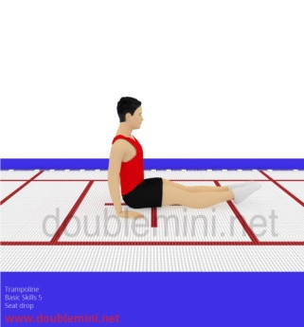

Seat Landing

Landing in a seated position with the legs straight. The hands support the body, one either

side and very slightly behind the posterior, palms down with fingers pointed towards the pointed toes.

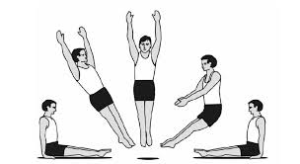Swivel Hips

Performing a seat landing, bounce up to a straight position (without landing) and then perform a half twist and landing in the second seat landing facing in the opposite direction.

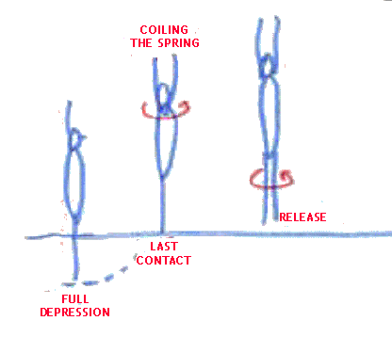

Half & Full Twist

While in a straight jump position rotating the body until facing the opposite direction for a half

twist, or a complete 360 degree rotation for a full twist.

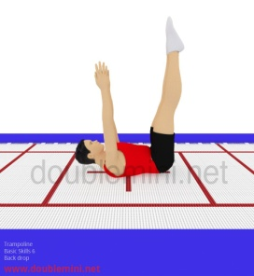MORE COMPLEX SKILLS

Back Landing

Landing on the bed of the trampoline on your back. The legs are bent up at about 90 degrees on landing,

with legs held straight and the head is held in line with the body flat on the bed.

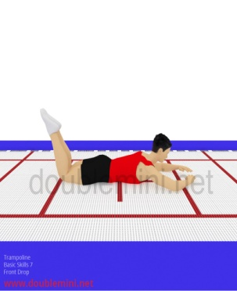Front Landing

Landing horizontally on the bed, face down, with the arms bent to form a diamond shape with the hands overlapping slightly in front of the face. The legs should be bent slightly at the knee keeping the feet off the trampoline bed.

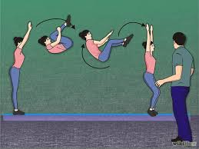

Front Somersault

One complete forward rotation, the body can be in any of the tucked, piked or straight positions.

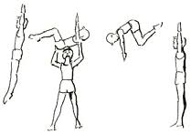

Back Somersault

One complete backward rotation, the body can be in any of the tucked, piked or straight positions.

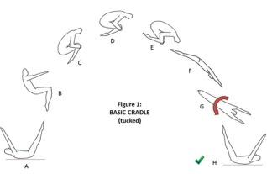

Cradle

From back landing, bouncing up and rotating forwards, then performing a half twist,

landing in second back landing.

METHODS OF DATA COLLECTION FOR PHYSICAL FACTORS

You will use two main methods of gathering data on Physical Factors for Higher Trampolining:

**1. Initial Data = Observation Schedule**

*(Initial data looks at your whole performance within the activity)*

**2. Focused Data = Standardised Fitness Testing**

*(Focused data looks at one specific part of your performance, e.g. - Core Stability / Flexibility / Power etc.)*

1. Observation Schedule

(Analytical Tool)

You will have used Observation Schedules extensively in your National 5 course to gather ***Initial Data*** on a range of activities. Initial Data is information about your performance that can be used to pinpoint areas of strength and weakness within your routine. It forms the basis for more Focused Data collection later on.

|  |  |  |  |  |  |
| --- | --- | --- | --- | --- | --- |
|  | **Height** | **Control** | **Body Shape** | **Centre of Bed** | **Neatness** |
| Full Twist |  |  | X |  | X |
| Straddle Jump | X |  |  |  | X |
| Seat Landing | X | X | X |  | X |
|  |  |  |  |  |  |

**Height** - All skills are expected to be performed at the same height at the top of the bounce. In a competition marks would be deducted if a skill is **lower** than the previous skill. There is an allowance made for skills that follow landings.

**Control** - Each skill / move should show evidence of Body Tension and control. The routine should end with a single exit bounce or finish with a Kill from the last skill. This is a way of showing control to the judges.

**Body Shape** - All skills must show a definite shape: *tucked, piked, straight* (a straddle is not a shape, but a version of a pike). For example the hands should grasp below the knees when the performer is in a tucked shape.

**Centre of the Bed** - All skills should take off from the centre of the bed, movement away from the centre is called travel, the performer should stay inside the Metre Box at all times to avoid deductions.

**Neatness** - Arms and legs should be straight whenever possible, arms should be close to the body wherever possible (in skills such as straddle this does not apply) legs should be together and toes should be pointed in flight.

*The above criteria is based on the requirements of a Model Performance in Trampolining*.

Using your previous knowledge and experience in Trampolining and the criteria detailed above you will be able to complete your Observation Schedule using a tick if you think the performance aspect was successful or a cross if you felt there was a problem or a weakness.

ANALYSIS OF DATA

When you look at your Observation Schedule, it will give you lots of information about your performance. You will be able to identify strengths and weaknesses within the Physical factors that impact on your performance, this includes the quality of your skills and your levels of fitness.

*However your focus for this portion of your Higher PE course is to examine how your levels of fitness impact on your Trampolining performance.*

**Weaknesses**

From the sample Observation Schedule you can see that the performer’s biggest weakness is her neatness closely followed by her body shape. She has the most crosses under those headings - this would lead her to assume that her Core Stability and Leg Strength may not be very good. In order to confirm this assumption she would then collect Focused Data to see exactly what her level of fitness was for Strength and Core Stability by comparing to national norms.

**Strengths**

Her main strength is her ability to stay in the centre of the bed during her performance, she has achieved success with this aspect of her performance consistently, as you can see from the number of ticks recorded under that column. She could then reason that her landing on the bed is even (both feet at the same time) and she is timing her moves really well as she is probably performing them at the top of her bounce, thus reducing the travel across the bed. This is something she could go back and check by looking at the video of her performance again, just to make sure that the conclusions she draws from her Observation Schedule agree with what she can see on the video footage.

|  |  |  |  |  |  |
| --- | --- | --- | --- | --- | --- |
|  | **Height** | **Control** | **Body Shape** | **Centre of Bed** | **Neatness** |
| **Back somersault (Tucked)** |  |  | X |  | X |
| **Tuck Jump** | X |  |  |  | X |
| **Back Landing** | X | X | X |  | X |
|  |  |  |  |  |  |

Look at your own Observation Schedule and start to draw your own conclusions about areas of strength and weakness in your performance, particularly in relation to your levels of fitness. You will then use this information to decide which fitness tests you will use as part of your Focused Data collection task.

*To help you come to these conclusions use the information below as a guide:*

**Height** **-** your ability to gain and maintain a high, consistent height is due to explosive power in your legs.

**Control** **-** your ability to control your body in the air relates to your timing of your skills and your body tension1.

**Body Shape** **-** your ability to get into and hold your body shape in the air is down to the quality of your body tension1 and in some skills also your flexibility.

**Centre of the Bed** **-** staying in the centre of the bed is down to your ability to land on two feet on the bed, jump up vertically and complete your moves at the top of your bounce.

**Neatness** **-** your neatness will be determined by your body tension1 and flexibility (depending on the skill)

1 *Body Tension will be dependent on your Core & Leg strength and stability.*

MC900299781[1]

Explaining Why You Gathered Initial Data

Benefits of Using an Observation Schedules with Video - (Analytical Tool)

* **Allows you to identify general strengths and weaknesses** which means the performer is then able to create a relevant PDP in order to improve upon their weakness, e.g. - their core stability.
* **The written format provides a permanent record as completed on paper.** Therefore, this allows for comparison at a later date, so you can measure any improvements in your performance / weakness.
* **Provides numerical data, as all ticks and crosses can be converted into statistics which are hard to argue with.** Thus, it provides you with hard, objective evidence and therefore is more accurate than someone’s opinion, which is subjective. Thus, provides more accurate benchmark data to measure back against in the future.
* **The schedule is relatively quick and easy to complete**, e.g. - as a knowledgeable observer only has to tick or cross successful or unsuccessful skills. Therefore, less training time is wasted and your PDP can start more quickly in order to improve your performance faster.
* **Combining the observation schedule with video footage** means that your gathered data will be reliable and valid as you will be able to pause, slow down & rewind the video to make sure that nothing is missed during your information gathering, making the data highly accurate. Therefore, the performer’s correct stage of learning is identified.
* **A knowledgeable observer will have experience in the activity** so they will be able to correctly identify the skills and the characteristics that make a performance successful therefore making the data collection more accurate and reliable. Consequently, relevant approaches can be selected in order to develop performance.
* **[](http://www.google.co.uk/url?sa=i&rct=j&q=&esrc=s&frm=1&source=images&cd=&cad=rja&uact=8&docid=0qKokSwXnC_LCM&tbnid=MuZHRsostiYIqM:&ved=0CAUQjRw&url=http://azanrza.blogspot.com/2011/02/if-you-are-in-sales-i-bet-you-will-love.html&ei=7zikU_fUGteqyASUwYLADw&bvm=bv.69411363,d.ZGU&psig=AFQjCNF3Ha6rLs6nHGJChAAQ81LjVC9IXA&ust=1403357735195915)The observation schedule is specific to the collection of information on Physical factors as it looks at each skill individually** across a range of five different aspects that would impact the effectiveness of each skill, as a result the validity and reliability of the data collected is increased.

Limitations of Using an Observation Schedules with Video - (Analytical Tool)

* **If the observer lacks activity knowledge,** their perception of what equals an effective skill might be different from the reality. As a result, the results may be unreliable and the wrong stage of learning is identified.
* **An observation schedule gives you an overall view of your performance in Trampolining but it does not provide specific information about why certain aspects of your performance may be weak** or causing problems for you when you complete your routines. Therefore, more data collection needs to take place which can be time consuming and will slow down the performer’s overall rate of development.
* **A person’s mental, or emotional state could affect your results.** Lack of determination, low confidence etc, will affect the quality of skills, decision making etc**.** Consequently, results may be unreliable and result in the performer working on the incorrect weakness.
* **It may not give you information on mental, emotional or social factors impacting on performance.** As a result, more data collection has to take place which can be time consuming and will take time away from the performer completing their PDP. Thus, they will not develop as quickly.
* **iPads and camera equipment are expensive**, therefore there may not be enough for one or two per performer and as such, may have to be shared amongst several people, which can mean that videoing all of the routines and completing the analysis can be a lengthy process. Therefore, time is taken away from developing performance which can affect the overall progression of the performer.
* **Occasionally there can be technical difficulties with equipment** which means that data might have to be carried out live, which will be very difficult for the observer and a lot of information will be missed. Therefore, the incorrect strengths and weaknesses may be identified.

2. Standardised Fitness Testing

(Recognised Test)

Having looked at your whole performance using the Observation Schedule (Initial Data) you can clearly see areas of weakness within the Physical Factors impacting on your performance. In this section of your Higher course we will look specifically at your level of fitness for Trampolining. To gather information on your fitness levels you will use Standardised Fitness Tests which will provide you with Focused Data. This Focused data will form the basis for your Training Programme.

Benefits of Using Standardised Fitness Testing - (Recognised Test)

* The use of Standardised Fitness Tests can give you clear information about the relevant components of fitness that you are trying to measure and therefore **identifies strengths and weaknesses in your fitness performance.** Thus, a relevant PDP can be created to develop upon your weakness, e.g. - Core Stability / Flexibility / Power etc
* The data gathered **allows us to make comparisons to other scores, norms and averages** due to the test conditions being standardised. Thus, able to see how you perform in relation to others at the same age / stage.
* **Can be very simple to administer and very little equipment required.** Therefore, the test can be completed quickly and can result in the performer being able to start training promptly in order to improve performance.
* **They only measure one factor, e.g. - Flexibility, so detailed information can be gathered on that factor.** As a result, able to specifically see when / if this factor impacts on your performance, so relevant approaches can then be selected.
* **[](http://www.google.co.uk/url?sa=i&rct=j&q=&esrc=s&frm=1&source=images&cd=&cad=rja&uact=8&docid=lifC0IsNAEvesM&tbnid=9Pm82bTj_OwBLM:&ved=0CAUQjRw&url=http://joannecarrollportfolio.com/college-projects/major-research-project/discussion/strengths-and-limitations/&ei=VjakU_HlI4alyASvhoCADw&bvm=bv.69411363,d.ZGU&psig=AFQjCNHtclZOzliDDCDAWnoiIdwPoZXVsw&ust=1403347347505596)Backs up the initial data collected, and allows for realistic targets to be set.** Fitness testing can also be used for monitoring progress during a fitness training programme, gauging when adaptations to training are necessary and to evaluate any improvements at the end of the plan.

Limitations of Using Standardised Fitness Testing - (Recognised Test)

* The validity of the results can be affected as some **tests do not take into account outside influences and it is also difficult to isolate a specific factor.** E.g. - Mental, Emotional or Social factors may still influence performance. Therefore, incorrect approaches could end up being selected when trying to develop performance.
* **Tests are not activity specific,** so the reliability of the results can be affected as tests are performed outwith the activity. Thus, may not be a true reflection of how you actually perform and therefore unrealistic goals may then be set.
* The **reliability of results can also be affected if there is poor preparation prior to test, or the timing of the test can affect results.** E.g. - No warm up, after big lunch, or day after a big performance. Thus, wrong stage of learning may be identified.
* **Practicability can be an issue as sometimes specialist equipment is required.** This could affect how often the performer is able to complete the test, as it may be difficult to monitor progress in the future, as do not have access to the equipment, which makes it difficult to see progress in training.
* **It is sometimes difficult to recreate the same conditions and standards, causing results to be skewed.** Therefore, in the future a performer may believe that they are improving when they are not.
* **There is a danger of over testing which will take too much time away from a training programme** which would limit your development and progress. Any testing must be planned as part of your training schedule and not just testing for the sake of it.

**There are samples of the different Fitness Tests in the Appendix of this booklet.**

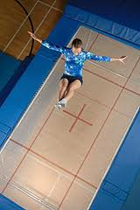

Examples of Standardised Fitness Tests -

* Sit & Reach Test *(Measures your level of flexibility)*
* Wall Sit *(Measures muscular strength and endurance in the lower body)*
* Standing Vertical Jump *(Measures your levels of explosive power in the legs)*
* Core Stability Test *(Measures how strong your core is)*

Your weakest aspect of fitness will be the main focus for your Training Programme, you will use both the results of your Initial and Focused data to plan a training programme and select appropriate methods of training.

Approaches to Develop Physical (Fitness) Factors

The following approaches can be used to develop physical (fitness) factors, in your performance.

Plyometrics for Explosive Power

Stretching for Flexibility

Isometric exercises for Core and Leg Stability and Strength

PLYOMETRICS TO DEVELOP EXPLOSIVE POWER IN THE LEGS

Aim of this type of APPROACH:

1. To improve your explosive power in the legs in order to gain height quickly on the Trampoline at the beginning of and during the routine especially after a Landing.
2. To help the performer maintain a consistent height when bouncing so as to avoid deductions from the judges.

Why this APPROACH is appropriate:

* Plyometrics is an ideal approach as the repeated jumping in short, sharp bursts mimics the type of movements you will perform on the Trampoline by using a lot of vertical jumps and combinations of drops and jumps. **This makes it** specific to the demands of your activity.
* It can start with a low intensity and build up to a high intensity as time passes or fitness levels increase **meaning you can** make it specific to your current levels of fitness.
* This approach can be completed alone at a time that suits you and requires very little specialist equipment, **this means that** you are not dependent on a specialist area / assistance giving your PDP more flexibility.
* It is easy to adjust the workloads e.g. - bigger, more powerful jumps, shorter rest periods, more reps etc **so you can** progressively overload your training without changing your approach and you can set specific targets to achieve and motivate you throughout your training.

**Example of Plyometrics:**

|  |  |  |
| --- | --- | --- |
| **Type of exercise** | **Examples** | **Intensity** |
| Standing based jumps performed on the  spot | Tuck Jumps x 5  Straight Jumps x 5 } Complete 3 sets of each  Squat Jumps x 5 | Low |
| Drop jumps from a low step | Drop Jumps x 5 } Complete 3 sets | Medium |
| Drop jumps from a bench | 6 x jumps for height} Complete 3 sets | High |

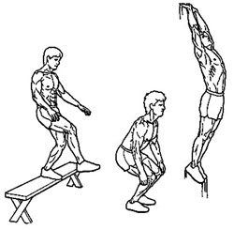

**Drop Jumps from a Bench**

STRETCHING FOR FLEXIBILITY

Aim of this type of APPROACH:

1. To increase the range of movement across the working joints in order to improve body shape in the air
2. Increase the mobility and suppleness of the working muscles

Why this APPROACH is appropriate:

* By combining different types of stretching you can develop not only the suppleness of the muscles but also increase the range of motion across joints**, which will allow** you to safely, quickly and more successfully get into some of the shapes required for higher level Trampolining.
* Dynamic stretching will help to make your training more specific to Trampolining **as it helps** to increase the range of movement while in motion **meaning that you** are mirroring the type of movements you will perform on the Trampoline.
* Static stretching is very safe and unlikely to cause injury, and will help you reduce the onset of DOMS (Delayed Onset Muscle Soreness) as you are **ensuring that** the muscles are ready to react and you are also helping the muscle return to its resting state after training.
* Partner / Assisted stretching helps to develop a full range of motion.

|  |  |  |
| --- | --- | --- |
| Leg Swing | Leg Swing | Leg swing |

**Example of Dynamic Stretching:**

Leg Swings

* Stand sideways onto the wall
* Weight on your left leg and your right hand on the wall for balance
* Swing your right leg forward and backward
* 6 - 10 repetitions on each leg.

**Example of Static Stretching:**

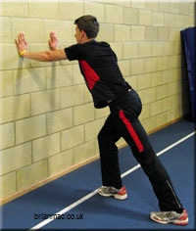Calf Stretch

* Stand tall with one leg in front of the other, hands flat and at shoulder height against a

wall.

* Ease your back leg further away from the wall, keeping it straight and press the heel

firmly into the floor.

* Keep your hips facing the wall and the rear leg and spine straight.
* You will feel the stretch in the calf of the rear leg.
* Repeat with the other leg.

ISOMETRIC EXERCISES FOR CORE AND LEG STABILITY AND STRENGTH

In order to develop your body tension in Trampolining you could use a programme designed to improve your core /leg strength and stability. Isometric exercises are body weight exercises that are held in static or still positions.

Aim of this type of APPROACH:

1. To improve your body tension when performing a Trampolining routine so that the body is controlled in the air.
2. To develop strength and stability in the core / legs so that all skills in a routine are of high quality, which will reduce the deductions made by Form judges.

Why this APPROACH is appropriate.

* This will help you control your body in the air and having good body tension means that your performance will be of a higher quality as your shapes will be strong and more controlled which are essential characteristics for a high score in competition as it makes the skills more aesthetically pleasing.
* These exercises are very good for developing your strength and stability as you can target specific muscle groups in the body, and through your data collection you will have identified the muscle groups you need to target for success **thus** making your PDP specific to your fitness needs.
* The training can be completed anywhere and with minimal equipment as the exercises are centred on using body weight as resistance.

**Example of a session of Isometric Conditioning:**

Static Squats against wall 30 seconds x 3

Plank 30 seconds x 5 } *Repeat the entire set 3 times (30 seconds rest between sets)*

Lunge hold for 15 seconds on each leg x 6

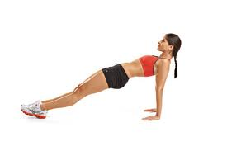

**Reverse plank 🡪**

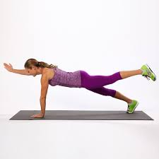

**Superman 🡪**

Approaches to Develop Physical (Skill) Factors

The following approache can be used to develop physical (skill) factors, in your performance.

Gradual Build Up

Gradual Build Up

Purpose of this type of APPROACH:

It is an approach to develop performance where you start learning a new skill, technique or action at a stripped down basic stage. You work at this stage until you are able to perform it consistently, effectively and confidently. You then gradually add a little more difficulty, making it harder as you build up to performing the skills, technique or action within a full performance or competition.

Benefits of Using Gradual Build Up

* Allows you to learn complex or potentially dangerous skills safely by breaking them down into smaller, simpler and safer actions.
* It suits all levels of ability as more able performers can start at more advanced stages whereas less able can start at easier stages.
* As you are constantly gaining success as you move through the stages, it allows you to build confidence.
* As the learner, you can decide when to move forward or back which helps to keep them motivated.
* Each learner can decide which new aspects they can add to the practice to make it more difficult, so it can be changed to suit the needs of each performer taking into account their own needs and that of the activity or situation that they are preparing for.

Limitations of Using Gradual Build Up

* The performer must master one step before moving on to the next step. This can cause frustration if a performer is unable to move past a particular step / stage, resulting in them giving up and therefore not improving upon their performance.
* The skill will not be improved if the steps are rushed. The performer will lose confidence because they will not improve and motivation will decrease.



PRINCIPLES OF TRAINING

(SPECIFIC TO FITNESS)

When creating a personal development programme to work on Physical (Fitness) features, the following Principles of Training (SPORT FIT) are essential to the successful creation of an effective training programme. Applying the following Principles of training when creating your own programme will make sure that the work you undertake is suitable for you and your development needs and that ultimately your overall performance in Trampolining should improve as well as your levels of fitness. You will need to consider:

SPECIFICITY

PROGRESSIVE OVERLOAD

SETTING SHORT & LONGTERM TARGETS

MONITORING

SPECIFICITY

The approach you undertake must be specific to your own individual needs. Every activity requires a specific mix of fitness components and the training you do should address the areas of specific weakness whilst maintaining the other aspects of fitness. The main areas to be considered are:

* **The individual** training must be specific to your own individual needs. It is important that you assessed your initial levels of fitness to work out your strengths and weaknesses, this will also allow you to set your initial training workloads.
* **The activity as** the training must reflect the fitness demands of that activity.
* **The energy systems** most frequently used in the activity must be identified and their overall contribution and ensure your training reflects this e.g. CRE you need to work your heart & lungs.
* **The approach** used needs to suit the identified aspect of fitness e.g. Core Stability = Isometric Training.

This principle ensures:

* My programme was specific to the area of weakness I identified in data collection and analysis **therefore** my programme was specific to my needs in Trampolining, as the approaches selected were appropriate for developing the aspect of fitness / areas of weakness I identified.
* The training involves the same muscle groups and patterns of movement essential to Trampolining.
* By using the principles of FIT (Frequency, Intensity, Time) I made my programme specific to my needs
* My training programme was specific to my current level of fitness, so my FIT was at an appropriate level.

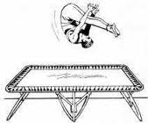

PROGRESSIVE OVERLOAD

The purpose of training is to improve your level of fitness. This can only happen if you make your body work harder than it is used to, this is called OVERLOADING. By making your body work harder it gradually adapts to the higher workloads and your fitness level increases. When you overload you need to consider:

**FREQUENCY**: how often you need to train per week

**INTENSITY**: how hard you work (the workloads that you will use)

**TIME**: how long each individual training session will last

After a few weeks your body will have adapted to the overloading and your fitness levels will have increased. In order to continue improving you need to continue to increase the workloads, this is called Progression. Progression can be achieved by:

* **Increasing the Intensity** e.g. - increasing the sets completed.
* **Increasing the Frequency** of training e.g. - from 3 up to 4 times a week.
* **Increasing the Duration** e.g. - working for 50 minutes as opposed to 40 minutes. It is important that you don’t try to progress by too much too quickly or you may injure yourself or over train.

This principle ensures:

* Progressive Overload is crucial to your progress and development, as you will stay at the same level (plateau) unless you make your training more challenging.
* As you train, your body adjusts to your training programme, and you won’t improve further, unless you subject the body to more stress. Your body again adapts to this new harder workload, and you become fitter.

REST (RECOVERY TIME)

****It is important that you have rest days in your training programme to allow your body to recover, muscle fibres to rebuild and avoid injury from over training. Therefore a heavy intense session should be followed by a rest day or a light recovery session.

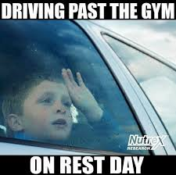REVERSIBILITY

Fitness cannot be stored, you have to keep training in order to maintain your fitness. If you stop training your fitness levels will start to drop and in a relatively short period of time the adaptations that have taken place will be lost i.e. your fitness levels will be reversed.

TEDIUM (VARIETY)

Using a variety of training methods relieves tedium and avoids boredom in training which could in turn lead to a lack of motivation to train, reach targets or give your best.

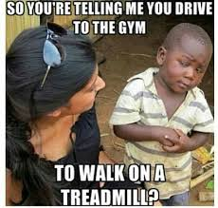

EMOTIONAL FACTORS IMPACTING ON TRAMPOLINING

There are a number of Emotional factors that impact on a Trampolining performance. You will look at the impact these factors can have on a performance (both positive and negative effects). We will consider the following:



****Happiness / Sadness

Fear

**Happiness/ Sadness** is an emotional state of mind. Ranging from feeling content and happy to a feeling of despair, grief or sorrow. Happiness will affect performance positively and sadness will have a negative effect. They can impact on numerous feelings such as confidence, resilience and optimism or pessimism. For example being in a happy state of mind before performing a routine in Trampolining will increase your confidence in executing skills and your belief in your ability to perform successfully. If you were sad before the performance, your confidence and belief in your ability to perform skills successfully will be low, resulting in a poorer level of execution.

***The following 3 emotions are part of the feelings you may experience if you are Happy during performance.***

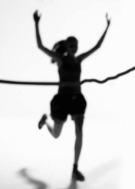

***Confidence*** is about believing in your own ability and being willing to try new things, even if they seem challenging, for example learning a Back Somersault, it is a complex and dangerous skill and to learn it safely and successfully you need to have confidence in your own ability. Confidence can be a self-fulfilling prophecy as those without it may fail or not try because they lack it and those with it may succeed because they have it rather than because of a natural ability. This tells us that you are more likely to achieve success in Trampolining if you have confidence, even if your skill level needs improvement.

***Resilience*** is your ability to recover from losing or making a mistake during a routine while still maintaining a positive attitude. It is defined as an individual’s ability to properly adapt to stress and challenge. Resilience is not a rare ability; in reality, it is found in the majority of people and it can be learned and developed by virtually anyone. Resilience will be essential if you do make a mistake or if you struggle when learning a new skill, as it will help you recover quickly and focus you mind on achieving what you set out to do, without being bogged down by negative thoughts or feelings.

***Optimism*** is about staying positive and hopeful that success can be achieved even in difficult circumstances. A person who is optimistic will always look for the best in a situation and optimistic people have been shown to have more success due their more positive attitude and approach to life. Being optimistic in Trampolining will help you to achieve more success, learn more complex skills and routines and have the confidence to get up and perform in front of an audience for a competition.

**Fear** is a negative emotion induced by a perceived threat, which causes you to quickly pull away or avoid a situation. Fear produces negative thoughts, which directly impact on a sportspersons’ confidence. Winning and losing is so important in most competitive settings that fear of failure or fear of not performing well is at the forefront of an athlete’s mind. Athletes that are full of positive energy and excitement will always outperform negative opponents. Fear of failure prevents performers from pushing themselves outside of their comfort zone and achieving their potential.

***The following 3 emotions are part of the feelings you may experience if you are Fearful during performance.***



***Anxiety & Panic*** are the unpleasant feelings of dread over something that is unlikely to happen, such as the feeling that something bad will happen when attempting a new or complex skill on the Trampoline. Anxiety is a feeling of fear, worry, and uneasiness, usually as an overreaction to a situation that may pose no real threat. Panic is an emotional state that happens suddenly. It is often accompanied by restlessness, fatigue, problems in concentration, and muscular tension.

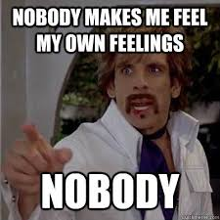***Stress*** *i*s a feeling of strain and pressure. Small amounts of stress may be desirable, beneficial, and even healthy. Positive stress helps improve athletic performance. It also plays a factor in motivation.

Excessive amounts of stress however, may lead to many problems in the body that could be harmful. Stress can be created by internal perceptions that cause an individual to have anxiety or other negative emotions surrounding a situation, such as pressure, discomfort, etc. For example a performer may become worried about what the judges or audience think about their performance, this sort of worry and stress will damage the performance.

METHODS OF DATA COLLECTION FOR EMOTIONAL FACTORS

In order to gather information about the impact the Emotional Factors that have an impact your Trampolining performance you will use two different methods of data collection:

**1. Initial Data = Performance Profiling Wheel**

*(Initial data looks at your whole performance within the activity)*

**2. Focused Data = Sports Competition Anxiety Test (SCAT Test)**

*(Focused data looks at one specific part of your performance, e.g. - Anxiety)*

1. Performance Profiling Wheel

(Analytical Tool)

If a Trampolinist appeared to lack height towards the end of a routine, a knowledgeable observer would see this and any data gathered would be used to help design an appropriate training program to address this area of weakness.

Similarly, if emotional factors require attention, the development approach must be tailored to the performer’s specific needs. However, whereas speed, or lack of it, can be directly observed, emotional factors are often hidden.

A key problem for performers who are looking to address such issues, is how to work out what the problem is when they cannot observe what is going on in the person's mind. Questioning does not always provide the full facts since athletes can be reluctant, at least initially, to discuss such things.

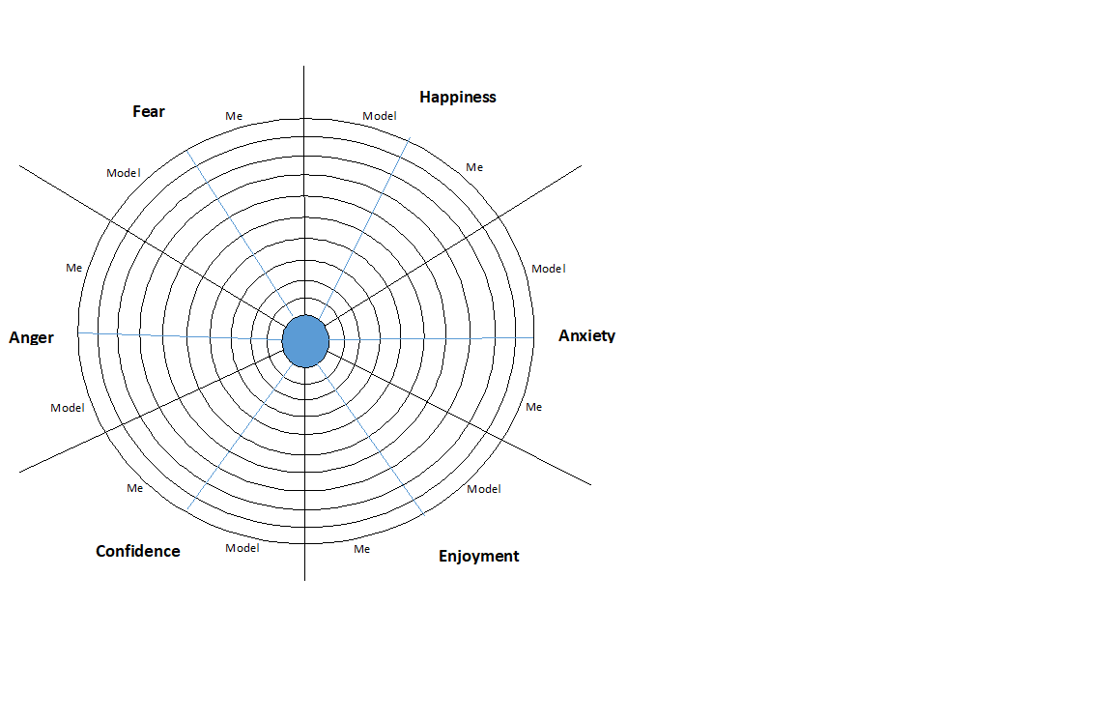An approach that is becoming popular in sport is ***Performance Profiling.***

* On a scale of zero *(not at all and closest to the centre spot)* to 10 *(extremely and box closest to the edge of the circle)*, the athlete rates each of the characteristics for a Model Performer in their particular sport / event by shading in the appropriate panels in one colour.
* The athlete uses the same zero to 10 scale to rate their current perception of themselves in relation to an ideal state of 10 by shading in the remaining panels in a different colour.
* A calculation is then carried out to determine the “Discrepancy” value. The higher discrepancies indicate areas that may need to be addressed through training or other intervention.

**The next step is for the athlete to rate each of the identified characteristics.**

The table below provides an example of these calculations for part of an athlete's performance profile.

|  |  |  |  |
| --- | --- | --- | --- |
| Characteristics identified by the athlete | Athlete's perceived level of importance (API) | Athlete's self assessment (ASA) | Discrepancy (10-ASA) × API |
| Confidence | 10 | 8 | 20 |
| Concentration | 9 | 6 | 36 |
| Control | 10 | 7 | 30 |
| Commitment | 9 | 8 | 18 |
| Refocusing after errors | 9 | 5 | 45 |
| Enjoyment | 8 | 8 | 16 |

For this particular athlete refocusing after errors and concentration are key concerns that could be addressed.

Re-assessment for monitoring and evaluating purposes should always relate to the same characteristics identified in the initial profiling process and be conducted every three to six weeks.

Benefits of Using a Performance Profiling Wheel - (Analytical Tool)

* **Allows you** **to identify your strengths and weaknesses** in the emotional factors **-** meaning you can create a training programme to improve upon your weakness, e.g. - anxiety.
* **Provides a** **permanent record** as completed on paper **-** meaning the PPW can be used to make comparisons to more recent PPW’s completed in the future to check for improvements in your performance.
* **The wheel is completed individually and is solely based on your own thoughts and feelings, without external input -** meaning results are personal to you and therefore more accurate and reliable. Thus, the correct information can be collected and helps you to be able to set appropriate goals.
* **Gives a direct comparison to a model performer in relation to emotional factors** **-** meaning it lets you see what you have to aspire to in order to improve emotional factors, which can improve your focus and determination when training.

Limitations of Using a Performance Profiling Wheel - (Analytical Tool)

* **Information collection is based on a performer’s perceptions of their emotional performance** **-** meaning bias could impact the validity of results as you may lie to look better than what you are. Therefore, the wrong stage of learning in your performance is identified.
* **It can depend on the importance the performer places on the process** **-** as if you rush through it, you could end up looking better than what you actually are, resulting in the wrong benchmark data being collected. Consequently, this would make comparisons in the future difficult to compare back against to measure success.

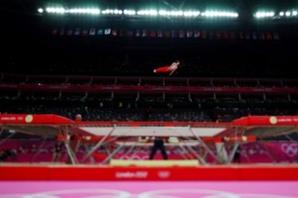

2. Sports Competition Anxiety Test (SCAT Test)

(Analytical Tool & Recognised Test)

This method of data collection allows you to analyse how you feel in a competitive situation, it is possible to determine your level of anxiety. You will complete a number of questions on how you feel about a competitive situation, you will decide if you “Rarely”, “Sometimes” or “Often” feel a particular way when faced with competition. There is no time limit and you can then calculate your Anxiety score using the accompanying grid.

The SCAT will allow you to examine how you feel in relation to competing against others in Trampolining. This will be important as your level of anxiety may have a direct effect on how successfully you perform your routine on the day of a competition or an assessment. If your initial data collection using a SCAT proves that your anxiety level is high, then you should be able to develop your ability to control and overcome your anxiety levels in relation to competitive situations, by completing another SCAT after completing a training programme over a number of weeks. You should then be able to compare results and see a reduction in your levels of anxiety.

Benefits of Using a SCAT Test - (Analytical Tool & Recognised Test)

* **Allows you** **to identify your strengths and weaknesses** with regards to your levels of anxiety **-** meaning you can create a training programme to improve upon when specifically you need to work on your anxiety to improve upon your trampolinign performance.
* **The written format provides a** **permanent record** as completed on paper **-** meaning the SCAT test can be used to make comparisons to more recent SCAT Test’s completed in the future to check for improvements in your performance.
* **The test is quick and easy to complete, as no equipment is required** and it is simple to set up and conduct which reduces the time taken to complete it, **meaning that** we can get on with our PDP quicker, meaning less training time is wasted and therefore the performer will develop their overall performance quicker.
* **Focuses a performer’s attention on the emotional factors impacting performance, which otherwise might have been forgotten**. Consequently, emotional strengths and weaknesses, such as when anxiety impacts on performance, can be identified from the SCAT Test which future performance development programmes and goal setting can be based upon.
* **Gives the opportunity to voice thoughts and feelings (subjective) which could impact performance.** Encourages self-reflection and develops a performer’s independence and problem solving abilities.
* **The SCAT Test is completed individually and is solely based on your own thoughts and feelings, without external input -** meaning results are personal to you and therefore more accurate and reliable. Thus, the correct information can be collected and helps you to be able to set appropriate goals.

Limitations of Using a SCAT Test - (Analytical Tool & Recognised Test)

* **The information which is being collected is based on a performer’s perception of their emotional performance**. Subsequently, this could impact on the validity of the results, as it could be a bias assessment.
* **It depends on the importance a performer places on the process.** If a performer doesn’t take the process seriously this will impact on the validity of the results.
* **Results could be inaccurate if a performer misinterprets the questions.** Therefore you may end up creating inappropriate goals to develop performance, which can hinder development.
* **Application and focus is very dependent on the circumstances of the performer and the environment the data is collected in.** Their knowledge will also impact the validity of the results.
* **It can take a long period of time to collect and analyse the results**. Therefore, time is taken away from performance development, resulting in a slower rate of development.
* **The questions being asked are only closed questions.** A lack of open ended questioning means that the performer’s answers lack explanation, which could impact on the accuracy of the results.

APPROACHES TO DEVELOP EMOTIONAL FACTORS

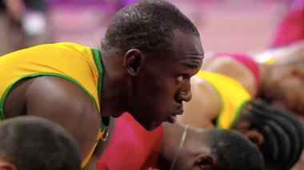

Visualisation / Mental Rehearsal

Positive Self Talk

1. Visualisation / Mental Rehearsal

Visualisation and mental rehearsal techniques teach us how to use our mind to achieve success and reach our goals. Visualisation is the process of creating the mental image in our mind, and it is one of the most effective ways to use our imagination abilities to help achieve our goals.

By creating a mental image or intention of what you would like to feel or what would wish to happen you are more likely to have a successful outcome. A performer can use this technique to “intend” an outcome of a race or a training session, or simply to rest in a relaxed feeling of calm and wellbeing. The scenarios imagined should include all of the senses for example visual (images and pictures), kinaesthetic (how the body feels) or auditory (the roar of the crowd).

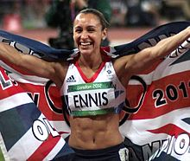The act of creating and ‘rehearsing’ a positive mental experience in order to enhance your ability to achieve a successful outcome in real life – is one shared by great athletes from Muhammad Ali and Andy Murray to Jessica Ennis-Hill. Prior to London 2012, Ennis-Hill revealed: “I use visualisation to think about the perfect technique. If I can get that perfect image in my head, then hopefully it’ll affect my physical performance.”

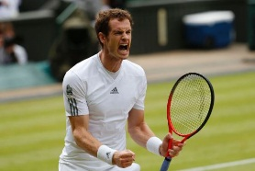When you visualise performing a successful skill on the Trampoline, you should try to feel your feet pressing on the bed, the feeling of rising into the air, the tension in your muscles to hold your position, the sense of accomplishment you will feel when you perform it effectively. This incredibly vivid imagery will help you to prepare for the emotional rigour of competition, by improving your confidence, focus and ability to control your anxiety. It will help you prepare for any scenario: how will I react to the judges? What if I make a mistake on my Back Landing? Will I remember my Voluntary routine? But it also fires impulses to the muscles, therefore preparing them for action. The more vivid the mental image, the more effectively your brain primes your muscles to complete the same physical and technical action in a real competition.

Aim of these two approaches:

1. To enhance confidence in your ability to perform under competitive pressure.
2. To develop your ability to manage your emotions throughout Trampolining training and competition.

Benefits of Using a Mental Rehearsal

* **It can motivate the athlete by recalling images of success in past competitions** meaning the performer is able to remain positive and have the confidence / determination to use a range of skills within the performance.
* **It can reduce negative thoughts by focusing on positive outcomes** meaning it can develop the performer’s confidence / determination, resulting in better decision making / improved motivation etc when performing.
* **Refocuses the athlete when the need arises**, e.g. - if a performer is feeling sluggish, imagery of a previous best performance can help get things back on track and prevent this from hindering performance / development.
* **Sets the stage for performance with a complete emotional run through of the key elements of their performance**. This allows the athlete to set desired pre-competition feelings and focus, so that they are fully prepared to perform at their best.
* **Having rehearsed any eventuality you will be able to cope with pressure** allowing you to remain calm and stay in control, regardless of what happens in the performance.
* **Boosts your knowledge and technique of the activity, as the pathways have already been developed in your mind** meaning the performer is able to make the correct decisions etc when performing at the appropriate time.

Limitations of Using a Mental Rehearsal

* **Some athletes may imagine negative previous performances in past competitions, or against a particular opponent**, which can impact negatively on performances and results.
* This type of approach **takes a lot of practice for it to have a positive impact.** Performers must use it every day in order to master the technique, especially with fast paced sports like trampolining. If an athlete is not completing this training, when they can dedicate their full time and attention to it, it can encourage bad habits and a lack of emotional focus in performance.
* **You must be physically able and proficient at trampolining for this technique to be successful.** If you are unable to perform the basic skills and movement patterns, imagery will be ineffective.
* 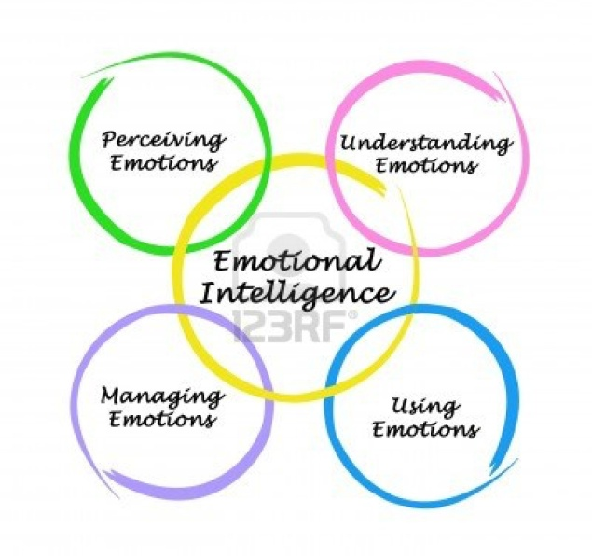**In the moment, this approach can be forgotten as distractions and external factors can result in the performer missing the cue which identifies that fear and / or excitement**. This could impact the performer’s level of confidence which can hinder overall development.

2. POSITIVE SELF TALK

One of the simplest concepts of [sports psychology](http://sportsmedicine.about.com/od/sportspsychology/Sports_Psychology.htm) is developing Positive Self Talk. It’s also one of the hardest sports psychology skills to master.

All day long, most people have a running dialogue with themselves. If you actually stop and listen to these messages, you may wonder how you accomplish anything at all. How many times in a given day do you find yourself mentally rehearsing the worst possible outcome, or telling yourself you can’t do something, or it's too hard? If you are in the middle of a 5K run and someone darts past you, does that little voice in your head encourage you or shoot you down?

Getting control of our Self Talk is one of the hardest things many of us will attempt, whether we play sports or not. For an athlete, negative internal messages and thoughts are among the biggest contributors of performance anxiety.

To combat these negative messages you will aim to replace them with positive ones that will increase your levels of optimism and confidence, in turn reducing anxiety and stress.

Benefits of Using a Positive Self-Talk

* It can help to **reduce negative thoughts by focussing on positive outcomes**, helping the performer to always maintain determined and confident when performing.
* It is **easy to use in practice and competition, as no specialist equipment is required.** Consequently, the athlete can use this approach as often as required in order to develop their performance.
* It is **specific to your needs and performance, as it can be tailored to your own individual needs.** Therefore, athletes can develop faster.
* It **can refocus the athlete when the need arises**, e.g. - if a performer is frustrated after making a mistake, positive self-talk can help get things back on track, by composing the athlete and getting them to focus on what’s important in the game. Consequently, ensuring they make effective decisions.
* **Increases motivation and willingness to exert yourself, combat anything thrown at you, and persuades your body to keep going** meaning the performer is always able to maintain an optimum level of arousal during training / games.
* Helps to centre a person and ground them, preventing complacency.
* **Having continually practiced positive self-talk during training sessions**, you will be able to cope with performance pressures, allowing you to control your anxiety better and in turn helping you to perform better within your performance.

Limitations of Using a Positive Self-Talk

* **It can take a lot of practice for it to have a positive impact on performance**. E.g. - Every day, especially with complex sports like trampolining. Consequently, unless they can dedicate their full time and attention to it, it can encourage bad habits and a lack of emotional focus.
* If you are **physically unable to perform core skills and movement patterns in the activity, positive self talk will be ineffective.** Therefore, this can hinder the performer’s overall development.
* **In the moment, this approach can be forgotten as distractions and external factors result in the performer missing the triggers which identify frustration, fear or anger.** Thus, performance continues to be negatively impacted and can slow down development.
* **Requires a level of self belief in what is being said.** Athletes will often feel awkward and lack focus. Therefore, this may discourage the athlete to use this approach, which will result in their mental factors not improving.

Example of Positive Self Talk / Mental Rehearsal / Visualisation Training:

1. **Choose a positive phrase / image**: this could be as simple as “I feel strong”, or “Focus”, or any other simple positive phrase / image you could repeat or visualize over and over.
2. **Practice multiple scenarios**: once you have developed the habit of repeating this phrase during practice to the point where it is automatic, start expanding the dialogue/ imagery so that you have familiar and comfortable statements for a variety of situations during Trampolining. For example if you are doing a Back Somersault in your routine you could think “I am good at this skill”, “I will perform at the top of my bounce”. If you watch another competitor who performs at an exceptionally high standard you could visualize yourself performing with similar skill and quality while repeating positive statements about your own performance.
3. 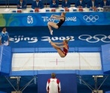**Create a positive mental image or visualisation**: the phrases and words you choose should be those that you can immediately call up and create a visual picture of yourself doing exactly what you say. The image along with the words are a powerful combination that creates a positive message tied to a belief in yourself.

SETTING SHORT AND LONG TERM GOALS

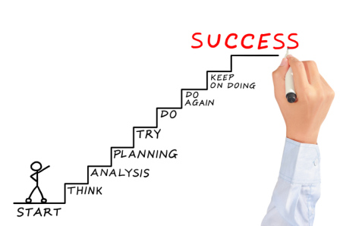When you are planning and implementing a personal development plan, it is important to set yourself goals as they **provide direction** and can be used to **measure progress**. Training goals can give you little steps on your way to your ultimate goal. Setting goals will help you to:

* Create a Focus for your Training
* Increase Motivation and Determination
* Prioritise and get more out of your time
* Get better results
* Monitor Progress
* Provide Valuable Feedback

Short and Long Term Goals

When goal setting, it is important that you have a clear idea of what you want to achieve. Teams and individual athletes usually set long-term goals by the end of the season or year. Likewise, at the start of your personal development plan you should have a clear idea of what you want to achieve by the end of your plan. To achieve these long-term goals, you need a series of short term goals to help you to. As the performer successfully achieves each goal their motivation stays high and the smash improves. For example:

*Short Term Goal -* To be able to perform basic shapes successfully and under some control in a 10 bounce routine.

*Medium Term Goal -* To have improved my core stability score by at least 10% by week 4.

*Long Term Goal -* To improve my overall performance in Trampolining so that I can successfully perform a range of basic complex skills in two 10 bounce competition routines – one Compulsory and one Voluntary.

Prior to embarking on any individual programme it is essential to establish a realistic starting point. Many factors will influence this such as:

[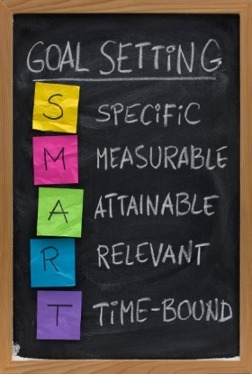](https://studentsuccess.unc.edu/setting-goals/smart-goal-setting-concept-4/)

* Time available to reach target
* Previous experience
* Ability to monitor progress

THINK S.M.A.R.T.E.R FOR EFFECTIVE GOAL SETTING

To set effective goals they should be S.M.A.R.T.E.R goals.

This means they should be:

* **SPECIFIC**

Your goals should be clear and precise. They should reflect your ability and experience within your chosen activity.

* **MEASUREABLE**

Goals must be easily measurable so that you can assess whether or not they are improving or have been successful.

* **ACHIEVEABLE**

Your goals / targets should be challenging, but at the same time be within your reach, so that you have a chance of success. The ideal level for a goal to be pitched at is “***challenging but achievable… with real, hard work”.***

* **REALISTIC**

Realistic goals are more likely to be achieved and you are, therefore, more likely to stay motivated throughout your personal development plan. Setting unrealistic goals will result in lack of success and, ultimately, in a drop in morale.

* **TIME-RELATED**

Your goals should be progressive. Planning short-term goals will ensure progress and help you achieve your long-term goals.

* **EXCITING**

Make sure your goals are rewarding and enjoyable. This approach will maintain motivation and prevent you becoming bored. When you enjoy a practice you are far more likely to see improvements and see the relevant of that practice.

* **REGULAR**

Practice sessions should be schedule a few times per week to allow you to consolidate your skill learning, and so that what you learned in previous sessions isstill fresh in your mind.

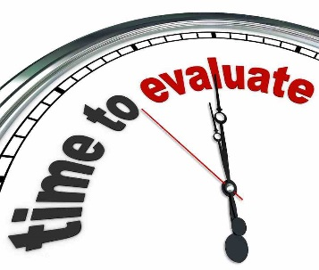

It is also important to make sure that you **evaluate** your goals as **goals change over time**. As you move towards your goals you become clearer as to what it is that you really want to achieve. Your goals will most likely need to change in shape or form to remain aligned to where you want to go in your SPORT.

**Continual evaluation** of your goals is essential to ensure you remain on path.

Qualitative, Quantitative, Objective and Subjective Information

This area relates to the type of information generated by data collection.

* Qualitative Data

This relates to someone's thoughts, feelings and observations. It is non-numeric information which is very much based on someone's opinion.

* Quantitative Data

This is information that can be directly measured and can be seen as factual information rather than opinion. The information collected is number based and provides hard facts.

Where possible a combination of quantitative, objective data, with some qualitative, subjective information provides a good starting point for planning performance development. This is because it gives a wide, detailed picture of the whole performance / factor.

***In order for data to be useful it must be***

* Accurate (True Reflection)
* Relevant (To Performer and Activity)
* Valid (Measures What it Should)
* Reliable (Consistent)
* Objective (Non-Bias)
* Comparative (Enables Comparison)

The Benefits of Quantitative Data and Objective Information

* The data collected is **easy to analyse**, e.g. - by performing the multi stage fitness test you can easily compare your score to the norms of people of the same age and gender to evaluate your levels of flexibility.
* **Comparing your score to standards,** e.g. - in the sit and reach test, **it makes it easier to make accurate comparisons later on.** The test conditions always remain the same and are easy to set up which makes it easier to benchmark performance and gain reliable data.
* **Easy to collect information from large groups quickly.** This means that comparisons can be made and norms established, in order to check for progress and adapt next steps if required. This means that PDP’s can start earlier, meaning there is more time available for improvement.
* **Data that is counted or measured and given a value can help set targets / development priorities**. Since these are facts it can be very motivating to see the numbers / values increase as a sign of progression, which could in turn encourage you to work harder in training to see further improvement.

Explaining Why You Would Use Quantitative Data

* + - * **Reliable, objective information is gathered**, so it can be standardised or used for benchmarking.
      * **Provides easy to analyse data**, e.g. - range of SCAT tests to monitor the impact of positive self-talk on developing performance.
      * **Data that is counted / measured can give a value** and can help set targets / development priorities.
      * **Easy to collect information from large groups quickly**, meaning that comparisons can be made and norms established to check progress / adapt next steps if required.
      * **Tests**, e.g. - SCAT test, **are easy to administer and obtain results** **for comparison** throughout the development programme, allowing for progress to be measured easily.

The Benefits of Qualitative Data and Subjective Information

* This type of information provides a **more detailed analysis of performance**, e.g. - the teacher / coach providing feedback on your play. The performer can build a more accurate picture of their strengths and development needs and use this to create realistic goals and an accurate development plan.
* This type of data is **useful for collecting information on Emotional, Mental and Social Factors that impact on performance.** In comparison to quantitative data and objective information it can provide clearer information on human behaviour, interaction between team mates and motivation levels. When monitoring and evaluating performance, this allows you to confidently adapt your programme, or re-assess goals, as the data is more accurate and reliable.

Explaining Why You Would Use Qualitative Data

* + - * **Gives the opportunity to voice thoughts and feelings** which impact on performance, therefore a performer is able to get a better understanding about what may be hindering performance and when. Thus, relevant approaches can then be selected.
      * **Encourages self-reflection and develops a performer’s independence and problem solving abilities**. Consequently, the performer does not always need to rely on coach / teacher identifying areas of development and can therefore improve quicker.
      * **Provides in-depth information** that can be reflected upon to inform future performance.
      * **It is completed individually then has the opportunity for peer / teacher feedback** to gain a more rounded view on mental factors, allowing appropriate targets to be set.

MONITORING YOUR DEVELOPMENT PROGRAMME

*Why* is it important to monitor? - EXAM QUESTION - MUST LEARN!**!**

* To track your progress
* To check whether you have made improvements
* To check whether you have reached your targets.
* So that you can adapt / change your programme as necessary depending on whether you are on track or not.
* To provide motivation particularly when you are making progress.
* To make comparisons between past and current results.
* To set new targets and identify new development needs based on the information you now have. Monitoring will both help you close the Cycle of Analysis and restart a new cycle as you continue to develop other areas of your performance that you have identified as having a development need – no one is perfect we are all learning and improving all the time!

*How* did you monitor your progress?

* I used the data collected at the start (e.g. - Observation Schedule and Fitness Testing), as a benchmark, so that I could compare future data gained against this.
* Indicate when you re-tested (e.g. - week 4), and what methods you used in the re-tests.
* I re-tested again at the end, keeping conditions & protocols the same and then comparing all my data.
* Regular feedback from Teacher / Partner; you may indicate what types of feedback this was.

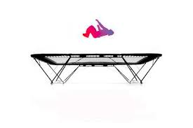

Possible Methods of Monitoring Progress / Evaluating Success

* Training Diaries
* Observation schedules / Fitness Tests, Performance Profiling Wheel, SCAT Test Video, and Coach Feedback.
* Personal Evaluation sheets.
* Video comparisons detailing differences between sessions.

Training Diary

You will keep a training diary to record and monitor your progress as you carry out your personal development plan (PDP).

Benefits of a Training Diary

* The format of the training diary offers an opportunity to clearly identify the aim of each session. This is important as it focuses planning on practices / approaches that are specific to targeted areas, leading to a greater purpose of training.
* A training diary can give an enormous amount of information about what has happened in the past and how training has gone in the past. When planning future training, information of this kind is invaluable to ensure programmes of work are appropriate and specific to development needs.
* The layout is always the same so it is easy to spot improvements / when targets are met or missed. This means that you will be able to quickly make the necessary adaptations to the PDP so that it stays specific to your needs and ensures you are continually improving.
* The Training Diary allows you to record information about all 4 factors, even the factors that you may not be currently developing. This can then allow you to identify other possible factors that may be impacting on your training in either a positive or a negative way.

Limitations of a Training Diary

However as with any method of recording & monitoring there will be drawbacks which you should consider before deciding if a Training Diary is the most appropriate method for you:

* A lot of the information contained in the Training Diary will be based on your personal opinion, such as how you felt physically, emotionally, socially & mentally. Since Mental, Social and Emotional recording will be easily influenced by your mood / emotions then your recordings will vary depending on your mood and what happens during the session meaning you may not be giving a true representation of your PDP.
* You will also evaluate the success of each session and again this evaluation will be largely based on opinion, making it unreliable.
* Due to the unreliability of opinion / likelihood of bias when completing Training Diaries it can make monitoring progress difficult and you may not be building an accurate picture of your development over the course of the PDP.

You will use a training diary after every session, to monitor your progress as you developed your performance in a range of activities. Your Higher Training Diary will require lots of detail, an example entry is given on the following page:

**Example Training Diary Entry:**

*C:\Users\13599derricklaur\AppData\Local\Microsoft\Windows\Temporary Internet Files\Content.IE5\LVBGUYCL\MC900359575[1].WMF****“****…today’s training session went very well. I completed all 3 sets of exercises successfully and in a shorter time than in my first session. This would indicate that my levels of fitness are increasing and the training is effective.*

*I also spent longer on my warm up and cool down phases of the session so that I do not experience the same muscle pain in the days following training that I had in weeks 1 and 2. I am enjoying the training sessions as they are challenging but achievable (I have managed to achieve several of my short term targets that I set for each training session) so I also feel that I am able to maintain a better height consistently when on the Trampoline so I also feel that there has been a positive effect on my performance as well as my fitness. I will complete another Observation Schedule to confirm this assumption…”*

* In the above extract the performer has given lots of information about how the session for that particular day had went as well as referring back to previous sessions and how she feels she has made progress since starting her training programme.
* This sort of detail will be invaluable when completing your Training Diary in order to accurately monitor the success of your programme.
* MC900352213[1]Monitoring will be a regular feature as you work through your training programme. Daily monitoring through your training diary and regular monitoring using Feedback from spotters / teachers (which will help you complete your diary after each session) Observation Schedules and Fitness Testing.

STEPS TO ANSWER SCENARIO QUESTION

Whichever format **(graph / text / table)**is used to present the scenario, the **procedure for tackling**it should be the same.

1. Read the **entire** question, parts (a), (b), (c) etc and how **many marks** each part is worth. This will ensure you put the correct information in the correct part.

2. Establish whether the **scenario relates** to:

* ***Factors*** Impacting on Performance
* ***Methods*** of collecting information to analyse factors impacting performance.
* ***Approaches*** to performance development.
* ***Recording, monitoring and evaluating*** performance development.

3. Try to **identify what activity / activities** the ‘prompt’ could relate to.

4. Identify and highlight the **command words** used in the question. This will give you a clue about what information is required.

5. **Identify** the **named factor(s)** from the question.

6. Briefly **note down the main sub-factors / features** under each factor which you are most comfortable talking about, based on the prompt given. For example -

Dodge C.R.F Determination Fear

Consistency of Tactics Confidence Cope Under

Skills Played Pressure

8. **1 mark = Point, Example and Explanation / Impact.**

E.g. - Agility is a physical feature that may have impacted the performer positively within volleyball as a score of 9 / 10 was given to the performer’s control and fluency during the game. ***(Point)***For example, due to good agility the performer was able to move quickly to cover the full court, meaning that they were able get underneath the ball early and have time to look to the opposition’s court to see where the space was. ***(Example)*** As a result, this made it difficult for opposition to return the ball and won the team many points. ***(Explanation / Impact)*** ***(1 mark)***

**Example Scenario Question:**

1. *You are a Trampolinist and you have gathered information on your performance looking at Physical factors and one other factor from Mental, Emotional or Social. Give details of how these 2 factors have impacted on your performance. (6 marks)*
2. 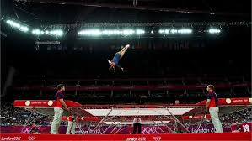*As a coach what approaches would you suggest to develop performance based on the results and impact you spoke about in the previous question? You should consider Principles of Practice/ Training and appropriate approaches you would suggest in the creation of a personal development programme.**(10 marks)*

**Appendix**

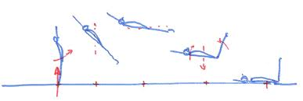

OBSERVATION SCHEDULE (TRAMPOLINING PERFORMANCE)

(Analytical Tool)

Name: ________________________ Date: ________________ Teacher: ____________________

Complete the following Observation Schedule whilst watching a video of your first Trampolining routine. Use the criteria given below the table to help you decide whether to award a tick or a cross.

|  |  |  |  |  |  |
| --- | --- | --- | --- | --- | --- |
|  | **Height** | **Control** | **Body Shape** | **Centre of Bed** | **Neatness** |
|  |  |  |  |  |  |
|  |  |  |  |  |  |
|  |  |  |  |  |  |
|  |  |  |  |  |  |
|  |  |  |  |  |  |
|  |  |  |  |  |  |
|  |  |  |  |  |  |
|  |  |  |  |  |  |
|  |  |  |  |  |  |
|  |  |  |  |  |  |

**Height** - All skills are expected to be performed at the same height at the top of the bounce. In competition marks would be deducted if a skill is **lower** than the previous skill. There is an allowance made for skills that follow landings.

**Control** - Each skill / move should show evidence of Body Tension and control. The routine should end with a single exit bounce or finish with a Kill from the last skill. This is a way of showing control to the judges.

**Body Shape** - All skills must show a definite shape: *tucked, piked, straight* (a straddle is not a shape, but a version of a pike). For example the hands should grasp below the knees when the performer is in a tucked shape.

**Centre of the Bed** - All skills should take off from the centre of the bed, movement away from the centre is called travel, the performer should stay inside the Metre Box at all times to avoid deductions.

**Neatness** - Arms and legs should be straight whenever possible, arms should be in line with the body wherever possible (in skills such as straddle this does not apply) legs should be together and toes should be pointed in flight.

The above criteria is based on the requirements of a Model Performance in Trampolining.

Using your previous knowledge and experience in Trampolining and the criteria detailed above you will be able to complete your Observation Schedule using a tick if you think the performance aspect was successful or a cross if you felt there was a problem or a weakness.

FLEXIBILITY FOR LEGS AND LOWER BACK – SIT AND REACH TEST

(Recognised Test)

Name: ________________________ Date: ________________ Teacher: ____________________

If you have identified that Body Shape or Neatness in certain skills such as Pike, Seat Landing or Back Landing is weak then you would consider testing your level of flexibility in your lower back and leg by carrying out a Sit and Reach Test.

This test requires a Sit and Reach box and an assistant.

* The athlete sits on the floor with their legs fully extended with the bottom of their bare feet against the box.
* The athlete places one hand on top of the other, slowly bends forward and reaches along the top of the ruler as far as possible holding the stretch for two seconds
* The assistant records the distance reached by the athlete’s finger tips (cm)
* The athlete performs the test three times.
* The assistant calculates and records the average of the three distances and uses this value to assess the athlete’s performance.

Score 1: ______________ Score 2: _______________ Score 3: _______________

Overall Sit & Reach Result: _______________

This means I am in the ____________________________ category for flexibility.

*The following table is for flexibility results for 16 – 19 year olds. (Davis et al. 2000)*

|  |  |  |  |  |  |
| --- | --- | --- | --- | --- | --- |
| **GENDER** | **EXCELLENT** | **ABOVE AVERAGE** | **AVERAGE** | **BELOW AVERAGE** | **POOR** |
| **MALE** | > 14cm | 14 - 11cm | 10.9 - 7cm | 6.9 - 4cm | < 4cm |
| **FEMALE** | > 15cm | 15 - 12cm | 11.9 - 7cm | 6.9 - 4cm | < 4cm |



WALL SIT TEST FOR LEG STRENGTH IN TRAMPOLINING

(Recognised Test)

Name: ________________________ Date: ________________ Teacher: ____________________

This is a simple test of lower body muscular strength and endurance.

**Purpose**: to measure the strength endurance of the lower body, particularly the quadriceps muscle group.

**Procedure**: Stand comfortably with feet approximately shoulder width apart, with your back against a smooth vertical wall. Slowly slide your back down the wall to assume a position with both your knees and hips at a 90° angle. The timing starts when one foot is lifted off the ground and is stopped when the subject cannot maintain the position and the foot is returned to the ground. After a period of rest, the other leg is tested.

**Scoring:** the total time in seconds that the position was held for each leg is recorded. The table below gives a general guideline to expected scores for a single leg for adults, based on my personal experiences. Comparing the scores for each leg may indicate muscle weakness on one side.

|  |  |  |
| --- | --- | --- |
| **Rating** | **Males (Seconds)** | **Females (Seconds)** |
| Excellent | > 100 | > 60 |
| Good | 75 - 100 | 45 - 60 |
| Average | 50 - 75 | 35 - 45 |
| Below Average | 25 - 50 | 20 - 35 |
| Very Poor | < 25 | < 20 |

**My results: _____________________ this gives me a rating of ______________________**

Advantages: This test requires minimal equipment and can be conducted with large groups all at once

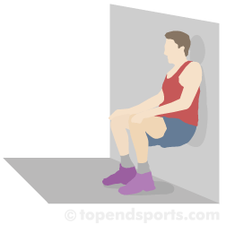

STANDING VERTICAL JUMP – EXPLOSIVE POWER IN THE LEGS

(Recognised Test)

Name: ________________________ Date: ________________ Teacher: ____________________

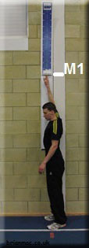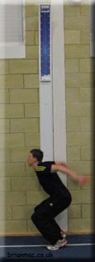**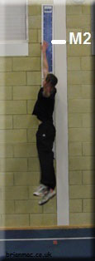Required Resources**

To undertake this test you will require:

* Wall
* Tape Measure
* Chalk

**How to Conduct the Test**

* The athlete chalks the end of his/her finger tips
* The athlete stands side onto the wall, keeping both feet remaining on the ground, reaches up as high as possible with one hand and marks the wall with the tips of the fingers (M1)
* The athlete from a static position jumps as high as possible and marks the wall with the chalk on his fingers (M2)
* The assistant measures and records the distance between M1 and M2
* The athlete repeats the test 3 times
* The assistant calculates the average of the recorded distances and uses this value to assess the athlete’s performance

Score 1: ______________ Score 2: _______________ Score 3: _______________

Overall Standing Vertical Jump Result: _____________________________

This means I am in the ____________________________ category for explosive power.

|  |  |  |  |  |  |
| --- | --- | --- | --- | --- | --- |
| **GENDER** | **EXCELLENT** | **ABOVE AVERAGE** | **AVERAGE** | **BELOW AVERAGE** | **POOR** |
| **MALE** | >65cm | 56 - 65cm | 50 - 55cm | 49 – 40cm | <40cm |
| **FEMALE** | >60cm | 51 - 60cm | 41 - 50cm | 35 – 40cm | <35cm |

*The following table is for Standing Vertical Jump results for 15 to 16 year olds (Beashel 1997)*

CORE STRENGTH & STABILITY FOR TRAMPOLINING

(Recognised Test)

Name: ________________________ Date: ________________ Teacher: ____________________

The objective of this test is to gather information on an athlete's core strength and endurance over time.

Get a partner to write in the number of seconds you complete for each stage of the test

**Conducting the Test:**

1. Start in the Plank Exercise Position (elbows on the ground) and hold _______

2. Lift your right arm off the ground and hold _______

3. Return your right arm to the ground and lift the left arm off the ground and hold _______

4. Return your left arm to the ground and lift the right leg off the ground and hold _______

5. Return your right leg to the ground and lift the left leg off the ground hold _______

6. Lift your left leg and right arm off the ground hold _______

7. Return you left leg and right arm to the ground _______

8. Lift your right leg and left arm off the ground hold _______

9. Return to the Plank Exercise Position (elbows on the ground) and hold _______

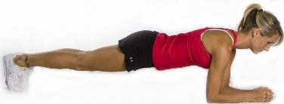My results: I can see that I have _________________ core strength

**Results**

* Good Core Strength: If you can complete the test fully without any breaks, you have good core strength.
* Poor Core Strength: If you can’t complete the test fully, regularly take breaks or collapse then your core strength needs improvement.
* Poor core strength results in unnecessary torso movement and swaying during all movements.
* This results in wasted energy. Good core strength means that the performer can move with high efficiency.
* By comparing your results over time, you will note improvements or declines in core strength.

*About the Test Design*

*Core Muscle Strength & Stability Test was designed by Brian Mackenzie , a senior athletics coach (UKA 4) with UK Athletics, the United Kingdom's National Governing body for Track and Field Athletics.*

SPORT COMPETITION ANXIETY TEST

(Recognised Test & Analytical Tool)

Assessing Your Anxiety

Read each statement below and decide if you “Rarely”, “Sometimes” or “Often” feel this way when performing in Trampolining. Tick the appropriate box to indicate your response.

1. **Before performing I feel uneasy**
2. **Before I compete I worry about performing well**
3. **When I perform I worry about making mistakes**
4. **Before I compete I am calm**
5. **Before I compete I get a queasy**
6. **Just before my performance I notice my heart beats faster than usual**
7. **Before I perform I feel relaxed**
8. **Before I perform I feel nervous**
9. **I get nervous waiting on my turn to perform**
10. **Before I compete I usually get uptight**

**My SCAT Score**

* 0 - 17 you have a low level of anxiety
* 17 to 24 you have an average level of anxiety
* 24+ you have a high level of anxiety

|  |  |  |  |  |
| --- | --- | --- | --- | --- |
| **Question Number** | **Rarely** | **Sometimes** | **Often** | **Score** |
| **1** | 1 | 2 | 3 |  |
| **2** | 1 | 2 | 3 |  |
| **3** | 1 | 2 | 3 |  |
| **4** | 3 | 2 | 1 |  |
| **5** | 1 | 2 | 3 |  |
| **6** | 1 | 2 | 3 |  |
| **7** | 3 | 2 | 1 |  |
| **8** | 1 | 2 | 3 |  |
| **9** | 1 | 2 | 3 |  |
| **10** | 1 | 2 | 3 |  |
| **Total** |  |

**Scoring Your SCAT Test**

The score for the response to each question is detailed below. Enter the score for each question in the “Score” column and then total the column up to provide a SCAT score.

PERFORMANCE PROFILING WHEEL

(Analytical Tool)

Me

Me

Me

Me

Me

Me

Model

Model

Model

Model

Model

* On a scale of zero (not at all) to 10 (extremely), the athlete rates each of the characteristics for a Model Performer in their particular sport/event by shading in the appropriate panels in one colour.
* The athlete uses the same zero to 10 scale to rate their current perception of themselves in relation to an ideal state of 10 by shading in the remaining panels in a different colour.
* A calculation is then carried out to determine the 'Discrepancy' value. The higher discrepancies indicate areas that may need to be addressed through training or other intervention.

CREATING A VOLUNTARY ROUTINE

When creating your routine you will have to consider the following in order to make sure your Voluntary routine is suitable to your abilities and gives you the best possible chance of a high score:

**Strengths & Weaknesses**: by including skills you can perform with control and fluency, into your routine, you are setting yourself up for the best chance for success. Including skills you feel confident in performing will also help you feel better about the competition and will hopefully reduce the negative Emotional factors on performance.



**Links:** you should try to include linking skills that help create fluid movement, maintain height and ensure a smooth transition from one skill to the next. The links you select should also consider the difficulty of the move before and after so that you do not lose the rhythm of your routine.

**Aesthetics of combinations:** you should strive to include a variation in height, shape, twists, somersault rotations all add to the visual impact of the routine. By mixing up these elements your routine will be challenging, exciting to watch and probably have a higher difficulty tariff than another routine that lacks this type of variation.

**Quality and refinement:** have to be considered when creating your Voluntary Routine. You should strive to make sure that your arms and legs should be straight whenever possible, arms should be close to the body wherever possible (in skills such as straddle this does not apply) legs should be together and toes should be pointed in flight. You should also allow yourself an “exit” bounce at the end of the routine which will help you maintain control of your body, and make sure you stand still at the end, so that the judges can clearly see you have completed your routine.

**Scoring**

There will be judges who mark the “Form” of your routine, by deducting marks for poor performance. Each skill in a routine is given a starting mark of one point (so the full routine is worth a maximum of 10 points). Form judges deduct from 0.0 to 0.5 from the base mark of each skill, depending on the number of errors in that skill.

In your Voluntary routine one more judge marks the difficulty of the routine or “Tariff”. The judge will calculate the difficulty of your routine and this score is added to your total from the Form judges to give you your overall score.

The tariff of a skill is assessed according to the amount of twist

/ and or somersault rotation there is in each skill.

* For every ½ twist (180°) 0.1 is awarded.
* For every ¼ somersault (rotation of the body, not legs so seat landings do not count as a ¼ rotation) 0.1 is awarded.
* Return to feet from Front or Back Landing ( ¼ turn) will be awarded another 0.1
* Complete somersaults (360°) are given 0.5
* Somersaults which are performed in the straight or piked shape also gain an additional 0.1
* Difficulty marks are only awarded for each **different** skill in a routine; if a skill is repeated, then no difficulty mark is awarded.

COMPOSITION OF VOLUNTARY TRAMPOLINING ROUTINE

As part of your practical assessment in Trampolining you will you will perform a Compulsory (set) routine and a Voluntary routine (which you will create yourself with help from your teacher) for the judges.

The Compulsory routine you will use in your practical assessment is the same as is used for the BSGA Open Schools Competitions:

1. 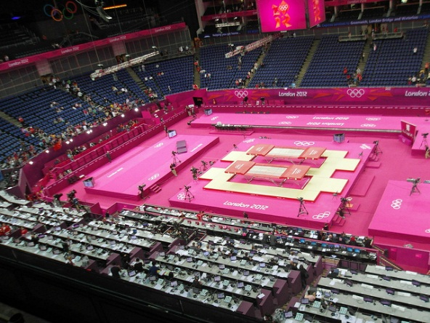**Full twist jump**
2. **Straddle jump**
3. **Seat drop**
4. **Half turn to seat**
5. **Half turn to feet**
6. **Pike jump**
7. **Back landing**
8. **Half turn to feet**
9. **Tuck jump**
10. **Front SS (Tucked)**

Each routine will have 10 bounces or actions, the Compulsory routine will be the same for everyone in the assessment, however in the Voluntary routine you have a chance to be creative and play to your strengths by making up your own 10 bounce routine.

There are rules to follow when you make up your Voluntary routine, as well as taking into account skills you can perform well, you must follow the guidelines set out by the governing body.

A Trampolining Routine comprises ten consecutive actions, an ‘action' being defined as any move, other than a straight jump, between taking off from the trampoline, and the next landing back on it. It is essential, therefore, to remember and to count any follow-on action which might be implied; e.g. a Front Drop will always require a following action, usually "To Feet". When preparing routines, this follow-on will be counted as one of the ten actions. A straight jump is not considered to be an action, and must not appear within a routine. The last action must end on the feet; body landings can’t, therefore, be used as the 10th action.

**N.B**. The term ‘Swivel Hips', often written as a single action by pupils, does in fact imply three actions:

1. Seat landing
2. Half Twist to Seat Landing
3. Return to feet.

Care must be taken to ensure that your chosen combination of actions is safe, as a poorly-performed action could lead to dangerous problems. For example, the link of Back Drop, Half Twist to Feet, Front drop could be dangerous if the Half Twist to Feet is under-rotated.

Hands-and-Knees landings are **NOT** suitable to be included into your routine.

