St Andrew’s HS
Physical Education Dept

HIGHER
NETBALL
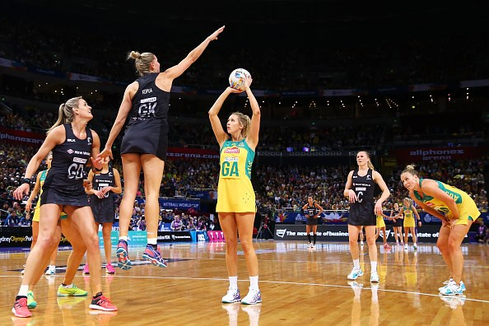

PHYSICAL FACTORS
Fitness - CRE & Agility
Skills

MENTAL FACTORS
Level of Arousal
Decision Making

Contents

Code of Conduct Page 3
Mandatory Knowledge for Exam Page 4
Command Words Page 5-9
Cycle of Analysis Page 10
Factors Impacting Performance Page 11
Homework Questions Page 12
Netball Court and Positions Page 13
Physical Factors Impacting Performance Page 14-15
Methods of Data Collection for Physical Factors Page 16-18
Qualitative, Quantitative, Objective & Subjective Information Page 19-20
Approaches to Develop Physical (Fitness) Factors Page 21-23
Approaches to Develop Physical (Skill) Factors Page 24-26
Principles of Training (SPORT FIT) Page 27-28
Goal Setting Page 29-30
Monitoring and Evaluating Page 31-32
Re-Prioritisation of PDP / Adaptations & Changes to a PDP Page 33
Mental Factors Impacting Performance Page 34-37
Factors Impacting Performance Development Page 38
Factors Impacting Upon Other Factors Page 39
Methods of Data Collection for Mental Factors Page 40-41
Approaches to Develop Mental Factors Page 42-46
Monitoring Performance / Programme (Mental Factors) Page 47
The Use of a Training Diary to Monitor & Evaluate Page 48
Difficulties / Problems when Monitoring and Evaluating Page 49
Feedback Page 50-51
Stages of Learning Page 52
Model Performance Page 53-58
Steps to Answer Scenario Questions Page 59

Appendix Page 60-67
Observation Schedule Pg. 61
Multi-Stage Fitness Test Pg. 62
Illinois Agility Test Pg. 63
Mental Toughness Questionnaire Pg. 64-66
Decision Making Grid Pg. 67
Higher Code of Conduct

The Higher course is made up of two internally assessed One Off Performances and an external exam -
2 practical assessments and 1 written

ALL ASSESSMENTS MUST BE PASSED AT HIGHER STANDARD IN ORDER FOR YOU TO BE PRESENTED AT HIGHER LEVEL.

Final results are made up from -
50% - 2 One Off Practical Performances in two different activities
50% - SQA Written Examination (Lasting 2 hours and 30 minutes)

The following are a list of rules which must be adhered to within the Higher class -
- Effort and hardworking attitude must be shown at all times.

- Always attend class with PE kit and appropriate theory materials.

- All homework must be completed properly and on time.
  - Failing to complete homework will result in no participation in practical.
  - Using “I don’t understand the homework” is not acceptable for missing deadlines - your teacher is always available for any questions.
  - Failing to complete homework twice will result in a letter being sent home.

- Appropriate behaviour must be shown at all times.
  - Failing to behave appropriately will result in no participation in practical or detention.
  - Failing to behave properly twice will result in a letter being sent home.

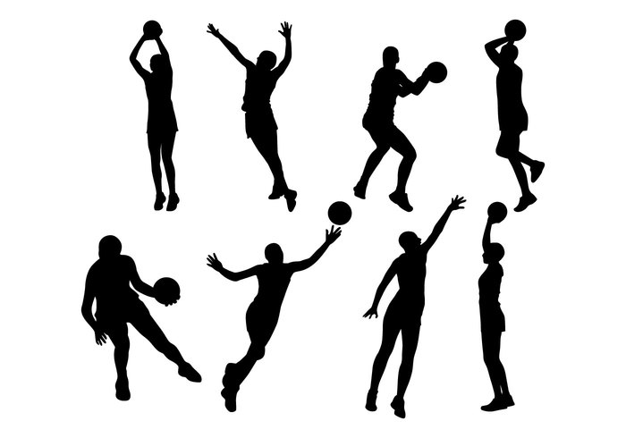

MANDATORY KNOWLEDGE FOR EXAM

- Impact of Mental, Emotional, Social & Physical (MEPS) factors on performance in a variety of activities and on the performance development process.
- Able to name the four main factors impacting on performance and relevant features under each factor.
- Able to give the positive and negative impacts of MEPS factors on performance and performance development in a variety of activities, including individual and team performances.
- Can give the potential impact of one factor upon others(s) during performance and the performance development process.
- Able to give the subsequent impact, both positive and negative, of all four factors on performance at the completion of a PDP.

- Methods to collect information on MEPS factors (Minimum of 2 per factor)
  - Use of model performance
  - Application of recognised tests or analytical tools (Data Collection Methods)
  - Appropriateness of methods for collecting data
  - Feedback

- Key Planning Information
  - Principles of Training (SPORT FIT)
  - Principles of Effective Practice (SMARTER)
  - Selecting Appropriate Approaches to Develop Performance
  - Performance Development Goals / Target Setting
  - Interpretation of Qualitative and Quantitative Information

- Performance Development Process
  - Approaches to develop performance on MEPS factors (Minimum of 2 per factor)
  - Production and implementation of Personal Development Plans (PDP) over a minimum of three sessions for at least two different factors.

- Recording, Monitoring and Evaluating Performance Development
  - Methods, tests or tools used to record, monitor and evaluate
  - Reasons Why We Record, Monitor & Evaluate during performance development
  - Adapting performance development plans
  - Evaluation of the performance development process
  - Future performance development planning

Command Words
DESCRIBE
‘Paint a picture’ of what you see or do!!
Describe all details and characteristics, giving details on -
WHAT, WHERE, WHO WITH & HOW
- What exactly did you do?
- How is it organised / laid out?
- What does it look like?
- Who is involved?
Make no assumptions!! Give specific details!!

EXPLAIN
- Requires you to give reasons or meaning to situations or actions.
Think - ‘So What?’
- Makes something clear. E.g. - Why do you use this? Why did it happen?
E.g. - Cause & Effect.
- Follow a PEE paragraph. (Point, Example & Explanation / Impact)
- Try to use the following linking phrases in your answers -
Because… / this allowed… / to ensure that… / which meant… / so that…

ANALYSE
- Requires you to break down information into smaller parts for closer study. E.g. - Explain, explain and explain further!!
- May involve you thinking about some of the following aspects -
- Layout / Format
- Specialist Equipment
- Environment
- Expertise
- Analysis can be positive and negative.
- Structure for analysis will take the form of -
- Identify (Make a point)
- Explain / Implication
- Impact
- Try to use the following linking phrases in your answers -
As a result… / this meant that… / this allowed for… / this resulted in…

EVALUATE
- Requires you to make judgements which should be backed up with evidence to prove your judgement.
- Structure for evaluation will take the form of -
- Judgement (Make a point)
- Evidence to Support Judgement
- Impact
- Evidence can come from qualitative (opinions, feedback, personal experience, questionnaires etc) or quantitative sources (fitness tests, observation schedules, facts & figures etc).
- Evaluating means using phrases like:
Good / Bad / Really useful / Not Effective / Very Worthwhile / Boring

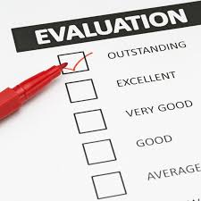

Describe Questions

When answering a Describe question you should always give DETAILS and DESCRIPTIVE POINTS.

You are NOT being asked to give reasons why!!

You will build a picture in the mind of the marker, by giving details on -

WHAT, WHERE, WHO WITH & HOW
- What exactly did you do?
- Where did it take place? Indoors / Outdoors?
- Who did you play against? What was their ability like in comparison to yours?
- How long did you train / play for?
- What did it look like? The sheet? The drill?
- How was it completed?
- What equipment did you use?
- How was everything set up?
- What did you do with results?

1 Descriptive point = 1 mark in a Describe Question

Read this model answer worth 4 marks…

Describe how you gathered data on Physical factors using an analytical tool. (4 marks)

[I played a 7 v 7 game of Netball, for 30 minutes, against opponents of similar ability.]¹ A knowledgeable observer completed my Observation Schedule (O.S) specific to Netball while we played. [The O.S had a table with different skills listed across the top row: Passing, Shooting, Dodge and Rebounds etc.]² [Down the left hand side there was time periods listed: 0 - 5mins, 6 - 10mins, 11 - 15 mins etc.]³
The [observer would place a tick or a cross under the appropriate skill and time period depending on whether or not a skill was successful or unsuccessful. For example a chest pass received a tick when it was passed strong and accurately towards my teammate, this meant is was a successful pass.]⁴

Success Tips for Describing
- You need to give SPECIFIC details!!
- Your answer should help the marker picture exactly what you are talking about, if they can’t see it in their head, they can’t give you a mark.
- No vague statements!!
- Never give reasons why, as this information will be worth nothing in a Describe Question.

Explain Questions

When you are tackling an Explain question you will be looking to give reasons why you have done something or why something has happened.
You might also be asked to talk about “cause and effect”. An example of this could be when a Netball player is distracted by the noise of the crowd, they miss being able to catch the ball and lose possession for their team.
The noise of the crowd is the “cause” and missing being able to catch the ball and losing possession is the “effect”.
To access marks in your Explain answers you will make a POINT, provide an EXAMPLE, and then give the EXPLANATION / IMPACT. (PEE Paragraph) You will link these together using LINKING PHRASES.
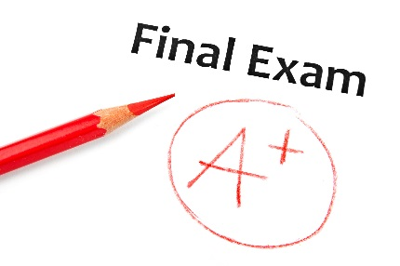
These phrases will lead you into your explanation and force you to give information on impact…which the SQA are looking for in your answers. Examples of linking phrases are:
- “because…”
- “this allowed…”
- “as a result of this…”
- “to ensure that…”
- “which meant that…”

Read this model answer worth 4 marks…

Bold = Point Italics = Impact Underlined = Linking phrase
Explain why your chosen method(s) of data collection are appropriate. (4 marks)
I collected this data during pre-season as this allowed me to collect baseline data to enable appropriate targets to be set. (1 mark)
I completed this method before leaving the dressing room, this allowed me to complete the process in private meaning I was not distracted and could reduce the possibility of errors. (1 mark)
I carried out this method online, meaning that the information was instantly compared to national norms, helping me to set appropriate targets. (1 mark)
As it was completed straightaway it meant that I did not forget any information and therefore the results were more reliable and could be used to set relevant targets. (1 mark)

Success Tips for Explaining
- You need to make a POINT then use a LINKING PHRASE to give the IMPACT
- You will need to be able to identify cause and effect, e.g. - when this happens, what effect does it have?

Evaluate Questions

The key to success when answering this command word is to make sure that you structure your answer correctly.

When you are Evaluating you are giving YOUR OWN OPINION on something, it can be positive or negative, but you have to give a statement of JUDGEMENT.

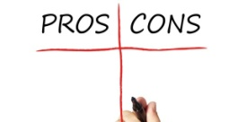
You then have to back up this judgement with evidence to prove your judgement and then give the impact on training or performance.

Structure your Evaluate Answer by including the following information:

- Judgement - You need to use a word that shows you have made a judgement. The language you would
use could be - useful, effective, unsuccessful, helpful, good, bad etc.

- Back It Up! - You will need to back up your judgement, you can’t give an opinion without backing it up,
so start to explain why this is your opinion. This can come from qualitative (opinions,
feedback, personal experience, questionnaires etc) or quantitative sources (fitness tests,
observation schedules, facts & figures etc)

- Impact - You would then use one of your linking phrases to lead you into giving details of the impact
caused by what you are evaluating. You should give a clear, specific example with details. Do not be vague here!!

You will need ALL of this information to access 1 mark when you are answering an Evaluate question.
So for a four mark answer you would need to give four paragraphs, structured with all the above information, to achieve that number of marks.

Read this model answer, worth 1 mark…
Evaluate how effective one method was in gathering data on the Physical factor. (4 marks)
- A method I used to gather data on the Physical factor was the multi stage fitness test (Bleep Test). This method was fairly effective. One benefit of the Bleep Test was that it was easy to interpret my results. (Judgement)
- This was because all I had to do was compare my score to the NORMS and easily identify what NORM my score was in. (Evidence)
- This was helpful as it led to me easily identifying if my CRE levels were a strength or a weakness in my performance, so that I could set up a developmentally appropriate training programme, using relevant approaches, at the correct intensities for me to improve. (Impact)
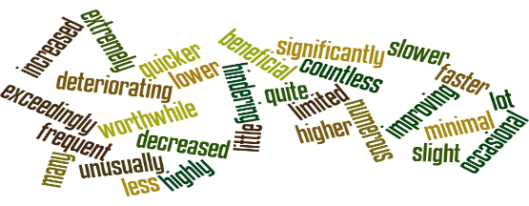

Success Tips for Evaluating
- You will need to know positives and negatives of the method / approach / analytical tool / recognised test etc.
- You should draw on your personal experience of using different methods / approaches etc as this will make the evaluation easier to complete.
- Always follow the three point structure, e.g. - Judgement, Evidence & Impact
- Use your linking phrases!! E.g. -
“This means that…”, “as a result of this..”, “this allowed me to…” etc
Analyse Questions

When you are asked an Analyse question you are being asked to break something down into smaller parts to then look at each part and explain its importance. Your analysis answer can include both positives and negatives.

One of the main tools for success in Analyse questions will be your structure. A well structured answer will stop you writing too much and prevent you from losing your train of thought!!
Firstly you should look at the number of marks available and see if you can break down the subject you are being asked about into that number of parts, e.g. - if it is a four mark answer on a training diary, then you should be looking to break the training diary down into four different parts that will form the basis for each of your paragraphs.

Structure for your Analyse answers will take this form:

- Identify - This is where you will state what part you will talk about in your analysis.

- Explain - You will talk about why the part is important, it can be either a positive or a negative and you will
use your linking phrases to help you to give a detailed explanation. Remember to explain & explain further!

- Impact - Here you can give details of how the part has impacted on training, performance, data collection etc.

Read this model answer worth 2 marks… Italics = part Underlined = Linking phrase

Analyse the impact social factors can have on each of the other 3 factors during a performance. (4 marks)
Impact of Social Factor (Gender Issues) on Physical Factor (Strength)
In Netball, a girl in a mixed team might not be passed to each time she is free, due to her male team mates thinking she lacks skills. This would cause problems as the rest of the team would need to work harder in attack to keep running and create spaces / passing options, which makes them tire more quickly, resulting in their skill level dropping as the game goes on. (1 mark)

Impact of Social Factor (Cooperation) on Physical Factor (Tactics)
In Netball cooperating with my team can impact positively on our tactics as I understand my role as WA within my team. If I run ahead of the ball, close to the semi-circle, I can receive the ball as I am a passing option for the ball carrier, which can result in us scoring a goal as I am able to quickly pass to the shooter before the defenders can get into position. (1 mark)
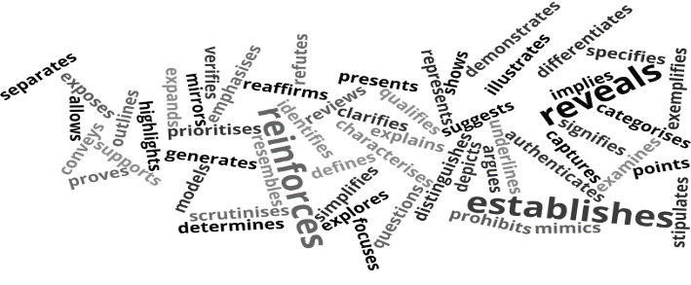

Success tips for Analysing
- You need to break down what you are going to talk about into the number of parts required for the marks available in the question.
- Your structure should always follow: Identify, Explain (Implication) & Impact!!
- Use your linking phrases, as this will help you give detailed explanations in your impact!! E.g. -
“This means that…”, “as a result of this..”, “this allowed me to…”, “ this resulted...” etc
- Explain, explain, explain!!!
Cycle of Analysis

In order to develop your performance in any activity in your Physical Education course, you must follow and carry out a Cycle of Analysis. This is demonstrated in the diagram below -

1. Collecting Information

This is where you gain information about your performance. This could include completing an observation schedule, questionnaire or carrying out a recognised fitness test.

2. Analysing Data

This is where you will analyse and interpret the data that you have collected to identify your performance strengths and weaknesses, and specifically where the problem / weakness occurs.

3. Applying Knowledge

At this stage of the cycle you will use the information you have collected to create a training programme to develop your identified weakness. This programme must be suitable / relevant to your own personal development needs.

4. Practice

You will then carry out your training programme to develop your identified weakness(es). The aim in this part of the cycle is to bridge the gap between practice and the demands of performing in that activity.

5. Monitoring & Evaluating

As you work through your training programme you will monitor its effectiveness to see if the programme is actually working. Consequently, you may need to adapt your programme if it is not having a positive effect on your performance. Finally, after completion of your training programme you will evaluate its success, and from there you will identify any future development needs within your performance.
Factors Impacting Performance
PHYSICAL
(TACTICAL)
Space
Time
Overload
Depth
Width
Delay
Positioning
Creativity

PHYSICAL
(SKILLS)
Netball:
- Chest Pass
- Shoulder Pass
- Dodge
- Rebounds
- Landings (Footwork) etc

Volleyball:
- Volley
- Dig
- Overarm Serve
- Spike etc

Trampolining:
- Front Somersault
- Swivel Hips
- Back Landing
- Straddle Jump etc
PHYSICAL
(FITNESS)
C.R.E
Agility
Power
Core Stability
Speed
Muscular Endurance
Flexibility
Strength
Balance
- Static
- Dynamic

Factors and Features
Impacting on Performance

MENTAL
Focus / Concentration
Motivation
Decision Making
Level of Arousal

SOCIAL
Cooperation
Communication
Teamwork
Roles / Responsibilities
Enjoyment
Respect
Fair Play
Team Dynamics
Gender Issues

EMOTIONAL
Confidence
Fear
Controlling Anger
Resilience
Desire
Controlling Anxiety OR
Cope Under Pressure

Homework Questions

PHYSICAL FACTORS IN NETBALL

- Describe the impact of physical factors on performance. (4 marks)
- Explain the positive and negative impact of physical factors on performance. (4 marks)
- (a) Describe an analytical tool or recognised test you have used to gather data on a physical factors. (4 marks)
(b) Explain why the method chosen in part (a) was appropriate to gather data on physical factors. (4 marks)
- (a) Describe two approaches that can be used to develop physical factors in your performance. (6 marks)
(b) Evaluate the use of the two approaches chosen in part (a) to develop physical factors. (6 marks)
- Describe how the Principles of Training were applied to your Personal Development Plan. (6 marks)
- (a) Identify a short term and long term goal for physical factors. (2 marks)
(b) Explain why you set these goals. (2 marks)
- Evaluate the effectiveness of your Personal Development Plan. (4 marks)
- Describe how you monitored performance development when working through your PDP. (4 marks)
- Analyse the method(s) you used to monitor your progress when carrying out your PDP. (4 marks)
- Explain why it is important to monitor / review performance when working through a PDP. (4 marks)
- (a) Describe the adaptations / changes that may need to be made to a PDP for physical factors. (4 marks)
(b) Explain why the adaptations / changes described in part (a) might be necessary. (4 marks)
- Analyse the effective of the changes to your PDP on your level of motivation. (4 marks)
- Describe your strengths and development needs in comparison to a model performer. (4 marks)
- Explain possible future development needs within physical factors which impact on performance. (4 marks)

MENTAL FACTORS IN NETBALL

- Describe the impact of mental factors on performance. (4 marks)
- Explain the positive and negative impact of mental factors on performance. (4 marks)
- (a) Describe two different analytical tools you have used to gather data on mental factors. (4 marks)
(b) Explain the benefits and limitations of using the methods chosen in part (a) to gather data. (4 marks)
- (a) Describe two approaches that can be used to develop mental factors. (6 marks)
(b) Evaluate the use of one approach described in part (a) to develop mental factors. (4 marks)
- Describe how you applied the Principles of Effective Practice to a PDP to develop mental factors. (6 marks)
- Describe one short term goal and one long term goal for mental factors. (2 marks)
- Explain three considerations a performer will have when setting goals to develop mental factors. (6 marks)
- Explain the impact any improvements in mental factors can have on performance development. (4 marks)
- (a) Identify one way you have monitored the effectiveness of your plan to develop mental factors. (1 mark)
(b) Explain why you have chosen this method of monitoring. (4 marks)
- Explain the difficulties that may arise when monitoring mental factors in your performance. (4 marks)
- Evaluate the effectiveness of your Personal Development Plan to improve mental factors. (4 marks)
- Explain four reasons why a performer may re-prioritise the focus of their PDP for mental factors. (4 marks)
- Evaluate your mental strengths and development needs in comparison to a model performer. (4 marks)
- Explain possible future development needs within mental factors which impact on performance. (4 marks)

Netball Court and Positions

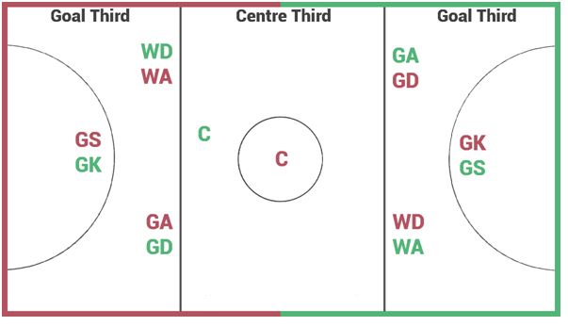

Court Positions

Court Positions | Boundaries on Court & Main Responsibilities
GK (Goal Keeper) | Responsible for the goal third. Their job is to work with the GD and prevent the GA / GS from scoring.
GD (Goal Defence) | Responsible for the goal third and centre third. Their role is to mark the GA by defending the ball and trying to not let the GA shoot.
WD (Wing Defence) | Responsible for the centre third and goal third, but not in the goal circle. Their job is to look for interceptions and prevent the WA from feeding the ball into the circle.
C (Centre) | Allowed everywhere apart from the two goal circles on court. Their role is to take the centre pass and to link the defence and attacking phases of play.
WA (Wing Attack) | Responsible for the centre third and goal third, but not in the goal circle. Their job is to feed the ball into the goal circle to the GA or GS.
GA (Goal Attack) | Responsible for the goal third and centre third. Their job is to feed and work with the GS, by creating space / assisting with the shooting.
GS (Goal Shooter) | Responsible for the goal third. Their main role is to work in and around the goal circle with the GA, in an attempt to score goals.

Factors Impacting Performance
Physical Factors (Fitness)
1. Cardio Respiratory Endurance (CRE)

CRE is the ability of the heart & lungs to supply oxygen to the working muscles for a long period of time.

This helps in Netball in the following ways:

- Ability to keep a consistent skill level throughout the game, e.g. - passing still remains strong and accurate towards the end of the game. This increases the team’s chances of retaining possession in an attempt to score.
- Ability to sustain effective movement to all areas of the court when attacking and defending throughout the game, e.g. - still able to drive into space for the ball towards the end of the game. Provides more passing options and prevents teammate from getting pulled for held ball.
- Ability to stay focused and concentrated throughout the game, e.g. - still able to read opponent’s tactics at centre passes. Therefore, able to adapt play in an attempt to intercept the ball and win back possession.
- Ability to choose the correct options, at the correct time, throughout the game. (Fewer wrong decisions are taken due to tiredness). E.g. - Always playing the ball to a teammate in space, instead of to one behind a defender. Thus, team able to move the ball up the court more successfully in an attempt to score.
- Your level of arousal remains consistent throughout the game, e.g. - even towards the end of the game the player still remains motivated to drive into a space to re-offer for the ball. Therefore, team are able to provide multiple passing options, which makes it harder for the opposition to defend and in turn prevents interceptions.
- Judgement of the ball’s flight path is better, especially later in the game. Therefore, successful interceptions can still be made, as the player is still able to time correctly when to move in for the ball. Thus, team have more opportunities to move the ball down the court to score.
- Ability to recover quickly after passages of attacking and defensive plays throughout the full game. E.g.- Helps the player to get back into position quickly before the next centre pass, so that they can mark their opposition and increase their chances of winning the interception in an attempt to move the ball down to score.

2. Agility
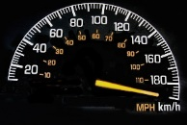
Agility is the ability to change speed and direction quickly while still maintaining balance and control.

In Netball this is important in the following ways:

Good Agility when Attacking Enables the Following -

- Ability to change speed and direction quickly so you can dodge successfully to get away from your opponent into a space on the court. Therefore, able to move the ball down the court more successfully.
- As netball is a fast-paced game, with many quick changes of direction, having good agility means you are able to stop, turn and run in a new direction as quickly as possible in order to provide a passing option to your teammates. Therefore, prevents team getting pulled for held ball.
- Quick movements around the court may allow you to take the ball early out of the air which gives you a greater choice of passing options, as you may be able to release / pass the ball before your opponent is able to pressure you. Therefore, less mistakes are made and allows your team to move the ball more successfully down the court.
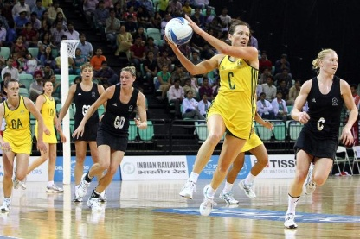
- Gives you more time to prepare as able to move into the space quickly, therefore more accurate and consistent passes / shots. As a result, prevents interceptions and allows team to retain possession.

Good Agility when Defending Enables the Following -

- To be able to keep up / stay with your opponent when defending. Therefore, increases player’s ability to win interceptions and win back possession for team.
- Helpful if you intercept the ball because you need to be able to land, pivot and then throw a ball to one of your teammates before moving into a new space to re-offer. Thus, provides more passing options and prevents team being pulled for held ball.
- To get your body / arms into position quickly to defend (3 feet away) allowing you to put pressure on your opposition’s pass / shot. Thus, opponent more likely to make a mistake which your team can then exploit.
- If opponent’s gain possession, you are able to track back down the court quickly in order to pick up your opponent. Therefore, no free player on court and makes it more difficult for the opposition to score.
Physical Factors (Skill)

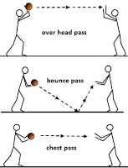
Within the game of netball, there is a range of different skills that can be used, such as passing (shoulder pass, bounce pass & chest pass), shooting, rebounding, successful landings (one footed & two footed), use of the dodge, ability to catch the ball & interceptions of the ball etc.

Passing

Within netball, there is three different types of passes -

- Chest Pass -
Used for quick, short and accurate passes to teammates who are close by.

- Bounce Pass -
Used for when the area is crowded and should only be used over a short distance. It is a good pass to teach shorter players who have trouble passing around a defender’s long arms. Can be used to trick your opponent into thinking you are going to chest pass the ball.

- Shoulder Pass -
A one handed pass used for speed and accuracy over longer distances. This pass should be aimed in front of the reciever to where they are running to. This is the pass that should be used by all players most of the time during the game.

Shooting

In the game of netball, only the GA or GS can score from within the goal circle. An effective shooting technique is when the ball is held above your head, resting on your preffered hand’s fingers and thumb and with your opposite hand placed on the side of the ball to help steady it.

Rebounding

After an unsuccessful attempt at goal, the attackers (GA / GS) and defenders (GK / GD) all
attempt to rebound the ball. This means jumping / moving to catch the ball out of the air
before your opponent’s so as to gain possession of the ball.

Landings within the Game (Footwork)
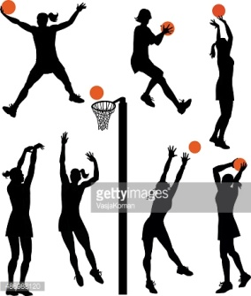
In netball, you are not allowed to move with the ball. You can either land one-footed or two- footed.

      - One - Footed Landing -
Involves one of your feet landing before the other. The foot which touches the ground first is called your ‘landing foot’. This foot cannot be moved, or if lifted off the ground, cannot be re-grounded until you have released the ball.

      - Two - Footed Landing -
This is when the player lands simultaneously on two feet at the same time. The player is then allowed to choose which foot to pivot on. Once chosen, you cannot change your landing foot until the ball has been released.

Dodge

In order to get away / stick with your opponent, you need to be able to dodge. This involves changing speed and direction quickly. There are a variety of different dodges that can be used, which will be covered during this block. In addition, a successful dodge requires the performer to do the following -

- Emphasise the drop of their shoulder
- Move fast and sharp into space at an angle
Methods of Data Collection
Physical Factors
Within Higher Netball, we will use the following methods of data collection to gather data on Physical Factors.
1. Initial Data = Observation Schedule
(Initial data looks at your whole performance within the activity)

2. Focused Data = Standardised Fitness Testing
(Focused data looks at one specific part of your performance, e.g. - CRE / Agility etc)

Describing How You Gathered Initial Data
1. Time Related Observation Schedule
(Analytical Tool)

- Where it took place and type of situation:
Was it inside or outside? Was it in the games hall, gym etc?
Full Court / Half-Court / Conditioned Game / Practice Situation, e.g. - set play or action.

- Team size:
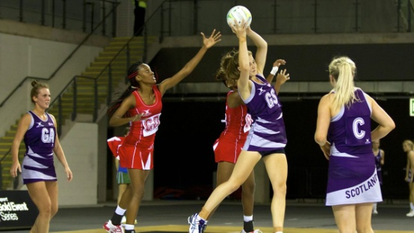
7v7, 1v1, 3v3, 2v1 etc.

- How long were you observed for?
20 minutes, 30 minutes or best of 3 games up to 21 goals?
- Who did you play?
Was it an opponent of similar ability? Why would this help?

- Was it completed live or in conjunction with video analysis?
- What did the method look like?
What was along the top of the observation schedule? What went down the side?
- What was the success criteria? E.g. - What did you write on the observation schedule?
What was a tick for and what would you get a cross for? Give an example of a successful / unsuccessful skill.

 | Passing | Catching | Interceptions | Dodge | Footwork | Shooting | Rebounds
0 - 5 mins
6 - 10 mins
11 - 15 mins
16 - 20 mins
21 - 25 mins
26 - 30 mins
% Total
Additional Comments

Explaining Why You Gathered Initial Data
Advantages of Using an Observation Schedule - (Analytical Tool)
- Allows you to identify general strengths and weaknesses which means the performer is then able to create a relevant PDP in order to improve upon their weakness, e.g. - the dodge.
- The written format provides a permanent record as completed on paper. Therefore, this allows for comparison at a later date, so you can measure any improvements in your performance / weakness.
- Can be used to compare different parts of the same performance, e.g. - first quarter compared to last quarter. Therefore, this could help pinpoint issues with fitness levels, such as CRE, so relevant approaches can then be selected in order to improve.
- Provides numerical data, as all ticks and crosses can be converted into statistics which are hard to argue with. Thus, it provides you with hard, objective evidence and therefore is more accurate than someone’s opinion, which is subjective. Thus, provides more accurate benchmark data to measure back against in the future.
- The schedule is relatively quick and easy to complete, e.g. - as a knowledgeable observer only has to tick or cross successful or unsuccessful skills. Therefore, less training time is wasted and your PDP can start more quickly in order to improve your performance faster.
- Videoing the performance means that no information is missed, as able to pause / rewind the performance. Consequently, the results are more accurate and reliable and the performer’s correct stage of learning is identified.
- Collecting data over two games reduces the element of luck or chance. Therefore this makes the data more reliable and in turn relevant approaches are then selected to improve performance.

Limitations of Using an Observation Schedule - (Analytical Tool)
- When you have someone else recording information on your performance, the validity of the results is dependent on the observer’s focus and attention during the match and the importance they place on the process. Therefore, this could result in inaccurate results and the performer working on the wrong weakness.
- If the observer lacks activity knowledge, their perception of what equals an effective skill might be different from the reality. As a result, the results may be unreliable and the wrong stage of learning is identified.
- Netball is a very fast paced sport and if you are filling out the schedule as the game takes place, you could miss shots, questioning the reliability of the findings. Thus, incorrect / unrealistic goals may be set.
- It may not give you precise information on exactly what part of a skill is the weakness resulting in more data collection having to take place. Thus, it will slow down the performer’s overall rate of development.
- A person’s mental, or emotional state could affect your results. Lack of motivation, determination etc, will affect the quality of skills, decision making etc. Consequently, results may be unreliable and result in the performer working on the incorrect weakness.
- It may not give you information on mental, emotional or social factors impacting on performance. As a result, more data collection has to take place which can be time consuming and will take time away from the performer completing their PDP. Thus, they will not develop as quickly.
- Having two full matches recorded is a time consuming process and will reduce the amount of time you have to perform your development plan. Therefore, the performer may not improve as much as they would have liked.

However, this is only INITIAL DATA!! We need more FOCUSED DATA in order to identify / confirm the data we collected from our initial method. To gain this we undertake appropriate fitness tests. E.g. - For CRE, we use the 20 metre shuttle run (Multi Stage Fitness Test).

Describing How You Gathered Focused Data
2. Standardised Fitness Testing

- The Multi Stage Fitness Test (CRE)
(Recognised Test)

Two cones are set 20 metres apart. A CD is played, where bleeps are numbered, to give the athlete a score. The athlete must run from one cone to the other before the next bleep. As the bleeps become faster, so must the pace of running, until eventually they cannot keep up. When the athlete misses two bleeps on a row, they are out. The score is then taken.
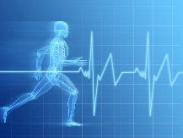
This test measures the ability of the heart and lungs to supply oxygen to the working muscles. When this process fails to keep the muscles supplied, the athlete slows down or can’t keep up. It is therefore a good indicator of the athlete’s CRE level. Your score can then be compared to other attempts, class averages and national standards.
- Illinois Agility Test (Agility)
(Recognised Test)
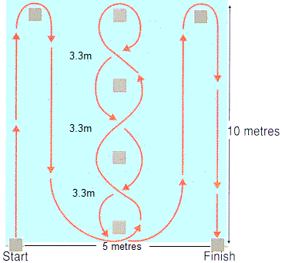
The Illinois Agility test measures your agility, using a course that requires the athlete to show speed over short distances, the ability to turn quickly and also the ability to maintain speed when changing direction.
The length of the course is 10 meters and the width (distance between the start and finish points) is 5 meters. Four cones are used to mark the start, finish and the two turning points. Another four cones are placed down the centre an equal distance apart. Each cone in the centre is spaced 3.3 meters apart. To begin the test you should lie on your front (head to the start line) and hands by your shoulders. On the command ‘go’ the stopwatch is started, and you must get up as quickly as possible and run around the course in the direction indicated, without knocking the cones over, to the finish line, at which the timing is stopped.
Advantages of Using Standardised Fitness Tests - (Recognised Test)
- The use of Standardised Fitness Tests can give you clear information about the relevant components of fitness that you are trying to measure and therefore identifies strengths and weaknesses in your fitness performance. Thus, a relevant PDP can be created to develop upon your weakness, e.g. - CRE.
- The data gathered allows us to make comparisons to other scores, norms and averages due to the test conditions being standardised. Thus, able to see how you perform in relation to others at the same age / stage.
- Can be very simple to administer and very little equipment required. Therefore, the test can be completed quickly and can result in the performer being able to start training promptly in order to improve performance.
- They only measure one factor, e.g. - CRE, so detailed information can be gathered on that factor. As a result, able to specifically see when / if this factor impacts on your performance, so relevant approaches can then be selected.
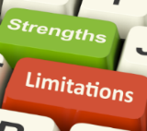
- Backs up the initial data collected, and allows for realistic targets to be set. Fitness testing can also be used for monitoring progress during a fitness training programme, gauging when adaptations to training are necessary and to evaluate any improvements at the end of the plan.

Limitations of Using Standardised Fitness Tests - (Recognised Test)
- The validity of the results can be affected as some tests do not take into account outside influences and it is also difficult to isolate a specific factor. E.g. - Mental, Emotional or Social factors may still influence performance. Therefore, incorrect approaches could end up being selected when trying to develop performance.
- Tests are not game specific, so the reliability of the results can be affected as tests are performed outwith the activity. Thus, may not be a true reflection of how you actually perform in a game and therefore unrealistic goals may then be set.
- The reliability of results can also be affected if there is poor preparation prior to test, or the timing of the test can affect results. E.g. - No warm up, after big lunch, or day after a big game. Thus, wrong stage of learning may be identified.
- Practicability can be an issue as sometimes specialist equipment is required. This could affect how often the performer is able to complete the test, as it may be difficult to monitor progress in the future, as do not have access to the equipment, which makes it difficult to see progress in training.
- It is sometimes difficult to recreate the same conditions and standards, causing results to be skewed. Therefore, in the future a performer may believe that they are improving when they are not.
Qualitative, Quantitative, Objective and Subjective Information

This area relates to the type of information generated by data collection.

- Qualitative Data

This relates to someone's thoughts, feelings and observations. It is non-numeric information which is very much based on someone's opinion.

- Quantitative Data

This is information that can be directly measured and can be seen as factual information rather than opinion. The information collected is number based and provides hard facts.

Where possible a combination of quantitative, objective data, with some qualitative, subjective information provides a good starting point for planning performance development. This is because it gives a wide, detailed picture of the whole performance / factor.

In order for data to be useful it must be
- Accurate (True Reflection)
- Relevant (To Performer and Activity)
- Valid (Measures What it Should)
- Reliable (Consistent)
- Objective (Non-Bias)
- Comparative (Enables Comparison)

The Benefits of Quantitative Data and Objective Information

- The data collected is easy to analyse, e.g. - by performing the multi stage fitness test you can easily compare your score to the norms of people of the same age and gender to evaluate your levels of CRE.
- Comparing your score to standards, e.g. - in the Illinois agility test, it makes it easier to make accurate comparisons later on. The test conditions always remain the same and are easy to set up which makes it easier to benchmark performance and gain reliable data.
- Easy to collect information from large groups quickly. This means that comparisons can be made and norms established, in order to check for progress and adapt next steps if required. This means that PDP’s can start earlier, meaning there is more time available for improvement.
- Data that is counted or measured and given a value can help set targets / development priorities. Since these are facts it can be very motivating to see the numbers / values increase as a sign of progression, which could in turn encourage you to work harder in training to see further improvement.

Explaining Why You Would Use Quantitative Data

      - Reliable, objective information is gathered, so it can be standardised or used for benchmarking.
      - Provides easy to analyse data, e.g. - range of decision making grids to monitor the impact of positive self-talk on developing performance.
      - Data that is counted / measured can give a value and can help set targets / development priorities.
      - Easy to collect information from large groups quickly, meaning that comparisons can be made and norms established to check progress / adapt next steps if required.
      - Tests, e.g. - mental toughness questionnaire, are easy to administer and obtain results for comparison throughout the development programme, allowing for progress to be measured easily.

The Benefits of Qualitative Data and Subjective Information

- This type of information provides a more detailed analysis of performance, e.g. - the teacher / coach providing feedback on your play. The performer can build a more accurate picture of their strengths and development needs and use this to create realistic goals and an accurate development plan.
- This type of data is useful for collecting information on Emotional, Mental and Social Factors that impact on performance. In comparison to quantitative data and objective information it can provide clearer information on human behaviour, interaction between team mates and motivation levels. When monitoring and evaluating performance, this allows you to confidently adapt your programme, or re-assess goals, as the data is more accurate and reliable.

Explaining Why You Would Use Qualitative Data

      - Gives the opportunity to voice thoughts and feelings which impact on performance, therefore a performer is able to get a better understanding about what may be hindering performance and when. Thus, relevant approaches can then be selected.
      - Encourages self-reflection and develops a performer’s independence and problem solving abilities. Consequently, the performer does not always need to rely on coach / teacher identifying areas of development and can therefore improve quicker.
      - Provides in-depth information that can be reflected upon to inform future performance.
      - It is completed individually then has the opportunity for peer / teacher feedback to gain a more rounded view on mental factors, allowing appropriate targets to be set.

Approaches to Develop Physical (Fitness) Factors
The following approaches can be used to develop physical (fitness) factors, in your performance.
Continuous Training
Fartlek Training
Agility Training
Game Related Training

1. Continuous Training

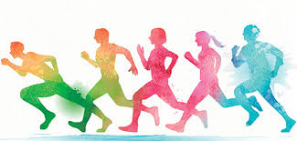
This is a very useful approach to improve CRE. This includes any form of exercise (e.g. - running, swimming or cycling) that ensures that the heart rate is operating in your training zone for approximately 20 to 30 minutes. The activity must be non-stop and there are no rest periods, until the training session is completed. Training must be progressively overloaded through intensity (how hard you train), frequency (how often you train) or duration (how long you train for) regularly to ensure your fitness is always improving.

Advantages of Continuous Training
- Ideal for developing CRE, as you are working for a longer period of time, and therefore at medium pace to stay within your training zone. Therefore, able to have a positive impact on developing CRE, which in turn will aid performance within a netball game.
- There is no real need for expensive specialist equipment, as the training can be tailored to the specific activity. Therefore, it helps the performer to replicate similar movements that are required within a netball game.
- Easy to plan as most exercises are simple to replicate and perform. Therefore, more time can be spent developing performance, which in turn will allow the performer to improve faster.
- You can work on your own and don’t need to rely on anyone else being present. Thus, able to train whenever or as often as you want, helping to develop performance faster.
- It is fairly easy to monitor your progress, as you can easily compare one session with another. Consequently, able to see if training is having a positive impact and in turn helping you see if you have met the goals which you set.
- Easy to adjust workloads, by progressively overloading to ensure that your fitness levels are always improving. You can achieve this by changing the frequency, intensity or duration of a session (FID). Consequently, training is always challenging and in turn helps the performer to develop.

Disadvantages of Continuous Training
- It can become boring, as not completed in a game situation. Consequently, you may not work as hard and this will slow down your overall rate of development.
- It does very little to improve your ability to exert short bursts of speed which is needed in many sports. As a result, further approaches will need to be completed within your training which can take up more time.
- Does not improve your skill level within the game, so will not develop your overall game performance within an activity. As a result, your performance in netball will not improve without using game specific approaches.
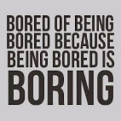
- Does not necessarily use the specific muscle groups needed within the required activity. Therefore, muscular endurance may still negatively impact performance during netball, as muscles are not prepared for game demands.

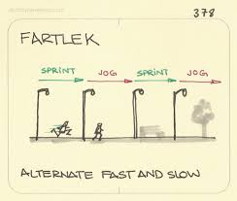
2. Fartlek Training

Fartlek Training involves different paced work, similar to what you would experience in a game.
Advantages of Fartlek Training
- It involves different paced work, similar to what you would experience in a game. Therefore by training in this way, it should help you experience similar game pressures.
- Requires no specialist equipment and can be carried out almost anywhere. Consequently, training can be completed as often as required without the worry of having to collect equipment / hire a court etc, which can speed up your rate of progression.
- Can easily be adapted to suit the individual needs of all performers. You can achieve this by adapting the frequency, intensity and duration of sessions (FID). Consequently, training is always challenging and in turn helps the performer to develop.
- You can do this on your own, without needing anyone else to be present. Thus, can train whenever or as often as you want, helping to develop performance faster.
Disadvantages of Fartlek Training
- Can sometimes be too easy for the performer to skip or put less effort in to the harder parts, as working on their own. Therefore, the performer may not develop as quickly.
- Can become boring for the performer, as not completed within a game situation. Therefore, they may give up on their PDP, which will prevent them from developing their performance within netball.
- The performer does not develop their skill level within the activity, resulting in a slower rate of development.

3. Game Related Training

Game Related Training is training using the skills and or movements of the activity. It can be adapted to be useful for any aspect of fitness and can be continuous or interval, depending on your requirements.
Advantages of Game Related Training
- It can motivate, as it can be more enjoyable than fitness approaches, and can usually allow us to work with other people. Thus, the performer is always working to their best in practices to develop performance.
- Can improve technique / skill as well as fitness. This is particularly beneficial when you have time constraints on your training, as you will develop your overall performance quicker.
- Allows us to work the same muscle groups, muscle fibres, same movements as is required in the activity. Consequently, the skills / movements will be much more automatic within the game.
- You can easily make the training specific to your own needs. As a result, training can be made harder or easier based on development, to ensure the performer is being challenged appropriately.
- Able to become more familiar with certain games phases and players. Thus, can speed up rate of progress and overall development, as working on several aspects of performance at the same time.
- It involves the same work : rest ratio as in the game. As a result, the performer is able to experience similar game like pressures / movements, so that their body is able to cope more effectively within games in the future.

Disadvantages of Game Related Training
- Fitness may not be developed due to practices breaking down due to a lack of skill in either you or your teammate’s performances. As a result, the overall rate of progression for the performer will be slower.
- Court time or finding enough players to practice may not always be easy, which could limit the amount of training getting done. Thus, may not improve as quickly as would like.
- Sessions will be tailored for the needs of the group which may be too hard / easy for you, affecting your overall rate of progress.
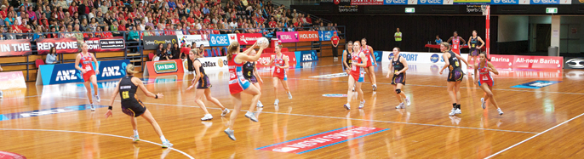
- It can be expensive to hire courts and netballs / posts regularly. Consequently, the performer may not be able to train as often as they would like in order to develop performance.

4. Agility Training

With this approach, you are improving the way your body reacts to sudden changes, by increasing your efficiency and reaction time. Your training follows a set pattern of intense cardio exercises, with a specific goal or number of repetitions. The circuit is then repeated one or several times, depending upon the exercises and your level of fitness.

Advantages of Agility Training
- Performers can increase the efficiency of certain movements and techniques required in their sport to make them better players. As a result, able to move more efficiently within games which can provide more passing options for teammates within the game.
- It can help to increase flexibility, as being able to move in an increased range of motion. Therefore, injuries are much less likely to occur.
- Ideally, your agility circuit will replicate the types of movements required of the sport in which you participate to receive the maximum benefits. Agility exercises also help to develop balance, footwork and coordination. As a result, the performer can develop multiple aspects of the game at the one time.
- Agility training within the activity, can be highly motivational, as you are working at maximum effort and can be using the equipment for your sport. Therefore this develops your skill at the same time as your agility levels.
- Training takes place in the environment of the activity and so players become more familiar with game surroundings, court lines and improving spatial awareness. Thus, helping to develop their overall performance.
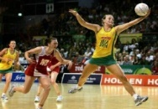
- The process also increases your mental alertness. You play better because you are more alert to the changes going on around you. If the ball suddenly heads down court, you can quickly react and provide a passing option / attempt to intercept the ball.

Disadvantages of Agility Training
- If agility training is not completed at the start of a training session when the athlete is fresh, sharp movements will not be achieved. Consequently, training will be counterproductive and bad habits may form.
- Practices which involve the performer working with teammates can be affected, unless the performers are of a similar fitness and performance standard. Subsequently, the quality and intensity of training may need to be reduced, which can slow down the development of performers as the sessions are tailored to the groups needs.
- If a performer struggles with their lefts and rights, movements will not be completed at as high intensity reducing the repetitions possible. As a result, the performer will not be able to experience similar pressures which are involved within games, preventing them from making skills more automatic.
- If combining skills and agility training together, if the drill requires complex skills and thought processes, the quality of movements may suffer as the performer’s attention is misdirected. As a result, the performer may complete practices incorrectly and in turn groove in bad habits.

Approaches to Develop Physical (Skill) Factors
The following approaches can be used to develop physical (skill) factors, in your performance.
Shadow Practice
Repetition Drills
Conditioned Game Related Training
Pressure Drills
1. Shadow Practice

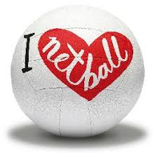
Shadow practice usually occurs at the cognitive stage of learning, but can be used at any time. It involves the performer working under no pressure to perform the requried skill. It involves a performer going through the motions of skill / shot without actually using any equipemnet, e.g. - a ball. E.g. - Think of the number of times a golfer will shadow a putt before taking a shot.
Advantages of Shadow Practice
- This approach is often used for beginners as it allows them to focus upon the movements / footwork in isolation, as there is no pressure for them of having to worry about where the ball is. As a result, they are able to ensure that they learn the technique correctly without bad habits forming.
- Allows the performer to focus on one particular aspect of the skill with precision. As a result, they are able to ensure that they learn the skill successfully / correctly, before they add further games phases / other movements.
- Allows performers to gain a feeling for the movements required to complete that particular skill. Therefore, begin to get an understanding of how to correctly perform a skill.
- It helps to build confidence before moving on to a more difficult stage, as the movements can be performed as slowly as you require. Therefore, the performer remains motivated to improve as training is challenging, but achievable.
- Immediate feedback on the action is possible in a closed environment with no external pressures. Therefore, the performer is able to correct performance / technique straight away while the feedback is still fresh in their mind.
- However, it can also be used for more experienced players who are experiencing difficulty in their technique. Consequently, they may go back to shadowing for a short time in order to develop confidence before progressing to the next stage again.

Disadvantages of Shadow Practice
- Performers at the cognitive and practice stage can find this particular type of practice boring which can result in lack of focus and attention. Therefore targets and feedback must be given regularly in order to ensure that this approach is effective in developing performance.
- If quality external feedback is not provided at this early stage of practice it can result in bad habits which are more difficult to remove at a later stage. Therefore, this can impact the development / improvement of performers.
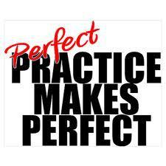

2. Repetition Drills

Repetition drills are any practices that allows you to repeat a particular skill exactly the same way over and over again. The intention is to groove the skill, or part of the skill, into muscle memory and therefore make the skill more natural and automatic. Repetition drills are used to focus on particular skills or certain parts (subroutines) of a skill.
Advantages of Repetition Drills
- The full skill can be repeated over and over again to develop muscle memory. Consequently, this makes the skill more natural and automatic and is useful for learners who are at the associative stage of learning and who are trying to improve the accuracy and consistency of a skill / action / movement.
- Used to develop a skill / action / movement with some features of the performance being focussed upon without the pressure of competition. Subsequently, a performer is able to ‘groove’ their technique without bad habits forming.
- Timing of the actions and the rest in between is controlled by the learner. This gives the performer time to receive feedback and evaluate their performance straight away when the feedback is still fresh in their mind.
- The level of difficulty can be easily controlled. E.g. - As a performer develops consistency other skills can be gradually introduced, thus developing their overall performance further.
Disadvantages of Repetition Drills
- If a feeder is inconsistent and therefore ineffective the approach will keep breaking down. Therefore, all repetitive practice is counterproductive as a performer will not get to refine movement patterns correctly and will affect their rate of development.
- Repetitive practice is only effective if constructive feedback is given regularly to prevent bad habits and poor technique. Therefore, the performer may rely heavily on other performers who are knowledgeable being present when performing in order for this to occur.
- If the equipment is of poor quality it will impact the success and motivation of the performer. As a result, this could result in them giving up and not completing the practice the way it was intended, in turn resulting in no improvements.

3. Conditioned Game Related Practices

In conditioned game related practices the normal rules of a game can be changed in order to encourage the performer to act in a certain way.

Examples of Conditions could be -

- Increase points / goals for scoring using a certain skill / technique or tactics.
- Only allowed to score using certain skill / technique or tactic.
- Must complete a particular sequence of skills / techniques before being able to score.
- Change the size of the playing area.
- Alter the number of players
- Introduce additional tasks to be able to score
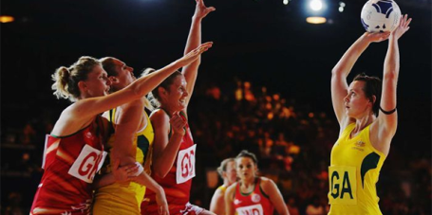

Advantages of Conditioned Game Related Practices
- Performers find this approach motivating as they get to participate in a competitive game. As a result, the performer is always working to their best which has a positive impact on performance and performance development.
- Conditions can be placed on the game that encourages the performer to change how they play / act during a game situation. Therefore, this can increase the performer’s confidence when completing this particular skill as they will have practised using it more, in turn encouraging them to use it more when in a game.
- The theme of the session is maintained in a competitive situation, therefore the performers won’t forget what they have been working on during the session when they go into a game.
- The performer can experience very similar situations to those they will face during real games. Therefore developing performance in conditioned games makes it easier to transfer this development into real games.
- Conditioned games will help to develop a range of factors over and above the focus of the session. For example, a player may be focusing on developing their rebounding and be given points for winning the ball back. This will not only help the player to develop this skill, but also their decision making, confidence, use of tactics, concentration and mental toughness. Thus, helping to develop the performer’s overall performance quicker.
Disadvantages of Conditioned Game Related Practices
- Can be easy to lose focus on what you are working on and you end up just trying to beat the opponent. Therefore, the performer will not improve their performance as much as what they have planned.
- Can become de-motivating if the practice is too difficult and you are not experiencing success. Therefore, performers may give up with their training, hindering their overall progress.
- Can develop poor decision making if you are being encouraged to perform skills or tactics at the wrong times. Therefore, performers may learn bad habits which hinders overall progress.
- If an opponent is aware of the condition then this may create a false situation, making it easier for the opponent to read what will happen and therefore will be in the right position at the right time to make it difficult for the performer to be successful. This may discourage the use of this in real games as you don’t feel it works.
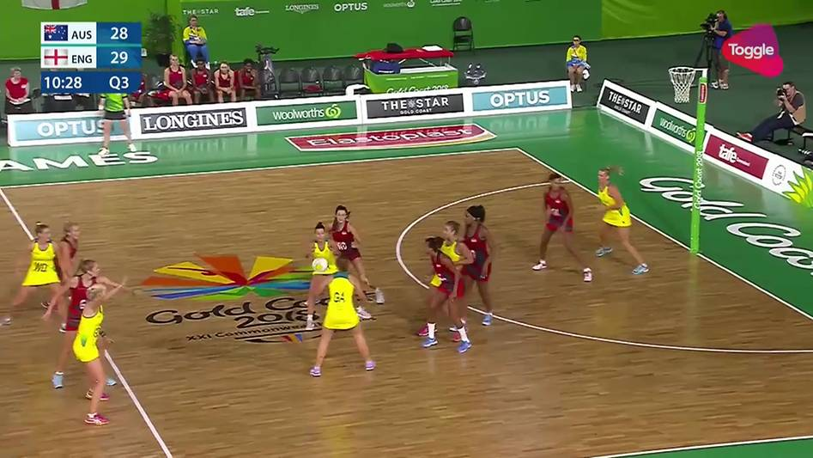
- Enough players are needed to run the conditioned games. This may be difficult to organise, and means practice time can be limited.

4. Pressure Drills

Pressure drills is an appraoch which consists of deliberately creating intensive conditions for skill practice, much more difficult than those required in the actual game. Pressure training allows a performer to experience greater pressure during training to give them the chance to learn how to use and cope with pressure effectively during conditions. You must practice pressure situations in training, so they become normal and easy to handle.
Advantages of Pressure Drills
- This approach would normally be used for performers who can perform the skill fairly well, with the skill not breaking down under pressure.
- Introduces a level of competition into the practice, making the practices more enjoyable and motivating. Therefore, performers keep motivated to continue with their training and improve their performance further.
- Helps to maintain / increase motivation as the focus required is now greater.
- Develops my reaction time or awareness as I no longer control all aspects of the practice. E.g. - when the performer takes a shot at goal. Therefore, the performer is able to experience similar game pressure, making them more prepared when playing in games in the future.
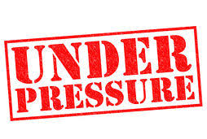
- Practices are now more realistic to the context you will actually be experiencing in the game, as the time that you have to think, plan, decide and act is the same as you would face in a competitive situation.

Disadvantages of Pressure Drills
- If pressure training continues after the skill breaks down, learners may have their confidence destroyed. Therefore, training may be counterproductive.
- Performers under mental or physical stress could get muscle tension that leads to poor technique or movement during the activity. As a result, performers may develop bad habits in their performance.
- When movements happen faster, quality decision making can become impaired. As a result, this could hinder the performer’s development.
Principles of Training
(SPORT FIT)

When creating a development programme to work on Physical (Fitness) features, the principles of training (SPORT FIT) must be applied. This will make sure that the work you undertake is suitable for you and your development needs, which in turn should ultimately develop your overall performance in netball.

How long should my programme last?
How do I make it specific to my needs?
Setting relevant short and long term targets.
How do I monitor & evaluate progress?

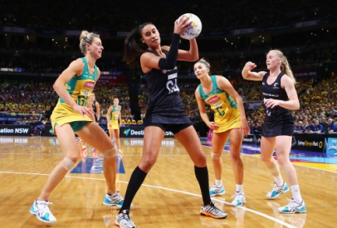
- Specificity
Specificity is the first key Principle of Training. Your training programme has to be:
- Specific to your Activity
- Specific to your own levels of fitness and ability (Stage of Learning)
- Specific to developing your weakness, e.g. - relevant approaches being selected. (E.g. - Continuous Training for CRE)

You must ensure that the factors you are working on are necessary and important to your activity. E.g. - Would a CRE programme be important to a Gymnast?

The approaches you decide to use must also be appropriate for the factor you are trying to develop. If you are trying to develop CRE, would Plyometric training be suitable?

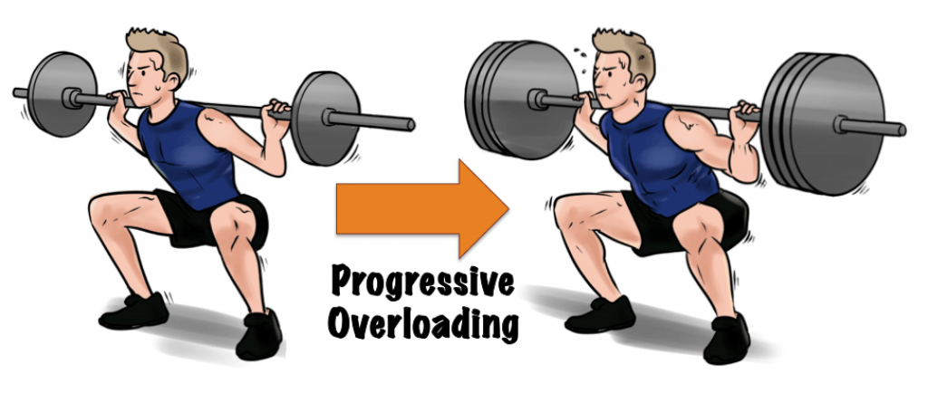
The programme must also be specific to you. You have different needs from other people, who may have different strengths and weaknesses. It is therefore important to develop a specific programme for you, with individual targets set, different from others. It is also important, especially in a team game, to consider what factors and training is important for the position you play in the team. A goal shooter will need different physical fitness and physical skill features, than a centre court player.

- Progressive Overload
This is crucial to your progress and development. This can only happen if you make your body work harder than it is used to, this is called overloading. By making your body work harder it gradually adapts to the higher workloads and your fitness level increases (progression), otherwise your fitness level will stay at the same level (plateau).
Progressive overload can be applied to your development programme by -

- Increasing the intensity, e.g. - running at a faster pace, reducing the rest time between sets etc.
- Increasing the frequency of training, e.g. - changing training from 3 times per week up to 4 times a week.
- Increasing the duration / time, e.g. - jogging for 50 minutes as opposed to 40 minutes.

However, it is important that you don’t try to progress by too much, too quickly, or you may injure yourself or over train.

Rest / Recovery Time

It is important in any programme to build in rest and recovery time. This is important not only between sessions, but also within a single training session. This will allow your muscle fibres to rebuild and recover, and also helps prevent any injuries from arising from over training.

Tedium

Training needs to be enjoyable to prevent boredom and to keep motivation levels high throughout the development programme. Using a variety of approaches will help to prevent boredom, and will help you to make sure you are trying your best, achieving the targets that you have set.

- Frequency
This is the number of training sessions you have per week. How often you train depends on the demands of the activity. Some activities require many training sessions over a period of a few months before significant improvements are seen. The number of sessions also depends on the level you are performing at. E.g. - An average performer may exercise 3-4 sessions per week for a few months to improve CRE. An elite performer may have to train every day of the week to maintain and improve their CRE.

Intensity

This is how hard you have to work in your training sessions. This varies depending on the factor you are developing. E.g. -
- For CRE, you should work between 70 and 85% of your maximum heart rate, e.g. - within your training zone (143-175bpm).
- For Agility, you should work for relatively short periods of time, and include rest periods. This gives your muscles times to recover, and will ensure you are always working effectively.

- Time /Duration
Duration is the length of each training session. Again, this varies depending on the factor you are developing. E.g. -
- Training for CRE requires a minimum of 20 minutes working within your training zone.
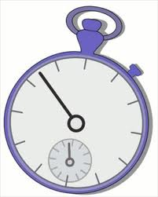
- Training for Agility, will require you to work for short intensive sessions, with rest periods in between.

- Reversibility
Fitness cannot be stored, you have to keep training in order to maintain your fitness. If you stop training your fitness levels will start to drop and in a relatively short period of time the adaptations that have taken place will be lost, e.g. - your fitness levels will be reversed.

GOAL SETTING

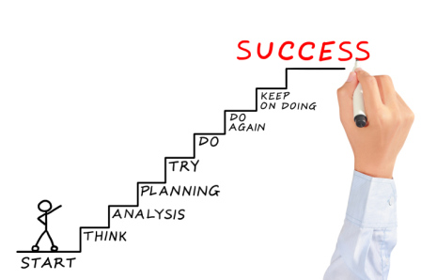
When you are planning and implementing a personal development plan, it is important to set yourself goals, as they provide direction and can be used to measure progress. Training goals can give you little steps on your way to your ultimate goal. Setting goals will help you to:
- Create a Focus for your Training
- Increase Motivation and Determination
- Prioritise and get more out of your time
- Get better results
- Monitor Progress
- Provide Valuable Feedback

Short and Long Term Goals

When goal setting, it is important that you have a clear idea of what you want to achieve. Teams and individual athletes usually set long term goals by the end of the season or year. Likewise, at the start of your personal development plan, you should have a clear idea of what you want to achieve by the end of your plan. To achieve these long term goals, you need a series of short term goals. As the performer successfully achieves each goal their motivation stays high and their CRE. For example:

Short Term Goal - To be able to last at least three full quarters within a game of netball during training, without being exhausted and having to be substituted, as you can no longer keep up with opponent.

Medium Term Goal - To show improvements within my level of CRE, by improving my multi-stage fitness test score by half a level, by week 3 of my PDP.

Long Term Goal - To improve my overall fitness and skill level, so that I can play effectively and be a key team member, as my team challenges to win a school netball tournament.

Prior to embarking on any individual programme it is essential to establish a realistic starting point. Many factors will influence this such as:
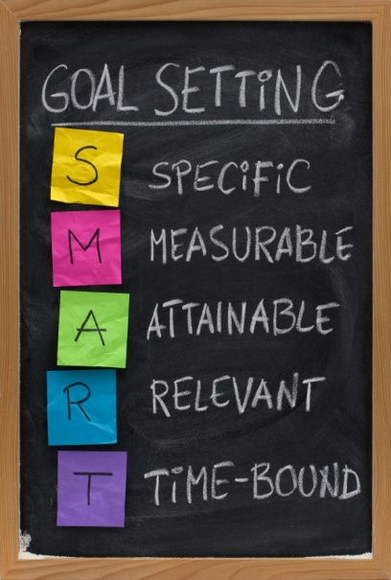
- Time available to reach target
- Previous Experience (Stage of Learning)
- Ability to monitor progress

THINK S.M.A.R.T.E.R

For goals to be effective, they should be S.M.A.R.T.E.R. This means they should be:

- SPECIFIC
Your goals should be clear and precise. They should reflect your ability and experience within your chosen activity.

- MEASUREABLE
Goals must be easily measurable so that you can assess whether or not you are improving or have been successful.

- ACHIEVEABLE
Your goals / targets should be challenging, but at the same time be within your reach, so that you have a chance of success. The ideal level for a goal to be pitched at is “challenging but achievable… with real, hard work”.

- REALISTIC
Realistic goals are more likely to be achieved and you are, therefore, more likely to stay motivated throughout your personal development plan. Setting unrealistic goals will result in a lack of success and, ultimately, in a drop in morale.

- TIME-RELATED
Your goals should be progressive. Planning short-term and medium term goals will ensure progress and help you achieve your long term goals within the time available.

- EXCITING
Make sure your goals are rewarding and enjoyable. Varying the approaches used to meet the goals will maintain motivation and prevent you becoming bored. When you enjoy a practice / training you are far more likely to see improvements and see the relevance of that practice.

- REGULAR
Practice sessions should be scheduled for a few times per week to allow you to consolidate your skill learning, and so that what you learned in previous sessions is still fresh in your mind.

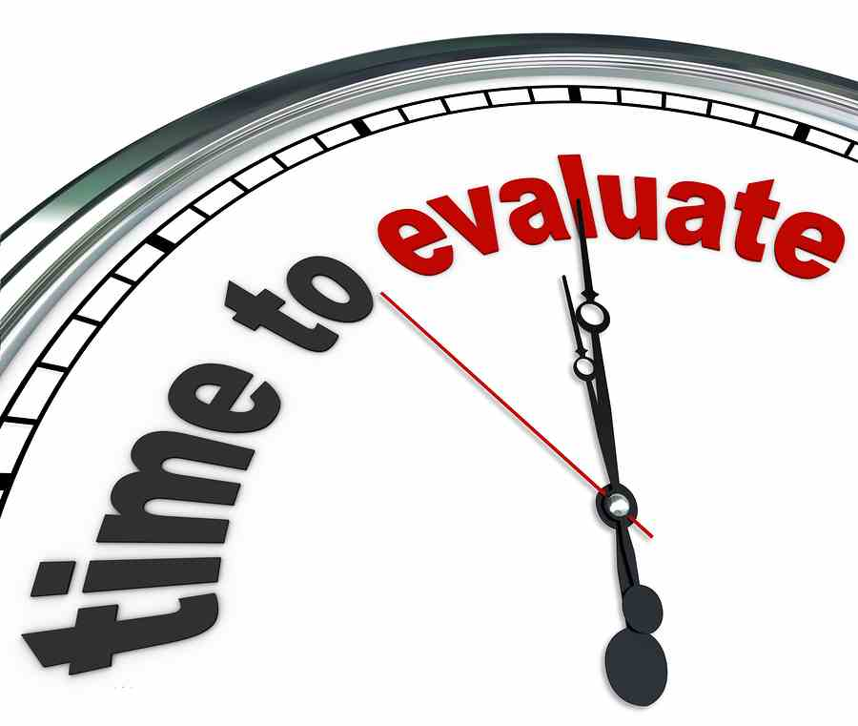

It is also important to make sure that you evaluate your goals, as goals change over time. As you move towards your goals you become clearer as to what it is that you really want to achieve. Your goals will most likely need to change in shape or form, to remain aligned to where you want to go in your SPORT.

Continual evaluation of your goals is essential to ensure you remain on path.

Monitoring and Evaluating Performance

MONITORING is about systematically collecting information that will help you answer questions about your performance. You can then use this information to help you evaluate.
CHECKPOINT

EVALUATION is about using monitoring and other information you collected to make informed judgements about your performance. It is also about using the information to make changes and improvements.
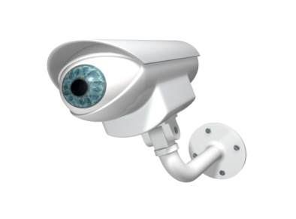

Monitoring and Evaluating Performance

When you undertake a training programme it is important to monitor and evaluate the effectiveness of your plan. This fulfils a number of important tasks. Firstly it provides a record of the progress you are making or not. This then means that your programme can be adjusted appropriately to ensure progression. Actually seeing that your skill or fitness level is improving has a motivational effect. You feel a sense of achievement and a realisation that all your hard work is paying off. This would indicate if you were achieving your short term training goals on the way to achieving your longer term goals. This ensures a freshness and excitement when training and prevents your interest from fading and your performance levels from plateauing. You are less likely to start to question the value of your training as you see results.

Possible Methods of Monitoring & Evaluating Performance

Physical Factor

- Observation Schedule
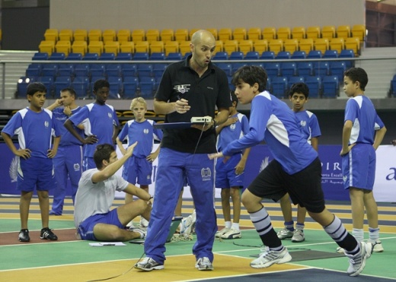
- Standardised Fitness Tests
- Training Diary

Mental Factor

- Mental Toughness Questionnaire
- Decision Making Grid
- Training Diary

Benefits of Monitoring and Evaluating

- Tracks your progress to see if the training programme is working / having the desired effect on developing your weakness.
- It can be motivational when you see improvements in your performance, e.g. - noticing more positive comments in your training diary. Therefore, you want to continue to work hard to improve further.
- Allows for changes / adaptations to be made depending on your progress / lack of progress. For example, as you get better you can make training harder. Consequently, your performance continues to develop.
- Allows you to see whether you have achieved your training targets / goals, allowing you to then reset them and make new goals for further performance development in the future.
- Provides regular feedback on how the training is progressing and how your level of fitness has improved, especially when you compare past and current results.
- To allow you to make comparisons in your most recent and final performances against your initial one, to see whether your programme was successful or not.
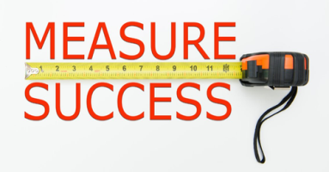
- Can set the way forward / next steps in your new training targets / goals. Consequently, you can then work on these weak areas in your performance.

How Do I Monitor My Progress?
- Use the data collected before you started your training programme as a benchmark (Observation Schedule, Standardised Fitness Tests etc), so that you can compare future data against this. Thus, you can measure progress.
- You will set short, medium and long term targets for your development programme, indicating what you would hope to achieve at certain points, e.g. - by week 3 improve your level of CRE by 10%.
- Re-test at regular intervals, e.g. - every 3 weeks, under identical circumstances, then again at the end of the training programme, comparing all the data.
- You can receive regular feedback (verbal, visual, knowledge of results etc) from teacher / peers, to keep you informed of your progress. You must indicate what type of feedback was given, e.g. - verbal / written etc and who / how this feedback was provided.
- Throughout the programme, it is advisable to keep a training diary. This allows you to see what you can do from one session to the next, and from week to week. By looking at my workloads, I could clearly see if I was progressing, and it made it easier to plan future sessions. I also made a note of how I felt after each session.

Describing How You Monitor Progress?
You must be able to describe how you would use these methods to monitor your training. How often would it be completed, how would you carry it out, etc.

- Observation Schedule

- When was the method completed? - For the second time halfway through your PDP
- What conditions did you complete this in? - Exact same conditions as week 1, e.g. - teams / game length
- What did you write down / record?
- What did you then do with all the information - Compare to first O.S to measure improvements
- Training Diary

- When was the method completed? - At the end of every training session
- Who completed the method? - Completed on your own in a quiet space
- What did you write down? - Wrote down what I did that session, how I felt, next steps etc
- What did you then do with all the information - Compare to previous entries to measure progress

Reasons Why A Performer May Re-Prioritise the Focus of a PDP

It is important that during the monitoring and evaluating process that you adapt your development programme, when necessary, so that you are always improving. You made re-prioritise your PDP due to -

- Boredom of Using Same Approaches
- Training Partner / Teammates holding you back as not progressed as quickly as you
- Training was becoming too easy / too hard
- Found a new weakness from monitoring that is now more of a priority
- Injury May Have Occurred
- Developed Quicker than you Expected
- Not Specific to Your Development Needs / Stage of Learning
- De-Motivated
- Undisciplined

Describing Adaptations / Changes to a PDP (Physical Factors)

- One change I made when developing physical factors in my performance in netball is to increase the frequency of training sessions as I got better. For example, in week 3 of my PDP I changed the frequency of my training sessions from three times a week to four times a week. (1 mark)

- A second change that I made when developing physical factors in netball was to change the approaches that I was using. For example, in week 2 I changed the approach that I was using to repetition drills instead of shadow practice when developing my dodge. (1 mark)

- A third change that I made when developing physical factors in netball was that I changed the peers that I was working with. For example, half way through my PDP I changed my teammates / groups as I got better to ensure that I am always still working with people of similar ability as me. (1 mark)

- A fourth change that I made when developing physical factors in netball was to decrease the duration of my training sessions from 90 minutes to 60 minutes. (1 mark)

Explaining Why Adaptations / Changes Were Necessary to PDP (Physical Factors)

- I would choose to increase the frequency of my training sessions in week three to ensure that my performance keeps developing. For example, as my performance improves I need to increase the frequency of training so that I can challenge myself further and prevent my performance levels from plateuing. (1 mark)

- I would change the approaches that I am using from shadow to repetition drills so that I can now focus on developing the technique of my dodge in more game like circumstances, e.g. - through the use of adding in a ball and defenders. This will allow me to develop my dodge further and ensure I improve upon my stage of learning. (1 mark)

- The reason I would change the groups that I am working with half way through my PDP is so that I am always working with people of similar ability. For example, I may have progressed quicker than some of my classmates, so by changing the groups it means that I am always being challenged and having to perform at my best. Consequently, this will ensure that I stay motivated and prevent bad habits from arising in my performance. (1 mark)

- I would change the duration of my training sessions as due to injury I had to take time out of my training which meant it slowed down my rate of progression. Decreasing the duration of the sessions as I started to come back to training meant it did not cause further injury or boredom, as the training was challenging, but still within my reach of achieving success. (1 mark)

Factors Impacting Performance
Mental Factors

1. Level of Arousal

Level of arousal in netball may be described as how motivated or complacent you are about the game you are about to play or actually playing.
The correct level of arousal allows you remain focused and determined for the full game, producing your best performance, no matter the situation you are in during the game. (Well up, well down, lost or won a run of goals, received a poor umpiring decision etc.) You are therefore more likely to make correct decisions and perform to a higher standard.
Having too high a level of arousal may produce an aggressive, over attacking impatient style of play, which may not be the correct tactics against a particular opponent. It can also result in you being in-disciplined and being pulled up often for contact and / or obstruction, resulting in a penalty / free pass to the opposition team.
Conversely having a low level of arousal can lead to a casual style of play, where you move late in to a space and where your passes are often sloppy and inaccurate. This can occur if you are playing an opponent who is too good for your standard (“I’m never going to beat her”) or a team you have beaten easily in the past. (“I’ll beat them easily anyway”).

Optimum Level of Arousal
The level of arousal required for different sports significantly varies along with how athletes get themselves to this mental state. Think of Usain Bolt as he embraces the crowd and jokes about on the start line and the New Zealand rugby team as they perform the Hakka. If you took this high level of arousal to another sport, such as the gymnastics beam or rifle shooting, you can see the problems that this will cause to the performer, where a calm mind, relaxed muscles and steady breathing are required.

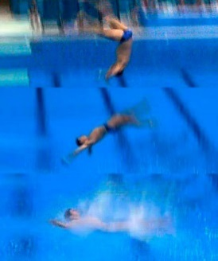
Think of the ‘Catastrophic’ Effect of Over Arousal -
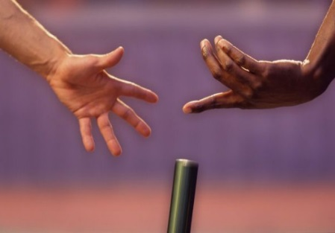

German Diver, London Olympics Dropping the baton

If a Performer is Under / Over Aroused - Watch the Cracks appear!!!!!
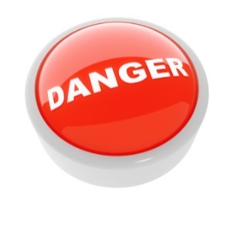
- Errors due to nerves getting the better of you
- Lack of drive to succeed
- Blame culture rather than reflect on self
- Dwell on the past and errors rather than the future
- Anger (Focus on Mistakes)
- Impossible to goal set
- Anxiety dominates play (Observed in Mannerisms and Body Language)
- Concentration deteriorates
- Fatigue (Negative Thoughts)

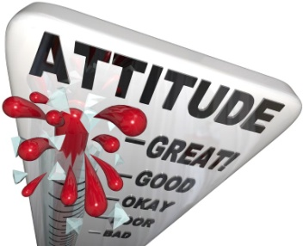
Level of Arousal is impacted by:
- Criticism
- Recovery from injury
- Mistakes
- Crowd Pressure
- Anxiety
- Excitement
- Dips in form
- Intimidation by opponents

How does being able to control your level of arousal impact positively on your performance?
In netball being able to control your level of arousal and get it to the right level gets you prepared to do your best. The performer can shut out distractions and make the right decisions throughout the game on which pass to play and where best to move to. They have confidence in their performance and are less likely to choke under pressure. They are able to read and react to the cues of their opponent’s, in order to intercept passes successfully, helping to regain possession for their team. They use their experience to shake off any issues in their performance, to re-group very quickly. For example, if a player plays two unsuccessful passes in a row, they quickly focus on past performances and maintain concentration and correct the issue immediately and never dwell on the fault.

2. Decision Making

‘Decision making is an action or process of choosing a preferred option or court of action at the right time from a set of alternatives. It forms the basis of all deliberate and voluntary behaviour’.

Quality decision making is a critical skill in sports. The quality of your decisions has a massive impact on your results.

For example Concentration Level of Arousal Decision Making Capabilities

The more developed a performer’s information processing system, the better adept they are at responding to cues, sorting information, and drawing on past experiences, which results in instant decisions. Anticipation is linked to the decision making process and players must learn to “read” a situation early to establish what things are unimportant, less important and very important. This helps an athlete to predict what might happen next and to think one step ahead of their opponent and the game. This means they can plan ahead.

For Effective decisions we make use of

SENSES PAST EXPERIENCE OUR ABILITY TO “READ” WHAT NEXT

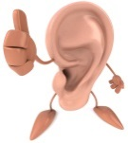

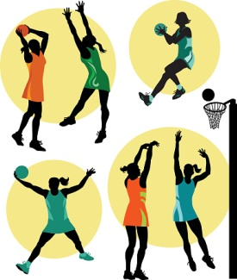
In netball there are lots of factors which may influence the choice of pass you select at any time or where you choose to move to during a game. These may be:-
- Your own position on the court.

- Your opponent’s position on court. (Make it difficult for them)

- The passes you have previously played in that game. (Try not to be predictable)

- Tactics you may wish to employ. (Make the most of your strengths and exploit opponent’s weaknesses)

Experience in situations as well as our ability to perceive and process information, therefore ‘read’ opponents, will help us make correct decisions, even when under pressure.

How Does Good Decision Making Positively Impact on Performance?
Good strategic play (decisions) is rooted in a solid skill and fitness base which can allow the player to be:
    - Able to play the required pass at the precise moment in order to play the ball successfully to your holding / moving teammate. Consequently, the defender is unable to intercept the ball and your team retain possession.

    - Able to move into or play the ball into an awkward area for your opponent. This may be evident by seeing your opponent under pressure, wrong footed or struggling to get their body in to position to defend, as they have less time to react and think. Consequently, increases chances of errors and could result in you being able to win the ball back.

    - Good decision making reduces errors in play, as players respond effectively to cues in the game to make the correct judgements and are also able to ignore possible distractions. For example, recognise when your teammate signals with their hand forward that you should pass the ball in front to their fingertips. Thus, able to run onto the ball and decreases chances of making a foot fault.

    - Decisions are more spontaneous, without conscious thought, as a player has strong belief in their ability. Thus, able to move the ball down the court quicker and prevents opposition from being able to get into position to defend.

    - Players are able to adapt their game plan if they see that it is not working. Consequently, good decisions also play to your team’s strengths, as well as attempting to exploit your opponent’s weaknesses.

How Does Poor Decision Making Impact Negatively on Performance?
- Choosing the wrong pass to your teammate for the position you are in / where your opponent is standing. Consequently, the defender is able to intercept the ball and gives opponent’s a goal scoring opportunity.

- Recall of past experiences limited impacting decisions and judgments in a "live performance". Thus, performer could continue to make the same mistakes and lose possession for their team.

- Poor attention selection (Focusing on what is not important) Consequently, more errors occur.

- Inability to read the game and solve problems. For example, unable to read phases of play, such as centre passes, and opponent’s are continually able to use the same tactics without you winning it back.

- Miss vital cues in the game which would direct attention, impacting anticipation. Thus, you may mis-time when to move in for the ball to intercept, resulting in you contacting opponent and penalty pass given.

- Frequent, repetitive mistakes such as continually moving into the same space on the court as teammates. Consequently, less passing options available and teammate will get pulled for held ball, gifting possession back to the opposition.

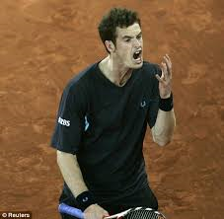
- Confusion from brain overload. Decision not instinctive, delayed as it takes longer to process information. Consequently, easier for opponent’s to mark you and put pressure on team and increases their chances of winning back possession.

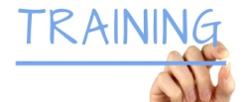
Factors Impacting Performance Development

Mental Factors
- The ability to concentrate during training can impact positively on performance development, as I am able to focus on the feedback given to me by my partner about the weak areas of my dodge. Consequently, I am then able to take this advice on board and put all of my efforts into improving this weaker area in my next set to improve my dodge in netball.
- Being able to concentrate in training also helps me focus on ensuring I can work on the technique of landing on two feet in netball, as I am able to block out all the distractions of others talking. Thus, I can then carry out the approach correctly and in turn improve my ability to land correctly in netball.
- If I am highly motivated during training, I will really want to achieve my goals meaning I will give my all in training and will even do extra outside the training ground to help me improve my further.
- Being mentally tough can help you during the final set of sprints during interval training. This means that even though you are tired, and you want to give up, you push through the tiredness and lactic acid to complete this final set so that you continue to develop during training.
Emotional Factors
- Failing to control my anger can impact my performance development. If I were to get frustrated at my teammates for “mucking around” during sessions, it can lead to me shouting at them and arguments breaking out which can lead to us not focusing during training and therefore not developing.
- Failing to control my levels of fear can also impact my performance development. If I was working with peers that I did not get on with, I may be hesitant about practising my interceptions, as I am scared that I accidentally bump into the player if I mis-time my movements. Consequently, I am unable to practice this skill in training and therefore do not improve.
- Sadness can also impact my training performances. When my coach told us she was leaving, my teammates and I were upset meaning we were not fully focused or motivated during the session meaning we did not carry out approaches correctly and we hardly developed our weaknesses.
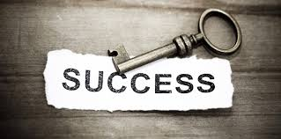
- Finally, the level of trust I have in my teammates could impact my performance development. When working on developing centre passes, I did not trust that one of the weaker players would be able to catch the ball without being pulled for footwork. Therefore, I did not follow the “planned” certain pass, which then resulted in my team not practising a variety of different options in training, which could impact us negatively within games in the future.
Social Factors
- Co-operation can impact performance development. Being co-operative during a repetition practice in netball can help me improve in training because you can provide feeds to your partner and give them feedback on their strengths and areas for development.
- Relationships is another factor that could impact performance development. Having poor relationships with a teammate can mean that you do not respect their opinion and are therefore unwilling to listen to their feedback meaning you could lose one source of improvement.
- Finally, team dynamics can impact performance development. Being part of a team that has high team dynamics means they will support and encourage you when you fail to reach a goal to help you bounce back in your next training session.
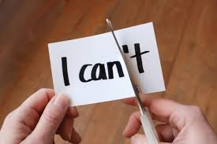
- Poor communication meant that when I was playing small sided games, the first player didn’t know who to pass to because no one called for the ball, so the game kept breaking down and there was no improvement during the training session.
Physical Factors
- Poor CRE affected my performance development, as towards the end of the training session, fatigue set in. Consequently, my technique started to be affected as I no longer performed the skills as they should be, resulting in me developing bad habits and thus slowing down my rate of progression.
- Agility impacted my performance development negatively as I was unable to change speed and direction quickly in order to get free from the semi-active defender during training to be able to catch the ball and practice my footwork. Consequently, I was unable to develop.
- Being unable to effectively pass the ball during training affected performance development. For example, my teammate often did not have enough power in her pass for it to reach where it was supposed to go in the repetition drill. Consequently, I was unable to practice taking the ball out of the air early and meant I did not improve this aspect within this training session.
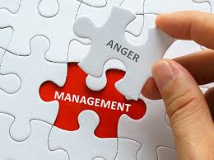
Factors Impacting Upon Other Factors

Impact of Emotional Factors Upon Physical Factors
- The emotional factor anger had a negative impact on my physical factors during my performance development. For example, in netball whenever my teammate made a mistake in training or in a game, I got angry that they kept giving the ball away. This meant that my skill level started to drop and my passes became inaccurate and less powerful due to a drop in focus which made it difficult for my teammates to catch, which lost us several goals. (1 mark)

- Failing to control my anger (emotional) can link to a drop in my teammates CRE levels (physical) in netball. This means that if my team were losing and I then got so angry that I kept contacting my opponent. This then resulted in a penalty pass for the other team and meant my teammates had to work harder to cover the free player on the court which would then tire them out quicker and could lead to us conceding easy goals later in the game as they were too tired to keep up with their player. (1 mark)

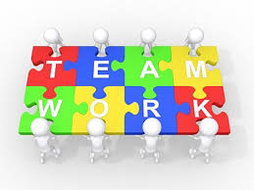
- Determination had a positive impact on physical factors during performance development. For example, when learning the technique of how to successfully dodge in netball I was unable to perform it successfully initially. However, due to my good levels of determination it meant that I did not give up and instead kept working hard, going through the progressions of this skill until I could perform it successfully. Consequently, resulted in more passing options for my team as more players are now free and in a space to receive the ball during a game. (1 mark)

Impact of Emotional Factors Upon Social Factors
- Having a lack of confidence (emotional) can link to relationships breaking down (social) in netball. This means that by not believing in your abilities, you may not show for passes when your teammate is being closed down when in possession. This can then lead to your teammate falling out with you and criticising you for not helping them which can lead to arguments breaking out on court and your team then making silly mistakes and losing possession. (1 mark)

Impact of Social Factors Upon Mental Factors
- Failing to trust your teammates (emotional) can link to inappropriate decisions being (mental) made in netball. This means that if you do not rate your teammate and do not trust them to catch the ball successfully despite them being in a good space, you ignore them and pass to a teammate who is being tracked closely by the opposition. This then leads to the ball being intercepted and gives the opponents another goal scoring opportunity. (1 mark)

- Poor communication (social) can have a negative impact on my level of concentration (mental) during netball. For example, as GK, if I do not communicate with my teammates when defending which could result in my teammates losing focus at key moments and therefore losing the opponent they are marking. Consequently, this could result in the GA being able to get closer to the post and increases their chances of scoring.

Impact of Mental Factors Upon Physical Factors
- Decision making is a mental feature that can impact positively on the development of physical factors during netball. For example, due to good decision making the performer is able to read different cues from their teammates, such as when they are running forwards with their arms extended they pass to space as opposed to body. As a result, the player is able to develop their footwork within a game as they can practice moving on to the ball and then releasing to a teammate, helping to move the ball up the court more successfully. (1 mark)

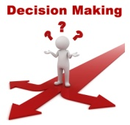
- Motivation is a mental feature that can impact positively on the development of physical factors during netball. For example, if the performer does not successfully manage to score after the first couple of times trying during training, due to good levels of motivation they keep working hard to learn the correct technique / progressions of shooting until they can successfully shoot. As a result, the player is able to successfully develop their performance and in turn improve their shooting ability, which will increase their team’s chances of scoring in games in the future. (1 mark)

Methods of Data Collection
Mental Factors
Within Higher Netball, we will focus on the following methods of data collection to gather data on Mental Factors.
1. Initial Data = Mental Toughness Questionnaire (MTQ)
(Initial data looks at your whole performance within the activity)

2. Focused Data = Decision Making Grid
(Focused data looks at one specific part of your performance, e.g. - Decision Making.

1. Mental Toughness Questionnaire
(Analytical Tool)

The MTQ is used to collect information on the mental factors that impact on performance in netball. The questionnaire is in a paper format and has 36 questions which are split into six different sections, as detailed below:

1. Reboundability 2. Handling Pressure 3. Concentration
4. Motivation 5. Level of Arousal 6. Decision Making

For each section you answer the questions, as either true or false, in relation to your mental toughness. After completing the questionnaire you use the marking scheme to calculate your overall score. A score of 30-36 indicates strength in overall mental toughness, scores of 24-29 indicates average to moderate skill in mental toughness and scores of 23 or below mean that you need to start putting more time into the mental training area.

Advantages of using a Mental Toughness Questionnaire - (Analytical Tool)
- The written format provides a permanent record as completed on paper. Therefore, this allows for comparison at a later date to measure any improvements in your performance / weakness.
- Focuses a performer’s attention on the mental factors impacting performance, which otherwise might have been forgotten. Consequently, mental strengths and weaknesses can be identified from the questionnaire which future performance development programmes and goal setting can be based upon.
- Gives the opportunity to voice thoughts and feelings (subjective) which could impact performance. Encourages self-reflection and develops a performer’s independence and problem solving abilities.
- Everyone in the class is answering the same questions. This reduces bias and increases the validity and reliability of the results because the performers are not being influenced by an interviewer.
- The performer is gaining lots of information on their mental state. The more information they have on their performance the more accurate and valid the results.
- A coach / teacher / performer can get large quantities of information about mental factors in a relatively short period of time. Subsquently, strengths and more importantly weaknesses can be identified quickly and addressed through an appropriate development programme and monitoring process.
Limitations of using a Mental Toughness Questionnaire - (Analytical Tool)
- The information which is being collected is based on a performer’s perception of their mental performance. Subsequently, this could impact on the validity of the results, as it could be a bias assessment.
- It depends on the importance a performer places on the process. If a performer doesn’t take the process seriously this will impact on the validity of the results.
- Results could be inaccurate if a performer misinterprets the questions. Therefore you may end up creating inappropriate goals to develop performance, which can hinder development.
- Application and focus is very dependent on the circumstances of the performer and the environment the data is collected in. Their knowledge will also impact the validity of the results.
- It can take a long period of time to collect and analyse the results. Therefore, time is taken away from performance development, resulting in a slower rate of development.
- The questions being asked are only closed questions. A lack of open ended questioning means that the performer’s answers lack explanation, which could impact on the accuracy of the results.
2. Decision Making Grid
(Analytical Tool)

Gathering Information on Decision Making
The decision making grid may be completed by a teacher, coach or informed observer while you play a game. It allows information to be collected about your decision making, when in possession of the ball.
The person watching your performance must place a tally mark, in the appropriate box for each pass that you make. At the end of the game, the tally marks are counted and converted into a success rate percentage.

Advantages of using a Decision Making Grid - (Analytical Tool)
- Decision making strengths and weaknesses can be identified from pass selection and court position. This will inform future performance development programmes and goal setting.
- By playing in a competitive match against a team of equal ability you are forced to play to your full range of skills, adding to the validity of the findings, as the pressurised situation can highlight consistency.
- Having an observer provides objective feedback which is non-bias providing more accurate results.
- Objective feedback by a person with activity knowledge ensures validity and reliability of the results to create a detailed analysis of performance.
- The written format provides a permanent record as completed on paper that allows for comparison at a later date to measure progress in your performance / decision making.

The Limitations of using a Decision Making Grid - (Analytical Tool)
- When you have someone else recording information on performance, the validity of the results are dependent on the observers focus and attention during the match and the importance they place on the process. Therefore, data can be unreliable and incorrect strengths and weaknesses identified.
- Netball is a very fast paced sport and there is likely to be a number of passes in a short space of time. This can make it impossible for one observer to record all passes played. When they take their eye off the game to complete the grid, shots are missed, questioning the reliability of the findings.
- If the opposition is not of a similar ability this will provide false results and a performer might not be forced to play their full range of passes if insufficient pressure is applied. Therefore, the performer will have incorrect benchmark data, which will make measuring progress in the future difficult to see.
- Lack of motivation, resilience, and anxiety from a performer will impact decision making. If a performer is over tired, hungry etc this will impact their play and ultimately the results.
- The tally marks are still an opinion and it is therefore subjective data. Therefore, results may not be 100% accurate and could result in the wrong stage of learning being identified for the performer and ultimately the wrong approaches being selected.

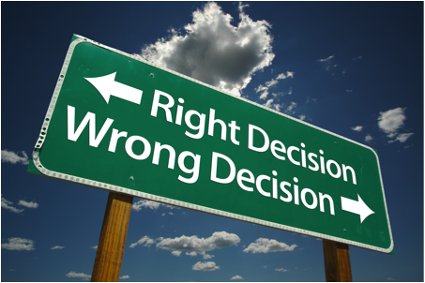

Approaches to Develop Mental Factors
The following approaches can be used to develop mental factors in your performance.
Mental Rehearsal / Visualisation
Positive Self-Talk
Relaxation / Motivation Techniques

1. Mental Rehearsal / Visualisation
This approach is proving to be an understandably popular mechanism with elite athletes eager for marginal gains. You rehearse entire sequences in your brain without moving a muscle. Every part of a skill or performance is repeated over and over again. The brain is activated when we imagine a movement. Rehearsal in your mind creates pathways in the brain cells as if executing the skill / performance, grooving the actions. Pathways are therefore already in place when a performer carries out the performance leading to confidence, self-belief and success. The use of imagery primes their muscles to perform correct technique and to execute appropriate actions in competition, but it also conditions their mind to think clearly about how they will react to certain pressures, situations and problems. Consider it a ‘mental warm-up or walk through’ of what you want to see happen. A vivid picture and strong feelings are like a magnetic attraction, so be careful of what you picture with feeling, because you will be pulled in that direction. For the novice, Mental imagery may well improve confidence, relieve anxiety and help to control arousal levels.
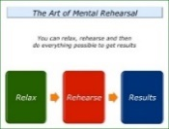
“Over the years he [Usain Bolt] has developed mental skills. I taught him to visualize and always see himself winning regardless of who he competes against. If success is in your subconscious, it is a part of you. So when you see people, you see people you are going to beat. If you are nervous, you visualize failure. If you visualize winning, you have fun…” - Glen Mills, Usain Bolt’s Coach.

When should it be carried out?
This approach should be carried out daily which focuses on different elements of the performance. Targets are set for all mental training to replicate goals during practice. Every eventuality should be visualized so that the performer is fully prepared for unpredictable situations. It is equally if not more important than the physical training.
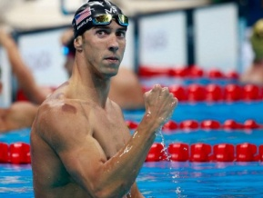
Michael Phelps swimming coach admittedly broke his goggles during training to enable the Olympic medallist to practice swimming without them, should it ever happen during competition. He was able to visualise this eventuality to mentally prepare. Ironically, it did during the 100m butterfly in the 2008 Olympics and Phelps went on to the win the race.

How to Apply Mental Rehearsal / Visualisation?
- This method is used regularly by many of the world’s best tennis players. Novak Djokovic and Andy Murray both use imagery to prepare for games. Djokovic was taught to visualise his shots to the accompaniment of classical music by his first coach.
- Murray has even been known to make several visits to a deserted Centre Court in advance of Wimbledon in order to mentally acclimatise to the environment. “I have sat on Centre Court with no one there and thought a bit about the court, the matches I have played there,” Murray said. “I want to make sure I feel as good as possible, so I have a good tournament.”
- A basketball player will use imagery in a free through situation and close their eyes visualizing successful execution. (Mechanics, flight of the ball, sound of the swoosh etc)
- A cyclist will rehearse their race knowing where all the uphill sections of the course are, where he or she plans to overtake, where the tight more technical sections are etc.

During mental rehearsal / visualisation training you should consider the 3 F’s -

This focuses on MISTAKE CORRECTION
- Fix It - Try to remember when and where you went wrong in previous matches, or training,

or when mistakes affected execution. Rehearse the correct way to do things
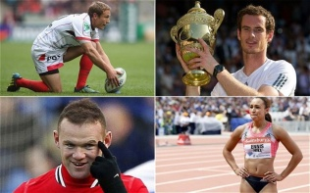
- Forget it - Don’t dwell on past mistakes, just learn from them and move on.

- Focus - Get back on track and re-focus your mind on the task in hand.

Advantages of using Mental Rehearsal / Visualisation
- It can motivate the athlete by recalling images of success in past competitions meaning the performer is able to remain positive and have the confidence / motivation to use a range of skills within the game.
- It can reduce negative thoughts by focusing on positive outcomes meaning it can develop the performer’s confidence / motivation, resulting in better decision making / improved motivation etc within games.
- Refocuses the athlete when the need arises, e.g. - if a performer is feeling sluggish, imagery of a previous best performance can help get things back on track and prevent this from hindering performance / development.
- Sets the stage for performance with a complete mental run through of the key elements of their performance. This allows the athlete to set desired pre-competition feelings and focus, so that they are fully prepared to play at their best.
- Having rehearsed any eventuality you will be able to cope with pressure allowing you to remain calm and stay in control, regardless of what happens in the game.
- Boosts your knowledge and technique of the game, as the pathways have already been developed in your mind meaning the performer is able to make decisions etc within the game at the appropriate time.

Disadvantages of using Mental Rehearsal / Visualisation
- Some athletes may imagine negative previous performances in past competitions, or against a particular opponent, which can impact negatively on performances and results.
- This type of approach takes a lot of practice for it to have a positive impact. Performers must use it every day in order to master the technique, especially with fast paced and complex sports like netball. If an athlete is not completing this training, when they can dedicate their full time and attention to it, it can encourage bad habits and a lack of mental focus in performance.
- You must be physically able and proficient at netball for this technique to be successful. If you are unable to perform the basic skills and movement patterns of the game, imagery will be ineffective.
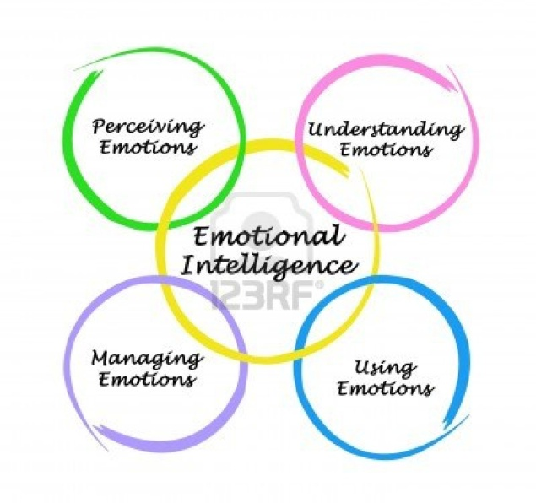
- In the moment, this approach can be forgotten as distractions and external factors can result in the performer missing the cue which identifies that fear and / or excitement. This could impact arousal level to refocus which can hinder overall development.

2. Positive Self-Talk:
Everyone has an inner voice which can be either helpful or unhelpful - the angel on one shoulder (Helpful) and the devil on the other (Unhelpful). It is vital to remember that the devil is only your brain playing tricks on you and to pay more attention to the angel!
Positive self-talk, if used correctly, is one of the most effective methods of instilling self-confidence and belief in your ability. Positive self-talk can be like an internal coach, encouraging you, boosting your level of arousal, believing in you, and motivating you to achieve your goals.

When to Use Positive Self-Talk?
Positive self-talk can be done during training and competition to motivate you. To do this, you must develop alternative positive responses to negative triggers. This could be saying cue words to yourself, or repeating phrases designed to help you stay in control if your opponent contacts / obstructs you continuously within a game or stressful situation.

The 3 R's approach is an excellent method to take:
- Recognise that you are dwelling on the mistake, which limits your ability to focus on the next phase of play.
- Regroup by interrupting this negative chain of thought. This requires you to battle your own emotions and dispute your irrational thinking. Using positive self-talk helps in this situation, e.g - saying to yourself "Be patient, you're better than that".
- Refocus is then crucial for the next phase of play. Ask yourself what you need to focus on right now to do your best in the next phase of play. The answer will help you refocus on the game.

When to Practice the 3 R's Approach?
The 3 R's approach can be practiced during every training session, particularly during pressure drills, conditioned games or practice matches. These approaches replicate similar pressures to what you would experience in a game, which can be unpredictable and open. Subsequently, you are likely to experience the same types of emotions, e.g. - getting angry when you make a mistake.
Examples of Athletes who have used Positive Self-Talk -
Scottish Athlete Lynsey Sharp repeated the phrase “Get out strong, commit”
before competing in the 800m final in front of a home crowd at the
Glasgow 2014 Commonwealth games. Lynsey did just that putting in a
brave performance to win a silver medal for Scotland with an on-going
injury. There was no room for self-doubt in her emotions.
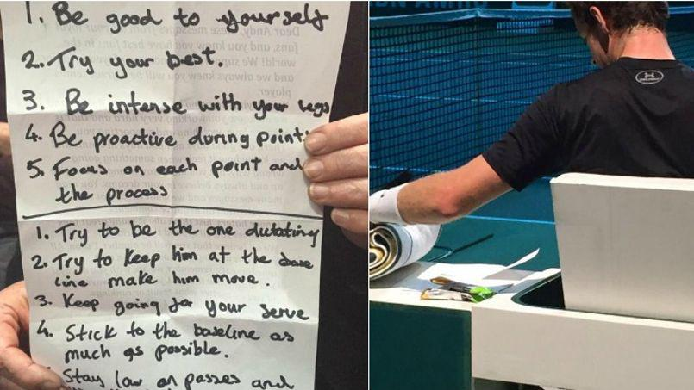

Andy Murray regularly uses positive self-talk, both during matches and between games. Between games Andy regularly refers to his notes, where he has wrote down positive statements related to his performance, in order to re-focus his attention to these areas of his game.
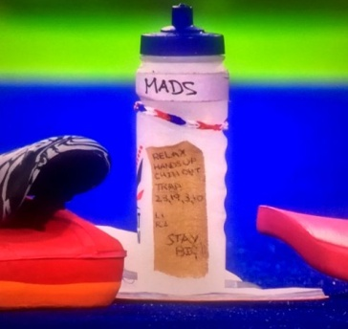
Maddie Hinch was GB’s women’s hockey goalkeeper in Rio 2016 who proved herself to be unbeatable in the gold medal match that went to a penalty shoot-out, as she prevented Netherlands from scoring a single penalty. The image of the water bottle shows firsthand how top level athletes use such approaches to overcome challenges in their own performances.

Advantages of Positive Self-Talk
- It can help to reduce negative thoughts by focussing on positive outcomes, helping the performer to always maintain an optimum level of arousal.
- It is easy to use in practice and competition, as no specialist equipment is required. Consequently, the athlete can use this approach as often as required in order to develop their performance.
- It is specific to your needs and performance, as it can be tailored to your own individual needs. Therefore, athletes can develop faster.
- It can refocus the athlete when the need arises, e.g. - if a performer is frustrated after making a mistake, positive self-talk can help get things back on track, by composing the athlete and getting them to focus on what’s important in the game. Consequently, ensuring they make effective decisions.
- Increases motivation and willingness to exert yourself, combat anything thrown at you, and persuades your body to keep going meaning the performer is always able to maintain an optimum level of arousal during training / games.
- Helps to centre a person and ground them, preventing complacency.
- Having continually practiced positive self-talk during training sessions, you will be able to cope with game pressures, allowing you to control your level of arousal better and in turn helping you to make more effective decisions within a game.

Limitations of Positive Self-Talk
- It can take a lot of practice for it to have a positive impact on performance. E.g. - Every day, especially with complex sports like netball. Consequently, unless they can dedicate their full time and attention to it, it can encourage bad habits and a lack of mental focus.
- If you are physically unable to perform core skills and movement patterns in the game, positive self talk will be ineffective. Therefore, this can hinder the performer’s overall development.
- In the moment, this approach can be forgotten as distractions and external factors result in the performer missing the triggers which identify frustration, fear or anger. Thus, performance continues to be negatively impacted and can slow down development.
- Requires a level of self belief in what is being said. Athletes will often feel awkward and lack focus. Therefore, this may discourage the athlete to use this approach, which will result in their mental factors not improving.

3. Relaxation / Motivation Techniques:
This is a technique often used by sports performers to try and remain calm, helping to control their level of arousal, as well as helping them to make better decisions during the game, as the performer will feel much calmer.
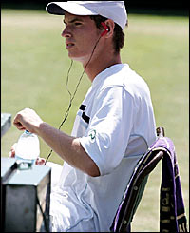
Relaxation techniques can be used prior to competition, or if practiced enough, during competition. There are many techniques for keeping cool prior to and during competition. The ability to relax, bring the mind back under control and focus is not something that can be implemented instantaneously, but developed over time and practiced.
This may be done by listening to soft music or carrying out breathing exercises in a quiet area before your game. During the game we can try to relax by taking our time before we make our next pass or shot. If you are over aroused, the tendency is to play even faster and be impatient, hurrying to get the ball to the shooters or playing a pass before it has been ‘set’ by the umpire. This stops this bad habit and helps us regain focus. Conversely the opposite can be done to raise your level of arousal. (Fast music in an attempt to motivate the player)
The above can be allied to focus. When relaxing before the game, you may think of scenarios which may occur during it. We then think of how we are going to react and visualise this.
E.g. - If my team wins 4 or 5 goals in a row, I’m not going to relax but push for even more goals OR if I disagree with an umpiring decision, I’m not going to get upset. I will remain calm and concentrate on the game.
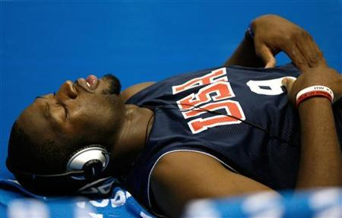
You may also think of your tactics, imagining the perfect passage of play or use affirmation to eliminate negative thoughts or experiences.
Benefits of Relaxation Techniques
- Helps the promotion of rest, recovery and recuperation.
- Can help remove stress related reactions, e.g. - muscular tension.
- Helps establish a physical and mental state which has an increased receptivity to positive mental imagery.
- Helps establish an appropriate level of physical and mental arousal prior to competition. Removes self-doubt, anxiety etc and increases concentration and performance.
- Reduces arousal level when self-control could be lost.
- Clears the mind of mistakes and allows appropriate decisions to be made.
Limitations of Relaxation Techniques
- If we asked an under-excited athlete to use relaxation procedures it would only make it harder for him / her to "get-up" for the competition. The coach therefore has to know his / her athletes and how they react in competitive situations.
- If relaxation techniques are not rehearsed in an appropriate, quiet environment, where the performer can zone out, tension will continue to be experienced.
- It can be difficult to employ relaxation techniques within team sports. The nature of the skills are mostly open and therefore limited moments to counter nerves and frustration occur.
- If an athlete is not relaxed enough or committed to the process, therefore it will be ineffective. Some performers may not take it seriously and emotions can escalate.

How Should We Monitor Progress for Mental Factors?

The Use of a Training Diary to Monitor & Evaluate

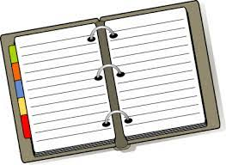
You will keep a training diary to record and monitor your progress as you carry out your personal development plan (PDP).

Benefits of using a Training Diary
This method of recording and monitoring is appropriate because:
- The format of the training diary offers an opportunity to clearly identify the aim of each session. This is important as it focuses planning on practices / approaches that are specific to targeted areas, leading to a greater purpose of training.
- A training diary can give an enormous amount of information about what has happened in the past and how training has gone in the past. When planning future training, information of this kind is invaluable to ensure programmes of work are appropriate and specific to development needs.
- The layout is always the same so it is easy to spot improvements / when targets are met or missed. This means that you will be able to quickly make the necessary adaptations to the PDP so that it stays specific to your needs and ensures you are continually improving.
- The training diary allows you to record information about all four factors, even the factors that you may not be currently developing. This can then allow you to identify other possible factors that may be impacting on your training in either a positive or a negative way.

Limitations of using a Training Diary
However as with any method of recording & monitoring there will be drawbacks which you should consider before deciding if a Training Diary is the most appropriate method for you:

- A lot of the information contained in the training diary will be based on your personal opinion, such as how you felt physically, emotionally, socially & mentally. Since Mental, Social and Emotional recoding will be easily influenced by your mood / emotions, then your recordings will vary depending on your mood and what happens during the session meaning you may not be giving a true representation of your PDP.
- You will also evaluate the success of each session and again this evaluation will be largely based on opinion, making it unreliable.
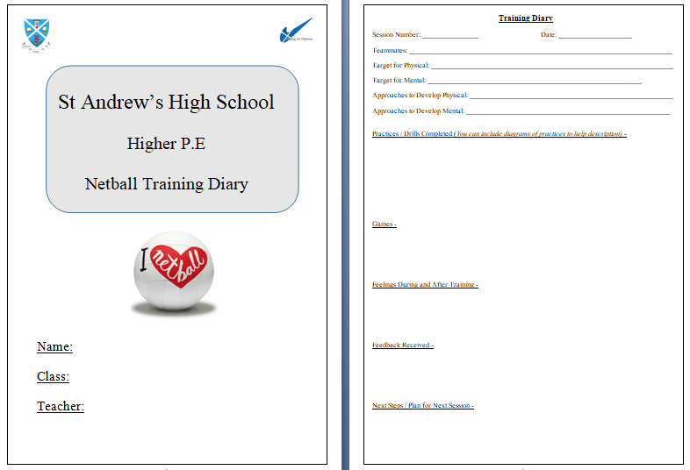
- Due to the unreliability of opinion / likelihood of bias when completing training diaries it can make monitoring progress difficult and you may not be building an accurate picture of your development over the course of the PDP.
What is Noted in Training Diary
                - Session Number / Date
                - Practices Completed
                - Feelings During and After Game
                - Feedback Received
                - Next Steps

Difficulties / Problems When Monitoring & Evaluating Performance

PHYSICAL FACTORS
- The knowledge of observer as may be unable to see if shot is effective / ineffective if completing live. Perceptions different from reality affecting results.
- Observer may not see process as important so switch off / lose focus, which reduces the quantity of information, so limited picture on performance. As a result this restricts the information given to the performer.
- Performer frustrated due to poor results, as not a true reflection of performance. May end up working at wrong stage of learning and this directs attention away from weakness.
- If performer is tired, they will not be in the correct frame of mind to play at their best which can affect their decision making and concentration. Movements will be more laboured as they have no real energy, which results in a poor skill level and success on the day.
- If coming back from injury, monitoring can be frustrating as scores and results are down on their high expectations meaning the performer may lose motivation and give up with their training.

MENTAL / EMOTIONAL / SOCIAL FACTORS
- Completing a training diary / questionnaire etc too late after performance may result in the performer forgetting important data affecting reliability of results.
- Performer may not see the process as important, so they don’t take it seriously and as a result rush to get through questions, so not much information put down.
- Performer may not be honest with themselves, making results invalid / false.
- Training diary can be too vague as doesn’t give cause as to why you felt this way / why the practice didn’t go well, meaning the performer will not know specifically what they need to work on in order to develop areas of weakness in their performance.
- Similar situations may not arise so difficult to have same feelings making it hard to compare findings.
- Performer may misinterpret questions affecting reliability of results.
- Dependant on performer’s mental state which could result in bias judgement.

FEEDBACK
What is Feedback?
Feedback is information that you receive about your performance in order to help you improve.

The Benefits of Feedback
- Data Collection Process
- Sets training priorities specific to your needs, meaning I can use this information to plan a relevant PDP to work on my areas of weakness.
- Highlights stage of learning, social development stage or tactical limitations, meaning I am able to set relevant targets / goals to work towards when developing performance.
- Through comparison to a model performer, I am able to see a visual picture of what a performance should look like. Consequently, this enables detection of weakness in performance and can allow me to correct issues in performance / technique.
- The use of teacher / coach feedback is useful as they have expert knowledge, which means your development needs are accurately identified.
- Teacher / coach feedback is also personal because the teacher knows you well and the feedback could be applied straight away to save wasting time that could be spent on training.

- During PDP / Monitoring Progress

- Through feedback received during practice and competitions, adaptations to a programme can be made. Therefore, you are always maximising training time, so no time is wasted.
- Able to assess to see if on track to hit long term targets when you compare current feedback statements to those previously recorded. Thus, able to see if PDP is having a positive impact.
- Positive feedback gives purpose, drive and determination to training and competition. Consequently, this motivates the performer to continue working hard with their PDP and prevents their performance levels from plateauing.
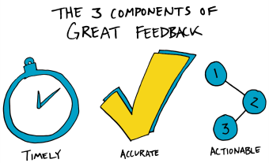
- Receiving regular feedback helps to sustain focus and directs a team / performer(s) attention to the specific areas that are needing developed in their performance. Thus, no time is wasted and can speed up their overall rate of progression.
For Feedback to be Effective
- RELEVANT To the performer(s) and the area of weakness.

- TIMING Feedback needs to be immediate to allow the performers to reflect and make corrections
quickly, whilst the information is fresh in their minds.

- VOLUME Feedback should also be only one or two points at a time so that the performer is not
confused by an overload of information.

- POSITIVE Feedback should be positive, but constructive so that the performer remains motivated,
but still knows exactly what they need to do in order to develop further.

- ACCEPTANCE Player’s must be open to listening to the feedback and willing to accept constructive
criticism, being defensive and failing to take on board advice will have a negative effect.

- OBJECTIVE & Increases validity and reliability and creates a clearer picture of performance SUBJECTIVE and the progress being made.
Types of Feedback
INTERNAL Kinaesthetic (Internal Feedback)
EXTERNAL Verbal, Visual, Knowledge of Results or Written
Kinaesthetic Feedback (Subjective) | Verbal / Written Feedback (Subjective) | Knowledge of Results (Objective)
Based on your own thoughts and feelings. E.g. - I could feel right away that I had thrown the ball with too much power, therefore I knew the ball was about to go out of court and not going to the place I intended it to go to.  Usually this method is in the form of a training diary or by revisiting a questionnaire. | Verbal communication can come from the teacher constantly during practice and performance.  Verbal or written feedback should be given in each training session and game, by a teacher, and should be specific to the area you are developing. | Can be gained from a variety of external sources such as mental toughness questionnaires, observation schedules, competitive results and practice scores. E.g. - I scored 29 in the mental toughness questionnaire, highlighting this is an area that needs developed within my performance.  This method produces statistics which should relate to the weak area which is being developed.
Advantages  - Encourages self-reflection of training.  - Encourages confidence, motivation and focus, as they are becoming more successful.  - Very specific to self so a true reflection.  - Regular and immediately after performance or training leading to more accuracy. | Advantages  - Teacher has a detailed knowledge of the sport and the development area, therefore their opinion and advice is invaluable to improve factors that impact performance.  - As feedback is regular and immediate players can make alterations quickly.  - The teacher can prevent bad habits forming and their feedback focuses the performer / team and can be a source of positivity and motivation.  - Can direct the performer’s attention to flaws and increases their understanding of strategic play and roles etc. | Advantages  - Objective data is more reliable and accurate as it comes from an external source.  - Impacts positively on confidence and motivational levels through the hard facts highlighting improvements.
Disadvantages  - Subjective information can always be impacted by how the performer feels (mood) at that specific moment.  - Performer’s personal opinion and thoughts could differ from the teacher’s. | Disadvantages  - Always a potential of a clash between performer and teacher’s feedback, especially if underachieving.  - If feedback is not given frequently and immediately after errors, then by the time teacher addresses the problem, it has been forgotten by the performer(s). | Disadvantages  - Highlights exactly what is says, but it does not explain why these results are being achieved.  - Poor results can de-motivate a performer.  - However, poor results do not always suggest no progress. E.g. - O.S does not explain an increased understanding of roles / positioning etc.
STAGES OF LEARNING
There are 3 stages of learning we all go through when we learn anything new. You start at the Cognitive Stage where you are finding out about the skill in question, starting to put together the basic movements and perform it similarly to the Model Performance.
You then move on to the Associative Stage, where many people will stay for a long time, where you know how to perform the skill & can apply it successfully in context but you are working towards refining the quality of the skill and aim to perform it without thinking.
Finally you will reach the Automatic Stage, you will be in the Automatic stage for skills such as walking but in terms of PE you will not be an automatic performer across all of your skills. The Automatic stage is when you can perform an action or skill without thinking about how to do it, instead you are able to focus on other aspects of your performance such as tactics and maintaining control over Mental, Emotional & Social factors. Elite athletes and Model Performers would be in the Automatic stage of learning for their specialised skills/ activities.
COGNITIVE
- Practice skills in ISOLATION
- Simple instructions
- Little movement required
- Practice the main pattern of the movement/ skill.
APPROACHES
- Shadow Practice
- Easy Feed Drills

ASSOCIATIVE
- Starting to link skills together
- More game related
- Some pressure applied
- More movement involved
- More understanding of the skill

APPROACHES
- Repetition Drills
- Conditioned Games

AUTOMATIC
- Game speed & pressure
- Can focus on fine details
- Physically demanding
- Accuracy & consistency
- Game phases linked
APPROACHES
- Pressure Drills
- Game Related Drills
- Conditioned Games

Model Performance
“A model performance is the perfect way in which a skill or performance should be carried out”
Who could be a model performer?
- A Class Mate
- Teacher / Coach
- Professional Sportsman / Woman
If our Preparation, Action, Recovery was carried out perfectly, we would consider this to be a Model Performance.

The Benefits of Comparing Your Performance to a Model Performer -
- By examining a model performance, we are provided with an accurate picture of what the skill involves. The performer will therefore have a clear picture of what is expected of them and have a better understanding of the correct techniques to use. By watching them in a game, you can watch and copy their movements and decision making.

- The use of model performance / criteria, allows the individual to make comparisons with their own performance, as they help to create a ‘picture’ in your mind of how a skill or performance should be carried out. By watching them practice you get a better understanding of the correct techniques to use and the type of positive attitude to adopt.

- Comparing your performance with a model allows specific strengths and weaknesses to be identified. This allows you to pin point and focus on area of weakness, such as over throwing a pass or passing continuously behind your teammate.

- Allows you to set realistic but challenging individual goals and targets to strive for. This should give you the confidence and motivation to improve and reach that high standard of an automatic performer.

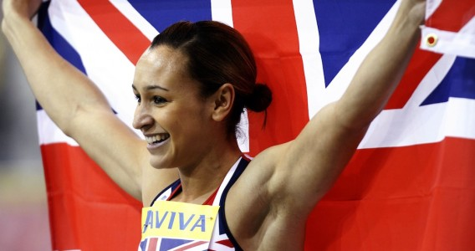
- You can make further comparisons at different stages of your improvement programme, so that you can identify the effectiveness of your programme.

The Limitations of Comparing your Performance to a Model Performer -

- If a performer has limited knowledge of the game, or a skill, this may lead to an inaccurate comparison. Subsequently, progress will be limited as they are working on the wrong areas for development.

- The model performer you are watching might be at a level that is too advanced for you. This could lead to you setting unrealistic targets and goals. Also, you could become de-motivated as you realise you will never reach their level.

- In certain activities there might be a lack of model performers for you to observe. Your class mates or teacher might not be playing at a level which allows for a strong comparison. Also, it may be difficult to get a video which clearly highlights a strong performance.

- The time involved in collecting and analysing your results in comparison to a model performer may be disproportionate to the benefits. Your time might be better spent focussing on developing your performance through other approaches.
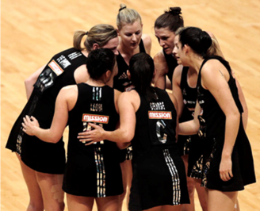

Analysing Your Performance Against a Model Performer (Netball Example)

The Characteristics of a Model Performer in Netball | My Performance when Playing / Participating in Netball
- They can play a wide range of skills and can consistently link them together with high levels of control and fluency.  - They can move quickly, gracefully and efficiently around the court, often being able to take the ball early out the air.  - They make decisions quickly, which allows them to attack space on the court and move away from their opponent effectively.  - They do not allow their anger to cloud their judgements on court. E.g. - If they have played a bad pass, they forget about it and remain focused on the game. This reduces the number of unforced errors they play.  - They can communicate effectively with their teammates in order to organise centre passes / back line passes etc. | - I can play a wide range of skills, however, my skills can lack consistency and I am prone to unforced errors.  - I am able to move around the court, but at times I am slow at getting into the correct spaces, and can often contact as I try to get into tight spaces on the court.  - Because my skills are not automatic, I still have to think about the technique of skills. This means my decision making is slower, which means my play is more reactive than proactive.  - I often let anger cloud my judgements on the court. E.g. - If I disagree with an umpiring decision, I tend to dwell on this which often leads to me making poor decisions / unforced errors.  - We not do organise tactics before the quarter, resulting in confusion within the team of who should be moving out for the pass.

How have you compared yourself to a Model Performer?
Video Analysis
- I watched a video of a model performer / model team performance in Netball.

- Whilst watching the video I analysed their performance carefully and noted down their characteristics in relation to the four factors (MESP).

- I then watched a video of my team and me playing Netball. I compared my performance to the characteristics of the model performer and then recorded what I felt were my strengths and weakness.

MENTAL MODEL PERFORMERS

Can maintain an optimum arousal level throughout a performance ensuring emotions and distractions do not impact training or competitive matches. A positive mind set is always maintained.
They can shake off any issues in their performance and maintain composure and regroup.
A model can maintain focus and concentration which enables them to make the correct decisions throughout a match on shot selection and movement.
Can switch focus on and off to prevent mental fatigue and brain overload.
As a model maintains focus, they develop consistency in their play and will respond faster to cues in the game, resulting in faster decisions and motor responses.
Few careless mistakes are made as they are mentally switched on.
Make fast decisions under pressure playing the correct pass at the correct time.

Having a more developed information processing system in their brain, a model through experience of the sport has more options available to them. This allows them to read a situation early and predict what will happen next, thinking one step ahead of their opposition.
A model’s fast decisions results in a higher success rate, good timing, variety and fluidity in movements.

A model is highly motivated and thrives in a pressurised environment. They are driven to succeed and push themselves in training and competition to be the best they can be.

They are mentally tough and rebound from any injury, mistakes or lose quickly.

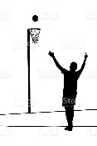
PHYSICAL MODEL PERFORMERS

A model’s skills and techniques are performed with control, fluency, consistency and accuracy.
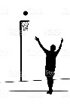
They perform the correct skills at the correct times and have variety in their skill repertoire which enables them to change the pace, angle and direction of play to target or defend space.
A model is creative with their pass selection and is very adaptable under pressure to solve performance problems and challenges and react quickly.

Movements are graceful and economic which allows them to prepare early to execute a skill with
control. They are also able to cover the court much more efficiently.

They are tactically very aware of their own strengths and weaknesses, as well as their opposition’s,
which enables them to exploit and defend space and maximise their strengths on the court.

They adapt their tactics to keep their opposition guessing and build a strong attack as well as to
defend effectively.

A model will use width and depth in attack and defence to support teammates to co-ordinate attacks
and defensive plays.

A model possesses the fitness requirements for the sport, e.g. - agility, cardio respiratory endurance,
muscular endurance, speed, power, flexibility and strength to sustain the quality of play both mentally
and physically for training, a competitive match and season.

A model equally has the skill related fitness requirements to compete at the top level, e.g. - balance,
agility, co-ordination, reaction time and core stability.

EMOTIONAL MODEL PERFORMERS
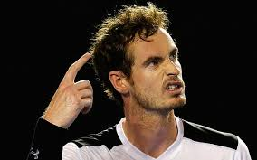
Emotionally the model has resilience, emotional strength and the ability to respond to challenging situations with a cool head. They manage setbacks, have fighting spirit and are fully engaged in the performance.
They have positive thoughts which provide a more balanced approach to competition. They have self-belief and confidence in their ability.

Fear and anxiety do not impact performance and movements are fluent as muscles move freely without tension.

They have emotional intelligence to identify emotions early, understand them and then react to these feelings to maintain control. This maintains optimum arousal level and enables them to use their full repertoire of skills effectively without freezing or choking under pressure.
Emotional control positively impacts their decision making, confidence, and self-control.

Models have self-control which enables them to deal with the demands of performance, without showing signs of anger and frustration. This controlled aggression which has been channelled ensures they fully commit to training and competition. Positive feelings create positive behaviours.
With high levels of self-control they are assertive in carrying out their roles with confidence and without hesitation and have clean discipline record.
They trust their teammates and have mutual respect for each other and take their team responsibility very seriously.

SOCIAL MODEL PEFORMERS

Players have excellent listening skills and lines of communication are open. They are willing to accept feedback and work together to problem solve and resolve any issues in performance.

Through excellent team dynamics, the team can adapt to the environment and challenges that they face as they work as one cohesive unit preventing group fragmentation and friction.

Players put trust in each other and work towards common goals and respect each other.

Models have a clear understanding of their roles and responsibilities within the game and carry this out effectively. This increases the clarity and awareness of players and enables them to execute strategies and decisions quickly.
Players are highly motivated and on the same page and anticipate each other’s moves instinctively. By taking timing from each other early and responding to cues, movements are much more automatic.
They play to the rules and show good etiquette and fair play throughout a performance.

They have good leadership skills which motivates and inspires teammates and are calm and supportive at all times.

STEPS TO ANSWER SCENARIO QUESTION

Whichever format (graph / text / table) is used to present the scenario, the procedure for tackling it should be the same.

1. Read the entire question, parts (a), (b), (c) etc and how many marks each part is worth. This will ensure you put the correct information in the correct part.

2. Establish whether the scenario relates to:
- Factors Impacting on Performance
- Methods of collecting information to analyse factors impacting performance.
- Approaches to performance development.
- Recording, monitoring and evaluating performance development.

3. Try to identify what activity / activities the ‘prompt’ could relate to.

4. Identify and highlight the command words used in the question. This will give you a clue about what information is required.

5. Identify the named factor(s) from the question.

6. Briefly note down the main sub-factors / features under each factor which you are most comfortable talking about, based on the prompt given. For example -

Dodge C.R.F Determination Fear

PHYSICAL

EMOTIONAL

Consistency of Tactics Confidence Cope Under
Skills Played Pressure

8. 1 mark = Point, Example and Explanation / Impact.

E.g. - The ability to dodge is a physical feature that may have impacted the performer positively within netball, as they scored a 75% success rate when using this skill within the game. (Point) For example, being able to dodge successfully means that the performer is able to move quickly and successfully into a space away from their opponent in order to receive a pass successfully from their teammate. (Example) As a result, this made it difficult for the opposition to intercept the ball, increasing the team’s chances of scoring within the game. (Explanation / Impact) (1 mark)

Appendix

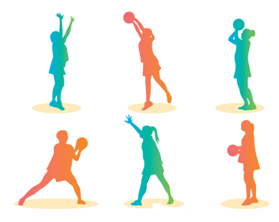

OBSERVATION SCHEDULE (NETBALL)
(Analytical Tool)

Performer: ______________________________ Opponent: _________________________________

Teammates: _____________________________ Match Score: Date: ________________

 | PASSING | INTERCEPTIONS | DODGE | FOOTWORK | SHOOTING | REBOUNDS
0 - 5 mins
6 - 10 mins
11 - 15 mins
16 - 20 mins
21 - 25 mins
26 - 30 mins
% Total

Additional Comments:

Multi - Stage Fitness Test (CRE)
(Recognised Test)

Name: ___________________________________ Date: ________________________

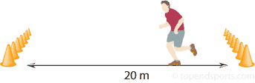
Required Resources
- Flat Non Slip Surface
- Multi - Stage Fitness CD
- Tape Measure
- Cones
- CD Player

How to Conduct the Test
This test requires the athlete to run 20m in time with a beep from a CD recording. The athlete must place one foot on, or beyond the 20m marker at the end of each shuttle.
- Two cones are set 20 metres apart.
- An assistant starts the CD and the athlete commences the test.
- If the athlete arrives at the end of shuttle before the beep, the athlete must wait for the beep and then resume running.
- If the athlete fails to reach the end of the shuttle before the beep twice in a row, they are withdrawn and a score taken.

Score: _____________________________

This means I am in the ___________________________ category for CRE.

The following table is for the Multi Stage Fitness Test. (Bizley et al, 2010)
GENDER | AGE | EXCELLENT | ABOVE AVERAGE | AVERAGE | BELOW AVERAGE | POOR
Male | 14 - 16 | L12 S7 | L11 S2 | L8 S9 | L7 S1 | < L6 S6
Male | 17 - 20 | L12 S12 | L11 S6 | L9 S2 | L7 S6 | < L7 S3

GENDER | AGE | EXCELLENT | ABOVE AVERAGE | AVERAGE | BELOW AVERAGE | POOR
Female | 14 - 16 | L10 S9 | L9 S1 | L6 S7 | L5 S1 | < L4 S7
Female | 17 - 20 | L10 S11 | L9 S3 | L6 S8 | L5 S2 | < L4 S9

Illinois Agility Test (Agility)
(Recognised Test)

Name: ___________________________________ Date: ________________________
Required Resources
- Cones
- Tape Measure
- Stopwatch
- Flat Non Slip Surface

How to Conduct the Test
- Set the course up (as per the diagram). The length of the course is 10 meters and the width (distance between the start and finish points) is 5 meters. Four cones are used to mark the start, finish and the two turning points. Another four cones are placed down the centre an equal distance apart. Each cone in the centre is spaced 3.3 meters apart.
- To begin the test you should lie on your front (head to the start line) and hands by your shoulders. On the command ‘go’ the stopwatch is started, and you must get up as quickly as possible and run around the course in the direction indicated, without knocking the cones over, to the finish line, at which the timing is stopped.

Score : _______________________________

This means I am in the ___________________________ category for Agility.

 | Male | Female
Excellent | < 15.2 | < 17.0
Above Average | 15.2 - 16.1 | 17.0 - 17.9
Average | 16.2 - 18.1 | 18.0 - 21.7
Below Average | 18.2 - 19.3 | 21.8 - 23.0
Poor | > 19.3 | > 23.0

Mental Toughness Questionnaire
(Analytical Tool)
Section 1 – REBOUNDABILITY | True | False
1) I frequently worry about mistakes.
2) I get really down on myself during performance when I mess up.
3) It’s easy for me to let go of my mistakes.
4) If I start out badly, it’s hard for me to turn my performance around.
5) I get distracted by what the coach thinks whenever I screw up.
6) I bounce back quickly from setbacks, bad breaks and mistakes.
Section 2 - HANDLING PRESSURE | True | False
7) I do my best when there’s more pressure on me.
8) I get too nervous to really perform to my potential.
9) I do better in practice than I do when it really counts the most.
10) I tend to get easily psyched out or intimidated.
11) I can keep myself calm and composed under pressure.
12) I don’t want the ball, I dread competing at “crunch time.” (Big / Important Games)
Section 3 – CONCENTRATION | True | False
13) The coach’s yelling knocks me off my game.
14) I tend to get easily distracted.
15) Certain opponents can get into my head and throw me off my game.
16) Lousy playing conditions (weather, field conditions, temperature, etc) negatively affect me.
17) I have no trouble focusing on what’s important and blocking everything else out.
18) I think too much about what could go wrong right before and during performance.
Section 4 – MOTIVATION | True | False
19) I get more motivated after failures and setbacks.
20) It’s easy for me to consistently train at a high level of intensity.
21) I think about how today’s practice will help me get to my goals.
22) I find myself just going through the motions a lot in practice.
23) I have clear goals that are important for me to achieve.
24) I am a highly motivated athlete.
Section 5 - LEVEL OF AROUSAL | True | False
25) I have some anxiety, worry or excess tension prior to or during competition.
26) Pre-game jitters stay with me well into the competition and don’t go away.
27) I often feel too excited or amped up to perform to my best in a competition.
28) I sometimes feel distracted or confused when I perform under pressure.
29) I am sometimes too laid back in training and competition.
30) I sometimes miss vital signals in the game.
Section 6 - DECISION MAKING | True | False
31) I can ignore irrelevant information during my performance.
32) I can focus on more than one piece of information at a time.
33) I frequently become overloaded which results in errors.
34) My decisions are sometimes delayed, resulting in a slower response.
35) I can adapt my play in response to different problems.
36) I tend to make the same mistakes throughout a game.

Mental Toughness Questionnaire
(Analytical Tool)

Section Overview

Section 1, questions 1-6, deal with “Reboundability” or your skill at mentally bouncing back from setbacks and mistakes. Mental toughness depends on your ability to quickly leave your mistakes and failures behind you. Hanging onto your mistakes will get you into big trouble, performance-wise. Athletes, who dwell on their mistakes while the competition continues, end up making more.

Section 2, questions 7-12, deals with the ability to handle pressure. Without the ability to stay calm in the clutch, an athlete will always underachieve. Peak performance demands that you are relaxed once the performance begins. While a little nervousness is critical for getting “up” for a game / match / race and performing at your best, (“good nervousness”) too much nerves (“bad nervousness”) will tighten your muscles and send your performance down the tubes.

Section 3, questions 13-18, deals with your concentration ability. In every sport, your ability to focus on what’s important and block out everything else is one of the primary keys to performance excellence. Poor concentration is the major reason why athletes “choke” and get stuck in performance slumps. Getting psyched out or intimidated is a direct result of concentrating on the wrong things.

Section 4, questions 19-24, deals with motivation. Motivation is the fuel that will drive your training to a successful completion and the accomplishment of your goals. Without adequate motivation athletes get stuck having “permanent potential”. Without motivation you won’t put in the work necessary to become a winner. Your motivation allows you to pick yourself up after a setback and keep going.

Section 5, questions 25-30, deals with Level of Arousal. This is the ability to control your state of alertness in order to perform at your optimum level. An athlete who is under-aroused will be over relaxed and may miss vital signals in the game. In contrast, an athlete who is over-aroused will have an adrenaline surge which will result in them over-anticipating cues and making mistakes and panicking.

Section 6, questions 31-36, deals with decision making. This is the ability to process information and respond to cues in the game, resulting in an appropriate motor response from a number of options. An athlete who can make decisions quickly and effectively will experience positive outcomes, however poor decisions can lead to loss of points, loss of concentration and frequent errors.

Mental Toughness Questionnaire
(Analytical Tool)

Marking Scheme
QUESTION | TRUE | FALSE
Section 1 - Reboundability
1) | 0 | 1
2) | 0 | 1
3) | 1 | 0
4) | 0 | 1
5) | 0 | 1
6) | 1 | 0
Section 2- Handling Pressure
7) | 1 | 0
8) | 0 | 1
9) | 0 | 1
10) | 0 | 1
11) | 1 | 0
12) | 0 | 1
Section 3 - Concentration
13) | 0 | 1
14) | 0 | 1
15) | 0 | 1
16) | 0 | 1
17) | 1 | 0
18) | 0 | 1
Section 4 - Motivation
19) | 1 | 0
20) | 1 | 0
21) | 1 | 0
22) | 0 | 1
23) | 1 | 0
24) | 1 | 0
Section 5 - Level of Arousal
25) | 0 | 1
26) | 0 | 1
27) | 0 | 1
28) | 0 | 1
29) | 0 | 1
30) | 0 | 1
Section 6 - Decision Making
31) | 1 | 0
32) | 1 | 0
33) | 0 | 1
34) | 0 | 1
35) | 1 | 0
36) | 0 | 1
Section | Score
Reboundability
Handling Pressure
Concentration
Motivation
Level of Arousal
Decision Making
A score of 6 in any category means this is a mental strength for you

OVERALL SCORE
A score of -
- A score of 30 - 36 indicates strength in overall mental toughness.
- A score of 24 - 29 indicates average to moderate skill in mental toughness.
- A score of 23 or below means that you need to start putting more time into the
mental training area.

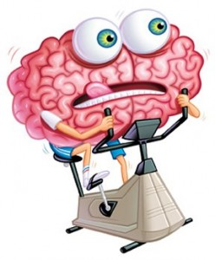

Decision Making Gird ( NETBALL)
(Analytical Tool)

Performer: __________________________________________ Opponent: ____________________________________________

Teammates: _____________________________________________________ Match Score: Date: ________________

Situation During the Game | Correct or Incorrect Decision (√ or x) | % Total
In possession of the ball under no pressure from opposition
In possession of the ball under pressure from opposition

Not in possession of ball when team are attacking

Not in possession of ball when team are defending

Additional Comments -

