**St. Andrew’s High School**

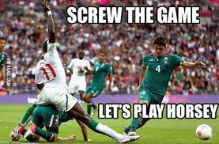

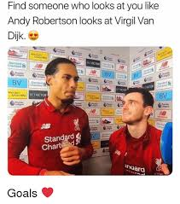

**Higher**

**Football**

**Contents**

Page 3 – Code of Conduct

Page 4 – Mandatory Knowledge

Page 5 – Command Words

Page 11 – Training Diary

Page 14 – Physical Factor

Page 18 – Methods to Gather Information on Physical Factor

Page 29 – Approaches to Develop Physical Factor

Page 33 – Emotional Factor

Page 35 – Methods to Gather Information on Emotional Factor

Page 41 – Approaches to Develop Emotional Factor

Page 44 – Mental Factor

Page 46 – Methods to Gather Information on Mental Factor

Page 52 – Approaches to Develop Mental Factor

Page 56 – Objective and Subjective Information

Page 59 – Principles of Training

Page 62 – Goal Setting

Page 64 – Model Performance

Page 667– Monitoring Performance Development

Page 70 – Feedback

Page 72 – Scenario Questions Guidance

Page 78 – Practice Questions

**Higher Code of Conduct**

The Higher course is made up of 2 internally assessed One-Off Performances and an external exam – 2 practical assessments and 1 written.

**ALL ASSESSMENTS MUST BE PASSED AT HIGHER STANDARD IN ORDER FOR YOU TO BE PRESENTED AT HIGHER LEVEL.**

Final results are made up from:

50% - 2 One-off Performances in different activities (60 marks)

50% - SQA Written Examination (50 marks)

**The following are a list of rules which must be adhered to within the Higher class:**

1. Effort and hardworking attitude must be given at **all times**
2. Always attend class with PE kit and appropriate theory materials
3. All homework must be completed properly and on time
   1. Failing to complete homework will result in no participation in practical
   2. Using ‘I don’t understand the homework’ is not acceptable for missing deadlines – your teacher is always available for any questions
   3. Failing to complete homework twice will result in a letter being sent home
4. Appropriate behaviour must be shown at all times
   1. Failing to behave appropriately will result in no participation in practical or detention

Failing to behave properly twice will result in a letter being sent home

**MANDATORY KNOWLEDGE**

*Understanding of different command words and how to structure answers*

*Impact of Mental, Emotional, Social, & Physical factors (MESP) on performance in a variety of activities*

* + Also, impact of factor’s on other factors

*Methods to collect information on MESP factors* (minimum of 2 per factor)

* + Use of model performance
  + Application of recognised tests, analytical tools or data collection methods
  + Appropriateness of methods for collecting data
  + Feedback

Key planning information

* + Principles of training (SPORT FIT)
  + Principles of effective practice (SMARTER)
  + Goal/ target Setting
  + Interpretation of qualitative & quantitative information

Performance development process

* + Approaches to develop performance on MESP factors (minimum of 2 per factor)
  + Production and implementation of personal development plans (PDP)

Recording, monitoring and evaluating performance development

* Methods used to record, monitor & evaluate
* Reliability of methods used
* Adapting performance development plans
* Evaluation of the performance development process
* Future performance development planning

Useful Websites

* Search for ‘SQA PE Higher’ – good for past papers
* Search for ‘SATPE Student Notes’ – good for notes and questions

**Command Words**

|  |  |
| --- | --- |
| **Describe**   * Paint a ‘picture’ of what you see or do * How did you do it? * Describe all details and characteristics – no matter how small   paint brush | **Explain**   * Giving reason or meaning to situations or actions * Makes something clear – why do you use this? Why did it happen? * Gives impact to actions   + Point and Impact * explainBecause…/ this allowed…/ to ensure that…/ to make sure that…/ which meant… |
| **Analyse**   * Study and explain something in great detail * Break down something in to parts and interpret * Use explanations to show connections * Analysis can include positive and negatives * As a result of…/ This allowed for…/ This resulted in…/ This meant that…   analyse | **Evaluate**   * Make a judgement on something * Back up judgements with evidence   + Objective and Quantitative (O.S, fitness test, etc.)   + Subjective and Qualitative (opinions, feedback, questionnaires, etc.) * Judgements can also be made by making comparisons between:   + Successful v Unsuccessful   + Before v After   + Benefits v Limitations * evaluateIt worked because…/ results showed that…/ it was worthwhile because… |

**Command Words – Describe**

When answering a Describe question you should always give DETAILS and DESCRIPTIVE POINTS.



**You are *NOT* being asked to give reasons why.**

You will build a picture in the mind of the marker. You will do this by giving details on the following:

* What exactly did you do?
* Who did you play against? What was their ability like in comparison to yours?
* How long did you train/ play for?
* What did it look like? The sheet? The drill?
* How was it completed?
* Any special equipment or set up required to carry it out?
* What did you do with results?



**1 Descriptive point = 1 mark in a Describe question**

Read this model answer worth 4 marks…



**Describe how you gathered data on Physical factors using an analytical tool. (4 marks)**

[I played a 4 v 4 game of Volleyball, to 25 points, against opponents of similar ability.]**1** Two observers completed an Observation Schedule specific to Volleyball while we played. [The O/S had a table with different skills listed across the top row: Volley, Dig, Set, Spike and Serve.]**2** [Down the left hand side there were time periods listed: 0 - 5mins, 6 – 10mins, 11 – 15 mins etc.]**3**

The [observers would place a tick or a cross under the appropriate skill and time period depending on whether or not a skill was successful or unsuccessful. For example a dig pass received a tick when it was passed high and accurately towards the setter at position 3, this meant it was a successful shot.]**4**

**Success tips for Describing**



* You need to give SPECIFIC details.
* Your answer should help the marker picture exactly what you are talking about, if they can’t see it in their head, they can’t give you a mark.
* No vague statements.
* Never give reasons why as this info will be worth nothing in a Describe question.

**Command Words – Explain**

When you are tackling an Explain question you will be looking to give reasons why you have done something or why something has happened.

You might also be asked to talk about **“cause and effect”.** An example of this could be when a Badminton player is distracted by the noise of the crowd, they miss the shuttle and lose a point.

The noise of the crowd is the “cause” and the missed shuttle and the lost point is the “effect”.****

To access marks in your Explain answers you will make a POINT then give the IMPACT, you will link these together using LINKING PHRASES.

These phrases will lead you into your explanation and force you to give information on impact…which the SQA are looking for in your answers. Examples of linking phrases are:

* “because…”
* “this allowed…”
* “as a result of this…”
* “to ensure that…”
* “which meant that…”

Read this model answer worth 4 marks…

**Bold = Point** *Italics = Impact* Underlined = Linking phrase



**Explain why your chosen method(s) of data collection are appropriate**

**I collected this data during pre-season** *as this allowed* me to collect base-line data to enable appropriate targets to be set (1 mark)

**I completed the method before leaving the dressing room**, *this allowed me to* complete the process in private *meaning* I was not distracted and could reduce the possibility of errors (1 mark)

**I carried out the method online**, *meaning that* the information was instantly compared to national norms, helping me to set appropriate targets (1 mark)

**As it was completed straightaway** *it meant that* I did not forget it and therefore the results were more reliable. (1 mark)

**Success tips for Explaining**

* ****You need to make a **POINT** then use a *LINKING PHRASE* to give the IMPACT
* You will need to be able to identify cause and effect e.g. when this happens, what effect does it have?

**Command Words - Evaluate**

The key to success when answering this command word is to make sure that you structure your answer correctly.

When you are Evaluating you are giving YOUR OWN OPINION on something, it can be positive or negative, but **you have to** give a statement of JUDGEMENT.

You then **have to** back up this judgement and give impact on training or performance.

**Structure your Evaluate answer by including the following information:**

**Judgement** – you need to use a word that shows you have made a judgement, the language you would use could be: useful, effective, unsuccessful, helpful, good, bad etc.

**Back It Up!** – you will need to back up your judgement, you can’t give an opinion without backing it up so start to explain why this is your opinion. This can come from *qualitative* (opinions, feedback, personal experience, questionnaires etc.) or *quantitative* sources (fitness tests, Observation Schedules, facts & figures etc.)

**Impact** – you would then use one of your *linking phrases* to lead you into giving details of the impact caused by what you are evaluating. You should give a clear, specific example with details. Do not be vague here.

**You will need ALL of this information to access 1 mark** when you are answering an Evaluate question. So for a 4 mark answer you would need to do 4 paragraphs, structured with all the above information, to achieve that number of marks.

Read this model answer, worth 1 mark…

**Evaluate how effective one method was in gathering data on the Physical factor.**

* A method I used to gather data on the Physical factor was the Bleep Test. This method was fairly effective. One benefit of the Bleep Test was that it was easy to interpret my results.
* This was because all I had to do was compare my score to the NORMS and easily identify what NORM my score was in.
* This was helpful as it lead to me easily identifying if my CRE levels were a strength or a weakness and let me set up a developmentally appropriate training programme using relevant

approaches at the correct intensities for me.



**Success tips for Evaluating**

* You will need to know positives and negatives of the method/ approach/ analytical tool/ recognised test etc.
* You should draw on your personal experience of using different approaches/ methods etc. as this will make the evaluation easier to complete.
* Always follow the 3 point structure
* Use your linking phrases!! “this means that…” “as a result of this..” “this allowed me to…”

**Command Words – Analyse**

When you are asked an Analyse question you are being asked to **break something down into parts** then look at each part and explain its importance. Your analysis answer can include both positive and negatives.

One of the main tools for success in Analyse will be your structure, a well-structured answer will stop you writing too much and prevent you from losing your train of thought.



Firstly you should look at the number of marks available and see if you can break down the subject you’re being asked about into that number of ***parts***, e.g. if it a 4 mark answer on a Training Diary then you should be looking to break the Training Diary down into 4 different parts that will form the basis for each of your paragraphs.

**Structure for your Analyse answers will take this form:**

**Identify** – This is where you will state what ***part*** you will talk about in your analysis.

**Explain** – You will talk about why the ***part*** is important, it can be either a positive or a negative and you will use your linking phrases to help you to give a detailed explanation. Remember to explain & explain further!

**Impact** – Here you can give details of how the ***part*** has impacted on training, performance, data collection etc.

Read this model answer worth 2 marks… *Italics = part* Underlined = Linking phrase



**Analyse the impact social factors can have on each of the other 3 factors during a performance**

*Impact of social factor (gender issues) on physical factor (strength)*

In Basketball, a girl in a mixed team might not be passed to each time she is free, due to her male team mates thinking she lacks skills. This would cause problems as the rest of the team would need to work harder in attack to keep running and create spaces/ passing options, which makes them tire more quickly, resulting in skill level dropping as the game goes on. **(1 mark)**

*Impact of social factor (cooperation) on physical factor (tactics)*

In Netball cooperating with my team can impact positively on our tactics as I understand my role as WA within my team. If I run ahead of the ball, close to the semi-circle, I can receive the ball as I am a passing option for the ball carrier, which can result in us scoring a goal as I am able to quickly pass to the shooter before the defenders can get into position. **(1 mark**)



**Success tips for Analysing**

* You need to break down what you are going to talk about into the number of ***parts*** required for the marks available in the question.
* Your structure should always follow: Identify, Explain, Impact.
* Linking phrases throughout will help you give detailed explanations in your impact
* Explain, explain, explain!!!

**Factors Impacting On Your Performance in Football**

There are many factors that have an effect on how you perform in any activity. They fall under the 4 main headings of:

**PHYSICAL MENTAL EMOTIONAL SOCIAL**

These 4 factors affect your performance across all activities and they can have a positive or

negative impact on how you perform depending on the given situation.

During the Football Block we are going to look closely at the impact **Physical**, **Emotional &**

**Mental** factors have on your performance. Through a greater understanding of these factors

you will hopefully be able to develop your performance by identifying areas of weakness

and use appropriate approaches to develop these areas.

When answering a ‘FACTORS IMPACTING’ question use the format Point, Example, Impact for 1 mark e.g.

CRE has a negative impact on my performance in football (P). Towards the end of the game I often feel very tired and struggle to keep up with opponents (E). This means that strikers can easily get past me and continue to the goal under no pressure increasing their chances of scoring (I).

**Training Diary**

You will keep a training diary to record and monitor your progress as you carry out your personal development plan (PDP).

This method of recording and monitoring is appropriate because:

* The format of the training diary offers an opportunity to clearly identify the aim of each session. This is important as it focuses planning on practices/approaches that are specific to targeted areas, leading to a greater purpose of training.
* A training diary can give an enormous amount of information about what has happened in the past and how training has gone in the past. When [planning](http://www.brianmac.co.uk/plan.htm) future training, information of this kind is invaluable to ensure programmes of work are appropriate and specific to development needs.
* The layout is always the same so it is easy to spot improvements/ when targets are met or missed. This means that you will be able to quickly make the necessary adaptations to the PDP so that it stays specific to your needs and ensures you are continually improving.
* The Training Diary allows you to record information about all 4 factors, even the factors that you may not be currently developing. This can then allow you to identify other possible factors that may be impacting on your training in either a positive or a negative way.
* It is specific to your own individual needs and allows you to select appropriate approaches in relation to your stage of learning, progress or any feedback received.
* A training diary allows you to quickly identify if adaptations are needed in the programme.
* Comparisons can be made from session to session that allow you to identify any particular patterns in your performance which could include your effort levels, mood or development from week to week.
* It is easy to track progress as information is kept together and the format of the diary is the same from session to session allowing you to monitor improvements or areas that need work.
* It is a quick and easy method of recording information, which can be completed straight after training when specific details are still fresh in your mind. This means you will not miss anything and the information is concise and accurate.

However as with any method of recording & monitoring there will be drawbacks which you should consider before deciding if a Training Diary is the most appropriate method for you:

* A lot of the information contained in the Training Diary will be based on your personal opinion, such as how you felt physically, emotionally, socially & mentally. Since Mental, Social and Emotional recoding will be easily influenced by your mood/ emotions then your recordings will vary depending on your mood and what happens during the session meaning you may not be giving a true representation of your PDP.
* You will also evaluate the success of each session and again this evaluation will be largely based on opinion, making it unreliable.
* Due to the unreliability of opinion/ likelihood of bias when completing Training Diaries it can make monitoring progress difficult and you may not be building an accurate picture of your development over the course of the PDP.
* Sometimes performers may rush completing their entry meaning that details entered lacked detail or specifics. This would mean that future planning would be difficult due to vague notes.

[](http://www.google.co.uk/url?sa=i&rct=j&q=&esrc=s&frm=1&source=images&cd=&cad=rja&uact=8&ved=0CAcQjRw&url=http://kwhite.weebly.com/crew-checklist.html&ei=dTxcVdStCpT77AaLyYJA&psig=AFQjCNHCknXCvfgQ8OfbIRMn3vmVQ9gZ7Q&ust=1432194458609017)

**Training Diary**

|  |  |
| --- | --- |
| Benefits | |
| Little Time | The training diary only takes a few minutes after training to complete and does not negatively impact on the amount of time I have to practise. |
| Constant information  Immediate changes | The training diary produces constant information on each session which means I can make immediate changes to practises so that I do not train at an inappropriate level for a significant period of time. |
| Personal | The information gained from the training diary is first hand and is more likely to be accurate as it is straight from the performer. |
| Range of information | The training diary collects a range of information so you are making judgements about your progress from several sources rather than just one. Having more sources of information will make any judgement I make more valid |
|  |  |
| Limitations | |
| Not objective | As the information comes from the performer they may be slightly bias giving themselves an overly critical or generous critique. This would cause the information to be invalid |
| Boring | Having to fill out the training diary every session can be boring and labourism. This may lead to the performer not taking the proper time to do the exercise properly, leading to inaccurate data and comparisons. |
| Too often | Using the training diary may produce information too often. As the performer is getting information daily it is highly possible that they will get early information showing their performance hasn’t improved as they haven’t had sufficient time. This may cause the performer to become disheartened or wrongly change their programme. |
| No ‘in game’ information | The data produced here is from training sessions and doesn’t show if the training is having a practical impact on the performer’s performance. So the performer is in danger of getting better at practises which aren’t impacting their actual performance. |

**Physical**

**Factor**

The Physical Factor for a Footballer is arguably the most important of the 4 main factors.

The diagram below shows how the Physical Factor can be divided into 3 main areas.

**PHYSICAL**



**Skills Fitness Tactics**

Each of these areas have a huge impact on how you and your team perform during a game

and although your skill level and tactical awareness will develop throughout the course we

are going to look specifically at how the area of **Fitness** impacts on your performance.

**Fitness**

To perform effectively in football players require several different **Physical Aspects** of

fitness. Look at the examples given below and add any affects you feel the aspect would

have on your performance (this can be in both a positive or negative way).

**Aspect – Cardio Respiratory Endurance**

Cardio Respiratory Endurance is the ability of the heart and lungs to provide the working muscles with oxygenated blood for a prolonged period of time.

**Positive effect on performance**

* Ability to keep skill level consistent throughout the match.
* Ability to sustain effective movement to all areas of the pitch when attacking and defending.
* Ability to recovery quickly after long runs.
* Judgements of when and where to pass the ball is more accurate.

**Negative effect on performance**

* Skill level starts to deteriorate towards the end of a game.
* Fewer supporting runs are made when my team are attacking towards the end of a game.
* Concentration levels and focus are poorer as the game goes on.



**Aspect – Speed and Speed Endurance**

**Positive effect on performance**

* It allows me to get away from defender and make penetrating runs into the opponent’s box.
* It allows me to sprint into a space to receive the ball.
* It enables me to sprint back to help out the defence.
* It allows me to match my opponents attacking runs into the box.
* It allows me to get the ball before the defender i.e. in a fifty-fifty ball challenge.
* It allows me to gain positional advantage over the defenders.

**Negative effect on performance**

* I can’t often get away quickly from the player marking me.
* In the latter stages of a game I find it difficult to match my opponents runs.
* In fifty-fifty challenges I rarely get to the ball before my opponent.

**Aspect – Strength**

**Positive effect on performance**

* It allows me to make strong effective challenges for the ball, win tackles in order to gain possession of the ball
* It prevents you being eased of the ball, and be able to hold off defenders when in possession of the ball

**Negative effect on performance**

* I struggle to hold off the oppositions defenders which results in me losing possession.
* 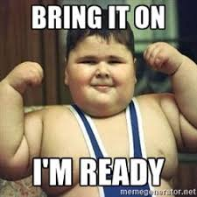My lack of strength often results in me losing possession when going in for tackles

**Aspect – Power**

**Positive effect on performance**

* Leg power is required to jump high in the air to compete for defensive headers in order to clear the ball away from the danger area
* Leg power is required to jump high in the air to compete for attacking headers to convert crosses and corners into scoring opportunities.

**Negative effect on performance**

* I often lose out in aerial challenges as I can’t get high enough off the ground to compete for the ball.
* When shooting I find that the keeper has little trouble in dealing with my shots as they lack power.

**Aspect – Agility**

Agility is the ability to change the position of the body quickly, precisely and with control. This uses a combination of speed and flexibility.

**Positive effect on performance**

* I find I can change direction quickly to get into space to receive a pass.
* Even when I am being closely marked, I manage to get away from the oppositions defenders to either cross the ball into the box or have a shot on goal.

**Negative effect on performance**

* The opposition’s defenders find it easy to mark me as I am slow to move and turn when looking for a pass.
* I rarely manage to pick up loose balls as I find it difficult to change direction quickly.

**Methods of Gathering Information on the Physical Factor**

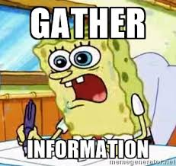We require to gain information on our fitness. Any fitness assessment must take into account the **nature of the activity, standardised test procedures, and regular monitoring of performance.** To do this we need Initial and Focused data. This fitness assessment can be done in the following ways;

1. Standardised Fitness Tests
2. Time Related Observation Schedules / Movement Analysis Schedules

**Standardised Fitness Tests**

These are tests that measure an athlete’s level of one specific type of fitness.

Information is collected out of performance with a scientific test that measures a specific type of fitness and provides the athlete with a ‘rating’ - usually in comparison to normative data.

**This is a useful method because**:

1. The tests follow a set protocol (set of rules) which make the results valid and reliable
2. The tests have been developed over many years by sports specialists and are proven to be valid
3. The results from tests can be compared against ‘normative data’ to give an accurate level of fitness – this means you can find out your level of fitness compared to similar age groups across the nation
4. They can be used at different points during training to measure how much progress has been made

**Observation Schedule**

These are sheets which are used to record information when an athlete performs in a competitive situation.

Information can be collected by someone else who watches your performance, or you can collect the information yourself when watching a recording of your performance.

**This is a useful method because**:

1. It collects information about how you perform *under pressure* in a competitive situation.
2. In a competitive situation, you are likely to be performing to your best ability.
3. The observations that are recorded relate to the different factors that impact on performance in that event.
4. Having time segments allows the performer to see how their performance is affected throughout the duration of the game and is particularly useful when looking at Aspects of Fitness
5. By using some of the methods highlighted above you should be able to highlight any areas of strength in your performance but also areas of weaknesses that require development. The information gained also allows you to assess which methods of practice would be most suitable to develop your weaknesses.

**How do we gather information on your performance?**

*Gathering Data within the activity - This involves the fitness level of a performer being assessed while they participate within the activity. Thus the methods that are used have to be carried out as the activity takes place without influencing or intruding on the actual activity*

It is important that the evidence that you collect is **reliable** and **valid**.

To do this it helps if you:

* Observe more than one game, so that the chance of a lucky or unlucky match is reduced.
* Play against evenly matched opponents, so that you can be tested and it gives a good representation of your ability.
* Gain objective, hard facts as evidence.
* Are observed in an actual game rather than just a practice.
* Have an experienced observer watching your performance or have it filmed to ensure that you do not miss any important information.

**Initial Data Collection**

I gained information on my performance in Football by using a ***Observation Schedule*** in conjunction with a video.

* When did you carry it out?
* Where did you carry it out?
* What was the reason for you carrying it out?
* Who Videoed you?
* Videoed in 2 matches, ***WHY?*** *-* More than one game reduces the element of luck or chance, therefore making the data more reliable and allows more data to be gathered.
* Played against evenly matched opponents, ***WHY? -*** Allows me to be tested so that a realistic assessment of my performance can be made. If I play against a very weak or very strong opponent, it is difficult to make a true analysis of my performance.
* How did you construct the Observation Schedule?
* I took the video home, watched it, and recorded the information on an Observation Schedule. This provided me with Initial data.
* How did you complete the Observation Schedule?
* What information did you gain from completing this process?
* What can you do with this information?



**Observation Schedule**

**(C.R.E)**

I constructed this by;

- Listing the main skills of the game across the top of the schedule

- Dividing the schedule into time zones to allow me to compare my performance at different times in the game

- I filled in a tick or cross for each successful or unsuccessful skill

- I left space at the bottom of the schedule for any comments that may not be obvious from the schedule

Name of Performer - Name of Observer –

Date - Venue - Score in Game -

|  |  |  |  |  |  |  |
| --- | --- | --- | --- | --- | --- | --- |
| **Time** | **Control** | **Passing** | **Dribbling** | **Tackling** | **Heading** | **Shooting** |
| **0 -10** |  |  |  |  |  |  |
| **11 - 20** |  |  |  |  |  |  |
| **21 – 30** |  |  |  |  |  |  |
| **31 - 40** |  |  |  |  |  |  |
| **41 – 50** |  |  |  |  |  |  |
| **51 - 60** |  |  |  |  |  |  |
| **61 - 70** |  |  |  |  |  |  |
| **71 - 80** |  |  |  |  |  |  |
| **81-90** |  |  |  |  |  |  |

|  |
| --- |
| **General Comment** |

**Observation Schedule**

As the game progresses my performance starts to decline. There are more errors occurring across most of the skills the longer the game progresses. As a result of this I am becoming less involved in the game as I am performing less skills. From this I can conclude that my C.R.E is a weakness.

**Observation Schedules – this is an ANALYTICAL tool**

**Advantages & Disadvantages**

**(A)** It is a simple and easy method to understand meaning that information can be gathered quickly and accurately

**(A)** The data collected is concrete and systematic as it looks into every skill used in the game as well as every minute of the game.

**(A)** It gives an accurate; true reflection of the performers ability as the analysis takes place within the actual game meaning the information is reliable

**(A)** Can be used to compare different parts of the same performance, e.g. first half compared to second half meaning the impact of fitness can be identified in performance

**(A)** The information gained identifies strengths and weaknesses and provides a starting or base level on which training programmes can be built

**(A)** Provides numerical data which makes it easy to set future targets and quickly monitor and see improvements in performance

**(A)** Data gathered is objective meaning that it is true and not based on opinion meaning that it can fairly be used to make comparisons

**(A)** Filming the performance means that no information is missed and results are more reliable

**(D)** There are many variables outside your own fitness level which may affect your results. Such as the quality of your teammates, opponents, the weather that day, if your team scored an early goal etc.

**(D)** Whether a skill is deemed successful or unsuccessful is subjective and is down to the observer’s option. This makes the results less reliable.

**Observation Schedule**

|  |  |
| --- | --- |
| Benefits | |
| Naturally occurs | Does not take time away from training. |
| Constant Gage | I was able to use this method every week which allowed me to keep a constant gauge of my improvement. |
| Comparison with a constant | The range of players I am playing against are not in the Higher PE class completing a programme to develop their C.R.E. This means that if my results maintain the same this is because there has not been any improvement in performance and not simply because both me and my opponents CRE has improved. |
| Practical Impact | This analysis takes place within my activity and allows me to see the practical impact my training has had on my performance. It enhances my motivation as I can see results which relate to my target. |
|  |  |
| Limitations | |
| Games off | Over winter periods and holidays there may be a significant amount of time when no games take place which would mean no information would be produced to track progress. |
| Varied quality of opponents | The quality of opponents that I face from one week to the next may vary dramatically. So changes in my performance may be due to my opponents rather than improved skill/fitness. |
| Finding someone to watch me | Finding someone who is willing to watch me consistently for a full match is difficult and my failure to find someone can produce gaps in my monitoring. |
| Change of position/tactic/  teammate | A variety of things may happen during a game which would alter the statistics I would produce and would make the comparison of my data invalid. For instance the coach may change formation, move my position or play me alongside a stronger/weaker player. All this aspects could alter my statistics making a judgment on my fitness/skill less valid. |

**Focussed Data Collection**

*Gathering Data out with the activity - This involves the fitness level of a performer being assessed while they participate out with the activity. The methods used here are usually some form of Standardised Fitness Tests. These tests usually have set protocols and to be of use should be done under the same conditions each time. Results gathered from these tests can be compared with National Averages*

Having gained your Initial Data you are now in a position to look more closely at specific weaknesses in your performance.

To confirm the information found on my Observation Schedule I decided to perform a Cooper Test/ Multi-Stage Fitness Test as this is a test specifically designed to measure a person’s levels of CRE.

* When did you carry it out?
* Where did you carry it out?
* What was the reason for you carrying it out?
* Were there any other people involved? If yes, what did they do?
* What information did you gain from completing this process?
* What can you do with this information?

*Remember to include a description of what you actually did when completing the test!!!*

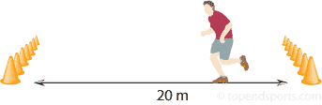

**COOPER TEST**

**(C.R.E)**

**The 12-minute Cooper run is a test that measures the fitness of your heart and lungs**

**TASK**:

The aim of the test is to travel as far as possible in 12 minutes around a set area. You should do this by running, jogging or even walking but you must not stop completely at any time during the test.

The further you travel the better your score will be as it is measured by the number of metres you have covered after 12 minutes.

Record your results by checking the chart for your own age and sex.

|  |  |  |  |  |
| --- | --- | --- | --- | --- |
|  | 15-16 Years  (meters) | | 17-18 Years  (meters) | |
| **RATING** | **Male** | **Female** | **Male** | **Female** |
| Excellent | 2800 | 2100 | 3000+ | 2300+ |
| Very Good | 2500 | 1900 | 3000 | 2300 |
| Good | 2300 | 1700 | 2500 | 1800 |
| Fair | 2200 | 1500 | 2300 | 1500 |

**I completed _____________ laps**

**The distance I covered was____________________**

**My fitness rating is_________ when I compared myself to the norm table above.**

**Multi - Stage Fitness Test (CRE)**

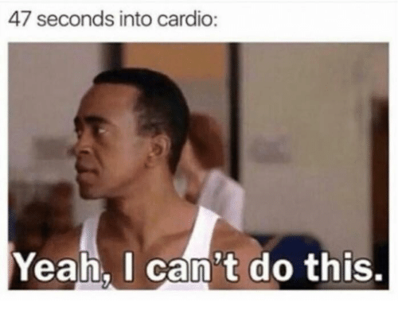**Date:** ________________________

**Required Resources**

* Non Slip Surface
* Multi - Stage Fitness CD
* Tape Measure
* Cones
* CD Player

**How to Conduct the Test**

This test requires the athlete to run 20m in time with a beep from a CD recording. The athlete must place on foot on or beyond the 20m marker at the end of each shuttle.

* Two cones are set 20 metres apart.
* An assistant starts the CD and the athlete commences the test.
* If the athlete arrives at the end of shuttle before the beep, the athlete must wait for the beep and then resume running.
* If the athlete fails to reach the end of the shuttle before the beep twice in a row they are withdrawn and a score taken.

**Score: _____________________________**

**This means I am in the ___________________________ category for CRE.**

|  |  |  |  |  |  |  |
| --- | --- | --- | --- | --- | --- | --- |
| **GENDER** | **AGE** | **EXCELLENT** | **ABOVE AVERAGE** | **AVERAGE** | **BELOW AVERAGE** | **POOR** |
| **Male** | 14 - 16 | L12 S7 | L11 S2 | L8 S9 | L7 S1 | < L6 S6 |
| **Male** | 17 - 20 | L12 S12 | L11 S6 | L9 S2 | L7 S6 | < L7 S3 |

|  |  |  |  |  |  |  |
| --- | --- | --- | --- | --- | --- | --- |
| **GENDER** | **AGE** | **EXCELLENT** | **ABOVE AVERAGE** | **AVERAGE** | **BELOW AVERAGE** | **POOR** |
| **Female** | 14 - 16 | L10 S9 | L9 S1 | L6 S7 | L5 S1 | < L4 S7 |
| **Female** | 17 - 20 | L10 S11 | L9 S3 | L6 S8 | L5 S2 | < L4 S9 |

**Standardised Fitness Tests**

**Advantages**

**(A)** Demonstrates strengths and weaknesses within a performer’s fitness profile meaning a suitable training programme can be developed.

**(A)** The numerical data supplied allows realistic targets to be set for our training programme which will give the performer enhanced motivation.

**(A)** Provides numerical data which allow us to monitor and evaluate our performance development easily at the start, middle and end of our training programme.

**(A)** Can be compared to norms and averages. This allows you to compare yourself to a larger sample of results and gives a better indication of your fitness compared to just people in your class.

**(A)** Provides a permanent record of your fitness levels meaning it can be used throughout training to easily identify improvements

**(A)** The test has very few variables, this means it is easy to recreate and make accurate comparisons.

**Disadvantages**

**(D)** It is difficult in controlling external conditions. This will include weather, state of mind of your athletes, injury

**(D)** An improvement in your cooper test result may simply be down to your enhanced knowledge of the test and being able to run it at a more even pace

**(D)** There is a danger of over testing which will take too much time away from a training programme. Any testing must be planned as part of your training schedule and not just testing for the sake of it.

**(D)** Due to the test being outside the activity it does not mirror the type of running demonstrated in football.

**Challenges to gathering data on performance**

There are many challenges when gathering valid and reliable information on your performance:

* **Game length** – is it long enough to see a full performance and gather valid information on your full skill set?
* **Opponents** – did you play opposition of similar ability so you were fairly challenged and could demonstrate an accurate representation of your skills?
* **Setting** – Was it in a competitive setting? Did this give a realistic view of your skills under proper pressure?
* **Understanding** – Did the observer understand how to complete the method and did he understand the game? Was he able to complete the schedule properly?
* **Focus** – Was the observer focussed on the performance? Did he miss any shots? Was he able to gather fully reliable and accurate information?
* **Feelings** – Was it completed with effort and honesty? Was it biased? Did this impact the validity of the results?
* **Time of Completion** – Was it completed straight after a game? Does this make results more reliable?

**Approaches to Develop CRE**

**Interval**

Alternating activity with periods of rest. (E.g. 10x50m sprints with 15secs rest).

Can improve Cardio-Respiratory Endurance (aerobic and anaerobic) and speed / speed endurance.

**Continuous**

A whole body activity (such as, running, cycling, rowing, swimming) that is performed without a rest. Normally done at a Medium intensity (60% - 80% MHR) and lasting a minimum of 20mins.

Can improve CRE.

**Fartlek**

Also known as ‘speed play’. The pace of the activity is varied (e.g. jog, run, sprint, jog, walk, run, and sprint). Particularly good for games players as it reflects the short bursts of intense activity followed by periods of low intensity movements.

Can improve Cardio-Respiratory Endurance (aerobic and anaerobic) and speed / speed endurance.

**Game Related**

Training through the game. This method incorporates skills training into games training. This develops skills and fitness at the same time. It can be designed to meet specific needs.

**Game Related Training**

**Advantages**

**(A)** Can improve skill as well as fitness. This is particularly beneficial when you have time constraints on your training.

**(A)** While developing fitness, we can become more familiar with certain game phases and players meaning we are able to improve CRE and gain a deeper understanding of our team mates’ strengths and weaknesses

**(A)** It can motivate us more as it can be more enjoyable than traditional CRE approaches meaning we are more likely to try harder

**(A)** It involves the same work: rest ratio as in the game and mirrors the same movements and fitness requirements of a match meaning that fitness and CRE improvements made are specific to the demands of football

**(A)** The level of demand can match that required in the game meaning that we can improve various aspects of physical, emotional, social and mental aspects of performance at the same time.

**Disadvantages**

**(D)** Fitness may not be developed due to practices constantly breaking down due to a lack of skill level or understanding.

**(D)** You can only use this type of training when your teammates are available meaning that you must always rely on others and can’t complete it whenever you want.

**(D)** Sessions will be tailored for the needs of the groups which may be too hard/easy for you meaning you are not able to develop at the optimum rate specific to your needs

**Example**

Small sided games with no goalkeepers/ multi-ball system/ limited touches/ multi-goal system/ dribble over the line

**Interval Training**

**Advantages**

**(A)** This type of training can reflect the high pace, high intensity situations that occur in a real game meaning that fitness and CRE developed is specific to the needs of football.

**(A)** You can work on your own at a time that suits you, and doesn’t require any specialist equipment meaning this approach can be used anywhere and anytime dependent on your needs.

**(A)** Easy to adjust workloads (longer sprint, shorter recover time, more reps) meaning that it can easily be made adapted to suit your progression and provide appropriate challenge.

**(A)** It is easy to measure progress and improvement meaning that it is easy to see if targets have been met and to then set new targets to provide motivation

**Disadvantages**

**(D)** It can be hard to keep going when you start to fatigue meaning that it is easy to give up and therefore stunt development.

**(D)** Can become boring for the performer meaning that effort levels decline and therefore improvement is slowed down.

(D) Easy to cheat and cut corners, etc meaning that fitness will not be developed at the optimal rate

**Example**

Cones set out at 10-15-20-30m. Performer must sprint to each cone and back within 10-15-20-30 secs and repeat 2 times. Performer is then given 1 minute rest and repeats again 4 times.

**Continuous Training**

**Advantages**

**(A)** Needs only a small amount of easy to use, accessible equipment, if any meaning that it can be carried out anywhere and anytime to suit your needs.

**(A)** Easy to record and monitor progress meaning it is easy to see improvements and change frequency, intensity or duration in order to provide suitable challenge.

**(A)** Working levels can be tailored to suit individual performers meaning that training will always be specific to your needs.

**Disadvantages**

**(D)** Can be boring for the performer meaning effort levels may drop and therefore slow down improvement.

**(D)** Doesn't improve anaerobic fitness so isn't as good for team games like football which involve short bursts of speed.

**Example**

Running around a track for 25 minutes at a steady pace. Checking that heart rate is within the training zone.

**Fartlek Training**

**Advantages**

**(A)** Can easily be changed to meet the needs of the performer – meaning training can be made harder or easier based on development to ensure performer is being challenged appropriately (e.g. change F. I. D)

(A) Requires no specialist equipment – suitable for use within schools and can be completed almost anywhere

(A) Includes various changes of pace – mimics same movements as football whilst developing CRE meaning performers can cope with full game demands better

**Disadvantages**

(D) Easy to skip hard parts – meaning performer might not be pushing themselves and therefore not developing as quickly

(D) Boring – performer may lose interest and stop trying

**Example**

100m square – performer must jog 25m, sprint 25m, walk 25m & side step 25m). This should be performed 4X5 mins with 1 mins rest in between.



**Emotional Factor**

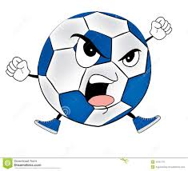

When taking part in any competitive situation whether it be in a Football match or a Gymnastics competition the ability to control your emotions is extremely important and can often have substantial consequences on the outcome of the performance.

In football, if a player losses their temper during a game it does not just have an effect on their own personal performance. The player may be booked or sent off by the referee, they may lose focus on their role in the team and they may also start to make poor decisions.

**Possible Negative Effects on Performance**

Too much aggression in Football has a significant effect on performance. Also, increased tension in the muscles impacts negatively on the fluency of play.

* Over arousal impacts a player’s ability to respond to situations and make appropriate decisions on the pitch resulting in a decline in form. It can be as simple as a player shouting at themselves after a bad pass, physically lashing out or even exerting themselves in a skill, such as too much power when shooting.
* Uncontrolled aggression leads to frustrations and results in a player acting irrationally and this increases a players self -doubt.
* A player can be drawn into making silly fouls against opponents and eventually anger and lack of self-control built up too many fouls until a player is substituted, booked or even sent off.
* Players with a lack of self-control will lash out verbally at their team mates and blame others for their own failings. This seriously impacts the cohesion of the team when players have to deal with an unpredictable, volatile personality.
* A bad attitude will impact on their concentration and can lead to a team losing by a bigger margin as this player can become less involved in the game due to lack of motivation.

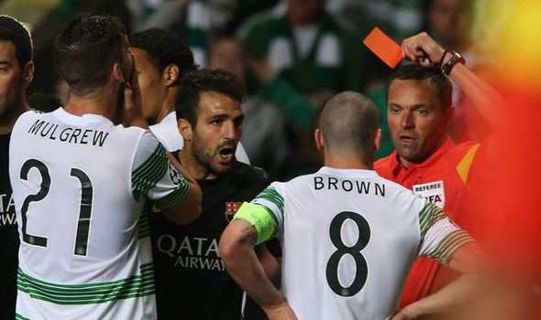

**Methods of Gathering Information**

Emotional Control Record – this is an ANALYTICAL tool

**Name:**

Your partner will watch you playing a Football match against opponents of similar ability to you. They will assess your discipline during the match using the record below. Each time they observe you exhibit one of the behaviours or actions listed they will place a tally mark in the appropriate box.

|  |  |  |  |
| --- | --- | --- | --- |
| Behaviour/Action | First Half | Second Half | Overall Score |
| Negative body language to personal mistake |  |  |  |
| Negative body language to team mistake |  |  |  |
| Negative verbal reaction to personal mistake |  |  |  |
| Arguing with team |  |  |  |
| Arguing with the other team |  |  |  |
| Contesting referee’s decision |  |  |  |
| Decrease in effort |  |  |  |
| Foul |  |  |  |
| Cynical Foul |  |  |  |
| Act of sportsmanship |  |  |  |
| Off the ball incident |  |  |  |
| Use of positive praise |  |  |  |

**Major incidents that affected discipline during the game**

**How did you carry out the emotional control record?**

To collect information on my emotional state (specifically anger) during a Football match I used an emotional control record. This record listed various emotional actions and/or behaviours that a performer might exhibit during a match. They included:

* **Negative Body language**
* **Negative verbal exchanges with team mates, opposition, officials**
* **Effort levels**
* **The number of fouls committed**
* **Acts of sportsmanship**

Whilst playing a match against opponents of equal ability an observer marked down each time I exhibited one of these actions/behaviours by placing a tally mark in the appropriate box. They recorded this information for both halves of the match and calculated my total score for each action/behaviour at the end of the game. The discipline record was completed at the beginning, middle and the end of the Football block.

**Advantages and Disadvantages of using an Emotional Control Record**

**Advantages**

**(A)** The written format provides a permanent record that allows for comparison at a later date.

**(A)** Having an observer provides objective feedback which is non-bias providing more accurate results.

**(A)** All tally marks can be converted into statistics which are hard to argue with and make future comparisons easy.

**(A)** Strengths and weaknesses relating to emotions can be identified from the record which future performance development programmes and goal setting can be based upon.

**(A)** Objective feedback by a person with activity knowledge ensures validity and reliability of the results to create a detailed analysis of emotional state.

**(A)** By playing a full game of Football against opponents of equal ability allows the observer plenty of time to collect valid, reliable and accurate information. The duration of the game gives the observer time to observe patterns of behaviour.

**Disadvantages**

**(D)** When you have someone else recording information on performance the validity of the results are dependent on the observers focus and attention during the match and the importance they place on the process.

**(D)** Football is a very fast paced sport and there is likely to be a number of incidents and patters of play. If an observer takes their eye of the match to complete the record they may miss something which brings into question the reliability of the findings.

**(D)** The content of the discipline record has to be correct in the first place to focus on key elements of emotional performance.

**(D)** The information which is being collected is based on an observer’s perception of what represents a negative behaviour or action. Subsequently, this could impact on the validity of the results as it could be a bias assessment.

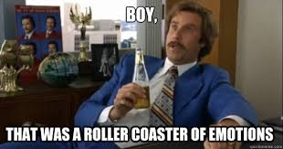**Sports Competition Anxiety Test (SCAT)**

Name: ____________________________________ Date:_______________

Answer the following question by shading in the most appropriate area on the chart.

Question Answers

1 .Rarely 2. Sometimes 3. Often

1. Competing against others is socially enjoyable
2. Before I compete I feel uneasy
3. Before I compete I worry about not performing well
4. I am a good sportsman when I compete
5. When I compete, I worry about making mistakes
6. Before I compete I am calm
7. Setting a goal is important when competing
8. Before I compete I get a queasy feeling in my stomach
9. Just before competing, I notice my heart beats faster than usual
10. I like to compete in games that demands a lot of physical energy
11. Before I compete I feel relaxed
12. Before I compete I am nervous
13. Team sports are more exciting than individual sports
14. I get nervous wanting to start the game
15. Before I compete I usually get uptight

Qu. 15

Qu. 14

Qu. 13

Qu. 1

Qu. 12

Qu. 2

Qu. 11

Qu. 3

Qu. 10

Qu. 4

Qu. 7

Qu. 8

Qu. 9

Qu. 5

Qu. 6

**Sports Competition Anxiety Test (SCAT)**

SCAT Test Marking Criteria

|  |  |  |  |  |
| --- | --- | --- | --- | --- |
| **Question** | **Rarely** | **Sometimes** | **Often** | **Score** |
| **Qu 1** | 0 | 0 | 0 |  |
| **Qu 2** | 1 | 2 | 3 |  |
| **Qu 3** | 1 | 2 | 3 |  |
| **Qu 4** | 0 | 0 | 0 |  |
| **Qu 5** | 1 | 2 | 3 |  |
| **Qu 6** | 3 | 2 | 1 |  |
| **Qu 7** | 0 | 0 | 0 |  |
| **Qu 8** | 1 | 2 | 3 |  |
| **Qu 9** | 1 | 2 | 3 |  |
| **Qu 10** | 0 | 0 | 0 |  |
| **Qu 11** | 3 | 2 | 1 |  |
| **Qu 12** | 1 | 2 | 3 |  |
| **Qu 13** | 0 | 0 | 0 |  |
| **Qu 14** | 1 | 2 | 3 |  |
| **Qu 15** | 1 | 2 | 3 |  |
|  |  |  |  | **Total=** |

**How is it carried out?**

* 15 Questions were answered by shading in correct area of graph
* Questions were answered with a 1 (rarely), 2 (sometimes), & 3 (often).
* An example question is ‘Before I compete I feel uneasy’
* Scores were then marked on the table and calculated to give a total
* This was completed before taking part in a match
* The total score from the table was then compared to SCAT marking criteria
  + 10-14 low anxiety
  + 15-20 low/ medium anxiety
  + 20-25 medium/ high anxiety
  + 26-30 high anxiety

**Advantages**

* It can allow you to gather information on a wide range of feelings and emotions – meaning you can make training appropriate to develop on weakest areas.
* It is simple to complete and easy to understand – meaning that it is completed correctly with no mistakes
* It is not time consuming and is quick to complete – meaning that training time is not wasted and it can be used quickly to monitor progress

**Disadvantages**

* Based on your mood on the day meaning totally valid comparisons cannot be made to check for improvements
* May give bias opinions meaning that results are not a true reflection of your actual emotional state
* May see the process as pointless meaning that no effort is put in to completing the test and therefore results lack accuracy

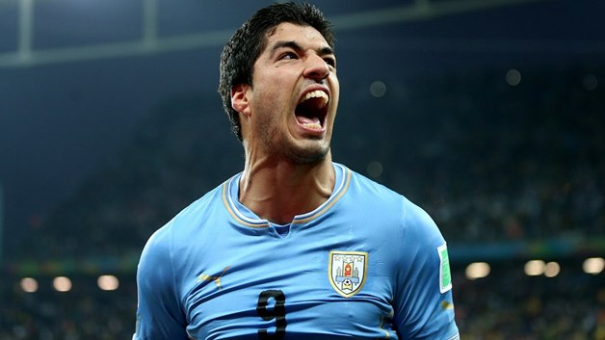

**Approaches to Developing Emotional Factors**

**Controlling Emotions**

**Positive Self Talk**

Positive self-talk can be like an internal coach, encouraging you, boosting your confidence, believing in you, and motivating you to achieve your goals.

If you feel anger building up inside you during the game using positive self-talk will help you to maintain composure, particularly after making a mistake or error. The **3 R's** approach is an excellent method to take:

1. **Recognise** that you are dwelling on the mistake, which limits your ability to focus on the next phase of play.

2. **Regroup** by interrupting this negative chain of thought. This requires you to battle your own emotions and dispute your irrational thinking. Using positive self-talk helps in this situation e.g. saying to yourself "Be patient, you're better than that".

3. **Refocus** is then crucial for the next phase of play. Ask yourself what you need to focus on right now to do your best in the next phase of play. The answer will help you refocus on the game.

**When to practice the 3 R's approach?**

The 3 R's approach can be practiced during every training session, particularly during pressure drills, conditioned games or practice matches. These methods of practice replicate similar pressures to what you would experience in a game which can be unpredictable and open. Subsequently, you are likely to experience the same types of emotions e.g. getting angry when you make a mistake.

**Advantages and Disadvantages of using Positive Self talk**

**(A)** Refocus the athlete instantly when the need arises e.g. a performer is angry after making a mistake, positive self-talk can help get things back on track by composing the athlete and getting them to focus on what's important in the game straight away.

**(A)** Having continually practiced positive self-talk during training sessions you will be able to cope with game pressures allowing you to automatically remain calm and stay in control at all times.

**(D)** This type of approach takes a lot of practice for it to have a positive impact. If performers do not use it in every training session in order to master the technique, especially with fast paced and complex sports, they will struggle to use it in full competitive games when needed.

**(D)** You must be physically able and proficient at football for this technique to be successful. If you are unable to perform the basic skills and movement patterns of the game, positive self-talk will be ineffective.

**Deep Breathing**

**What is Deep Breathing?**

* Deep breathing is a recognised approach that is used to help manage a performer’s anger or level of aggression.
* When a performer experiences a heightened level of aggression the first thing that is disrupted is their breathing. This means their body does not receive enough oxygen. This can lead to increased levels of frustration and consequently higher levels of aggression.
* By taking slow, deep breaths, it is possible for the performer to significantly lower their level of aggression and gain control of their emotions.

**How to use Deep Breathing**

* When a performer feels that their level of aggression is rising or they feel they have lost control, they should attempt to regain control by ‘deep breathing’
* Inhale and completely fill the lungs in a slow and controlled manner, aiming to take in as much oxygen as possible
* Exhale slowly while concentrating on controlling the breathing muscles
* This should be repeated 3 or 4 times, or until the performer has a positive feeling of being in control
* For example, when the performer strongly disagrees with a decision made by the referee, they should take 3 deep breaths while focussing on how they are going to defend against the next attack
* This technique should always be practiced in training sessions to ensure the performer is able to carry it out in competitive situations
* As the performer becomes aware of the ‘triggers’ or situations that raise their level of aggression, they will be able to quickly and effectively respond in the appropriate manner by means of ‘deep breathing’ control techniques.

**Advantages and Disadvantages of using Deep Breathing**

**(A)** Deep Breathing does not require any complex training or equipment meaning it is suitable for use in schools.

**(A)** If performed effectively, ‘deep breathing’ can clear the mind of frustration which can lower levels of aggression instantly and allow performers to carry on with their performance effectively.

**(D)** The performer may find it difficult to take the technique seriously, meaning the method will be ineffective.

**(D)**If the performer does not allow the method time to work, they may become frustrated which could ultimately increase their level of agitation and aggression.

**(D)** The performer may not be aware of their own trigger situation, which means they will not utilise the method at the appropriate time.

**(D)** Lack of practice could render the method useless if they are unable to perform it under stressful situations experienced in a competitive game.

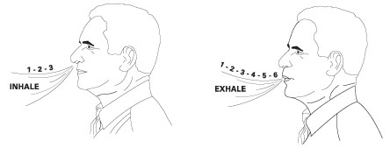

**MENTAL**

**FACTOR**

[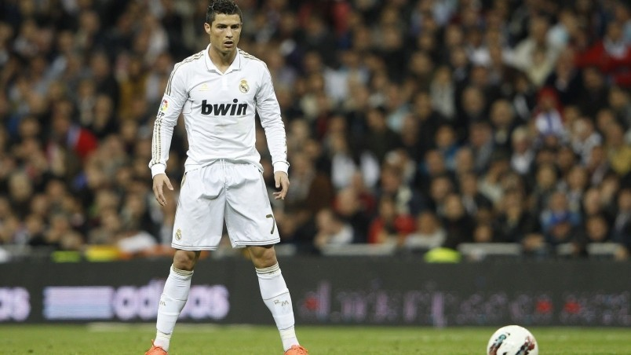](http://www.google.co.uk/url?sa=i&rct=j&q=&esrc=s&source=images&cd=&cad=rja&uact=8&ved=0ahUKEwiZjJ3Ii_DMAhWEJcAKHdugCFkQjRwIBw&url=http://wallpaperfx.com/sports/football/cristiano-ronaldo-concentrating-wallpaper-15754.htm&bvm=bv.122676328,d.ZGg&psig=AFQjCNEN4lPaPtJz31mWjPn6P3VzPYnldQ&ust=1464089185281296)

**Decision Making & Level of Arousal**

**DECISION MAKING**

**Definition**

Decision-making is an action or process of choosing a preferred option or course of action from a set of alternatives. It forms the basis of all deliberate and voluntary behaviour.

**Impact on Performance**

Quality decision making is a critical skill in sports. The quality of your decisions has a massive impact on your results. Experience plays a significant part in the decision making process. If you make the right decision on a regular basis you are likely to experience positive outcomes.

The best tennis players usually select the right return shot to play based on several factors. Due to their experience and skill and level of performance the decision making process is instant.

Making poor decisions can often lead to the loss of possession or loss of points or goals. In Football, if the wrong decision is made when passing out from defence it can lead to an interception and 1 v 1 situation on your goal.

**LEVEL OF AROUSAL**

Level of arousal in Football may be described as how motivated or complacent you are about the performance you are about to give.

The correct level of arousal allows you remain focused and determined for every skill you perform or for each situation that occurs during the match, producing your best performance no matter what. You are therefore more likely to make produce a positive result if your level of arousal is appropriate.

Having too high a level of arousal may produce a rushed, lower quality performance which may not reflect your true ability. It can also develop tension in your body which could result in a player diving into tackles or trying to do too much on the ball.

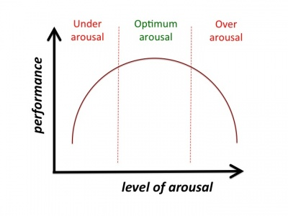Conversely having a low level of arousal can lead to a casual performance where you skills level is poor and sloppy. This can occur if you are competing against opponents who are of a much higher quality than you and you begin to allow negative thoughts such as ‘We’re never going to beat them’ or even if you are competing against someone you have beaten easily in the past who may be of a much lower standard than you are and as a result you don’t give the performance your best effort which again means the performance could be of lower quality than you would normally produce ‘We’ll beat them easily anyway so I don’t need to try as hard’.

Mental Toughness Questionnaire – this is an ANALYTICAL tool

**Section 1**, questions 1-6, deal with **“Reboundability”** or your skill at mentally bouncing back from setbacks and mistakes. Mental toughness depends on your ability to quickly leave your mistakes and failures behind you. Hanging onto your mistakes will get you into big trouble, performance-wise. Athletes, who dwell on their mistakes while the competition continues, end up making more.

**Section 2**, questions 7-12, deals with the **ability to handle pressure**. Without the ability to stay calm in the clutch, an athlete will always underachieve. Peak performance demands that you are relaxed once the performance begins. While a little nervousness is critical for getting “up” for a game / match / race and performing at your best, (“good nervousness”) too much nerves (“bad nervousness”) will tighten your muscles and send your performance down the tubes.

**Section 3**, questions 13-18, deals with your **concentration** ability. In every sport, your ability to focus on what’s important and block out everything else is one of the primary keys to performance excellence. Poor concentration is the major reason why athletes “choke” and get stuck in performance slumps. Getting psyched out or intimidated is a direct result of concentrating on the wrong things.

**Section 4**, questions 19-24, deals with **motivation**. Motivation is the fuel that will drive your training to a successful completion and the accomplishment of your goals. Without adequate motivation athletes get stuck having “permanent potential”. Without motivation you won’t put in the work necessary to become a winner. Your motivation allows you to pick yourself up after a setback and keep going.

**Section 5**, questions 25-30, deals with **Level of Arousal**. This is the ability to control your state of alertness in order to perform at your optimum level. An athlete who is under-aroused will be over relaxed and may miss vital signals in the game. In contrast, an athlete who is over-aroused will have an adrenaline surge which will result in them over-anticipating cues and making mistakes and panicking.

**Section 6**, questions 31-36, deals with **decision making**. This is the ability to process information and respond to cues in the game, resulting in an appropriate motor response from a number of options. An athlete who can make decisions quickly and effectively will experience positive outcomes, however poor decisions can lead to loss of points, loss of concentration and frequent errors.

|  |  |  |
| --- | --- | --- |
| **Section 1 - REBOUNDABILITY** | True | False |
| 1) I frequently worry about mistakes. |  |  |
| 2) I get really down on myself during performance when I mess up. |  |  |
| 3) It’s easy for me to let go of my mistakes. |  |  |
| 4) If I start out badly, it’s hard for me to turn my performance around. |  |  |
| 5) I get distracted by what the coach thinks whenever I screw up. |  |  |
| 6) I bounce back quickly from setbacks, bad breaks and mistakes. |  |  |
|  | | |
| **Section 2 - HANDLING PRESSURE** | True | False |
| 7) I do my best when there’s more pressure on me. |  |  |
| 8) I get too nervous to really perform to my potential. |  |  |
| 9) I do better in practice than I do when it really counts the most. |  |  |
| 10) I tend to get easily psyched out or intimidated. |  |  |
| 11) I can keep myself calm and composed under pressure. |  |  |
| 12) I don’t want the ball, I dread competing at “crunch time.” (Big / Important Games) |  |  |
|  | | |
| **Section 3 - CONCENTRATION** | True | False |
| 13) The coach’s yelling knocks me off my game. |  |  |
| 14) I tend to get easily distracted. |  |  |
| 15) Certain opponents can get into my head and throw me off my game. |  |  |
| 16) Lousy playing conditions (weather, field conditions, temperature, etc) negatively affect me. |  |  |
| 17) I have no trouble focusing on what’s important and blocking everything else out. |  |  |
| 18) I think too much about what could go wrong right before and during performance. |  |  |
|  | | |
| **Section 4 - MOTIVATION** | True | False |
| 19) I get more motivated after failures and setbacks. |  |  |
| 20) It’s easy for me to consistently train at a high level of intensity. |  |  |
| 21) I think about how today’s practice will help me get to my goals. |  |  |
| 22) I find myself just going through the motions a lot in practice. |  |  |
| 23) I have clear goals that are important for me to achieve. |  |  |
| 24) I am a highly motivated athlete. |  |  |
|  | | |
| **Section 5 - LEVEL OF AROUSAL** | True | False |
| 25) I have some anxiety, worry or excess tension prior to or during competition. |  |  |
| 26) Pre-game jitters stay with me well into the competition and don’t go away. |  |  |
| 27) I often feel too excited or amped up to perform to my best in a competition. |  |  |
| 28) I sometimes feel distracted or confused when I perform under pressure. |  |  |
| 29) I am sometimes too laid back in training and competition. |  |  |
| 30) I sometimes miss vital signals in the game. |  |  |
|  | | |
| **Section 6 - DECISION MAKING** | True | False |
| 31) I can ignore irrelevant information during my performance. |  |  |
| 32) I can focus on more than one piece of information at a time. |  |  |
| 33) I frequently become overloaded which results in errors. |  |  |
| 34) My decisions are sometimes delayed, resulting in a slower response. |  |  |
| 35) I can adapt my play in response to different problems. |  |  |
| 36) I tend to make the same mistakes throughout a game. |  |  |

Mental Toughness Questionnaire

Marking Scheme

|  |  |  |
| --- | --- | --- |
| **QUESTION** | **TRUE** | **FALSE** |
| **Section 1 - Reboundability** | | |
| 1) | 0 | 1 |
| 2) | 0 | 1 |
| 3) | 1 | 0 |
| 4) | 0 | 1 |
| 5) | 0 | 1 |
| 6) | 1 | 0 |
| **Section 2- Handling Pressure** | | |
| 7) | 1 | 0 |
| 8) | 0 | 1 |
| 9) | 0 | 1 |
| 10) | 0 | 1 |
| 11) | 1 | 0 |
| 12) | 0 | 1 |
| **Section 3 - Concentration** | | |
| 13) | 0 | 1 |
| 14) | 0 | 1 |
| 15) | 0 | 1 |
| 16) | 0 | 1 |
| 17) | 1 | 0 |
| 18) | 0 | 1 |
| **Section 4 - Motivation** | | |
| 19) | 1 | 0 |
| 20) | 1 | 0 |
| 21) | 1 | 0 |
| 22) | 0 | 1 |
| 23) | 1 | 0 |
| 24) | 1 | 0 |
| **Section 5 - Level of Arousal** | | |
| 25) | 0 | 1 |
| 26) | 0 | 1 |
| 27) | 0 | 1 |
| 28) | 0 | 1 |
| 29) | 0 | 1 |
| 30) | 0 | 1 |
| **Section 6 - Decision Making** | | |
| 31) | 1 | 0 |
| 32) | 1 | 0 |
| 33) | 0 | 1 |
| 34) | 0 | 1 |
| 35) | 1 | 0 |
| 36) | 0 | 1 |

|  |  |
| --- | --- |
| **Section** | **Score** |
| Reboundability |  |
| Handling Pressure |  |
| Concentration |  |
| Motivation |  |
| Level of Arousal |  |
| Decision Making |  |

A score of 6 in any category means this is a mental strength for you

OVERALL SCORE

A score of -

* A score of **30 - 36** indicates strength in overall mental toughness.
* A score of **24 - 29** indicates average to moderate skill in mental toughness.
* A score of **23 or below** means that you need to start putting more time into developing mental factors.

**Advantages and Disadvantages of the Mental Toughness Questionnaire**

**(A)** Strengths and weaknesses can be identified from the questionnaire which future performance development programmes and goal setting can be based upon.

**(A)** The written format provides a permanent record that allows for comparison at a later date in order to check for performance developments.

**(A)** The performer is gaining lots of information on their mental state. The more information they have on their performance the more accurate and valid the results.

**(A)** Everyone in the class is answering the same questions. This reduces bias and increases the validity and reliability of the results because the performers are not being influenced by an interviewer.

**(D)** The information which is being collected is based on a performer’s perception of their mental performance. Subsequently, this could impact on the validity of the results as it could be a bias assessment.

**(D)** It depends on the importance a performer places on the process. If a performer doesn't take the process seriously this will impact of the validity of the results meaning they can’t be used to make fair comparisons.

**(D)** Results could be inaccurate if a performer misinterprets the questions.

**(D)** It can take a long period of time to collect and analyse the results.

**(D)** The questions being asked are only closed questions. A lack of open questioning means that the performer’s answers lack explanation, which could impact on the accuracy of the results.



**Gathering data on Level of arousal**

It is difficult to collect quantitative data (a number, measurement or score) for this factor but we can systematically ask ourselves questions which will give us our opinion on how we felt. We would use a Level of Arousal Questionnaire.

A coach, teacher or informed observer can also be asked to give their opinion on how you looked. This is all *subjective, qualitative data*, but it can be backed up with some other data from the performance e.g. the score for each skill in your gymnastics sequence would allow you to identify perhaps where mental factors started to impact on your performance in either a positive or negative way.

Comments like this can be checked with others and backed up by the judges’ scores and video for verification.

**Level of Arousal Questionnaire – this is an ANALYTICAL tool**

The following questions will help us gauge your level of arousal before, during and after a performance, therefore allowing you to work on it if required.

**Name: __________________ Date: ______**

**How did you feel before the performance?** (Confident, determined, positive, nervous, complacent, or negative) *Please state why you felt this way.*

**How did you perform at the start?**

**Did your attitude to the performance change in any way during the game?** When and why?

**How did you feel after the performance?**

A teacher, coach or informed observer should also watch and try to answer the same questions from what they see in you.

**From the answers above, what conclusions can you come to?**

**Gathering Data On Decision Making**

**Decision Making Grid – this is an ANALYTICAL tool**

Name: __________________________ Date: ___________________________

The person watching must place a tick or a cross in the box each time a situation occurs. A tick means a good decision. A cross means a poor decision.

|  |  |
| --- | --- |
| **SITUATION DURING MATCH** | **CORRECT OR**  **INCORRECT**  **DECISION** |
| In possession of the ball under no pressure from opposition in own half |  |
| In possession of the ball under no pressure from opposition in oppositions half |  |
| In possession of the ball under pressure from opposition in own half |  |
| In possession of the ball under pressure from opposition in oppositions half |  |
| Not in possession of ball in oppositions half |  |
| Not in possession of ball in own half |  |
| Comments | |

**Approaches to developing Mental Performance**

The following approaches can be used to develop mental factors in your performance.

Mental Rehearsal / Visualisation

Relaxation / Motivation Techniques

Game Related & Overload Practices

1**. Mental Rehearsal/Visualisation** is proving to be an understandably popular mechanism with elite athletes eager for marginal gains. The use of imagery primes their muscles to perform correct technique and to execute appropriate actions in competition, but it also conditions their mind to think clearly about how they will react to certain pressures, situations and problems. Consider it a ‘mental warm-up or walk through” of what you want to see happen. A vivid picture and strong feelings are like a magnetic attraction so be careful of what you picture with feeling, because you will be pulled in that direction. For the novice, Mental imagery may well improve confidence, relieve anxiety and help to control arousal levels.

[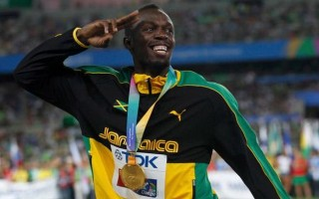](http://thecornerstones.net/blog/wp-content/uploads/2011/09/usain-bolt.jpg)*Over the years he [Usain Bolt] has developed mental skills. I taught him to visualize and always see himself winning regardless of who he competes against. If success is in your subconscious, it is a part of you. So when you see people, you see people you are going to beat. If you are nervous, you visualize failure. If you visualize winning, you have fun…”* – Glen Mills, Usain Bolt’s Coach***.***

[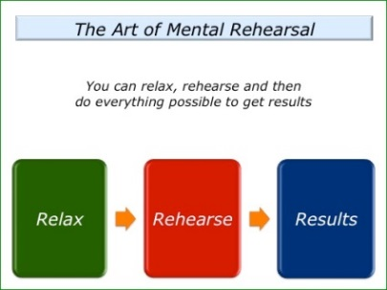](http://www.thestrengthsfoundation.org/3-tips-for-practicing-the-art-of-mental-rehearsal/slide1-290)

**When should it be carried out?**

This approach is carried out daily and focuses on different elements of the performance. Targets are set for all mental training to replicate goals during practice. Every eventuality should be visualized so that the performer is fully prepared for unpredictable situations. **It is equally if not more important than the physical training**.

**How to Apply Mental Rehearsal / Visualisation?**

* This method is used regularly by many of the world’s best tennis players. Novak Djokovic and Andy Murray both use imagery to prepare for games. Djokovic was taught to visualise his shots to the accompaniment of classical music by his first coach.
* Murray has even been known to [make several visits to a deserted Centre Court](http://www.theguardian.com/sport/2012/jun/24/wimbledon-2012-andy-murray-centre-court) in advance of Wimbledon in order to mentally acclimatise to the environment. “I have sat on Centre Court with no one there and thought a bit about the court, the matches I have played there,” Murray said. “I want to make sure I feel as good as possible so I have a good tournament.”
* A basketball player will use imagery in a free throw situation and close their eyes visualizing successful execution. (mechanics, flight of the ball, sound of the swoosh etc)
* A cyclist will rehearse their race knowing where all the uphill sections of the course are, where he or she plans to overtake, where the tight more technical section are etc.
* A gymnast will rehearse set skills in their routine and gradually develop this visual picture so that the full routine is linked together and performed fluently in the performers mind with an audience.
* **Picture Cristiano Ronaldo taking a freekick – What does he do? What is he thinking?**
* **Picture Steph Curry taking a free throw – Does he have a routine? What does he do? What is he focussing on?**

**Advantages of using Mental Rehearsal / Visualisation:**

* It can motivate the athlete by recalling images of success in past events meaning that they can remain confident and focussed on their skills.
* It can reduce negative thoughts by focusing on positive outcomes.
* Refocus the athlete when the need arises e.g. if performance is feeling sluggish or a few mistakes have been made - imagery of a previous best performance can help get things back on track.
* Set the stage for performance with a complete mental run through of the key elements of their performance to set the athletes desired pre-competition feelings and focus and to block out any distractions.
* Having rehearsed any eventuality you will be able to cope with pressure allowing you to remain calm and stay in control.

**Disadvantages of using this method:**

* Some athletes may imagine negative previous performances in past competitions or against a particular opponent, which can impact on performances and results.
* This type of approach takes a lot of practice for it to have a positive impact. Performers must use it every day in order to master the technique, especially with fast paced and complex sports like badminton.
* You must be physically able and proficient at badminton for this technique to be successful. If you are unable to perform the basic skills and movement patterns of the game, imagery will be ineffective.
* In the moment, this approach can be forgotten as distractions and external factors result in the performer missing the cue which identifies that fear, excitement could impact arousal level to refocus.

**Relaxation Techniques**:This may be done by listening to soft music or carrying out breathing exercises in a quiet area before your game. During the game we can try to relax by taking our time between points, calming yourself down before the next. If you are over aroused, the tendency is to play even faster and be impatient. This stops this bad habit and helps us regain focus. Conversely the opposite can be done to raise you level of arousal. (Fast music and reducing the time between rallies)

The above can be allied to **focus**. When relaxing before the game, you may think of scenarios which may occur during it. We then think of how we are going to react and **visualise** this.

E.g. If I win 4 or 5 points in a row, I’m not going to relax but push for an even longer run.

You may also think of your tactics, imagining the perfect rally or use **affirmation** to eliminate negative thoughts or experiences.

**Motivation Techniques** – opposite of relaxation techniques.

* Loud, fast paced music
* High 5’s, chest pumps, etc with team mates
* Encouragement, shouting and clapping with team mates
* Team captain constantly getting the team ‘up for it’

**Benefits of Relaxation/ Motivation Techniques:**

* Establishing a mental state which has an increased receptivity to positive mental imagery meaning previous success can be remembered therefore helping create a successful image of the forthcoming skill in the mind.
* Establishing an appropriate level of physical and mental arousal prior to competition therefore removing self-doubt and distractions, and increases concentration and performance.
* Clears the mind of mistakes and allows appropriate decisions to be made when under pressure.
* Requires no equipment meaning it can be carried out anywhere and anytime and is appropriate for use within school

**Limitations of Relaxation/ Motivation Techniques:**

* If we asked an under-excited athlete to use relaxation procedures it would only make it harder for him/her to "get-up" for the competition. The coach therefore has to know his/her athletes and how they react in competitive situations.
* If relaxation techniques are not rehearsed in an appropriate, quiet environment where the performer can zone out tension will continue to be experienced.
* If an athlete is not relaxed enough or committed to the process it will be ineffective. Some performers may not take it seriously and emotions therefore escalate.
* Both techniques sometimes require the assistance of team mates meaning that they cannot always be fully utilised individually and practice time is limited based on the availability of team mates.

**Game Related and Overload Practices**

Making the correct/incorrect decision during a Football match can have huge consequences on an individual performer and also their team. By using game related and overload practices the performer can practice in situations that arise during a match without the pressure they would experience in a competitive game. As the performer becomes used to situations through practice more pressure can be added to eventually replicate the pressure they would find themselves under during a competitive match. They would hopefully then be able to transfer their knowledge from these situations into the match.

**Advantages of using Game Related and Overload Practices**

**(A)** Can improve mental ability, skills and fitness. This is particularly beneficial when you have time constraints on your training.

**(A)** Helps you become more familiar with certain game phases and players allowing you to get used to making correct decisions in different situations.

**(A)** It can motivate us more as it is more enjoyable than traditional approaches, and can usually allow us to work with other people.

(A) As you can vary the pressure of these practices the performer can become better equipped mentally to deal with the situations when they occur in the game.

**Disadvantages of using Game Related and Overload practices**

**(D)** Mental factors may not be developed due to practices breaking down due to a lack of skill.

**(D)** You can only use this type of training when your teammates are available.

**(D)** Sessions will be tailored for the needs of the groups which may be too hard/easy for you.

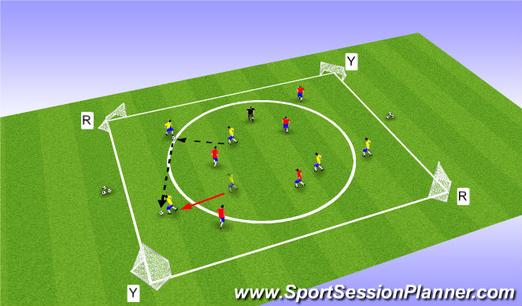

**Qualitative, Quantitative, Objective and Subjective Information**

This area relates to the type of information generated by data collection.

**Qualitative Data**

This relates to someone's thoughts, feelings and observations. It is non-numeric information which is very much based on someone's opinion.

**Quantitative Data**

This is information that can be directly measured and can be seen as factual information rather than opinion. The information collected is number based and provides hard facts.

Where possible a combination of quantitative, objective data, with some qualitative/subjective information provides a good starting point for planning performance development. This is because it gives a wide, detailed picture of the whole performance/factor.

**In order for data to be useful it must be**

* Accurate (True Reflection)
* Relevant (To Performer and Activity)
* Valid (Measures What it Should)
* Reliable (Consistent)
* Objective (Non-Bias)
* Comparative (Enables Comparison)

**The Benefits of Qualitative Data and Subjective Information**

* This type of information provides a more detailed analysis of performance e.g. the teacher/coach providing feedback on your play. The performer can build a more accurate picture of their strengths and development needs and use this to create realistic goals and a development plan.
* This type of data is useful for collecting information on Emotional, Mental and Social Factors that impact on performance. In comparison to quantitative data and objective information it can provide clearer information on human behaviour, interaction between team mates and motivation levels. When monitoring and evaluating performance this allows you to confidently adapt your programme or reassess goals as the data is more accurate and reliable.

**The Benefits of Quantitative Data and Objective Information**

* The data collected is easy to analyse e.g. by performing the 12 minute cooper test you can easily compare your score to the norms of people of the same age and gender to evaluate your cardio respiratory endurance.
* Comparing your score to standards for example in the Illinois agility test makes it easier to make accurate comparisons later on. The test conditions always remain the same and are easy to set up which makes it easier to benchmark performance and gain reliable data.
* Easy to collect information from large groups, quickly, which means that comparisons can be made and norms established to check for progress and adapt next steps if required.
* Data that is counted or measured and given a value can help set targets/development priorities.

[](http://www.google.co.uk/url?sa=i&rct=j&q=&esrc=s&frm=1&source=images&cd=&cad=rja&uact=8&ved=0CAcQjRw&url=http://kwhite.weebly.com/crew-checklist.html&ei=dTxcVdStCpT77AaLyYJA&psig=AFQjCNHCknXCvfgQ8OfbIRMn3vmVQ9gZ7Q&ust=1432194458609017)



**Explain why you would use qualitative & quantitative information.**

**Quantitative -**

* Reliable, objective information is gathered, so it can be standardised or used for benchmarking.
* Provides easy to analyse data, e.g. - range of decision making grids to monitor the impact of positive self-talk on motivation.
* Data that is counted / measured can give a value and can help set targets / development priorities.
* Easy to collect information from large groups quickly, meaning that comparisons can be made and norms established to check progress / adapt next steps if required.



**Qualitative -**

* Gives the opportunity to voice thoughts / feelings which impact performance. Encourages reflection and develops a performer’s independence and problem solving abilities. (Give Example)
* Provides in depth information that can be reflected upon to inform future performance.
* Completed individually then has opportunity for peer / teacher feedback to gain a more rounded view on mental factors, allowing targets to be set.



**Principles of Training**

The following Principles of Training are essential to the successful creation of an effective training programme. Applying the following Principles of training when creating your own programme will make sure that the work you undertake is suitable for you and your development needs and that ultimately your overall performance in football should improve as well as your levels of fitness. You will need to consider

**SPORT FIT**

**Specificity**

The training you undertake must be specific to your own individual needs:

* **The individual** training must be specific to your own individual needs. It is important that you assessed your initial levels of fitness to work out your strengths and weaknesses, this will also allow you to set your initial training workloads.
* **Training Approaches** used need to suit the identified aspect of fitness. E.g. CRE = Interval Training.

**Progressive**

**Overload**

The purpose of training is to improve your level of fitness. This can only happen if you make your body work harder than it is used to, this is called **overloading**. By making your body work harder it gradually adapts to the higher workloads and your fitness level increases. When you over load you need to consider:

After a few weeks your body will have adapted to the overloading and your fitness levels will have increased in order to continue improving you need to continue to increase the workloads, this is called **progression**. Progression can be achieved by:

* Increasing the Intensity e.g. running at a faster pace, reducing rest time
* Increasing the Frequency of training e.g. from 3 up to 4 times a week.
* Increasing the Duration e.g. jogging for 50minutes as opposed to 40minutes. It is important that you don’t try to progress by too much too quickly or you may injure yourself or over train.
* Progressive Overload is crucial to your progress and development, as you will stay at the same level (plateau) unless you make your training more challenging

**Reversibility**

Fitness cannot be stored, you have to keep training in order to maintain your fitness. If you stop training your fitness levels will start to drop and in a relatively short period of time the adaptations that have taken place will be lost i.e. your fitness levels will be reversed.

**Tedium (variety)**

Using a variety of training methods relieves tedium and avoids boredom in training which could in turn lead to a lack of motivation to train, reach targets or give your best.

**Frequency**

How often you need to train per week e.g. 3 days.

**Intensity**

How hard you work (the workloads that you will use) e.g. work for 45 secs rest for 15 secs.

**Time (duration)**

How long each individual training session will last e.g. 1 hour.

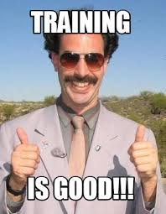**Adaptations to training/ Future Performance Decisions**

* Reversibility - Maintain training 3 times per week – keep up fitness/ avoid plateau
* Tedium - Use more pressure drills/ game related training – continue improving skills and fitness under game like pressure – leads to increased confidence also
* Tedium/ Intensity - Change partner/ team – ensure at the same level or better – give you appropriate level of challenge
* Specificity/ Tedium - Identify new skill to be improved – use practices with no pressure to build confidence
* Specificity/ Tedium - Identify new factor – add more practices to sessions/ more sessions

**Evaluation of Training**

**What parts were effective? What parts were not effective?**

* Using **different approaches** - Did this improve your motivation and enjoyment?
* **Changes to games** - Did you ever change opponents or the size of games? Did this challenge you more or improve your motivation?
* **Continuous training –** did you ever find it boring? Did you find training on your own helpful?
* **Fartlek training** – was it easy to cheat?
* **Interval training** – did the weather ever affect your training?
* **Game related training** – was it fun and enjoyable? Did team mates ever let you down?
* **Deep breathing** – did walking away and going to quiet areas help? Did you practice it enough? Did you take it seriously?

**Goal Setting**

When you are planning and implementing a personal development plan, it is important to set yourself goals as they **provide direction** and can be used to **measure progress**. Training goals can give you little steps on your way to your ultimate goal. Setting goals will help you to:

* Create a focus for your training meaning that all sessions are tailored to your weakness
* Increase motivation and determination meaning that effort improves in training and therefore development quickens
* Prioritise and get more out of your time meaning that no valuable training time is wasted
* 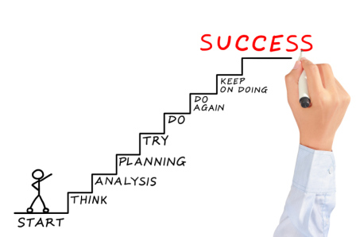Monitor progress meaning you can check to see if reaching short term targets and therefore monitor progress towards long term targets
* Provide valuable feedback to see if training is working and targets are being met therefore allowing you to set new targets and challenge yourself at an appropriate level

**Short and Long Term Goals**

When goal setting it is important that you have a clear idea of what you want to achieve. Teams and individual athletes usually set long-term goals by the end of the season or year. Likewise, at the start of your personal development plan you should have a clear idea of what you want to achieve by the end of your plan. To achieve these long-term goals, you need a series of short term goals to help you to. As the performer successfully achieves each goal their motivation stays high and effort improves. For example:

*Short Term Goal –* Increase my Cooper test score by 400m.

*Medium Term Goal –* Increase my Cooper test score by a further 400m and to have more successful than unsuccessful passes in the final 10 minutes of my OS

*Long Term Goal -* To last a full 90 minute game of football without being exhausted and having to be substituted.

Prior to embarking on any individual programme it is essential to establish a realistic starting point. Many factors will influence this such as:

[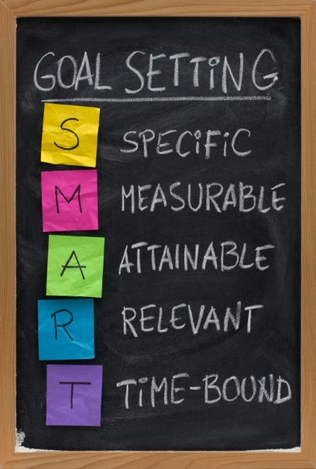](https://studentsuccess.unc.edu/setting-goals/smart-goal-setting-concept-4/)

* Time available to reach target
* Previous experience
* Ability to monitor progress

**THINK S.M.A.R.T.E.R**

To set effective goals they should be S.M.A.R.T.E.R goals. This means they should be:

**SPECIFIC**

Your goals should be clear and precise. They should reflect your ability and experience within your chosen activity.

**MEASUREABLE**

Goals must be easily measurable so that you can assess whether or not they are improving or have been successful.

**ACHIEVEABLE**

Your goals / targets should be challenging, but at the same time be within your reach, so that you have a chance of success. The ideal level for a goal to be pitched at is “***challenging but achievable… with real, hard work”.***

**REALISTIC**

Realistic goals are more likely to be achieved and you are, therefore, more likely to stay motivated throughout your personal development plan. Setting unrealistic goals will result in lack of success and, ultimately, in a drop in morale.

**TIME-RELATED**

Your goals should be progressive. Planning short-term goals will ensure progress and help you achieve your long-term goals.

**EXCITING**

Make sure your goals are rewarding and enjoyable. This approach will maintain motivation and prevent you becoming bored. When you enjoy a practice you are far more likely to see improvements and see the relevant of that practice.

**REGULAR**

Practice sessions should be schedule a few times per week to allow you to consolidate your skill learning, and so that what you learned in previous sessions is still fresh in your mind.

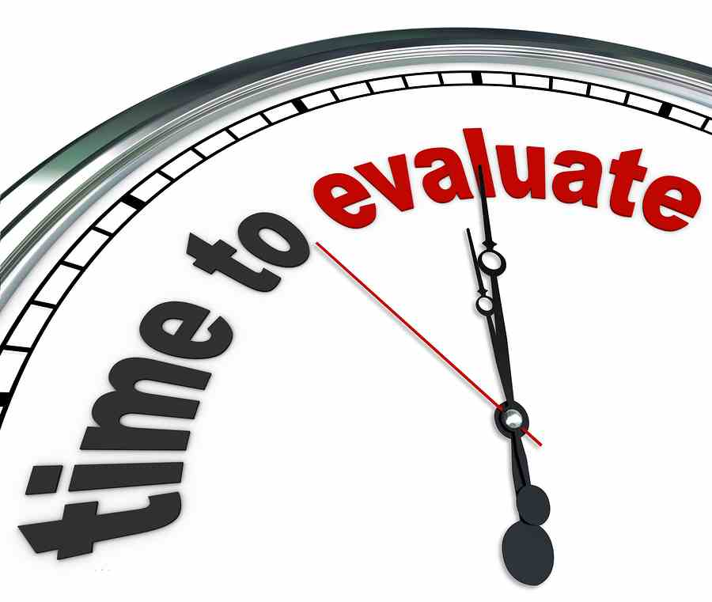

It is also important to make sure that you **evaluate** your goals as **goals change over time**. As you move towards your goals you become clearer as to what it is that you really want to achieve. Your goals will most likely need to change in shape or form to remain aligned to where you want to go in your SPORT.

**Continual evaluation** of your goals is essential to ensure you remain on path.

**Knowledge of a Model Performer**

**“A model performance is the perfect way in which a skill or performance should be carried out”**

In order to gather information and improve on your performance you will need to have knowledge of a model performance.

**A model performer can be:

*Class Mate*

*Teacher/Coach*

*Professional*

**Qualities of a Model Performer**

**Physical:**

* They can play a wide range of skills and can consistently link them together with high levels of control and fluency.
* Their performance is automatic.
* Their movement is economic and graceful.
* They are in complete control of their actions.
* Excellent physical fitness tuned to the demands of the activity e.g. Flexibility, Strength, Power etc.

**Social:**

* They provide detailed information to coaches through verbal speech, signalling and their actions.
* They can listen to and accept feedback.

**Mental**

* They are able to manage their level of arousal effectively prior to performance.
* They can maintain focus and concentration throughout a performance to execute the skills and sequences accurately.

**Emotional**

* They can control their anger during a performance and not allow their emotions to cloud judgements.
* They do not allow fear/anxiety to impact their performance. By controlling this emotion they can execute skills effectively, make the right decisions and be fluent in their movements.

**Advantages of using a Model Performance**

* They help to create a “picture” in your mind of how a skill or performance should be carried out. By watching them practice you get a better understanding of the correct techniques to use and the type of positive attitude to adopt. By watching them in a game you can watch and copy the quality in their game and the take note of the positive team dynamics.
* By watching the model it motivates you to want to reach that automatic stage of learning and therefore gives you the determination and drive to progress your performance.
* It allows you to identify your own strengths and weaknesses by comparing your performance to the model. This allows you to pin point and focus on areas of weakness such as over-hitting a pass or continually shooting over the bar.
* This also allows you to set realistic but challenging individual goals and targets to strive for. This should give you the confidence and determination to improve and reach that high standard of an automatic performer.

**Disadvantages of using a Model Performance**

* If a performer has poor knowledge of a skill this may lead to an inaccurate comparison.
* The model performer you are watching might be at a level that is too advanced for you. This could lead to you setting unrealistic targets and goals. Also, you could become demotivated as you realise you will never reach their level.
* In certain activities there might be a lack of model performers for you to observe. Your class mates or teacher might not be playing at a level which allows for a strong comparison. Also, it may be difficult to get a video which clearly highlights a strong performance.
* The time involved in collecting and analysing your results in comparison to a model performer may be disproportionate to the benefits. Your time might be better spent focussing on developing your performance through other approaches.

**How have you compared yourself to a Model Performer?**

**Preparation/ Action/ Recovery Sheet**

* Before looking at my own performance, I observed a model performer execute a pass or a shot as many times as necessary to gain and understanding the set criteria (P.A.R).
* An observer sat at the side of the Pitch and observed me perform a pass/shot repeatedly until enough data was gathered on each subroutine.
* The observer put a tick or cross next to each subroutine on the PAR sheet depending on whether or not my performance matched that of the model described on the sheet.

**Video Analysis**

* I watched a video of a model performer/ model team performance in Football.
* Whilst watching the video I analysed their performance carefully and noted down their characteristics in relation to the four factors (MESP).
* I then watched a video of my team and me playing Football. I compared my performance to the characteristics of the model performer and then recorded what I felt were my strengths and weakness.

**Model Performance**

**Lionel Messi v Me**

|  |  |  |  |  |
| --- | --- | --- | --- | --- |
|  | **Mental**  Concentration  Dn Making  Motivation  Lvl of Arousal  Anticipation | **Emotional**  Anger  Fear  Nerves  Confidence  Frustration | **Social**  Communication  Cooperation  Role/ Rspsnblty | **Physical**  Skills  Fitness |
| **Messi** |  |  |  |  |
| **Me** |  |  |  |  |

**My Performance**

Strengths –

Areas for Development -

**Monitoring Performance Development**

Monitoring is the process you go through in order to check that something is working.

At the start of your programme of work you investigate your performance, at the end you evaluate its effectiveness. **Any other evidence gathering is monitoring.**

Investigate

Evaluate

**Q – Why do we monitor**

|  |  |
| --- | --- |
| Achieving Targets  Motivation | One reason why we monitor performance is to see if we have achieved the targets we have set for ourselves. Knowing that we have achieved a target can give a performer motivation to continue on in a programme. |
| Effectiveness | Another reason why we monitor is to see if the programme is effective in developing performance. If the performance is not working then this informs the performer they must alter it by making it harder or easier. |
| Adaptations | Monitoring can inform you if your programme has been successful and if you require to adapt it to ensure you do not plateau. For instance, in your continuous training you may require to increase the target time of your 1km run to ensure your fitness continues to improve. |
| Being watched | Another reason why it is important to monitor is that I work to a higher standard if I am being watched. For instance if my partner is counting the success of my overhead clear in my repetition drills, I perform in a more intense and focused way. |

**Methods used -** OS/Cooper test/ Training Diary/ Multi stage fitness test/ emotional control record/ mental toughness questionnaire/ decision making grid/ level of arousal questionnaire

**Why do you monitor**

* To see if your programme is working/if improvement is taking place/to provide feedback on your progress.
* To see if you are on track to achieve your short term and long term targets.
* To make comparisons between your data so that you can measure your progress.
* To see if you will continue with your programme as you planned because you are on track, or if you need to change things because;

1. You are not progressing as you wished.
2. You are further ahead than planned, and need to adapt the rest of your programme.

* To see if you need to change the FIDO, Types of Training or Methods of Practice because you are behind or ahead of schedule.
* To allow you to re-set your targets based on where you are at the mid-point.
* To provide regular feedback so that you can make further progression.
* To provide Motivation and Encouragement for you particularly if you see you are making progress.
* To check you have reached your targets and plan for future development

**How and when do you do monitor?**

* Use the data you collected before you started your Improvement Programme as your base line/bench mark/starting point. You can then compare all future data against this.
  + (Observation Schedules/PAR/Fitness Tests/Video analysis/Questionnaires etc).
* You will set short and long term targets for your programme, indicating what you would hope to achieve at certain points; e.g. by week 3.
* You re-test ideally in exactly the same way as before **so that your results are more reliable.** You would probably do this half way through your programme and again at the end of your programme.
* You could also keep a regular record such as a Training Diary (for Fitness Programmes), so that you can compare one session with the next, one week with the next etc. You should mention what you would record in this diary.
* You can receive regular feedback – verbal, visual, knowledge of results etc, to keep you informed of your progress. Who/how would this feedback be provided?
* Your own thoughts and feelings are important. How do you feel you are doing now compared to before? What evidence do you have for this?

**Difficulties / Problems When Monitoring & Evaluating Performance**

**PHYSICAL FACTORS**

* Knowledge of observer, unable to see if shot is effective / ineffective if completing live. Perceptions different from reality affecting results.
* Observer may not see process as important so switch off / lose focus which reduces the quantity of information so limited picture on performance. As a result this restricts the information given to the performer.
* Performer frustrated due to poor results as not a true reflection of performance. May end up working at wrong stage of learning and this directs attention away from weakness.
* If performer is tired they will not be in the correct frame of mind to play at their best which can affect their decision making and concentration. Movements will be more laboured as they have no real energy which results in a poor skill level and success on the day.
* If coming back from injury monitoring can be frustrating as scores and results are down on their high expectations.

**MENTAL / EMOTIONAL / SOCIAL FACTORS**

* Completing diary / questionnaire etc too late after performance may result in the performer forgetting important data affecting reliability of results.
* Performer may not see the process as important so they don’t take it seriously and as a result rush to get through questions so not much information put down.
* Performer may not be honest with themselves, making results invalid / false.
* Training Diary can be too vague as doesn’t give cause as to why you felt this way / why practice didn’t go well.
* Similar situations may not arise so difficult to have same feelings making it hard to compare findings.
* Performer may misinterpret question affecting reliability of results.
* Dependant on performer’s mental state which could result in bias judgement.

**Feedback**

**What is Feedback?**

Feedback is information that you receive about your performance in order to try and improve.

**The Benefits of Feedback**

Data Collection Process

* Sets training priorities specific to needs.
* Highlights stage of learning, social development stage or tactical limitations.
* Through comparison to a model performer a visual picture of performance enables detection and corrects of issues in performance.

Monitoring Progress

* Through feedback received during practice and competitions adaptations to a programme can be made.
* Able to assess to see if on track to hit long term targets.

Motivation / Concentration

* Positive feedback - gives purpose, drive and determination to training and competition.
* Sustains focus and directs a team / performer(s) attention.

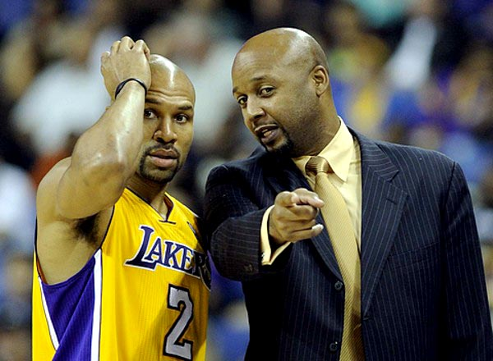

**For Feedback to be Effective**

* **RELEVANT**

To the performer(s) and the area of weakness.

* **TIMING**

Frequent and immediate to allow the performers to reflect and make corrections quickly whilst the information is fresh in their minds. Short chunks of information too so it is easier to process and make changes.

* **ACCEPTANCE**

Players must be open to listening to the feedback and willing to accept constructive criticism. Feedback should be sensitive so it is easier to accept and act on.

* **OBJECTIVE & SUBJECTIVE**

Increases validity and reliability and creates a clearer picture of performance and the progress being made.

**Types of Feedback**

|  |  |  |
| --- | --- | --- |
| **Kinaesthetic Feedback *(Subjective) (Internal)*** | **Verbal / Written Feedback *(Subjective)(External)*** | **Knowledge of Results *(Objective)(External)*** |
| Based on your own thoughts and feelings. E.g. - I could feel my ankles together in my pike jump, therefore I knew my legs were together.  Usually this method is in the form of a training diary or by revisiting a questionnaire. | Verbal communication can come from the teacher constantly during practice and performance.  Verbal or written feedback should be given in each training session and game, by a teacher, and should be specific to the area you are developing. | Can be gained from a variety of external sources such as video, observation schedules, competitive results and practice scores. E.g. - 7/10 of my OHC’s failed to reach the back of the court.  This method produces statistics which should relate to the weak area which is being developed. |
| Advantages –   * Encourages self-reflection of training. * Encourages confidence, motivation and focus as they are becoming more successful. * Very specific to self so a true reflection. * Regular and immediately after performance / training leading to more accuracy. | Advantages -   * Teacher has a detailed knowledge of the sport and the development area, therefore their opinion and advice is invaluable to improve factors that impact performance. * As feedback is regular and immediate players can make alterations quickly. * The teacher can prevent bad habits forming and their feedback focuses the performer / team and can be a source of positivity and motivation. * Can direct the performer and teams attention to flaws and increases their understanding of strategic play and roles etc. | Advantages -   * Objective data is more reliable and accurate as it comes from an external source. * Impacts positively on confidence and motivational levels through the hard facts highlighting improvements. |
| Disadvantages -   * Subjective information can always be impacted by how the performer feels (mood) at that specific moment. * Performer’s personal opinion and thoughts could differ from the teacher’s. | Disadvantages -   * Always a potential of a clash between performer and teacher’s feedback, especially if underachieving. * If feedback is not given frequently and immediately after errors then by the time teacher addresses the problem it has been forgotten by the performer(s). | Disadvantages -   * Highlights exactly what is says but it does not explain why these results are being achieved. * Poor results can de-motivate a performer. * However, poor results do not always suggest no progress. E.g. - O.S does not explain an increased understanding of roles etc. |

**Steps to answer a SCENARIO question**

Whichever format **(graph / text / table)**is used to present the scenario, the **procedure for tackling**it should be the same.

1. Read the **entire** question, parts (a), (b), (c) etc and how **many marks** each part is worth. This will ensure you put the correct information in the correct part.

2. Establish whether the **scenario relates** to:

* ***Factors*** Impacting on Performance
* ***Methods*** of collecting information to analyse factors impacting performance.
* ***Approaches*** to performance development.
* ***Recording, monitoring and evaluating*** performance development.

3. Try to **identify what activity / activities** the ‘prompt’ could relate to.

4. Identify and highlight the **command words** used in the question. This will give you a clue about what information is required.

5. **Identify** the **named factor** from the question.

6. Select your **second factor area** which is most appropriate to the information in the question.

7. Briefly **note down the main sub-factors / features** under each factor which you are most comfortable talking about, based on the prompt given. For example -

Agility C.R.E Determination Fear

Consistency of Tactics Confidence Cope Under

Skills Pressure

8. 1 mark **= Point (relate to data given), Example and Impact**.

E.g. The comment showed that the player looked very tired towards the end of the game (P). This suggests that the physical factor affected the player and his CRE was low (E). Because his CRE was low and he had become tired he would be struggling to keep up with the pace of the game (I).

**SCENARIO QUESTIONS**

**Scenario Part (a) -**

**In previous years, part (a) of the scenario has normally asked about problems that may have occurred within a performance / activity / activities.**

**Scenario Part (b) -**

**This section normally relates to how you overcome the problems identified in part (a). This section could relate to approaches / principles of training / principles of effective practice.**

**HOWEVER, this is not to say that this will not change!!! It is important in scenario questions that you come prepared for anything to be asked from the mandatory knowledge. You must identify the command word and then structure your answer around this.**

**Examples of potential part (b) question answers are given below.**

***Explain how this feedback might be used to plan future performance development for the two factors chosen in 1(a). (8 marks)***

* *With regards to the physical factor the performer could chose relevant approaches in order to develop their performance. To develop CRE they could use game related training because it allows the performer to use the same muscle groups that are used in the activity. Consequently, it will help to develop their CRE so that they do not get as tired towards the end of a game, resulting in their skill level staying high. (1 mark)*
* *Another reason they may use game related training to develop CRE is....*
* *In addition, they could also use continuous training to develop this feature because.....*
* *Furthermore, when developing their CRE the performer may also consider SPORT FIT. For example, they may consider progressive overload. For example, as the performer gets better during the course of the PDP they will make the training harder by increasing the frequency of sessions from three to four times a week so that the performer keeps improving. (1 mark)*
* *To develop emotional factors the performer may....*

***Evaluate possible approaches which could ensure future performance will improve. (8 marks)***

* *Positive self-talk is a* ***useful*** *approach to help improve my anxiety because it lets me instantly interrupt my negative thoughts allowing me to refocus on the centre pass which is just about to happen so that I am able to move into the correct space. (1 mark)*
* *Moreover, this approach is also* ***very easy*** *to use as it does not require any equipment, meaning I can use it anytime that I feel angry. Thus, even after an umpiring call that I disagree with I will remain calm and focussed on the game, so that I am always playing skills consistently. (1 mark)*
* *Mental rehearsal is also* ***valuable*** *because it lets me rehearse any eventuality in my head so that when I go on to play I am able to remain focussed and stay calm at all times, regardless of what happens. Consequently, my decision making remains good and I will not give the ball away. (1 mark)*
* *Game related training was also a* ***very effective*** *approach to use because....*

***Analyse the improvement that could be made as a result of the approaches used to develop the factors selected in (a).***

* *The use of game related training to improve my CRE will be good because even towards the end of the game I will still be able to keep a high skill level. For example, I will still be able to make strong and accurate passes towards the end of the game, helping my team be able to keep possession and increase our chances of scoring. (1 mark)*
* *Another improvement that can be made through the use of CRE is.....*

***Analyse approaches which may be used to overcome the negative impact of the presence of others during performance, practice or training. (8 marks)***

* *To develop the mental factor I could use the approach mental rehearsal to improve my decision making. This approach does not require any equipment and can therefore be used at any point during training or in a game without taking up too much time. Consequently, I will be able to picture various different good decisions I can make during the game, which I can then copy. (1 mark)*
* *However, when using mental rehearsal a performer may imagine negative previous performances in past games, which can then result in the performer’s confidence dropping further. As a result, the performer will not be able to develop their performance and will continue to play poor passes within the game losing their team possession on even more occasions. (1 mark)*
* *To develop physical factors I used repetition drills. This approach......*

***Explain how knowledge of model performance could assist this student develop the factors identified in part (a). (8 marks)***

* *By observing how relaxed a model performer is before a performance, this student could attempt to use or copy the use of positive self-talk within their performance to be able to deal with coping under pressure. (1 mark)*
* *This would enable the student to shut out distractions and focus on the role they have to carry out right from the very beginning of the performance. (1 mark)*
* *In addition, during a performer a model performer would encourage other performers to carry out their role effectively as the game progresses. This would mean the student could try to motivate and encourage others to develop a positive team ethos. (1 mark)*

***Explain the considerations which would be made to ensure continued improvements. (8 marks)***

* *When developing physical factors such as CRE I would consider the principles of training, e.g. – SPORT FIT. For example, I would consider the principle specificity. I would make sure that my training is specific to my weakness (CRE), but also to my stage of learning within the activity. For example, if at the associative stage of learning I would use repetition drills. (1 mark)*
* *I would also consider the frequency of my sessions. For example, to develop CRE I would ensure that I was training at least three times a week in my training programme. This ensures that I was always training often enough in order to improve my CRE ability. (1 mark)*
* *When developing my emotional factors I would consider SMARTER. For example......*
* *In addition, when trying to improve my performance I would consider the use of setting goals. For example, I would ensure that I set myself appropriate short, mid and long term goals so that it gives me a focus for my training and ensures I make full use of my time when trying to overcome my anger. (1 mark)*

***Evaluate two methods which could have been used to gather information on his performances. (8 marks)***

* *The use of a SCAT test was really useful in collecting data because it is a recognised sports psychology test. This means that research has been done and has actually proven that it collects data on anxiety levels and the data we get will therefore be valid, as long as the protocols are followed correctly. (1 mark)*
* *A limitation of a SCAT test is that it contains subjective data which could make it untrustworthy. This is because participants worry that their coach refuses to put them on their team because they have high levels of anxiety. As a result, participants deliberately lie to avoid this and make their results inaccurate and unreliable. (1 mark)*

**Scenario Question Example**

**The extract is a summary of a footballer’s performance in a recent game.**

* **Pass completion rate was only 40%**
* **Booked in 40 minutes, sent off in 71 minutes**
* **Was at fault for the oppositions first goal, not tracking the opponent**
* **Appear agitated and distracted by the crowd**

In your answer you must refer to the following factors impacting on performance; **Mental** and **one other** – from physical, social and emotional.

**A) Analyse some of the reasons for the footballer putting in this kind of performance.**

**(8 marks)**

It appears that the mental and physical factor both had an impact on this players’ performance. It is possible that decision making impacted on the performance as the pass completion rate was only 40%. This could have potentially been caused by too often choosing the harder option of pass rather than shorter and easier options (1). The low pass completion rate may also have been caused by the player having a low skill level and playing against opponents of higher ability meaning that he wasn’t able to execute skills successfully under pressure from quality opposition (2). Additionally, the low pass completion rate may also have been caused by having low CRE levels. This would mean that as the game progressed and the player became more tired his skill level and ability to play successful passes dropped (3).

The mental factor also appeared to impact the player as he was booked and then sent off in the game. This may have been caused by his level of arousal being too low meaning that he didn’t want to give total effort and was making unnecessary challenges instead of being patient and jockeying opponents which led to his booking (4). Furthermore, the low level of arousal may also have been why he got sent off as he still didn’t want to work hard for the remainder of the game and chose to pick up a second booking instead (5).

The physical factor could have been a reason for the loss of the first goal as the player may have had a low level of CRE which meant he felt tired and subsequently was unable to track his runner (6). A lack of determination could possibly also have played a part in this goal as the player may not have been willing to try his hardest and chase back to stop his direct opponent from scoring (7).

The player also let the mental factor impact his performance negatively as he became distracted by the crowd and lost concentration on his performance. This means that he allowed the crowd to affect his performance rather than solely concentrate on his task within the game which may have helped him have a higher pass completion rate and avoid a sending off (8).

**b) Explain possible approaches to development that may be used to improve the footballers performance within the two factors mentioned in part (a).**

**(8 marks).**

In order for the player to develop his CRE he could use a variety of approaches suitable to the physical factor. The player could use interval training which reflects the high pace and high intensity situations that occur during real games (1). This approach would also allow the player to adjust the principles of training easily by making it harder or easier dependant on their needs e.g. longer sprints and shorter recovery time (2). The player could also use continuous training to develop his CRE as it would allow him to train alone which means that he doesn’t need to rely on other people, can work at his own pace, and can train anywhere without needing any specialist equipment (3). To develop CRE the player may also use Fartlek training which requires using different types of movements at different paces meaning it is ideally suited to develop fitness specifically for footballers as it replicates actual game like patterns of movement (4).

In the physical factor the player could use game related training in order to develop his passing skills and CRE. This method is beneficial as it would improve both features simultaneously and would motivate the player to work hard as it would be in a competitive game-like environment (5).

In order to develop concentration and decision making in the mental factor the player could use mental rehearsal/ visualisation techniques. Before the game the player would sit in a quiet area, block out all distractions, and think clearly about how they would deal with specific situations that would arise in the game, meaning that when situations actually arose they were prepared and knew exactly how to handle them (6). For example, the player could create mental images of passing scenarios in his head and what type of pass to use and who to pass to when certain situations arose. This means that during the actual pressure of the game he would be able to make better decisions as he had visually prepared for each situation (7). Additionally, the player could also use motivation techniques before games in order to raise his level of arousal to an appropriate level. By listening to heavy rock or high tempo dance music directly before a game will help raise the players’ level of arousal meaning that he is more motivated and determined to try hard during the game (8).

**PRACTICE QUESTIONS**

**All worth 4 marks**

**Know the difference between performance (in games) and performance development (training) when answering questions**

Describe a method used to gather information on the physical factor.  
Evaluate why you would select this method.  
  
Describe a method used to gather information on the social factor.  
Evaluate why you would select this method.  
  
Describe an approach used to develop a physical factor.  
Analyse why you would use this approach to develop that factor.  
  
Describe an approach to develop a social factor.  
Analyse why you would use this approach to develop that factor.  
  
Explain why it is important to monitor performance.  
Describe a method used to monitor physical factors and analyse any problems that may be encountered.  
Describe a method used to monitor social factors and analyse any problems that may be encountered.  
  
Evaluate an approach used to develop the social factor.  
Evaluate the effectiveness of an approach used to develop the social factor.  
  
Explain the reasons for using one method to gather information on physical factors over another.

Describe 2 different methods that could be used to collect information about MESP factors that impact on performance.

Explain the advantages and disadvantages of using these methods to collect information about the potential impact of MESP factors on performance.

Describe in detail one method of gathering information on the MESP factor within an activity.

Evaluate the benefits and limitations of using the method you have chosen in part (a) to gather information on the MESP factor.

Describe two different methods that could be used to collect information to identify any MESP factor of your performance.

Select one of the methods described in part (a). Outline why this method is appropriate and give a brief account of the information gathered.

Describe two different methods that could be used to collect information about the potential impact of MESP factors on performance.

Select one of the methods described in part (a).Evaluate one benefit and one limitation of using this method to collect information and give a brief account of your findings.

Explain *why* it is important to collect information on your performance.

Evaluate the effectiveness of one method you have used to collect information on MESP factors.

Describe a method that could be used to collect information about the potential impact of MESP factors on performance?

From the method described in part (a). Analyse the method you used to gather information on MESP factors?

Explain why it is important to collect information about the impact of MESP factors on performance before starting a development plan.

Evaluate your MESP strengths and development needs in comparison to a model performer.

In relation to MESP factors; analyse your performance compared to a model performer.

Explain the advantages of considering a model performance when developing performance.

Explain the advantages of considering a model performance when developing performance.

Choose an activity. Describe how you compared your whole performance to that of a model performer in this activity.

Explain the advantages of considering a model performance when developing MESP performance.

Choose an activity. Describe how you compared your whole performance to that of a model performance in this activity.

Describe a method(s) you could use to gather information about the impact the MESP factor has on performance.

Analyse the information gathered from the method used in part (a)

Analyse the appropriateness of two methods for collecting information on MESP factors impacting on performance.

Based on the data collected, evaluate the MESP factors which were strengths in your performance.

You will have collected data on one MESP factor. Analyse what the data tells you about your performance.

Explain how you know your data to be valid and reliable.

Choose a MESP factor that impacts on performance. Explain one approach to develop this factor.

Evaluate one advantage and one disadvantage of applying this approach prior to a performance.

Choose a MESP factor that impacts on performance. Evaluate what impact this had on your performance.

Explain how you used performance development goals to improve this factor.

Choose a MESP factor that impacts on performance. Explain one approach to develop this factor.

Evaluate one advantage and one disadvantage of applying this approach during a performance.

Choose an activity and a MESP factor that impacts on performance. Describe an approach you could use to develop this factor.

Choose a different MESP factor that impacts on performance. Evaluate a different approach to develop this physical factor.

Select one MESP factor that has had a negative impact on your performance. Explain how you developed this factor to help improve your performance.

Describe how improving this MESP factor can impact on performance.

Explain the decisions you would need to make when preparing a performance development plan to improve the MESP factor

Choose one MESP factor that impacts on performance. Explain one approach to develop this factor.

Explain the importance of two mental factors on performance.

Analyse the benefits of setting short and long-term goals to develop a performance.

Explain two goals that you have set to develop performance in MESP factors.

Analyse the impact these goals could have on your performance in developing MESP factors.

Explain, in detail, why it is important to monitor and evaluate performance development.

Explain the difficulties that might be encountered when monitoring and evaluating the impact of MESP factors on performance.

Describe how you monitored and evaluated the social factors that impacted on your performance.

Explain the difficulties you might experience when monitoring and evaluating the impact of MESP factors on performance.

Explain the purpose of monitoring and evaluating performance.

Explain at least two difficulties that might be encountered when monitoring and evaluating the impact of MESP factors on performance.

Describe two different methods that could be used to monitor and evaluate MESP factors impacting on performance.

Choose one method mentioned in Part (a). Explain at least one advantage and one difficulty of using this method to monitor and evaluate the impact of MESP factors on performance.

Describe performance development goals that a performer could set for MESP factors.

Explain why a performer might use each of the following when monitoring the development of MESP factor:

Qualitative information

Quantitative information

Explain the purpose of monitoring and evaluating performance.

Analyse the benefits of collecting both subjective and objective data

Explain the purpose of monitoring and evaluating performance

Describe one approach you could use to record the impact of MESP factors on performance.

Explain why it is important to monitor and review your programme of work to develop MESP factors impacting on performance.

During your training you will have made adaptations to your programme of work, explain what adaptations were made and why.

Describe two methods you have used to monitor performance within MESP factors.

Explain how you used this information to set future development targets in relation this factor.

Explain the impact that the physical factor has on the emotional factor.

Explain the impact that the mental factor has on the physical factor.

Explain the impact that the emotional factor has on the social factor.

**SCENARIO QUESTIONS**

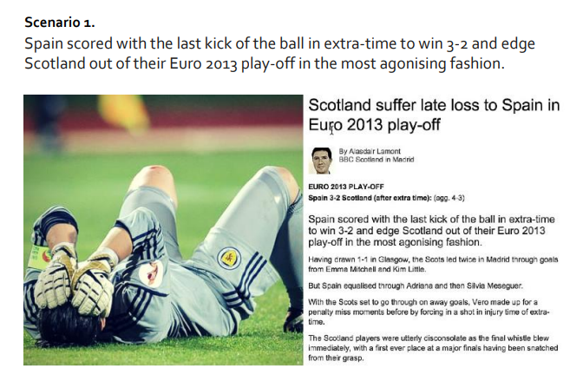

In your answer you must refer to the following factors impacting on performance; **Emotional** and **one other**.

1a) Analyse the possible factors that led to this outcome for the Scotland team (8)

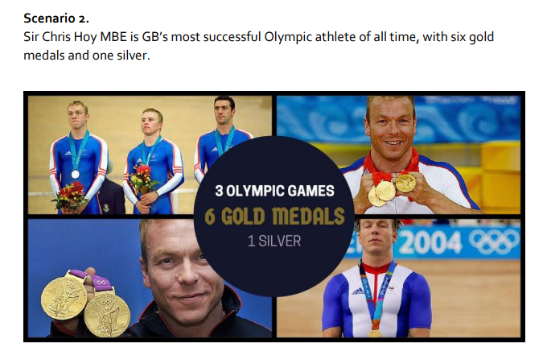b) Explain how you could plan future performance development following this defeat (8).

In your answer you must refer to the following factors impacting on performance; **Mental** and **one other**.

2a) Analyse the factors contributing to Sir Chris Hoy’s success (8).

b) Evaluate 2 methods that could have been used to gather information on his performances (8).

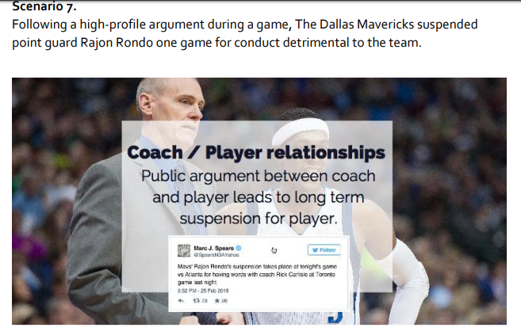

In your answer you must refer to the following factors impacting on performance; **Emotional** and **one other**.

3a) Analyse factors which may have led to this breakdown in relationship (8).

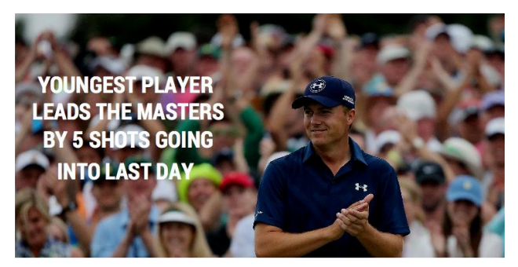b) Explain how these factors could be improved to enhance performance (8).

In your answer you must refer to the following factors impacting on performance; **Mental** and **one other**.

4a) Analyse the key factors that would have contributed to Jordan Spieth’s success (8).

b) For each of the factors, analyse an approach a performer could use to enable them to improve their performance (8).

**Read the scenario below and attempt the question which follows.**

A team or performer have lost their last 4 competitive games

The coach has made the following statements at the end of the fourth game.

* *We are not starting each game very well it is taking us 10-15 minutes to get going…*
* *We have worked on these things in training but we are making the same mistakes…*
* *When we get behind our body language is poor …….*
* *Our performances are ok at home but as soon as we play away our performance drops………*
* *We are definitely not working hard enough towards the end of the game……*

(a) **Analyse** the reasons why the coach is giving this feedback. In your answer you must refer to the factors impacting on performance: **emotional** and **one other** - from mental, social or physical. *(8 marks)*

(b) **Explain** how this feedback might be used to plan future performance development for the two factors chosen in 1(a). *(8 marks)*

**This is an extract from a Performer’s Training Diary:**

* I was not performing at my best due to my poor decision-making…
* I was feeling very anxious and lacked confidence…
* My opposition are a very high standard…
* I struggled to motivate myself during this performance…

(a) **Analyse** factors that can influence your performance. In your answer you must refer to the following factors impacting on performance: **mental** and **one other** – from physical, social or emotional. *(8 marks)*

(b) In relation to part (a) and the factors that you have selected, **explain** how a performer’s decision making can affect their performance. *(8 marks)*

**Read the scenario below and attempt the questions which follow:**

**The below quotes are taken from a Sports Report in a local Newspaper Article:**

“THE PLAYER’S LOOKED OFF THE PACE AND UNFIT”

“THE TEAM LACKED LEADERSHIP”

“TOWARDS THE END OF THE GAME THE PLAYERS GAVE UP AND VERBAL ARGUMENTS BROKE OUT ”

“TWO PLAYERS WERE SENT OFF FOR MISCONDUCT”

“A NUMBER OF SIMPLE MISTAKES WERE MADE WHEN PERFORMING BASIC SKILLS”

(a) **Analyse** reasons why a performer might receive this feedback. In your answer you must refer to the following factors impacting on performance:

* **Emotional**
* And one other — from **Mental, Social or Physical.** *(8 marks)*

(b) For each of the factors (Emotional and your chosen factor from Mental, Social and physical), analyse an approach a performer could use to enable them to improve their performance. *(8 marks)*

After losing heavily in the opening competition of the season; you need to prepare for your next competitive performance…

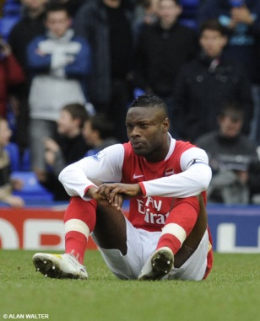

**(a) Explain** how social factors could have an impact on performance. *(4 marks)*

In your answer you must refer to the following factors impacting on performance: **Social** and **one other** - from mental, physical or emotional.

(b) **Analyse** 2 methods that could be used to **gather data** on the **two factors** that impact on

performance. *(6 marks)*

(c) Having gathered data, **explain** what you would take into account when setting goals to ensure improved performance in the future. Use examples to further develop your answer. *(6 marks)*

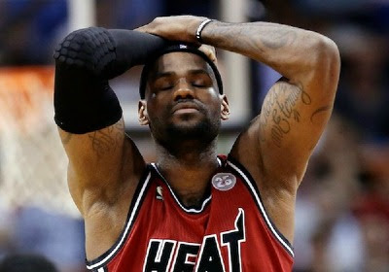

(a) **Analyse** reasons why the performer above may not be performing to his potential.

Your answer must make reference to Social and one other factor. *(8 marks)*

(b) **Explain** what this performer could do to ensure his next performance is improved. *(8 marks)*

**View the pictures below and attempt the questions which follow:**

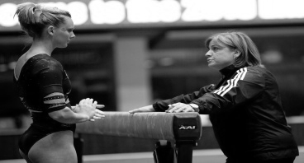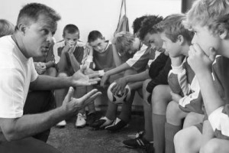

(a) **Explain** **two** emotional factors a performer might feel during coach feedback.  *(6 marks)*

(b) In your answer you must refer to the following factors impacting on performance: **emotional** and **one other** from mental, social and physical

**Explain** the importance of using different types of feedback when developing performance. *(4 marks)*

(c) **Analyse** improvements that could be made as a result of the feedback in the picture(s) *(6 marks)*

**The following are comments taken from a performer’s self-evaluation of their own performance:**

* + - * ***After the game today I felt so tired and disappointed....***
* ***We went 2-0 down in the first half and I had no drive in the second, we were already beat...***
* ***We ended up losing 3-0 and I made so many mistakes, especially in the second half...***
* ***I missed a penalty and got booked for having a late challenge and arguing with the referee. ...***
* ***I got so distracted by the crowd and felt so under pressure....***
* ***I can’t be bothered with training tomorrow. I am worried what my coach and team-mates will say...***

You must refer to the following factors: **Mental** and **one other**- from physical social or emotional.

(a) **Analyse** the negative factors impacting on this individual’s performance. *(8 marks)*

(b) Using the factors you have mentioned in part (a). **Evaluate** two approaches that could be used to develop this individual’s performance as part of a future development plan. *(8 marks)*

This is an extract from a questionnaire completed by a student studying Higher Physical Education.

|  |  |
| --- | --- |
| Questionnaire on Impact of **Mental Factors** on Performance | |
| **Statement** | **Response by Student** |
| Before I perform, I am relaxed. | *Never* |
| When I perform, I am highly motivated. | *Sometimes* |
| When I perform, I concentrate fully. | *Sometimes* |
| When I perform, I make appropriate decisions. | *Sometimes* |

Your answers must make reference to **mental** factors and one other selected from physical, emotional or social.

(a) Analyse how the **responses in the table above** could affect this student in an important performance. *(8 marks)*

(b) Explain how knowledge of a model performance could assist this student to **develop** the factors identified in part 4(a). *(8 marks)*