National 5 - Trampolining Course Revision Notes
Factors Impacting Performance (MEPS)

MENTAL | EMOTIONAL | PHYSICAL | SOCIAL
Concentration  Decision Making  Motivation  Level of Arousal | Anger  Fear  Anxiety  Confidence  Determination  Resilience | SKILLS  Swivel Hips  Back Landing  Front Landing  Tuck  Full Twist  FITNESS  Flexibility  Power  Muscular Endurance  Core Stability | Communication  Roles & Responsibilities  Cooperation  Teamwork  Etiquette
Explaining the Impact of Factors Impacting on Performance
Think - POINT, EXAMPLE, EXPLANATION (IMPACT) = 1 mark, e.g. -
Activity: Trampolining Factor: Physical Feature: Flexibility
Having good flexibility in trampolining is important because it allows me to perform basic shapes with clear shape and body tension. (Point) For example, being able to perform a straddle with straight legs and pointed toes. (Example) This means it will look better and in turn score me more points in my performance. (Explanation / Impact)

Activity: Trampolining Factor: Emotional Feature: Anxiety
Having high levels of anxiety negatively impacts my performance in trampolining as I rush through my routine when others are watching me. (Point) For example, when performing basic shapes such as swivel hips or a pike jump, I do not fully extend on my shapes so that I have straight legs. (Example) As a result, my performance does not look as aesthetically pleasing, which results in points being deducted from my overall score. (Explanation / Impact)

Cycle of Analysis

In each practical activity you will work through the cycle of analysis below -
1. Collect data on performance using the relevant method of data collection for the chosen factor.
2. Analyse the results from your method of data collection to identify your strengths and weaknesses.
3. Plan a relevant PDP (Training Programme) to work on your identified weakness.
4. Carry out your PDP within your practical lessons to improve your performance within the activity.
5. Monitor and evaluate the success of the training programme to make sure that it is working.
PHYSICAL FACTOR
Methods of Data Collection

DESCRIBE = Paint a Picture / What Exactly Did You Do? / Step By Step

Method of Data Collection = Observation Schedule with Video
Describing Observation Schedule with Video
- What activity / what area were you in?
- Type of situation? E.g. - Performing 10 bounce routine. What types of skills were in your routine?
- Who videoed you and where were they standing?
- Who then watched the video back and completed the O.S?
- What did the O.S look like? (Must give examples of headings along the top and skills down the side)
- What did you mark on the O.S? (Try to give an example of a successful / unsuccessful criteria)

EXPLAIN = Think - “Cause & Effect” / Why? / PEE Paragraph

Explaining Why We Chose the Observation Schedule with Video
- Allows you to identify your strengths and weaknesses - meaning you can create a training programme to improve upon your weakness, e.g. - my flexibility.
- Provides objective evidence - meaning the information gathered is true and not based on opinion. Therefore realistic goals can then be set to develop your performance.
- Simple and easy to understand - meaning it is quick to complete and doesn’t waste valuable training time. Consequently, you are able to start training quicker and in turn improve your overall performance faster.
- Provides a permanent record as completed on paper - meaning the O.S can be used to make comparisons to more recent schedules completed in the future in order to check for improvements in your performance.
- Videoing the performance means that no information is missed as you can pause / rewind - meaning results are more accurate and reliable, resulting in you being able to select relevant approaches to improve.

Explaining Limitations of Using the Observation Schedule with Video
- O.S. only tells you about your general strengths and weaknesses - meaning you need to complete more focussed data to see exactly what is wrong, which can take time away from developing your performance.
- If the observer has no knowledge on the sport they could fill in the O.S. incorrectly - meaning the results would be unreliable and could result in the wrong approaches being selected.
- O.S. only gives information on physical factors - meaning you would need to use other methods of data collection to find out about mental, emotional or social factors impacting on performance, slowing down rate of development.
- iPads are expensive, and there is not enough for the full class - meaning more time consuming to gather data and can slow down rate of development.

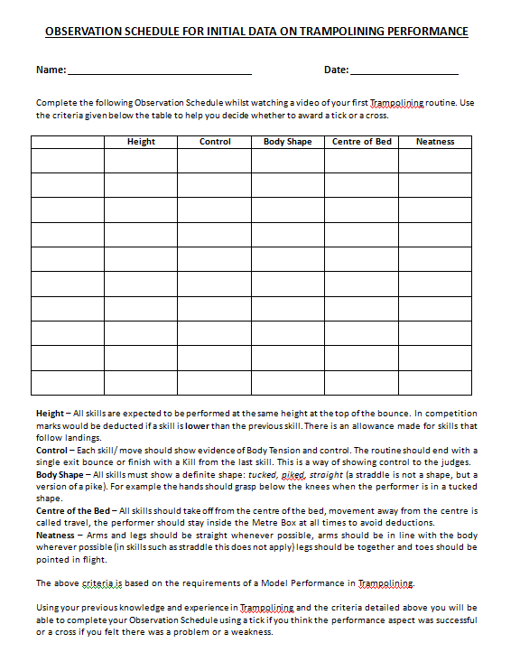

PHYSICAL FACTOR
Approaches to Develop Performance

- Gradual Build Up (Breaking a complex or dangerous skill down into stages)

DESCRIBE = Paint a Picture / What Exactly Did You Do? / Step By Step

Describing Approaches Used to Develop Performance
- What activity / what area were you in?
- What were you trying to improve?
- What is GBU? Breaking a complex or dangerous skill down into stages?
- What skill did you use this for?
- What were the stages / steps that you went through to learn this skill? (Describe them all)
- When did you move on to the next stage?

EXPLAIN = Think - “Cause & Effect” / Why? / PEE Paragraph

GRADUAL BUILD UP (GBU)
Explaining Benefits of Using Gradual Build Up
- Allows you to learn a complex or dangerous skill safely as you can break the skill down into smaller, simpler and safer actions - meaning the skill can be learnt safely without fear of injury.
- Suits all levels of ability as more able performers can start at a more advanced stage whereas less able can start at easier stages - meaning training can always appropriately challenge performers, so that they are able to improve their overall performance quickly.
- You are constantly able to gain success as you move through the stages - meaning that it can develop / build a performer’s confidence when developing a particular skill. Thus, you are then able to include this skill into your final 10 bounce routine.
- As the learner, you can decide when to move forward or back when working through the stages / steps of a skill - meaning the performer is always motivated to develop, as they are working at a level where they feel safe and comfortable.

Explaining Limitations of Using Gradual Build Up
- The performer must master one step before moving on to the next step - meaning if you reach a stage that you find challenging / difficult to achieve success quickly, you may lose motivation, which can result in you giving up and not being able to include this skill in your final 10 bounce routine.
- The skill will not be improved if the steps are rushed - meaning you may learn bad habits as you are not completing the steps correctly, which can result in you learning the wrong technique and in turn losing marks in your final routine as the skill is not performed correctly.

EMOTIONAL FACTOR
Methods of Data Collection

Method of Data Collection = Performance Profiling Wheel

DESCRIBE = Paint a Picture / What Exactly Did You Do? / Step By Step

Describing Mental Toughness Questionnaire
- What activity did you use this for / where were you when it was completed?
- Did you complete it before, during or after your performance?
- What type of situation was your performance? 10 bounce routine?
- Who completed the performance profiling wheel? Where did you complete it?
- What does the performance profiling wheel look like? What shape is it? What are the headings? (Give Examples)
- Is each segment of the wheel split into two? “You” & “Model Performer”? Is there 10 wee parts in each segment?
- How do you complete the wheel?
- How do you work out what your weakness is?

EXPLAIN = Think - “Cause & Effect” / Why? / PEE Paragraph

Explaining Why We Chose the Performance Profiling Wheel
- Allows you to identify your strengths and weaknesses in the emotional factors - meaning you can create a training programme to improve upon your weakness, e.g. - anxiety.
- Provides a permanent record as completed on paper - meaning the PPW can be used to make comparisons to more recent PPW’s completed in the future to check for improvements in your performance.
- The wheel is completed individually and is solely based on your own thoughts and feelings, without external input - meaning results are personal to you and therefore more accurate and reliable. Thus, the correct information can be collected and helps you to be able to set appropriate goals.
- Gives a direct comparison to a model performer in relation to emotional factors - meaning it lets you see what you have to aspire to in order to improve emotional factors, which can improve your focus and determination when training.

Explaining Limitations of Performance Profiling Wheel
- Information collection is based on a performer’s perceptions of their emotional performance - meaning bias could impact the validity of results as you may lie to look better than what you are. Therefore, the wrong stage of learning in your performance is identified.
- It can depend on the importance the performer places on the process - as if you rush through it, you could end up looking better than what you actually are, resulting in the wrong benchmark data being collected. Consequently, this would make comparisons in the future difficult to compare back against to measure success.

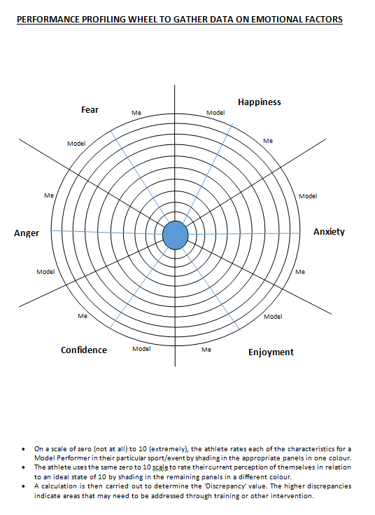

EMOTIONAL FACTOR
Approaches to Develop Performance

- Mental Rehearsal (Creating a successful image in your head about performance)
- Positive Self-Talk (Saying positive statements to yourself in your head)

DESCRIBE = Paint a Picture / What Exactly Did You Do? / Step By Step

Describing Approaches used to Develop Performance
- What were you trying to improve?
- Where did it take place?
- Who was involved?
- Where did you stand / complete it? Was it completed before, during or after the games?
- What did the approach involve? (Give Examples)
- How many times did you do it? How long did it last?

EXPLAIN = Think - “Cause & Effect” / Why? / PEE Paragraph

POSITIVE SELF-TALK
Explaining Why You Used Positive Self-Talk
- Reduces negative thoughts by focussing on positive outcomes - meaning you are always able to remain confident and perform to your best in the game.
- Easy to use in practice and competition, as no specialist equipment is required - meaning you can use this approach as often as you want in order to develop emotional factors in your performance.
- Specific to your own performance, as it can be tailored to your own individual needs - meaning you are able to use it to develop specific aspects of your performance which is personal to you.
- Can refocus the athlete when the need arises, e.g. - if you are frustrated after making a mistake - meaning it can help get things back on track, so that this does not hinder the rest of your performance.
Explaining Limitations of Using Positive Self-Talk
- In the moment, this approach can be forgotten as distractions and external factors result in the performer missing triggers in which identify frustration, fear or anger - meaning performance continues to be negatively impacted and slows down your overall development.
- Requires a level of self-belief in what is being said, as athletes will often feel awkward and lack focus using this approach in front of others - resulting in your performance continuing to be negatively affected.

MENTAL REHEARSAL
Explaining Benefits of Using Mental Rehearsal
- Reduces negative thoughts by focussing on positive outcomes - meaning it can develop confidence, resulting in a better performance as you are able to include a range of basic and complex skills in your routine.
- Boosts your knowledge and technique of skills, as the pathways have already been developed in your mind - meaning you are able to perform skills better within 10 bounce routine.
- Having rehearsed any eventuality in your head you are able to cope under pressure - meaning you will be able to remain calm / stay confident, regardless of what happens in the performance.
- Can motivate the athlete by recalling images of success in past competitions - meaning you are able to remain positive and have the confidence to performance successfully in front of an audience.
Explaining Limitations of Using Mental Rehearsal
- Some athletes may imagine negative previous performances from past competitions - meaning this can negatively impact performance and results.
- Takes a lot of practice for it to have a positive impact - meaning you must use it every day in order to master the technique, especially with fast paced sports like trampolining. If not completing this during training, when you can dedicate your full time and attention to it, it can encourage bad habits.

