Speed

Fourth Level
Third Level
The ability to move the body or part of the body from A-B in the quickest time possible
Moves at different speeds and changes direction quickly with precision.
Moves at different speeds and changes direction quickly with precision.
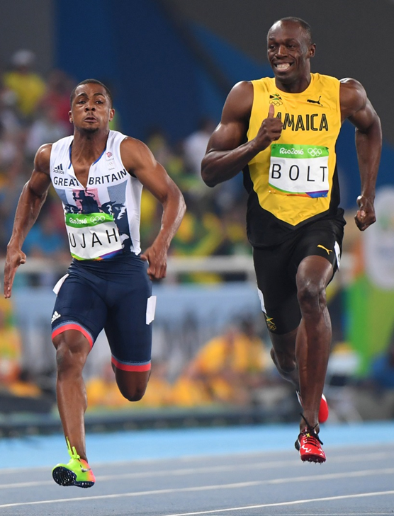
Consistently accelerates quickly from a stationary position to contribute to successful performance.
Consistently applies the use of speed and force with body parts and/or equipment e.g. swivel hips in trampolining.
Justifies the selection of personal goals to improve speed.
Applies anaerobic system for successful performance.
Accelerates quickly from a stationary position in response to movement challenges e.g. moves quickly to close down opponent.
Demonstrates the use of speed and force with body parts and/or equipment with control e.g. arm pull phase in front crawl.
Creates, implements and monitors personal goals to improve speed.
Demonstrates speed in physical activities for successful performance.

