Rhythm & Timing

I can effectively judge when to perform a movement
Fourth Level
Third Level
I can coordinate movements to a rhythm
Creates sequences of movement using a variety of stimuli with a focus on quality, leading to successful performance
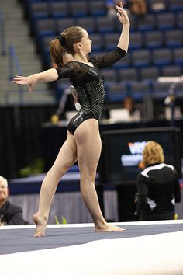
Creates a high quality performance using a variety of stimuli e.g. combination of six basic dance actions
Breaks and re-establishes rhythm in response to both internal and external cues e.g. short tennis drop shot to win an extended base line rally.
Performs actions that involve a smooth transition from one phase to another e.g. dance sequence; jump, clap, slide and pause (1,2,3,4)
Creates and establishes a rhythm to make the opportunity for timing available e.g. fluent passing round the key then player cuts to basket.

