Respect and Tolerance

Treat others with respect and fairness
Fourth Level
Third Level
Understand different people have different strengths/weakness
Display good sportsmanship and etiquette
Respect other people’s views and actions
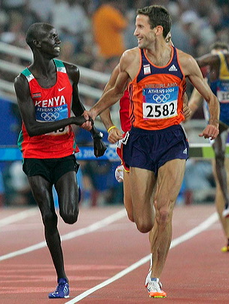
Contributes to an inclusive ethos, showing mutual respect in practice and performance environments
Accommodates a variety of abilities and needs as part of an inclusive ethos, showing mutual respect in practice and performance environments.

Modifies rules, equipment and scoring systems to enhance individual and group enjoyment of physical activity through fair play and sportsmanship.
Independently and confidently applies negotiation skills when working with others in a variety of movement challenges
Independently and confidently applies negotiation skills when working with others in a variety of movement challenges
Uses negotiation skills when working with others in a variety of movement challenges.

