Kinaesthetic awareness

I recognise how a successful performance of a movement should feel

Third Level

 I can evaluate my effectiveness of my movements by how they feel

Fourth Level

I have an awareness of my body when I am moving

Takes calculated risks showing an awareness of self, others and safety in the practice and performance environments.

Consistently demonstrates an awareness of self, others and safety in the practice and performance environments.

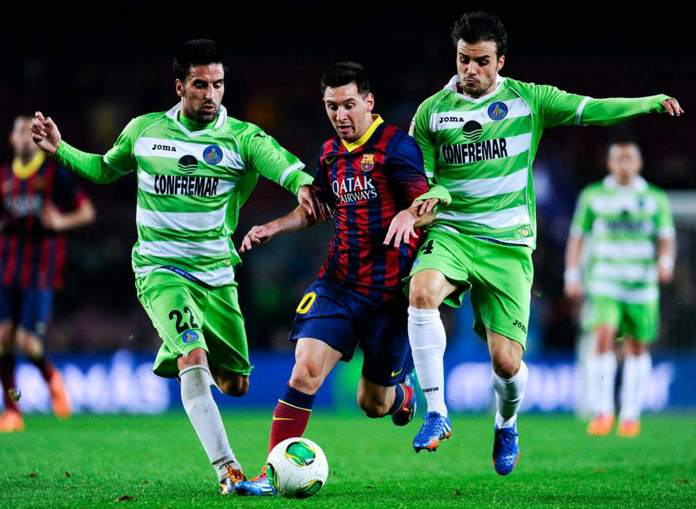

Is internally aware when creating and adapting movement sequences in new and challenging situations

Consistently and effectively adapts, transfers and improvises movement in the practice and performance environments.

Is internally aware when co-ordinating hand-eye/hand- foot movements to control different pieces of equipment e.g. drop shot in badminton

Performs, adapts and refines a variety of movements with a focus on quality, using different speeds/pathways/levels.