Gross & Fine Motor Skills

Gross - I can execute big movements requiring the moving of large muscle groups such as legs and arms

Third Level

Fine - I can execute small and precise movements using hands, fingers feet & toes

Fourth Level

Performs specialised movement skills/techniques with precision in practice and performance environments e.g. sprint forward, trap ball, pass and move to support possession.

Consistently performs specialised movement skills/techniques with precision in practice and performance environments.

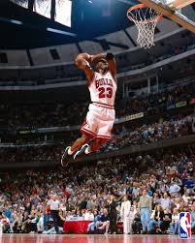

Uses eye/hand and eye/foot coordination as part of skilful performance.

Transfers skills learned in one performance environment to a different performance environment e.g. overarm throw /overhead shot in badminton.

Consistently uses eye/hand and eye/foot coordination as part of skilful performance.

Transfers skills learned in one performance environment effectively into a different performance environment e.g. hold streamlined position in glide phase of breaststroke/top of straight jump in trampolining.