Creativity

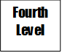
The use of imagination or original ideas to make something
Third Level
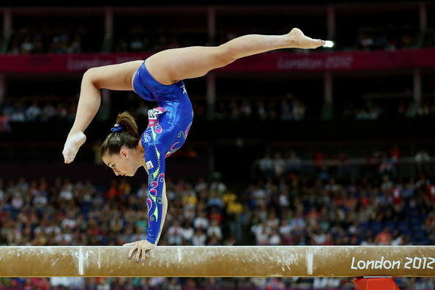
Make Something Up!
Show Imagination!

Create an idea!
Be Inventive!

Demonstrates flair, originality, imagination with increasing refinement, which contributes to a quality performance.

Demonstrates flair, originality, imagination with increasing refinement, which contributes to a quality performance.

Confidently creates movement sequences with precision, independently and with others.

Confidently creates movement sequences with precision.
Demonstrates independent, creative thinking when evaluating performance.

