Core Stability & Strength

Fourth Level
Third Level
Maintain tension allowing other body parts to work effectively
The maximum force a muscle/group of muscles can apply against a resistance
Consistently demonstrates precision through the use of balance, postural control and the links to core stability.
Demonstrates the use of balance, postural control and the links to core stability.
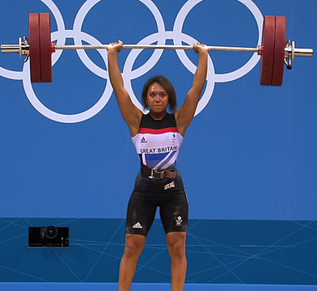
Consistently applies core stability and strength in physical activities for successful performance.
Justifies the selection of personal goals to improve core stability and strength.
Creates, implements and monitors personal goals to improve core stability and strength.
Demonstrates core stability and strength in physical activities for successful performance.
Demonstrates the use of speed and force with precision and control e.g. absorbing force when tackling an opponent in rugby.
Demonstrates the use of speed and force with precision and control e.g. absorbing force when tackling an opponent in rugby

