Coordination and Fluency

I can perform skills smoothly ensuring sub-routines flow and are not disjointed
Fourth Level
Third Level
I can move different body parts simultaneously
Consistently performs an efficient sequence of movements with accuracy.
Performs a fluent sequence of movements with confidence.
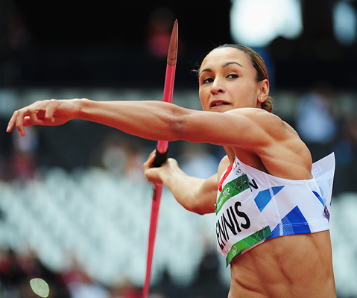
Independently selects and applies the key elements of movement that leads to a quality performance.
Consistently demonstrates efficient movement with poise that leads to successful outcomes.
Evaluates the key elements of movement that leads to a quality performance.
Demonstrates efficient movement that leads to successful outcomes.

