Balance & Control

I can control different parts of my body to enable effective movements
Fourth Level
Third Level
I use body tension during skills to achieve maximum range of motion
I ensure my body is steady and stable
My body can hold a shape with control
Differentiates between movements of different parts of the body with precision e.g. pike headstand.
Differentiates between movements of different parts of the body with control e.g. front crawl.
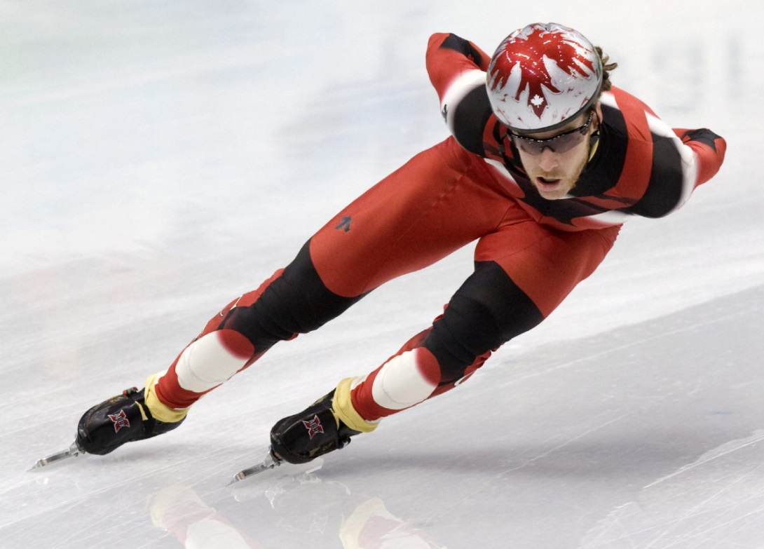
Performs precise transfers of weight with and without equipment involving static and dynamic balance.
Confidently and consistently manipulates objects whilst maintaining balance, resulting in high quality performance e.g. reverse pass in hockey.
Manipulates objects with precision whilst maintaining balance, resulting in high quality performance
e.g. set shot in basketball.
Performs smooth transfers of weight with and without equipment involving static and dynamic balance.

