Our Ref:  Your Ref:  Contact:  Tel:  Tel:  E-mail:  Date: | School Office  Sacred Heart Office 01698 274903  Orbiston Nursery Office 01698 274929  enquiries@sacredheart-bellshill.n-lanark.sch.uk  14th March 2022

Mrs K Somerville
Head Teacher
Sacred Heart Primary,
Sacred Heart Nursery and Orbiston Nursery
Liberty Road
Orbiston
Bellshill
ML4 2EU
www.northlanarkshire.gov.uk
Dear Parent/ Carer,

At the end of Term 3, we are looking to have video consultations for Parents’ Night. Each child will be issued with an invite e-mail sharing a link for you to join their class teacher on Webex.
Webex is a video call system which is used often in North Lanarkshire to host meetings online.

Please check we have the most updated email address on our records.

I have included a user guide to help with your access to the system.

Below is a list of when each class will be carrying out their meetings.
Your consultation will be week beginning the 21st March or 28th March 2022.
Class / Teacher | Day on w.b. 21st March | Day on w.b. 28th March
Rm 6  Miss Mackinnon | Monday | Monday
Rm 7  Mrs Vaugh | Monday | Monday
Rm 9  Miss Rossetti | Monday | Monday
Rm 10  Mrs Bradley | Monday | Monday
Rm 11  Mrs Jaconelli | Tuesday | Tuesday
Rm 12  Mrs Frew/ Mrs McNally | Wednesday | Wednesday
Rm 13  Mrs Hodgson | Wednesday | Wednesday
Rm 14  Miss Brown | Wednesday | Wednesday
Rm 15  Mrs Poutney | Monday | Monday
Rm 16  Miss Robertson | Monday | Monday

This is another system we are trying out to enable teachers and parents to communicate and discuss each child’s progress. We are looking forward to meeting you online and sharing with you, your child’s progress.

Kind regards

K Somerville HT
A Harley DHT

Accessing Webex Meetings

You will receive an email to the address we have on record, which looks like this....
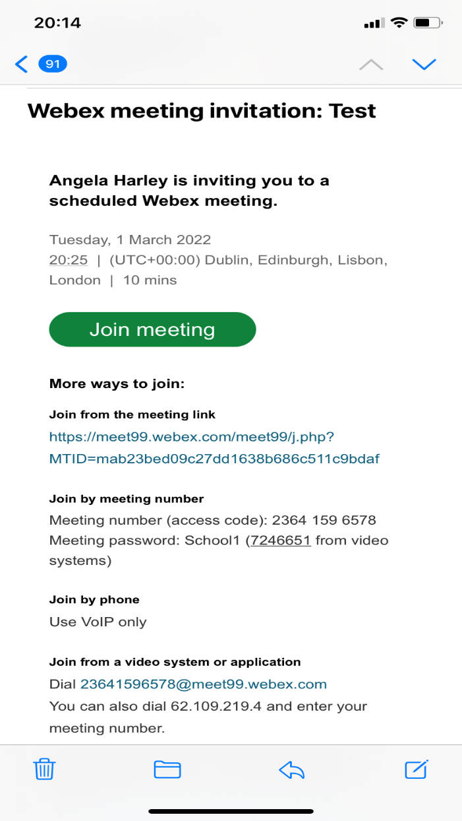

Class teacher’s name
Date and time of meeting

Join button to access meeting

‘Click’ the ‘Join Meeting’ button and the picture below should appear:

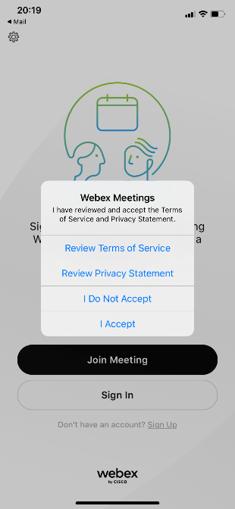

Click ‘I Accept’

This window should appear:

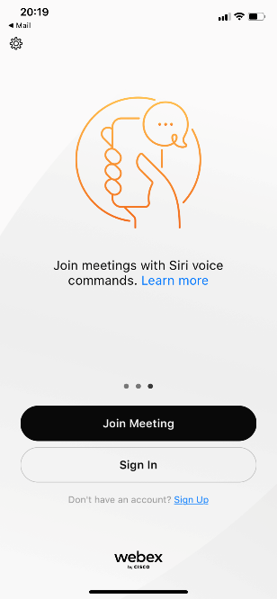

Click ‘Join Meeting’

This window appears:
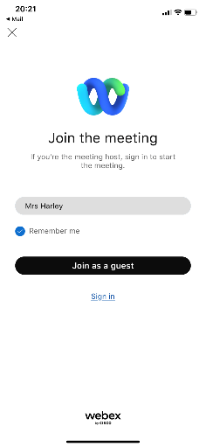
Add your name
Click ‘Join as a Guest’
This window appears:
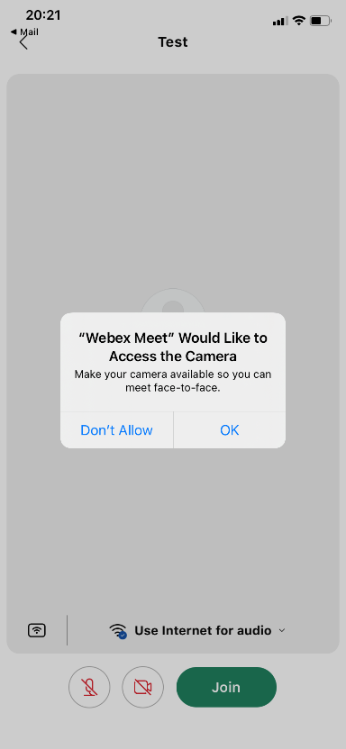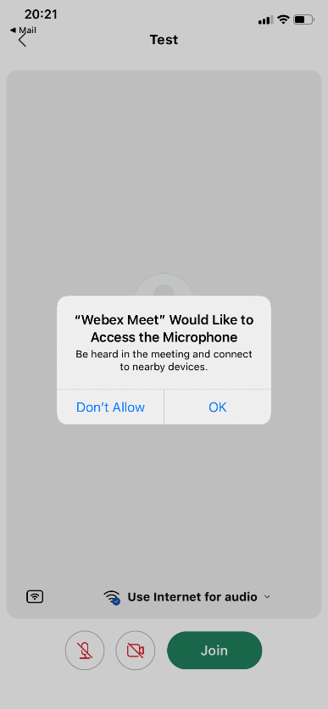

Click ‘ok’ to activate your camera and the next window one to access your microphone

Then ‘Join’

This window appears
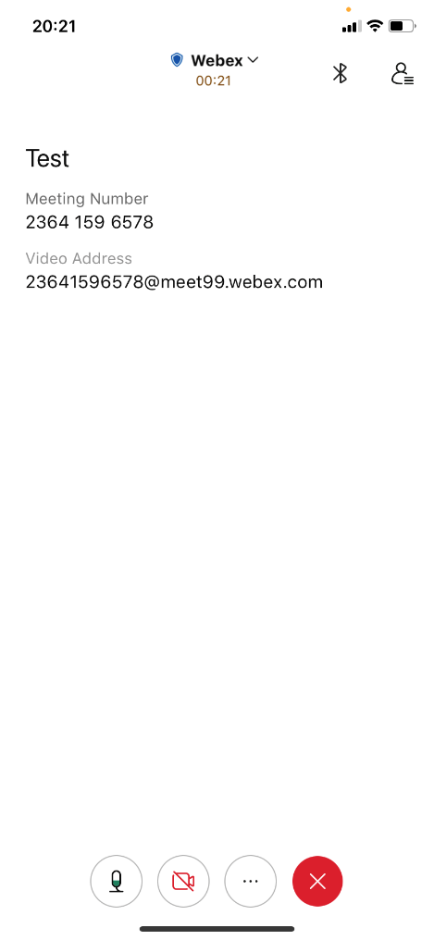

Then this one:

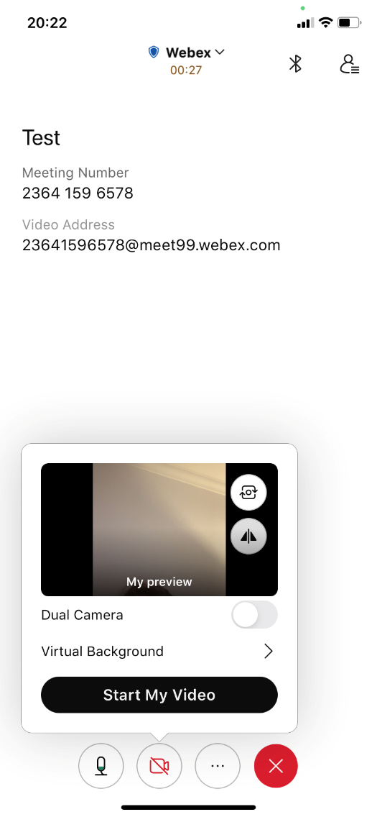

Here allows your microphone to come on/ off

This button turns your camera on/ off

Click ‘Start my Video’

You should now be in the meeting. The teacher will come in when she is ready to start your appointment.
Please remember the meetings are strictly 7mins long.
We hope the wifi system will be kind to us all.

Good luck

