Rights Respecting School Homework

We continue to learn about the Rights in the United Nations Convention on the Rights of the Child (UNCRC). The rights are what every young person should have no matter where they live. The following pictures show how young people are achieving their survival rights of protection, participation and development in different ways. Write a sentence about what you think are the most important things that are represented in each picture.

Eskimo family from Alaska, America 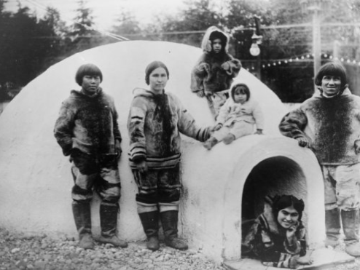 | Family from Kenya 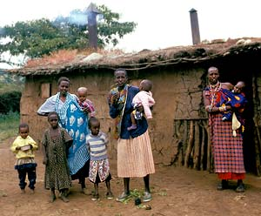
Families living in a caravan park in Newcastle, England.  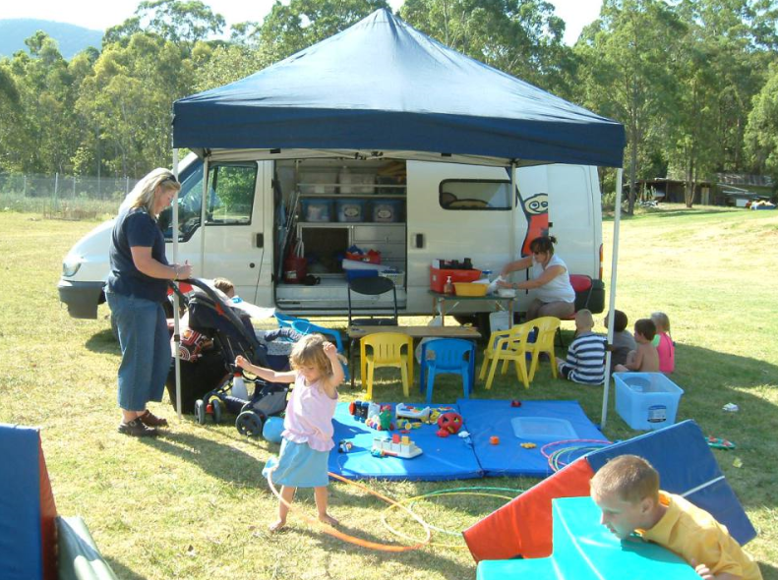 | Teepee in North America  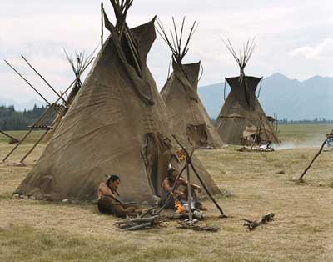
Cabin in Norway
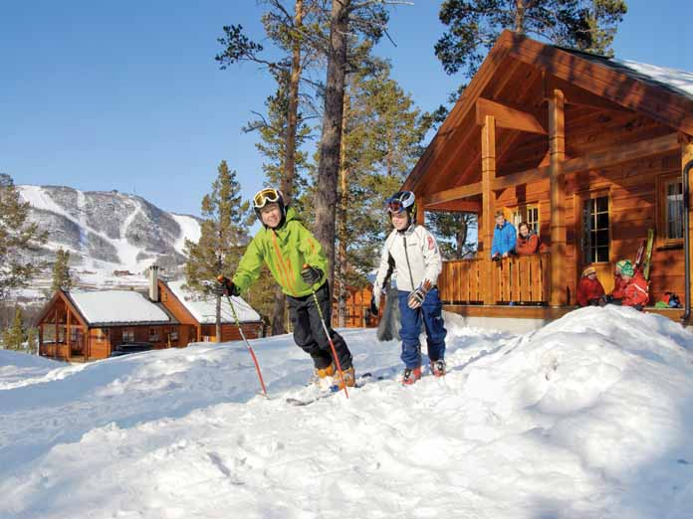
Stilt House, Cambodia
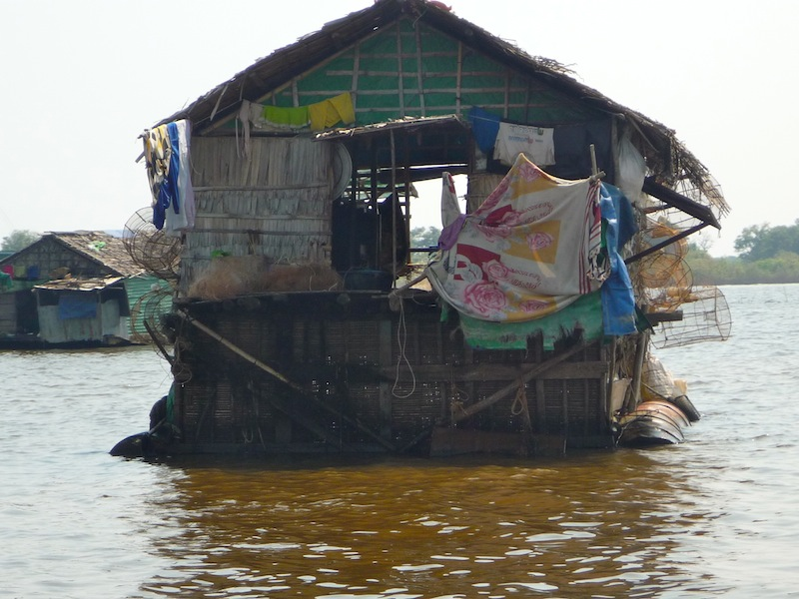
Article 6 (survival and development)
Every child has the right to life. Governments must do all they can to ensure that children survive and grow up healthy.
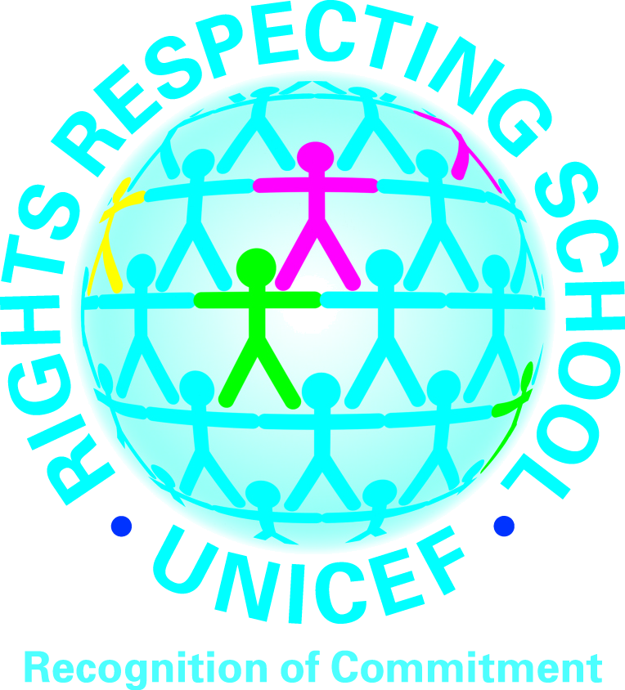




The colour version of this homework is available on our class blog accessed via our school website:
https://blogs.glowscotland.org.uk/nl/staidansps/

