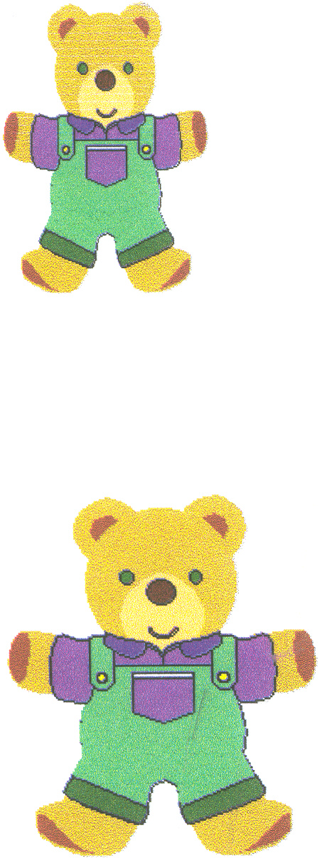
January 2017 Edition

Head Teacher’s Message

Happy New Year. I hope you had an enjoyable Christmas and have a happy and prosperous New Year. A new year also allows us to reflect on our progress so far. As you know we are all
‘Trying our very best to ensure everyone achieves success’ in our nursery.

Curriculum for Excellence
Our context for learning this month is “Long Long Ago”. We will be exploring this context through nursery rhymes and looking at the clothes, homes and way of life the linked to the characters.

Thank you
I am very grateful to you for your continued support of our nursery. A fantastic sum of £319 was raised from the sale of shortbread, calendars, concert donations and raffle tickets. A big thank you to the Parents Group for their hard work - making, organising and selling Christmas gifts at the nursery Christmas show. A chart showing how much was raised is displayed in the nursery foyer.

Registration of Infant Beginners for August 2017
Next week we will be enrolling children starting school in August. All children who will be 5 years old between 1st March 2017 and 29th February 2018 should be registered with their local school. Our sessions are: Tuesday 17th January to Friday 20th January between 9.30-12.00am and 1.00-2.00pm. If you have a child who will be starting school in the new session, please come along and bring the child’s birth certificate and proof of address e.g. Council Tax Bill. If you know of a child who is due to start school, please pass this information to their parents. Thank you.

Suggestions Box.
We have a suggestions box in the foyer and welcome any comments.

Newmains Nursery Newsletter

Nursery News

School Road, Newmains, Wishaw, ML2 9BE. Tel: (01698 274923)

Honor Roll:

Save the Date

Burns Celebrations
On Wednesday 25th January we will be celebrating the birth of Robert Burns by telling Scottish stories, singing Scottish songs and sampling some “haggis, neeps and tatties”. Please wear / bring something tartan to the nursery on that day.

Magic Show
Friday 27th January.
The “Magic Man” will be visiting our nursery to dazzle the children with his tricks.

Race Night
Friday 3rd March in St Brigid’s Center. There is a meeting to organize the event on 13th January at 11am and 1pm. Please come along.

Keep an eye on the Notice Board and nursery blog for more details on special events.

Upcoming Events
Friday 13th January 2017
Meeting to discuss and organize fund raising Race Night. 11am and 1pm

Wednesday 25th January 2017
Burns Celebrations

Friday 27th January 2017
Magic Show

13th February Holiday
14th February Holiday
15th February. In-service Day

Spring Break
Nursery closes Friday 31st March and reopens on Tuesday 18th April

Final Comment
Please ensure you have informed the nursery of your e mail address.
In the event of adverse weather conditions, parents are advised to check www.northlanarkshire.gov.uk for the latest information and news about nursery closures. Please ensure that we have the latest telephone number and that of your emergency contacts so that we can keep in touch with you.
We like the children to experience outdoor play daily. Please ensure the children have hats and gloves to keep them warm.

Regards,
E Maguire Principal Teacher

Kian 6th January
Lauren 8th January
Sophie 12th January
Mason 13th January
Lewis 22nd January
Mason 31st January



Birthdays

Contact
Information
Twitter:
@NewmainsPrimary
Phone:
01698 274923
Website:
http://www.newmains.n-lanark.sch.uk/

