CONTENTS

Pg No.
- HT Introduction
- School Pledge
- NLC Covid-19
- School Information: Contact Details
School Roll
Class Structure
Denominational Status
Community Facilities & Letting Procedures
- Location & Buildings
Staff List
- School Day / Times
School Year / Holidays
- Enrolment
Placing Requests
Transfer from Primary School to Secondary School
- Links with Partnership Schools
Links with Pre-5 Establishments
- Equal Opportunities
The Curriculum / Curriculum for Excellence
12 Literacy & English
13 Mathematics
Health & Wellbeing, Sciences, Social Studies, Technologies
14 Information Communication Technologies
15 Expressive Arts: Music / Drama / Physical Education / Art & Design
16 Religious & Moral Education
18 Raising Achievement For All
Additional Support Needs
19 Dispute Resolution
20 School Improvement Plan – Priorities 22/23
Homework
21 Promoting Positive Relationships
25 School/Community
Extra-Curricular Activities
Educational Visits
26 Visitors
27 Home / School Links
28 Attendance at School
29 Child Protection
Adult Protection
30 Clothing & Uniform
31 Supervision of Playground
Meals
Transport
32 Medical & Health
Information in Emergencies
33 Freedom of Information
General Data Protection Regulations (GDPR)
37 The Parent Forum / Parent Council
39 Important Addresses / Contacts

Morningside Primary School
School Road
Morningside,
Wishaw
ML2 9QW

Telephone No. : 01698 274938

Dear Parents/Carers,

Our handbook has been compiled in order that we might:

a) give you some general information about the school.
b) offer a brief outline of our educational aims for your child(ren).
c) give statements on our curriculum content.

It is our hope that, as you read through the pages, you will be assured that we share your commitment to your child’s social, moral, physical and academic welfare and that we share the same high expectations that we educate each child to his or her potential.

You have been your child’s first teachers and it is our aim to continue to foster the same positive attitudes of honesty, consideration for others, self-discipline and responsibility which are being encouraged in the home. Through mutual co-operation between home and school, we can then work in partnership with you to provide opportunities for practice of these virtues.

The school has very strong links in the local community and benefits from close liaison with other local primaries, pre-5 establishments and Clyde Valley High School.

We value each child as an individual and hope that experiences gained in Morningside Primary School will give your children a positive self-image, confident in their valued contribution to the school and the wider community.

If I can be of any further assistance and if you would like to arrange a visit to Morningside, please do not hesitate to contact the school.

Yours sincerely

Jennifer Gardiner
Head Teacher

We strive to be a Strong & Caring School Community
where everyone is ;

SAFE
HAPPY
INCLUDED
&
RESPECTED

by
Building Confidence & Raising Achievement

WE TRULY ARE MAKING PUPILS SHINE
Citizens • Effective Contributors

Covid-19 Pandemic

NLC will continue to align supports, from across the service, in response to the Covid-19 pandemic, to support children and families and maintain educational provision. Further information is available directly from the school or from North Lanarkshire Council’s website www.northlan.gov.uk

SCHOOL INFORMATION

Name and Address: Morningside Primary School
School Road
Morningside
Wishaw
ML2 9QW

Telephone Number: (01698) 274938

E Mail Address: enquiries-at-morningside@northlan.org.uk

Website/Blog: glowscotland.gov.uk/nl/morningsideblog

Twitter: Account@morningsideps

Roll: Our present roll is 224. Parents/carers should note that the working capacity of the school will vary dependent upon the number of pupils at each stage and the way in which the classes are organised. The planning capacity of the school is 185. In addition to this, the school has access to 60 temporary spaces. These are not included in the capacity calculations because of their temporary nature.

Class Structure: At present we operate a nine class structure from P1-7, with a mixture of 4 straight classes and 5 composite classes.

Denominational Status: Morningside is a non-denominational school.

Community Facilities & Letting Procedures: It is Council Policy that school accommodation be made available as far as possible outwith school hours for use by the community. Such use by groups and clubs will be in accordance with approved letting procedures and enquiries should be directed to NLC Offices located at Summerlee Museum of Scottish Industrial Life, Coatbridge.

Successful Learners • Confident Individuals • Responsible Citizens • Effective Contributors • Successful Learners • Confident Individuals •

LOCATION AND BUILDINGS

Morningside Primary is situated in the village of Morningside, approximately one mile from Newmains. The school was built originally in 1874, is of traditional style, with a main hall, seven classrooms, a learning hub, a support base/resource room, an office, janitor’s room and Head Teacher’s room. We also have two modular classrooms within the school grounds.

TEACHING STAFF
Head Teacher: Mrs Jennifer Gardiner
Principal Teacher: Mrs Lorraine White
Principal Teacher PEF: Mr George Stathis
Class Teachers: Ms Rebecca Jones
Mrs Danielle Russell
Mrs Kirsty Lawrence
Miss Jennifer Stillie
Miss Rachel Bennett
Mrs Lisa McAllister
Mrs Moira May
Mrs Laura Mitchell (P/T)
Mrs Caroline Robertson (P/T)
Miss Kellie McQuade (Temporary)
Miss Lara Brown (Temporary)
Mr Ross Cheyne (Probationer)

NON-TEACHING STAFF
Senior Clerical Assistants: Mrs Beverley Daly
Mrs Angela Carmichael (P/T)

Classroom Assistants: Mrs Veronica McInnes

Special Needs Assistants: Mrs Marion Kerr
Miss Gail Devine
Mrs Marta Balkova
Mrs Laura Lyons

Janitor: Mrs Catherine McLaughlin

Clearning Supervisor: Mrs Dorota Sokolowska
Cleaning Assistant: Mrs Katie McGranaghan

Catering Assistants: Mrs Irene Cunningham
Miss Diane Dow
Mrs Carol-Ann Crooks

SCHOOL DAY

Daily: 8.55am - 3.00pm (P1 - P7)

Morning Interval: 10.15am – 10.30am or 10.35 – 10.50am (split interval times)

Lunch: 12.10pm – 1.00pm

All P1 pupils will be required to attend full-time from the first day of the session.

THE SCHOOL YEAR - SESSION 2022/2023

The Education Committee has agreed the school calendar and holiday arrangements for Session 2022/23. These arrangements apply to pupils and teaching staff.

First Term
Teachers return for duty* Monday, 15th August 2022
In-service day* Tuesday, 16th August 2022
Pupils return Wednesday, 17th August 2022
September weekend close Thursday, 22nd September 2022
Re-open Tuesday, 27th September 2022
Mid Term close Friday, 14th October 2022
Re-open Monday, 24th October 2022
In-service day* Monday, 14th November 2022
Christmas Close Thursday, 22nd December 2022

Second Term
Re-open Monday, 9th January 2023
Mid Term Close Friday, 10th February 2023
In-service day* Wednesday, 15th February 2023
Re-open Thursday, 16th February 2023
Spring Break Close+ Friday, 31st March 2023

Third Term
Re-open Monday, 17th April 2023
May Day Monday, 1st May 2023
In-service day* Tuesday, 2nd May 2023
May Weekend close Thursday, 25th May 2023
Re-open Tuesday, 30th May 2023
Summer Close Wednesday, 28th June 2023

*These indicate the 5 In-service days for teachers this session.

+Good Friday 7th April 2023, and Easter Monday 10th April 2023

ENROLMENT
Parents/carers offered or seeking a place and wishing to visit the school are advised to telephone the Head Teacher.

PLACING REQUESTS
You have the right to make a placing request for your child to be educated in a school other than the local school. In December each year, the authority will advertise its arrangements for placing requests. There are sound educational reasons for trying to ensure that the transfer or admission of children to a school takes place at the start of a school session. Other than those who are moving
home to a new area, parents/carers are advised to time any placing requests so that they take effect from the beginning of the new school session. Every effort will be made to try to meet the parental wishes, but you should note that it is not always possible to grant every placing request to a particular school.

Placing requests to Primary School do not necessarily ensure that your child will have a direct entry into the associated secondary. Advice on this must be sought from the Primary School Head Teacher. Further information on placing requests is available from the school or the council’s website.

Parents/carers and young people have a right under the Additional Support for Learning Act 2009 to make a placing request for their child or young person to attend a nursery (including partnership nursery), special school or special class managed by the home authority. In the event of a successful placing request the authority are not required to provide transport. The Act also enables parents/carers and young people to make a placing request to attend a school/establishment belonging to another authority.
Co

TRANSFER FROM PRIMARY SCHOOL TO SECONDARY SCHOOL
Pupils normally transfer between the ages of 11½ and 12½ so that they will have the opportunity to complete at least 4 years of secondary education. Parents/carers will be informed of the arrangements no later than December of the year preceding the date of transfer at the start of the new session.

The school to which pupils normally transfer is:

Clyde Valley High School
Castlehill Road,
Wishaw
ML2 OLS
Tel: 01698 274950

The school’s partnership with parents and the wider community has many excellent features. Very strong community links have been established with the church, the local nursing home, and local businesses. Parents and grandparents are very well involved in the weekly work of the school.
The Parent Council is very supportive and is heavily involved in both curricular workshop evenings and in the establishment of business partners. Highly effective transition programmes are well established with the local nursery and secondary school.

LINKS WITH PARTNERSHIP PRIMARY SCHOOLS

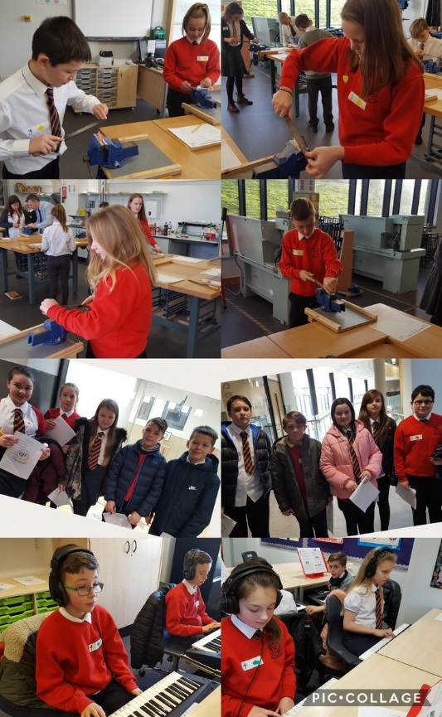
Clyde Valley High School has established extensive links with its ten partnership primary schools to prepare pupils for a smooth transition between primary and secondary school and to provide continuity of learning.

The Depute Head Teacher (S1 & S2), Mrs Yvonne McKenna, links closely with all of the primary Head Teachers when they have their monthly meetings to discuss curricular matters. All aspects of A Curriculum for Excellence are tackled in turn and expertise is shared within the group.

Each year, Clyde Valley organises a number of events and visits for the pupils in our primary school, e.g. Netball and Football Tournaments, P6 + P7 visits, school show, public speaking, Fete de Noel.

In addition, staff from Clyde Valley make a number of visits to the primary schools.

P7’s enjoy different aspects of CVHS

Pupil Support and Learning Support staff, in conjunction with the Primary 7 teachers, prepare profiles on the pupils. This ensures that pupils are kept together with friends and that any special needs are met. Responsible Citizens • Effective Contributors • Successful Learners • Confident Individuals • Responsible Citizens • Effective Contributors
By the time the pupils leave Morningside Primary School, Clyde Valley has gathered a wealth of information on each individual - health, progress, effort, test results, additional support needs.
As a result of our liaison programme, it is our experience that pupils settle very quickly into S1 and that they are able to experience continuity of education provision.

LINKS WITH PRE-5 ESTABLISHMENTS

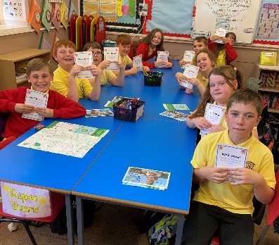
Morningside has established links with many of the Pre-5 establishments to prepare for transition from nursery school. (The current session has seen a planned programme of liaison visits between Newmains Nursery Centre, our nearest neighbour, and Morningside Primary. This has involved a nursery nurse working with the P1 Class Teacher for the first two days of term and a programme of class visits to the Nursery).

Our P7 buddies are rewarded The “buddies” of the future will help at parties and visit the centres
for their excellent work with from time to time. The pre-school children are invited to Morningside
our new Primary 1’s Primary for concert rehearsals, sports events, liaison visits.
Newsletters are exchanged between establishments.

EQUAL OPPORTUNITIES

The School is committed to ensuring its policies and practices do not impact adversely on any particular group(s) of people and opportunities to promote equality are actively pursued in line with the Equality Act 2010. The school endorses the Council’s Equality and Diversity Policy and Equality Strategy 2019-2024, the Service’s Promoting Equality and Diversity Circular Gen 155-10. and is committed to eliminating all forms of discrimination including disability, gender and religion.

The Equality and Human Rights Commission’s Technical Guidance for Schools in Scotland details the essential requirements of the Equality Act 2010 for schools. This can be accessed at: https://www.equalityhumanrights.com/en/publication-download/technical-guidance-schools-scotland

• Responsible Citizens • Effective Contributors • Successful Learners • Confident Individuals •

CURRICULUM

• Successful Learners • Confident Individuals • Responsible Citizens • Effective Contributors •

What is Curriculum for Excellence?
Curriculum for Excellence is Scotland’s national curriculum. It provides a coherent and inclusive curriculum from 3-18 years wherever learning is taking place, including early learning childhood centres, schools, colleges and community learning. It places children and young people at the heart of Scottish Education.
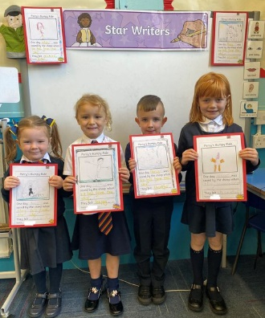
Well done to our Star Writers!
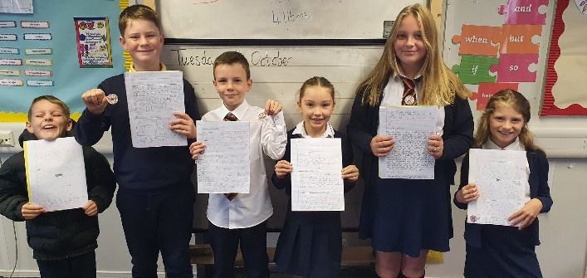

Fantastic effort in P6/5 with their descriptive writing P1’s fabulous taught writing

The purpose of Curriculum for Excellence is encapsulated in the four capacities – to enable each child or young person to be

- a successful learner
- a confident individual
- a responsible citizen
- an effective contributor

These four capacities govern the entire curriculum from age 3-18 and aim to raise the standards of achievement for all learners.

Curriculum for Excellence is underpinned by the values inscribed on the mace of the Scottish Parliament – wisdom, justice, compassion and integrity.

Throughout Curriculum for Excellence there is a strong focus on Literacy, Numeracy and Health & Wellbeing across all aspects of learning and every teacher will support learners with the development of these, including digital literacy skills.

Curriculum for Excellence is defined as:

“The totality of all that is planned for children and young people throughout their education”.

The opportunities for learning and teaching are governed by the Four Contexts for Learning, which ensure that the education your child receives is informative, interesting, relevant and fun. These contexts are:

- Ethos and life of the school as a community
- Curriculum areas and subjects
- Interdisciplinary learning
- Opportunities for personal achievement

What are the Curriculum for Excellence levels?

There are five levels and these are flexible depending on pupils’ needs and abilities (some children and young people may achieve these levels earlier or later dependent on ability:

- Early pre-school to P1
- First to the end of P4
- Second to the end of P7
- Third and fourth S1-S3
- Senior Phase S4-S6 and other forms of study

What is the Broad General Education?

The Broad General Education (BGE) is the first phase of two closely connected phases of education. The BGE phase stretches from age 3 until the end of S3 after which learners move into the Senior Phase which starts in S4.

Curriculum Areas and Subjects
The BGE is delivered via 8 curricular areas (which in secondary school
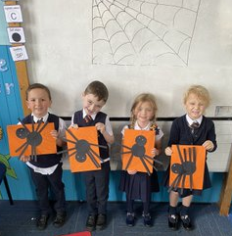
covers years S1-S3) and may be subdivided further into individual
subjects. The eight curricular areas are:-

- Languages and Literacy
- Mathematics and Numeracy
- Expressive Arts
- Religious and Moral Education
- Health and Wellbeing
- Sciences
- Social Studies Our P1’s make some spooky
- Technologies spider pictures

Assessment and Reporting
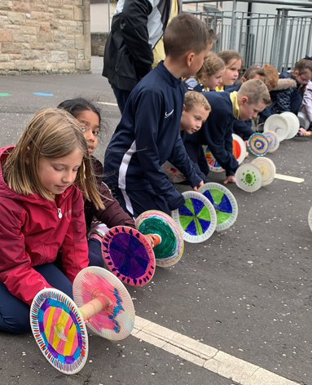
Assessment is an important part of the Curriculum for Excellence and,
at all levels, pupils’ progress is closely monitored by teachers and staff.

In turn, teachers and staff work with pupils to reflect on their results,
looking at their strengths and learning needs, agreeing next steps and
action based on these. As they progress, pupils become more involved
in this process, as they develop the skills to make effective judgements
on their own learning, developing personal expertise that will be
important to them throughout life.

Assessment also helps teachers plan learning experiences which are
P4 designed and made their motivating and challenging. Children who may have additional
own roly poly toys. support needs will be assessed using methods best suited to their
The race is on! individual requirements.

Rather than engaging in traditional written assessments, pupils will be asked to engage in a variety of activities which will assess their learning, typically evidencing their learning in terms of what they:

- Say
- Make
- Write
- Do

Learning logs evidence assessment in a diversity of ways e.g. photographs, written assessments, mind maps etc.

Key Components in Learning and Teaching
Pupils are made aware of their Learning Intentions (what we are learning) and Success Criteria (what we need to do to show we are successful) and these are made clear at the beginning of each lesson/block of learning. Pupils use these key components in order to assess their own, and each other’s, pieces of work. Learning Intentions and Success Criteria are also used within the high quality teacher feedback that pupils receive. ICT is also used to enhance learning experiences in all areas of the curriculum.

Furthermore, staff facilitate experiences which develop higher order critical thinking skills, devising tasks which encourage pupils to show they are:

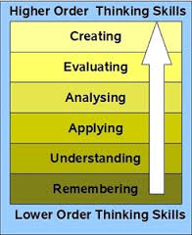
These higher order thinking skills encourage deeper learning and
promote creativity within our classrooms.

In playrooms and classrooms staff will be using improved ways of assessing children’s learning, taking account of national and local advice and guidance.

Reporting To Parents
Your child’s progress will be reported to you so that you know how well your child is doing. This can take many forms e.g.

- Interim and final written reports
- Parent-teacher consultations
- Class assemblies
- Blogging
- Opportunities to view/comment on classwork

Each year your nursery/school will let you know what is being done to implement Curriculum for Excellence so that you can be confident that your child is receiving a high quality education.

‘A Curriculum for Excellence’ (Scottish Executive 2004) is available at:
www.acurriculumforexcellencescotland.gov.uk

Building the Curriculum at Morningside Primary School
Our curriculum offers experiences in:

LITERACY & ENGLISH
Literacy and English is an integral part of every curricular area and has a high priority in our planning. Development of literacy to meet the standards and targets of the North Lanarkshire literacy programme is pivotal to the school’s Literacy Policy. It is the overall aim of our literacy programme that the children will progress throughout their primary years, developing the skills necessary in the four areas of language, i.e.

• Reading • Writing • Talking • Listening •

to allow them to communicate with fluency and confidence.
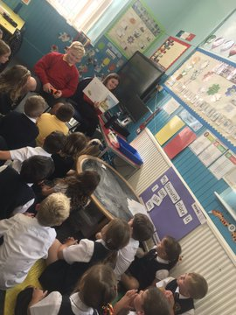

Reading:
At Morningside Primary School, we follow the North Lanarkshire
Council policy on reading which focuses on comprehension strategies
as well as on fluency. A diverse range of texts are used in order
to provide appropriate challenge and enjoyment. Pupils read to find
and handle information for a range of purposes and read, on occasion,
aloud to enjoy and respond to a variety of texts. All children in the
school have an opportunity to borrow a book from both the class
and the library van which visits the school weekly. P1 benefit from
‘Book Bags’ which the children are allocated each week by our ‘Book P7 pupils host Golden Time
Bag Ladies’. Story Time in our P2/1 class

Writing:
Opportunities for writing permeate the curriculum and occur daily. Writing is also developed through the North Lanarkshire Literacy Programme. Punctuation and structure, spelling, handwriting,
presentation and author’s craft are all recognised as being vital tools in achieving writing of quality. The school’s policy also places emphasis on content rather than only grammatical accuracy.
Children’s writing has been a major development and the quality of children’s writing has shown significant improvement over the years.

Talking and Listening:
The cooperative nature of A Curriculum for Excellence means that talking and listening activities are key to the learning opportunities that are facilitated in school. Children regularly work in pairs, trios and larger groups providing regular opportunities for pupils to become confident individuals who are equipped to communicate in an ever changing world of work.

MATHEMATICS
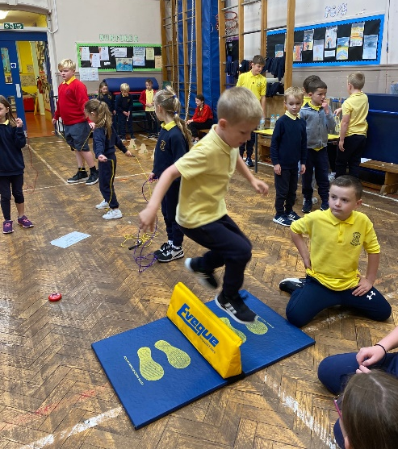
A variety of resources support the facilitation of our Numeracy and Mathematics Curriculum, including Numicon, SHM, Teejay, Education City, and the Professional Learning Resource for Numeracy. Pupils follow a clear Maths Pathway which ensure that all learners engage in the experiences and outcomes under the three main organisers:

- Number, Money & Measure
- Shape, Position & Movement
- Information Handling

As in all curricular areas, assessment is ongoing and informs future learning and teaching experiences.
P3/2 Mathletics! It is our aim to support each child’s development through active mathematics which is relevant to real life contexts, whilst ensuring the highest quality learning and teaching experiences.

HEALTH AND WELLBEING, SCIENCES, SOCIAL STUDIES, TECHNOLOGIES

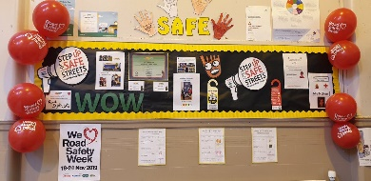
Throughout the school session, pupils embark upon
learning across different curricular areas, often through
interdisciplinary themes. The Health and Wellbeing
themes cover a host of issues including bullying, racism,
health and personal safety, to name a few. This is a superb
opportunity to get to know one another whilst preparing
Our JRSO’s created a Road Safety display to become a responsible citizen within our society.

Learning about the environment often involves engaging in outdoor learning, visiting places of relevance and interest or perhaps hosting a visiting expert, all giving first-hand experience.

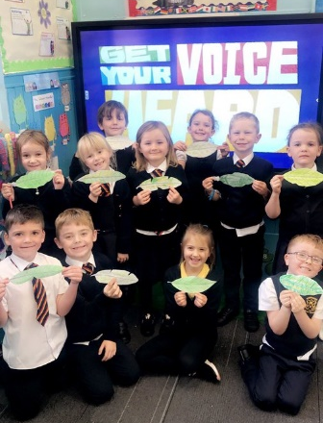
Children learn firstly about their own surroundings, followed
by people and places further away e.g. my school, Scotland,
Europe etc. History is taught by learning about people who
lived in the past e.g. Egyptians, life in a Medieval Castle and
the Second World War.

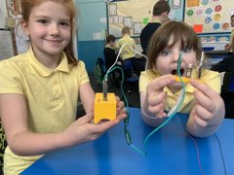

P2/1 Promises to the Planet

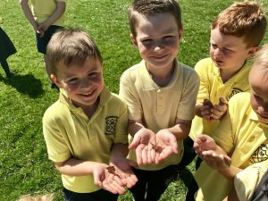
The discovery of Science and Technology involves
investigating, questioning, seeing connections and trying out
ideas. This is done using a balance of investigative and
practical work in order to develop transferrable skills
throughout learning.

P4/3 investigate electrical circuits

Health education has an important place with children being given the knowledge to enable them to make decisions which will benefit them and their families, allowing them to become responsible citizens who contribute to society in an effective way. Information is given about how our bodies work and children are encouraged to make healthy life choices. The teaching is done in a positive and engaging way.

INFORMATION COMMUNICATION TECHNOLOGIES

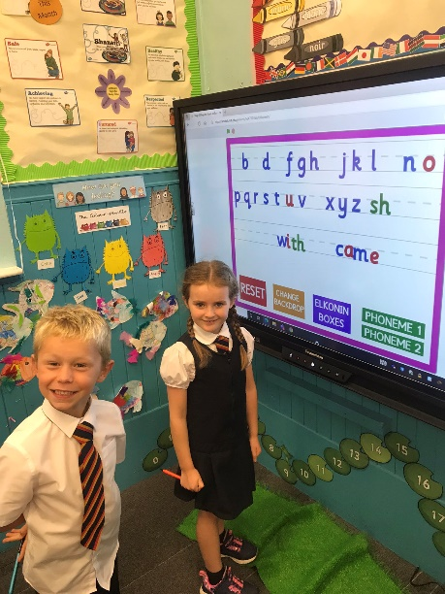
ICT is used daily in order to enhance learning and teaching. We currently have interactive smartboards or LED TVs in every classroom which allows interactive learning and teaching using high quality audio-visual resources. All classes have access to laptops and we currently have 31 in school. We also currently have 6 iPads for use in classes, too. Children are able to increase their research skills, create products using different media and become effective learners through monitored use of the internet.

Social Studies encompasses all areas of the curriculum and can
provide stimulus for art, drama, music and writing. The whole
school programme ensures balance and breadth.
P2/1 use the interactive board
to spell their common words

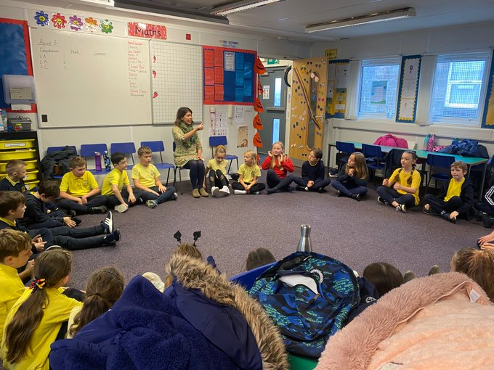
EXPRESSIVE ARTS

Music:
There has always been a great emphasis placed
on appreciation and enjoyment of music and the
music experience for our children is divided into
four categories:-

- Singing
- Playing
- Listening
- Inventing P5 Kodaly with Mrs Ewart

These four elements are developed throughout the school. Children are also encouraged to listen to all types of music: classical, pop, opera, folk, Scottish traditional, as well as their own choice.

Very often a class choice of songs, music or poems with accompaniment is linked to specific topic work in Social Studies or Religious & Moral Education. Children are given experiences in playing using both pitched and non-pitched percussion and are encouraged to experiment in sound collage and production of their own melodies.

The Kodaly Principles Music course (as taught by the National Youth Choir of Scotland) is taught in Primary 5 and we have some members of staff also trained in Kodaly. Children have regular opportunities to perform on stage throughout the year.

The school is currently updating music provision provided in order to ensure progression throughout the school.

Drama:
Most children come to school with extensive experience of imaginative play through which they will have begun to explore aspects of the world characteristics around them. In drama, this familiar and powerful way of learning is exploited as pupils engage in activities where they are given opportunities to develop their knowledge and understanding of themselves and their relationships to others to real-life events. By engaging feelings, knowledge and experience in this dynamic and enjoyable way, creative and imaginative thought is stimulated in promoting confident individuals.

Through observing, questioning, challenging and supporting pupils, teachers seek to promote individual and group responses within drama, including the development of insights into both the particular context and the drama process itself, e.g. Personal and Social Development themes such as peer pressure, bullying, etc.

There is a clear cross-curricular link to Language within drama, with a particular focus on ‘Talking and Listening’.

Physical Education:
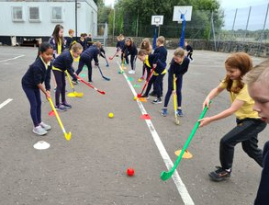
Physical well-being is recognised by all staff, and children follow a full education programme which includes:

- Inventive Movement
- Expressive Movement
- Games Skills

The programme currently in use develops ball handling,
gymnastics and active health.
P4 Hockey
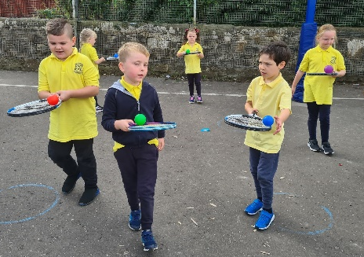
The school works closely alongside an Active Schools’ Co-ordinator to provide many out of hours learning opportunities throughout the year with activities including Netball, Football, Skipping, Basketball, Gymnastics and Dance. Participation in these activities also gives the children the opportunity to take part in festivals with other cluster schools, and helps promote
a sense of achievement both individually and as a school.
P2/1 balancing skills

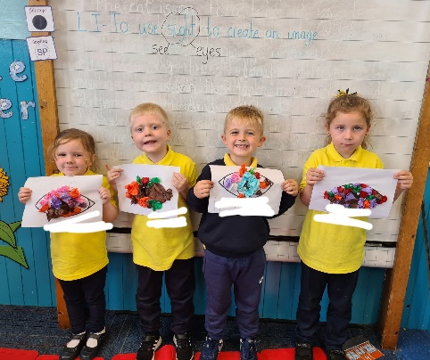
Successful Learners • Confident Individuals • Responsible Citizens • Effective Co
Art and Design:
As well as developing art and design through interdisciplinary
themes, skills in Art & Design are focussed upon discretely.
Children are given experience of 2-dimensional and
3-dimensional work using various art and craft materials from
crayon and paint to fabric and clay. The school’s programme
in art and design is being developed further as part of our
school improvement plan.
P2/1 combining science and art to
make wonderful eye pictures for
their Senses topic

RELIGIOUS AND MORAL EDUCATION
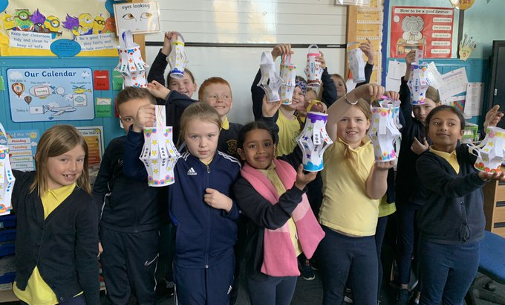
Religious and Moral Education is based on national guidelines. During the year children will be taught 2 topics focusing on Christianity and one each of Judaism and Islam topics, devised by the school and advisers. Practical expressions of ‘caring and sharing’ are stressed.

P3/2 make Diwali lanterns

Bright, up-to-date, songs and hymns are enjoyed at weekly assemblies led by senior management team. The School Chaplain, Rev. Raeburn leads us in Religious Observance each month. Pupils are also given opportunities to lead assemblies. Assemblies reflect special festivals throughout the year, e.g. Harvest, Christmas, Mother’s Day and Easter.

It is recognised that the Education Act allows parents/carers to withdraw their children from any instruction in religious subjects and from any religious observances, and any such pupil will not be placed at any disadvantage with respect to secular instruction.

Parents/carers from ethnic minority religious communities may request that their children be permitted to be absent from school in order to celebrate recognised religious events. Only written requests will be considered.

Appropriate requests will be granted on not more than three occasions in any one school session and the pupil noted as an authorised absentee in the register.

No child will be discriminated against due to social hardship, race or colour. Any incident involving racial harassment will be investigated following NLC guidelines.

The school actively participates in fund-raising for many charities, both local and national.

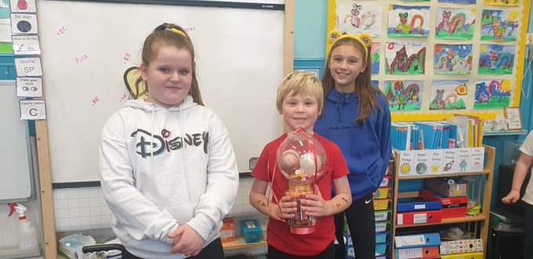

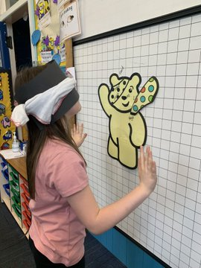
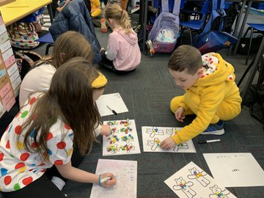

Our House Captains and Vice Captains organised individual classroom fun events for
a whole school Children in Need Day

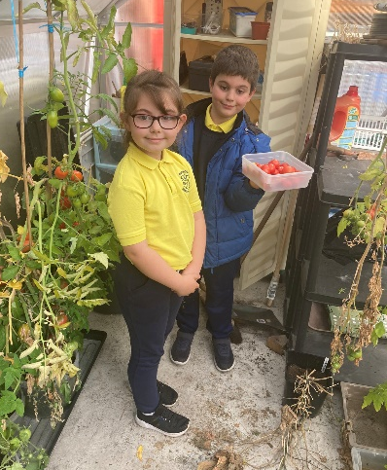
RAISING ACHIEVEMENT FOR ALL
Raising Achievement for All forms the overarching strategy for
the service. Subtitled ‘Experiences to Last a Lifetime’, this strategy
aims to harness the combined forces for Education & Families to
provide a rich set of learning opportunities and experiences for
young people and adults which begin in the classroom, nursery or
learning centre and extend out into the community and the wider
world beyond.

In seeking to offer ‘Experiences to Last a Lifetime’ we will also
look to draw upon ‘a lifetime of experiences’ already there in the
communities which make up North Lanarkshire. Gardening Club!
Picking our own grown tomatoes
to make tomato & chilli jam

ADDITIONAL SUPPORT NEEDS

Morningside Primary complies with the Additional Support for Learning (Scotland) Act 2004 as amended by the Additional Support for Learning (Scotland) Act 2009 and the Additional Support for Learning: Statutory Guidance 2017.

North Lanarkshire Council’s policy is contained within “Support for Learning Policy Into Practice 2, a copy of which is available in the school. The school has a Support for Learning Policy, available from the school on request, which is consistent with North Lanarkshire Council guidelines. We aim to enable all children to reach their full potential. We understand that most pupils have difficulty in learning some particular subject at some time. Among the reasons can be absence, ill-health, trouble in concentrating, speech difficulty. We strive to ensure that children in difficulty get the time, the help, the extra experience and practice they need in order to master each stage thoroughly.

Teachers plan work which is challenging but which is achievable. Support may be given to children experiencing difficulties and children who are very able. Initially when a child is identified as having additional needs, this may be met within the existing classroom setup, and throughout the school if required.

Multi-agency support may also be provided if the child’s needs are such that external support is required, i.e. Educational Psychologist, Speech and Language Therapy, School Nurse, Social Work etc. Regular reviews take place with parents/carers between promoted staff, class teacher and support agencies.

Provision from North Lanarkshire Council is available for pupils with English as an additional language.

Looked After Children, i.e. children who are cared for directly or whose care is supervised by the local authority are deemed to have Additional Support Needs unless assessment determines otherwise.

Parents/carers can request an assessment at any time to establish whether a child or young person has additional needs and/or requires a Co-ordinated Support Plan.

GIRFME Plans enable staff to plan effectively for children and young people when interventions are required to support their learning and improve outcomes. Parents/carers and pupils are an essential part of the assessment, planning and review processes and their views will be actively sought.

Some children and young people may require significant support from education and at least one other agency, such as health, social work and/or voluntary agency to help them meet their learning targets. Where this support requires a high level of co-ordination the opening of a Co-ordinated Support Plan (CSP) may be considered. A CSP may be initiated by the school or another agency.
Parents/carers and young people can, if they wish, request that a CSP be considered and would be involved in the process. Parents/carers will receive letters from the Education Authority throughout the CSP process. Parents/carers and young people will be invited to take part in multi-agency meetings and their views will be recorded in the plan.

Where more intensive support for a child or young person needs to be planned for, usually when a number of agencies are involved in supporting their wellbeing, then a Child’s Plan may be developed. That plan will tell you what actions need to be taken and who will help with each action. It will usually be someone called a ‘Lead Professional’ who will have the job of making sure that the actions outlined in the plan take place and things get better for the child or young person.

DISPUTE RESOLUTION
North Lanarkshire Council is committed to resolving any differences of views through discussions, dialogue and building on common ground.

If the matter cannot be resolved with the Education Authority you have the right to request mediation. An independent mediation service is available to parents/carers and young people through Resolve (see contact details at the back of this handbook). Mediation is free through Resolve and independent of the Education Authority.

In the event that a disagreement cannot be resolved through mediation, then an application for Independent Adjudication (see contact details at the back of this handbook) can be made by parents/carers free of charge. The Independent Adjudicator will make recommendations to the Education Authority about how the dispute should be resolved.

The Additional Support Needs Tribunal has been set up to hear appeals made by parents/carers or young people on the decisions made by the Education Authority relating to Co-ordinated Support Plans, ASN placing requests and post school transition. If you disagree with any decisions relating to your child’s Co-ordinated Support Plan, either the creation of a CSP, or the content of it, you may be entitled to refer to the Tribunal.

SCHOOL IMPROVEMENT PLAN

Priorities for 2022/23

Cluster Priority
To ensure equity for all learners and to close the attainment gap in response of COVID-19.

Priority 1
To raise attainment in literacy and numeracy through high quality pedagogy, ensuring equity for all learners and close the attainment gap.

Priority 2
To support the mental, emotional, social and physical health of all children, families and staff.

Priority 3
To develop digital pedagogy across all stages, which engages learners and delivers a high quality learning experience for all children.

HOMEWORK
It is recognised that homework is an important component in the educational experience provided for our pupils. It is widely accepted that continuous learning takes place within and outwith school. Teaching staff wish to work with parents/carers in supporting this learning in home and community.
“Homework provides a way of enabling parents/carers to see the kind of work being tackled during the school day . . . . . . encouraging a sense of partnership between the school and parents/carers.” (HMIe).

Homework tasks should reflect National Guidelines on the curriculum. Most classes are using a ‘weekly’ approach to homework. This helps parents/carers with the flexibility if children are attending evening activities. Homework tasks include parents/carers being asked to listen to their children reading, children practising spelling and learning the ‘number facts’ at home. 15-30 minutes should be enough time for homework.

Pupils throughout the school also experience a variety of rich tasks involving parents/carers in their children’s learning, e.g. ‘make a hut for Percy’ and ‘make a house for New Lanark’, linked to Curriculum for Excellence.

PROMOTING POSITIVE RELATIONSHIPS

Last session we introduced our new Positive Relationships Policy with all children, parents and staff involved in the consultation process. The policy is a right based approach which focuses on respecting the rights of all. Children are encouraged to show good behaviour for learning, communication and safety.

Full policy is available on request.

Houses
We have 4 houses within the school: Alcath (red), Torbush (yellow), Auchter (blue) and Cathburn (green).
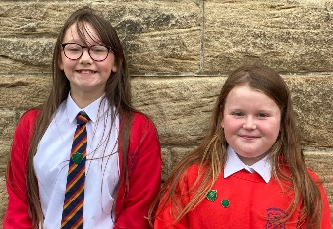

Our elected House Captains and Vice Captains 2021/22

Token Cupboard
Staff can award pupils with tokens which can be saved and traded at the weekly ‘token cupboard’ sessions. This is a whole school reward initiative which the pupils respond to fruitfully.

Golden Rules
Our Golden Rules relate to the behaviour we expect from all the children. They have been chosen by the Pupil Council and are displayed in each class and throughout the school. These rules state the positive actions that we strive to see from all Morningside’s Pupils. All stakeholders are asked to sign a Golden Rules Agreement at the beginning of the year to highlight their approval of the Golden Rules. The Golden Rules are:

We are gentle
We are kind and helpful
We listen
We are honest
We work hard
We look after property
We are polite
We always wear our uniform with pride

Golden Party
As a reward, children will be able to attend the Golden Party. This is to recognise the positive behaviour of children that have worked hard to follow the rules. Children attending 3 or more reflection sessions during a term will not be able to attend the Golden Party.

Our policy at Morningside depends heavily on praise and celebration of success. However, in the case of serious indiscipline and aggressive misbehaviour, the school will have recourse to the procedures leading up to, and possibly culminating in, exclusion from school.

Rights Respecting Schools
Unicef works with schools in the UK to create safe and inspiring places to learn, where children are respected, their talents are nurtured and they are able to thrive. The Rights Respecting Schools Award embeds these values in daily school life and gives children the best chance to lead happy, healthy lives, and to be responsible, active citizens.

There are three levels to the Award:
Bronze: Rights Committed; Silver: Rights Aware; Gold: Rights Respecting

At Morningside, we have achieved Silver level.

A Rights Based Approach
The three main points to remember are:
- Rights are something everyone has as a result of being born. No-one has power to give them to you or take them away from you. There are no conditions attached to them.
- When we learn about rights, we learn that not only do we have them ourselves, but everyone else has them too. When we are enjoying our own rights, therefore, we have a duty to make sure that we do so in a way that doesn’t deny other people theirs. A rights-based approach encourages responsible behaviours.
- Adults working with children need to model rights respecting behaviour and use rights respecting language in order to reinforce the benefits of this values system.

It is important that adults and children alike learn not only that all children should be rights respecting but also that adults bear the responsibility for ensuring these rights are known about, understood and realised (article 42).

This means that:
- parents and carers are responsible for ensuring they model rights respecting behaviour in bringing up their children
- schools are responsible for promoting a rights respecting environment
- children learn to become rights respecting global citizens

Class Charters
At Morningside Primary, we learn about United Nation Convention of the Child (UNCRC). In each class the children choose articles which are most relevant to their classroom. A class charter is then designed and created by the children and adults in the class, whilst considering how they can display respectful behaviours and actions that ensure the rights of every child in the class is considered. All members of the class then sign the class agreement. What is agreed is then set out in a way that can be easily seen around the room.

Charters can be developed with the active participation of children from infant to P7. They act as a reminder of the shared values and principles based on the UNCRC and are applicable to all.

If a rule is broken, the children then consider how the behaviour displayed has impacted the rights.
The aim is to make the UNCRC, a real and meaningful guide to action on a day-to-day basis. This means that both the initial process of creating the charter and its subsequent use should be inclusive and unite the children and young people and adults in the class. The charter develops a sense of ownership of the classroom and learning. Once developed it becomes a point of reference for the class and once signed by the teacher, assistants and pupils it signifies a shared enterprise and acts as the ‘social glue’ which binds everyone together.

Anti-Bullying and Restorative Practice (included as part of the positive behaviour initiative):
The aims of the policy are:
• To prevent bullying behaviour taking place wherever possible.
• To reduce bullying when it does happen and aim for cessation of bullying behaviour.
• To provide support for children and their families who have been affected by bullying.
• To build resilience in children and young people and their capacity to address bullying.
• To develop organisational capacity to address bullying.
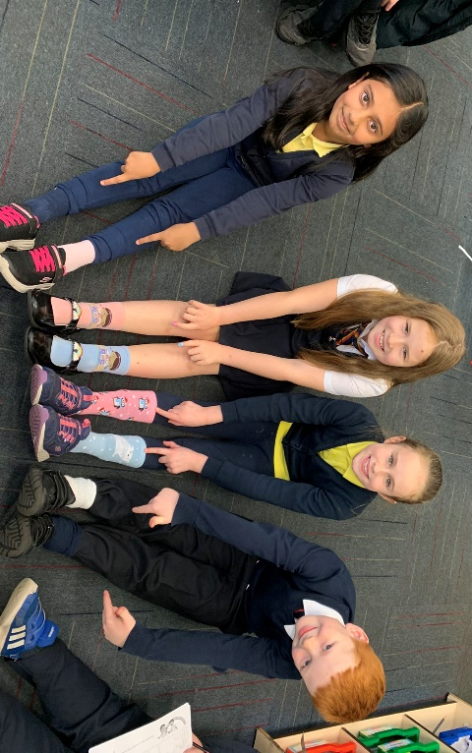
• To provide information on resources for people who have experienced bullying.
• To provide appropriate training for all staff working with children and young people.

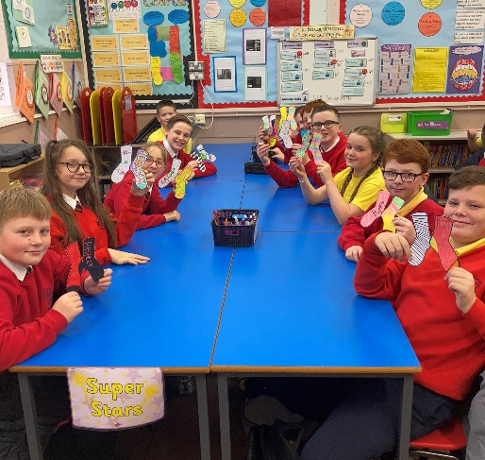

In recognition of Anti-Bullying Week and to celebrate diversity, we held an ‘odd socks day’.
The P7 class also designed their own pair of odd socks!

A Closer Look at Types of Bullying Behaviour

Physical
Includes hitting, kicking, pushing, choking. It also involves stealing or damaging someone else’s property.

Verbal
Involves speaking to a person or about a person in a way that is hurtful to that person e.g. rumours, name calling.

Emotional
Includes behaviour that embarrasses another person or upsets and excludes them e.g. exclusion from peer groups, hate notes, rude gestures and rude looks.

Cyber
Involves the misuse of mobile phones, social networking sites, email to communicate degrading information about others or to start rumours. It is often hard to identify the person responsible for this type of bullying behaviour.

Prejudice-based Bullying
• Asylum seekers and refugees
• Body image
• Disabilist - physical and learning disabilities
• Homophobic: because of or focusing on the issue of sexuality or perceived sexuality
• Looked After Children and Young People
• Racial
• Religious and belief

Homophobic Bullying
This is a specific form of bullying and is motivated by a prejudice against lesbian, gay, bisexual or transgendered people (LGBT) or those perceived to be so.

At Morningside Primary, we believe our pupils have the following rights:
• Everyone has the right to be safe and free from bullying behaviour and harassment
• Everyone has the right for their property to be safe
• Everyone has the right to learn in a pleasant and healthy environment
• Everyone has the right to be treated with respect and understanding
• Everyone has a right to their own identity; and
• Everyone has the right to report incidences of bullying behaviour through appropriate channels

We also expect pupils to undertake the following responsibilities:
• Respect all people, personal property, and the rights of others
• Observe safety rules at all times
• Report incidences of bullying behaviour, harassment, theft
• Respect others’ rights to the same happiness and enjoyment as you expect for yourself
• Avoid unhealthy and dangerous practices that affect you and others in the community; and
• Treat everyone with respect and understanding

Full policy available on request.
S Learners • Confident Individuals • Responsible Citizens • Effective Contributors • Successful Learners

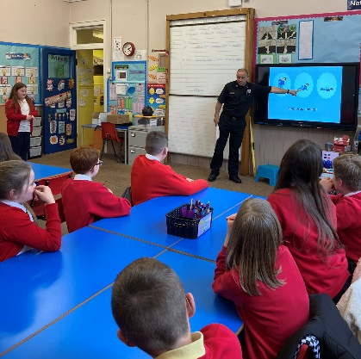
SCHOOL/COMMUNITY
The school encourages awareness of the benefits which accrue
from membership of the village and wider communities; also the
contribution which the child may make to these communities in
his/her turn. Regular visits are made to Morningside Care Home
to entertain residents. Local senior citizens are also invited to visit
the school regularly for entertainment and refreshment. Each y ear
the school participates in the local Gala Day. Close liaison is
maintained with Motherwell District Council Road Safety Committee,
Police Liaison and Community Education. Motherwell Fire Brigade visit P7 to talk about how to
keep safe at Bonfire Night

EXTRA-CURRICULAR ACTIVITIES

Events are organised throughout the year to which pupils and parents/carers are invited by letter. Football, Netball, Dance, Choir, Judo, Eco/Gardening , Spanish and Crafts clubs meet after school on a regular basis.

EDUCATIONAL VISITS

During the course of the year, children are taken on educational visits, where appropriate, to enhance class work and increase their understanding and appreciation of topics being studied. Most recent visits have included; The Wallace Monument and Stirling Castle, Strathclyde Park’s Roman Baths remains, Five Sisters Zoo, Whitelees Windfarm, Glasgow Science Centre, The Tall Ship, Glasgow, Motherwell Heritage Centre and the theatre.

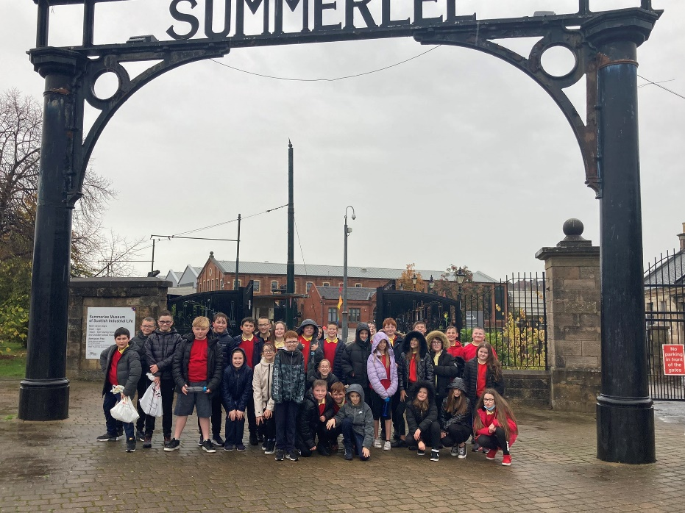

P7 visit Summerlee Museum where they attended the
Coal to Climate Change workshop

VISITORS

During the course of a year visitors from the world of industry and the wider community are often invited to speak with the children.

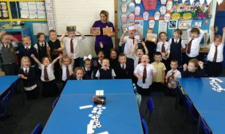
Throughout the session there are regular visits from many other agencies as well as other staff from different areas of the Department of Education.

Regular visitors include Community Police Officer, School Medical Officer and Nurse, Network Support Service, Additional Support Service, Psychological Services, Continuous Improvement Service, Educational Officers and Catering and Janitorial Services, to name
P2 had a visitor from Tesco who talked about but a few.
where our fruit and vegetables come from

At various times in the school year we also have students working with us. We provide places for Motherwell College Childhood Practice, and Strathclyde University and Glasgow University BEd students. Several local Secondary Schools ask us to provide work experience for 4th year pupils also.

It would be impossible to continually inform parents/carers of all visitors involved in the day-to-day life of the school, but should you have any concerns regarding the involvement of visitors within your child’s class, please do not hesitate to telephone the school.

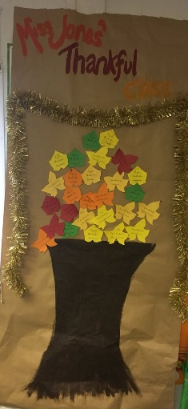
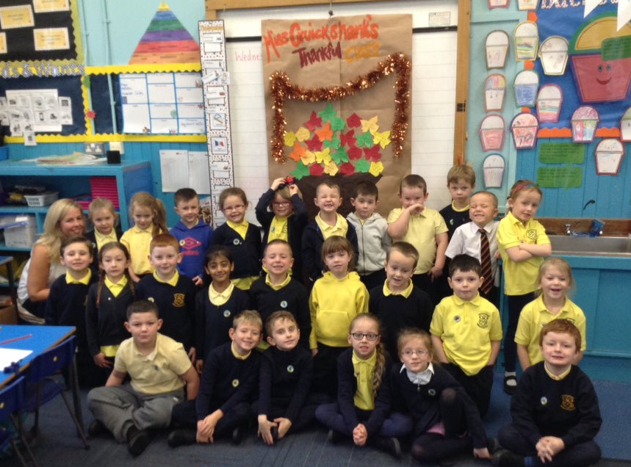
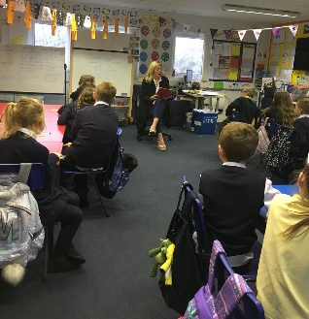

Our P2 and P4 classes enjoyed a visit from one of our parents who talked about Thanksgiving.
They made a ‘Thankful Tree’ and talked about reasons for being thankful

HOME - SCHOOL LINKS
Parents/carers are invited to meet with the class teacher in October and March at a mutually convenient time. Parents/carers may then wish to discuss their child’s progress in school; find out what they can do to help; give background information to enable the teacher to make better provision for the child; or raise matters which are causing concern to themselves or to their children.

‘Curricular’ workshops are held for all parents/carers from time to time, as and when the need arises, (e.g. new resources and methods). P1 parents/carers are given the opportunity each year to familiarise themselves with the P1 curriculum.

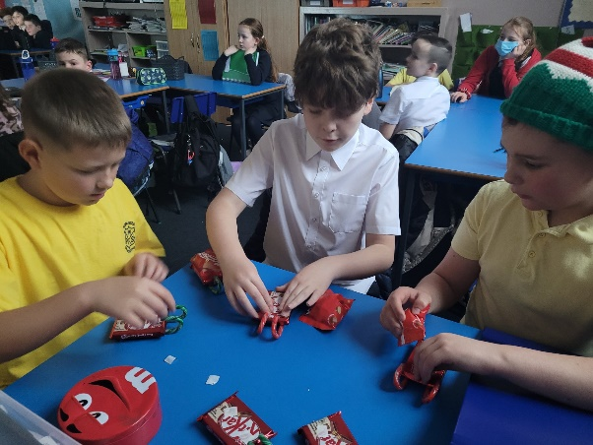

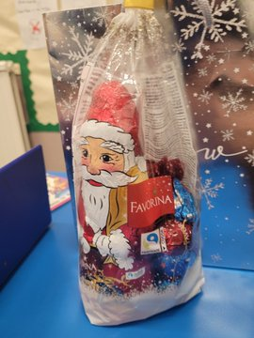
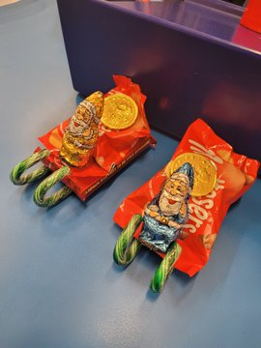

P7/6 class has been busy making Santa’s Fairtrade Express Sleighs to sell
and holding a raffle for a Fairtrade Chocolate Goodie Bag

The parents/carers and children of the new intake are invited before the start of the summer holidays to spend two sessions in school in order to become familiar with school surroundings, get to know staff and for parents/carers and children to get to know each other.

Please refer to our separate guide to beginning Primary 1 at Morningside Primary School.

Regular information is distributed to parents/carers via letters, blogs and text messages and email. Our blog is updated regularly and shares weekly diaries as well as celebrating success. This can be accessed at:

http://blogs.glowscotland.org.uk/nl/MorningsideBlog/Anyone wishing to contact the school urgently on matters affecting the education or welfare of his/her child should either call in person or telephone for an appointment.

The school is very fortunate in having parents/carers and other members of the local community who are willing to give their time and expertise to enrich the life of the school. Help of this kind is warmly welcomed.

ATTENDANCE AT SCHOOL
Section 30 of the 1980 Education Act lays a duty on every Parent/Carer of a child of ‘school age’ to ensure that their child attends school regularly. Attendance must be recorded twice a day, morning and afternoon. Regulation 7 of The Education (School and Placing Information) (Scotland) Amendment, Etc. Regulations 1993 requires each child’s absence from school to be recorded in the school register as authorised or unauthorised, as defined by the Scottish Government.

At the start of each school session, parents/carers will be asked to provide contact details including at least one emergency contact number, including where possible, a number that will accept a text message. Parents/carers are required to inform the school if these contact details change during the course of the school year. Parents and carers are asked to inform the school if a pupil is unable to attend from the start of the school day on the first day of absence. Failure to do so will result in school staff accessing all contact numbers provided for the child and may result in the school sending a text message. In terms of child safety police will be contacted if all attempts to locate the child have been exhausted.

Parents and carers are asked to inform the school by letter or telephone if their child is likely to be absent for some time, and to give the child a note on his or her return to school, confirming the reason for absence.

Family Holidays During Term Time
Every effort should be made to avoid family holidays during term time as this both disrupts the child’s education and reduces learning time. Parents/guardians should inform the school by letter of the dates before going on holiday. Absences will be classified as authorised only in exceptional circumstances. Such circumstances may include a family holiday judged to be important to the wellbeing and cohesion of the family, following serious or terminal illness, bereavement or other traumatic events.

A family holiday classified under the ‘authorised absence’ category will not include such reasons as:
• The availability of cheap holidays
• The availability of desired accommodation
• Poor weather experience during school holidays
• Holidays which overlap the beginning or end of term
• Parental difficulty obtaining leave (except in cases where evidence is provided by the employer that
it cannot accommodate leave during school holidays without serious consequences)

Family holidays with the above similar characteristics will be classified as unauthorised absence. Where the head teacher’s prior agreement has not been sought the absence will automatically be classed as unauthorised.

Where most family holidays will be recorded as unauthorised absence (see above) extended leave with parental consent will not be considered the same as a family holiday. Leave in such circumstances will be authorised under circumstances such as:
• Extended overseas educational trips not organised by the school
• Short-term parental placement abroad
• Family returning to its country of origin (to care for a relative, or for cultural reasons)
• Leave in relation to the children of travelling families

Parents/carers may request permission for such leave in writing and the school may authorise such requests under the following circumstances:
• The period immediately after an accident or illness
• A period of serious or critical illness of a close relative
• A domestic crisis which causes serious disruption to the family home, causing temporary relocation.

Parents/carers from ethnic minority religious communities may request that their children be permitted to be absent from school in order to celebrate recognised religious events. Only written requests will be considered. Appropriate requests will be granted on not more than three occasions in any one school session and the pupil noted as an authorised absentee in the register.

It should be emphasised that the school investigates unexplained absence, and that the authority has the power to write to, interview or prosecute parents/carers, or to refer pupils to the Reporter of the Children’s Panel, if necessary.

CHILD PROTECTION
Every adult in Scotland has a role in ensuring all our children and young people are safe and protected from harm at all times and in all situations. The Head Teacher is responsible for the school’s actions in response to Child Protection concerns.

If there are any Child Protection concerns, the Head Teacher will follow North Lanarkshire Child Protection Procedures and Guidelines.

Child Protection Co-ordinator is: Jennifer Gardiner
Telephone Number: 01698 274938

ADULT PROTECTION
The Council has responsibility under the Adult Support and Protection (Scotland) Act 2007 for the protection and support of adults at risk of harm within North Lanarkshire. Its employees therefore have the responsibility to ensure the welfare of all adults at risk of harm with whom they come into contact, as well as providing the highest possible standard of care for some of the most vulnerable members of our society.

If there are any Adult Protection concerns the Head Teacher will follow North Lanarkshire Adult Protection Procedures and Guidelines.

Adult Protection Co-ordinator is: Jennifer Gardiner
Telephone Number: 01698 274938

CLOTHING AND UNIFORM
It is not the policy of the Education Committee to insist on pupils having school uniform or specialised clothing. However, we do like to encourage the children to wear the school uniform which consists of navy blazer, navy skirt or trousers, white shirt, school tie (navy, red and gold) and school shoes (black gym shoes for indoor / gym). We discourage the wearing of trainers as we have found the choice/ brand of trainers leads to unnecessary fashion rivalry. Sweatshirts, polo shirts and jogging pants are available to order from the school twice yearly. It is preferable for children to have shorts, polo shirts and gym shoes for PE. Children are also asked to bring in black gym shoes to change into in school.

North Lanarkshire Policy: All North Lanarkshire schools must have a dress code which encourages pupils to dress in a way which is appropriate to attendance at school. This dress code must not lead to direct or indirect discrimination on the grounds of race, religion, gender or disability. Prior to drawing up the dress code the parents/carers, pupils and staff were fully consulted.

It is the expectation of Education and Families that parents/carers will be keen to support the dress code and written agreement may be sought. Clothing which is unacceptable in school under any circumstances includes items which:
- could potentially encourage factions (e.g. football colours). NB:This includes football training, packed lunch boxes;
- could cause offence (e.g. anti-religious symbolism or political slogans);
- could cause health and safety difficulties (such as loose fitting clothing, dangling earrings, and other potentially dangerous jewellery);
- are of flammable materials which may be a danger in certain classes (e.g.shell suits)
- could cause damage to flooring;
- carrying advertising, particularly for alcohol or tobacco or other
- could be used to inflict injury to other pupils or be used by others to do so.

Parents/carers in receipt of a clothing grant from the Council will be encouraged to purchase items which are in accordance with the school dress code. Approval of any requests for such grants in other circumstances are at the discretion of the Executive Director of Education & Families. Information and application forms may be obtained from First Stop Shops and can be downloaded from the Council website www.northlan.gov.uk.

Parents/carers are entitled to receive a clothing grant if they are in receipt of any of the following benefits: Income Support, Job Seekers Allowance (income based), Employment and Support Allowance (income related), Universal Credit (with an income below £625 per month), housing benefit or council tax reduction. Information and application forms for clothing grants may be downloaded from the council website www.northlan.gov.uk and are available in First Stop Shops.

Whilst in general terms it would not normally be the policy of the authority to exclude a pupil from school solely on the basis of his/her dress, persistent refusal to respond to a reasonable dress code might be deemed to be a serious challenge to the head teacher’s authority and be detrimental to the well-being of the whole school community. In such circumstances a head teacher could justify the use of the school discipline procedure.

The council wishes to minimise claims arising from the loss of pupils’ clothing and/ or personal belongings. Parents/carers are asked to assist in this area by ensuring that valuable items and unnecessarily expensive items of clothing, jewellery etc. are not brought to school. Parents/carers should note that any claims submitted to cover the loss of such items are likely to be met only where the authority can be shown to have been negligent.
SUPERVISION OF PLAYGROUND
An adult presence is provided in the playgrounds at break times in terms of the School’s Safety and Supervision of Pupils (Scotland) Regulations 1990. Currently, we operate a whole school interval each morning.

Mrs McLaughlin, our Janitor, who enjoys a very good rapport with the children, supervises the playground. During morning intervals and some lunchtimes, she is assisted by Classroom Assistants and Additional Support Assistants as required, and HT and PT on some occasions. Supervision during non-class time and wet intervals is provided by all support staff, and HT and PT.

MEALS
The school has a small kitchen which has recently been upgraded to accommodate our growing roll. Meals are prepared and brought in from St. Aiden’s High School. Children in need of a special diet can be catered for. A medically prescribed diet form must be completed by the child’s Registered Dietician or GP.

A vegetarian meal option is offered on a daily basis.

Children of parents/carers receiving Income Support, Job Seekers Allowance (income based), Employment & Support Allowance (income related), Universal Credit (with an income below £625 per month) are entitled to a meal without charge. Information and application forms for free school meals can be downloaded from the Council website www.northlan.gov.uk and are available in First Stop Shops.

All pupils in P1-P4 are entitled to a free school meal and free milk. From January 2022, P5 pupils will also qualify for a free meal.

Pupils in P6-P7 who qualify for a free school meal are also entitled to free milk. However, milk is available for purchase in the school during the lunch period.

Those children who prefer to have packed lunches have accommodation set aside for them and they are expected to keep such areas clean and tidy. A large percentage of pupils remain for lunch/packed lunch and they are expected to behave both in the dining areas and in the playground.

TRANSPORT
The Council has a policy of providing free transport to all primary pupils who live more than one mile from their local school by the shortest suitable walking route. This policy is more generous than the law requires. This provision may be reviewed at any time.

Parents/carers who consider they are eligible should obtain an application form from the school or from Education & Families. These forms should be completed and returned before the end of February for those puils beginning school in August, to enable the appropriate arrangements to be made.

Applications may be submitted at any time throughout the year, but may be subject to delay whilst
arrangements are made. There is discretion in certain circumstances to grant privilege transport for pupils to travel in transport provided by the authority where spare places are available and no additional costs are incurred, (not necessarily for the start of term).

Where free transport is provided, it may be necessary for pupils to walk a certain distance to the vehicle pick-up point. Walking distance in total, including the distance from home to the pick-up point and from the drop-off point to the school in any one direction, will not exceed the authority’s limits (see above paragraph).

It is the parents’/carers’ responsibility to ensure that their child arrives at the pick-up point in time.

It is also the parents’/carers’ responsibility to ensure their child behaves in a safe and acceptable manner while boarding, travelling in and alighting from the vehicle. Misbehaviour could result in the loss of the right to free transport.

The council does not provide transport for those pupils in receipt of a placing request other than in exceptional circumstances. In the case of early entry requests if a child is offered a place in the catchment area school, transport will be provided in accordance with the Council’s policy as stated above.

MEDICAL AND HEALTH CARE
The medical examination of children is undertaken during each child’s school life, normally in the first year of primary schooling and then at ages 10/11 and 13/14 years, by staff of NHS Lanarkshire and parents may refer their child at other times to the Clinical Medical Officer for examination and/or advice.

Dental inspections are also carried out on a routine basis in primary schools and parents are offered any necessary treatment for their children although they may choose to go instead to the family dentist; secondary school pupils receive examination and treatment at the local community dental clinic on request.

If a child takes ill or meets with an accident while in school, then the school will contact one of the child’s parents in order to arrange for his/her return into their safe-keeping. If medical assistance is urgently required the school will take steps to secure this.

Parents/carers are therefore requested to provide such information as will enable the school to contact them quickly in the event of an emergency, together with similar details about a relative, friend or neighbour willing to act on their behalf should the school be unable to get in touch with either parent. Parents/carers should also provide the name and telephone number of the family doctor.

Parents/carers will appreciate the need to inform the school of any particular medical requirements.

INFORMATION IN EMERGENCIES
We make every effort to maintain a full educational service, but on some occasions circumstances arise which lead to disruption. For example, schools may be affected by severe weather, temporary interruption of transport, power failures or difficulties of fuel supply. In such cases we shall do all we can to let you know about the details of closure or re-opening. We shall keep you informed by using texts, email, letters, notices in local shops and community centres, announcements in local churches and announcements in the press, on local radio, on NLC website and Twitter.

FREEDOM OF INFORMATION
The Freedom of Information (Scotland) Act 2002 came into force in 2005. The Act allows anyone to ask for information held by the Council – and imposes a time-scale of 20 working days for the Council to respond. To deal with Freedom of Information requests, the Council has appointed a Corporate Freedom of Information Officer with the support of an officer in each Service. The Freedom of Information Co-ordinator can be contacted by telephone on 01698-302484.

GENERAL DATA PROTECTION REGULATIONS (GDPR) STATEMENT FOR EDUCATION

What is this statement?
This statement explains when and why we collect personal information about you, your child or young person and how this information is used, the conditions under which it may be disclosed to others and how it is kept secure.

Who are we?
North Lanarkshire Council is a Local Authority established under the Local Government etc. (Scotland) Act 1994. Education & Families is located in Civic Centre, Motherwell ML1 1AB.

Why do we need your personal information and that of your child or young person?
The Council has a legal obligation to deliver an effective education service to all children and young people in North Lanarkshire. In order to do this we need to collect personal information about children, young people and their families so that we can help them to learn and keep them safe.

Legal basis for using your information
We provide this service as part of our statutory function as your Local Authority. Processing your personal information is necessary for the performance of a task carried out in the public interest by the Council If the information we have asked for is not provided, then we will not be able to provide this service to your child or young person.

Your personal information
Education & Families uses the national IT system, SEEMIS, to store personal information electronically. We ask parents/carers during registration and enrolment to provide us with their child’s name, date of birth, gender, address, family contact details (phone/email). We will also ask you to update this information annually.

We may also ask you for information about medical conditions, additional support needs, religion, and ethnicity. We may also record information you might wish to provide about your family circumstances. We require this information to ensure children and young people are educated appropriately, supported, and that we take account of their health and wellbeing.

During a child’s journey through education a pupil’s record is kept. This core record is mainly paper based and is stored securely in the child or young person’s establishment. If the establishment has requested assistance from educational staff outwith the nursery or school, key staff from these services may also store information securely about your child or young person.

How will we use this information?
Your personal information will be used:
- to enrol your child or young person in nursery or school
- to provide your child or young person with an appropriate education
- for teaching, assessment and planning purposes and to monitor educational progress of children and young people
- to support pupil learning, improve outcomes and identify where additional support is needed to help children and young people
- to provide appropriate pastoral care to support health and wellbeing of children and young people
- to keep children and young people safe
- to maintain records of attendance, absence and behaviour of children and young people (including exclusions)
- to support children and young people during transitions when moving on each year from nursery to primary, primary to secondary and when they move or leave school
- to enable schools and establishments to process personal data in support of SQA and Further Education
- to monitor and report on pupil attainment and achievement in relation to the national improvement framework issued by the Scottish Government
- to assure the quality of our education services in line with national expectations from Education Scotland.
- when we require to contact you by post, email, telephone or text

Who do we share information with?
To support your child or young person’s access to appropriate education and meet our legal obligation, personal information may be shared internally between departments of the Council. From time to time, education staff may also need to share information about you, your child or young person with another person from another agency or service, e.g. Social Work, Health.

We also share information with Scottish Government and bodies such as Education Scotland, Scottish Qualifications Authority, Skills Development Scotland and other organisations that support children and young people’s learning.

When a child or young person moves or transfers to another school the Council has an obligation to pass on information with regards to pupil records to the new school.

Only identified staff and those who require to have the information to enable them to carry out their job will have access to you, your child or young person’s information. We care about the information we hold in respect of the education of children and young people. We will keep this information safe and secure.

How long do we keep your information for?
We only keep personal information for the minimum period of time necessary. Sometimes this is set out in law, but in most cases it is based on what we need fulfil our function. We maintain a ‘records retention and disposal schedule’ which sets out how long we hold different types of information. You can view this on our website at http://northlanarkshire.gov.uk/index.aspx?articleid=15003.

Your rights under GDPR
You can:
- Request access to your information – you have the right to request a copy of the personal information that we hold about you, your child or young person. You can ask us to confirm what personal information is being used and with whom it has been shared.
- Request a correction to your information – we want to make sure that all personal information is accurate, complete and up to date. Therefore you may ask us to correct any personal information that you believe does not meet these standards.
- Request the restriction of processing – this enables you to ask us to suspend the processing of personal information about you, your child or young person, for example, if you want us to establish its accuracy or clarify the reason for processing it.
- Request the transfer – you can request the transfer of your information to another party.
- Deletion of your information – you have the right to ask us to delete personal information about you, your child or young person where:
- You think that we no longer need to hold the information for the purposes for which it was originally obtained.
- You have a genuine objection to our use of personal information.
- Use of personal information is contrary to law or our legal obligations.

If you wish to update any personal information, retrieve it, or have it removed from records, please contact you child or young person’s Head Teacher or Head of Establishment in the first instance.

The Council’s Date Protection Officer
If you have any questions or are unhappy about the way that we use the personal information of your child, young person or yourself you can contact the Data Protection Officer:

Data Protection Officer (DPO)
Civic Centre
Windmillhill Street
Motherwell ML1 1AB
Email: AITeam@northlan.gov.uk

The Information Commissioner
You also have the right to complain to the Information Commissioner about the way the Council has handled your rights, to enquire about any exercise of these rights or to complain about the way the Council has dealt with your rights (or any other aspect of data protection law).

Information Commissioner’s Office
45 Melville Street
Edinburgh EH3 7HL
Email: casework@ico.org.uk

Transferring Educational Data About Pupils
Education authorities and the Scottish Government Education Portfolio (SGEP) exchange data about pupils either on paper or electronically through the ScotXed programme.

What pupil data will be collected and transferred?
The data collected and transferred covers areas such as date of birth, postcode, registration for free-school meals, whether a pupil is looked after by his/her local authority, additional support needs including disability, attendance, absence and exclusions from school. Pupil names and addresses are collected by their school and education authority but they are not passed to SGEP. Your postcode is the only part of your address that is transferred. Data is held securely and no information on individual pupils can or would be published by SGEP.

Providing national identity and ethnic background data is entirely voluntary. You can choose the ‘not disclosed’ option if you do not want to provide this data. However, we hope that the explanations contained in this message and on our website will help you understand the importance of providing the data.

Why do we need your data?
In order to make the best decisions about how to improve our education service, SGEP and education authorities need accurate, up-to-date data about our pupils. We are keen to help all our pupils do well in all aspects of school life and achieve better exam results. Accurate and up-to-date data allows SGEP, education authorities and schools to:

• plan and deliver better policies for the benefit of all pupils,
• plan and deliver better policies for the benefit of specific groups of pupils,
• better understand some of the factors that influence pupil attainment and achievement,
• target resources better.

Your GDPR rights
The collection, transfer, processing and sharing of ScotXed data is done in accordance with the GDPR. We also comply with the National Statistics Code of Practice requirements and other legislation related to safeguarding the confidentiality of data. GDPR gives you the right to know how we will use your data. This message can give only a brief description of how we use data. Fuller details of the uses of pupil data can be found on the ScotXed website (www.scotxed.net).

SGEP works with a range of partners including Education Scotland and the Scottish Qualifications Authority. On occasion, we will make individual data available to partners and also academic institutions to carry out research and statistical analysis. In addition, we will provide our partners with information they need in order to fulfil their official responsibilities. Any sharing of data will be done under the strict control and prior agreement of the Data Access Panel in SGEP, which will ensure that no subject specific data will be made public as a result of the data sharing and that such data will not be used to take any actions in respect of an individual.

Further details are available on:
https://www2.gov.scot/Topics/Statistics/ScotXed/PrivacyInformation

Any Concerns
If you have any concerns about the ScotXed data collections you can email school.stats@scotland.gsi.gov.uk, or write to:

The ScotXed Support Office,
SGEP,
Area 1B,
Victoria Quay,
Leith EH6 6QQ.

Alternative versions of this page are available, on request from the ScotXed Support Office, in other languages, audio tape, braille and large print.

Want more information?
Further details about ScotXed data exchanges are available on the ScotXed website, www.scotxed.net.

THE PARENT FORUM
As a parent of a child at this school you are automatically a member of the Parent Forum. The Parent Forum is composed of all the parents and carers of children at the school.

As a member of the Parent Forum you can expect to:
• get information about what your child is learning
• get information about events and activities at the school
• get advice/help on how you can support your child’s learning
• be told about opportunities to be involved in the school
• have a say in selecting a Parent Council to work on behalf of all parents at the school
• be invited to identify issues for the Parent Council to work on with the school.

The Parent Council
The membership of the Parent Council must be a minimum of three parents of children attending the school. The maximum is eleven. Two-thirds of the Parent Council is made up of Parent Forum members and one third of the membership is reserved for other co-opted members including teaching and support staff in the school. The number of parent members on the Parent Council must always be greater than co-opted members.

The Parent Council is selected for a period of three years, after which time they may put themselves forward for re-selection if they wish. The selection will be made by nominations and if there are too many, then by drawing lots. All the parents of children at the school can take part in the selection by post, text or email. Parents will have 6 weeks to select their representatives.

Co-opted members are invited to serve for a period of three years, after which time the Parent Council will review and consider requirements for co-opted membership.

The Chair, Secretary and Treasurer of the Council will be agreed by the Parent Council members immediately following its formation. Office bearers will be re-selected by the Parent Council on an annual basis (at the annual meeting of the Parent Forum in June of each year).

The Head Teacher is the professional adviser to the Parent Council. The HeadTteacher has a right and duty to attend all meetings of the Parent Council. Meetings of the Parent Council are open to members of the public.

The Parent Council’s rights and duties include:
(a) supporting the work of the school;
(b) representing the views of parents;
(c) consulting with parents and reporting back to the Parent Forum on matters of interest;
(d) promoting contact between the school, parents, pupils, providers of nursery education and the
wider community;
(e) fundraising;
(f) taking part in the selection of senior promoted staff;
(g) receiving reports from the head teacher and education authority;
(h) receiving an annual budget for administration, training and other expenses;
(i) improving home/school partnership & facilitating parental involvement.

Members of Parent Councils, on a voluntary basis, may also have an advisory role in decisions on placing requests by parents in respect of those situations where the number of placing requests for a particular school or for a particular stage in a particular school exceeds the number of places available.

The Parent Council is made up of the following members:-

Chairperson: Mrs Gillian Hill
Vice Chairperson: Mrs Rebecca Weir
Treasurer: Mrs Louise Miller
Secretary: Mrs Beverley Daly

Parent Members: Mrs Lesley Angus Mrs Claire Boyce
Mrs Lynsey Houston Mrs Jillian Johnstone
Mrs Nikki Forbes Mrs Julie Przyborski
Mrs Alison McLean Mrs Melanie Keir
Mrs Yvonne Colquhoun

Head Teacher: Mrs Jennifer Gardiner
Teacher Representative: Miss Rebecca Jones

The Parent Council can be contacted at: enquiries-at-morningside@northlan.org.uk

IMPORTANT ADDRESSES

North Lanarkshire Council
Education & Families
Civic Centre
Windmillhill Street
MOTHERWELL ML1 1AB
Tel: 01698 403200

Judi Pollock
Education Manager
Education & Families
Civic Centre
Windmillhill Street
MOTHERWELL ML1 1AB
Tel: 01698 403200

Contacts in relation to Support for Learning
Help and advice on any matters relating to Support for Learning can be obtained from:
Bob Duncan
duncanb@northlan.gov.uk

Sheila Robertson
CIIL (Cluster Improvement and Integration Lead)
RobertsonSh@northlan.gov.uk

You can also get more help and advice from:

Enquire - the Scottish advice service for additional support for learning operated by Children in Scotland, Enquire offers independent confidential advice and information on additional support for learning. Enquire also provides a range of factsheets. Contact can be made at:

Children in Scotland
Rosebery House
9 Haymarket Terrace
EDINBURGH EH12 5EZ
Tel: 0345-123 2303
Email: info@enquire.org.uk
www.enquire.org.uk for parents/carers and practitioners, and children and young people

Children in Scotland – Resolve Mediation
Independent Adjudication
Scottish Government
Directorate for Learning
Support & Wellbeing Unit
Area 2C North
Victoria Quay
EDINBURGH EH6 6QQ
Tel: 0131 313 8844
Email: resolve@childreninscotland.org.uk

Additional Support Needs Tribunal (Scotland)
ASNTS
Health & Educational Chambers
First Tier Tribunal for Scotland
Glasgow Tribunals Centre
20 York Street
Glasgow G2 8GT
Helpline: 0141 302 5860
www.asntscotland.gov.uk

NHS Lanarkshire
Wishaw Health Centre
Tel: 01698 355511

Social Work
Wishaw/Shotts Area Office
Tel: 01698 348200

Community Learning and Development Locality Office
Wishaw/Shotts CLD Locality Office
Calderhead High School
Dyfrig Street
Shotts ML7 4DH
Tel: 01698 274343
Email: CLD-Wishaw@northlan.gov.uk

Local Councillors

Councillor Clare Quigley
email: Quigleyc@northlan.gov.uk

Councillor Martin McCulloch
email: mccullochm@northlan.gov.uk

Councillor Kenny Stevenson
email: stevensonk@northlan.gov.uk

Councillor P Kelly
email: KellyPe@northlan.gov.uk

Councillor Clare Adamson MSP
Tel: 01698 337540

Although this information is correct at time of printing, there could be changes affecting any of the matters dealt with in the document:
(a) before the commencement or during the course of the school year in question.
(b) in relation to subsequent school years.

Education Authorities are required by law to issue a copy of the school handbook to certain parents/carers in December each year. It details the current policies and practices of both the council and the school.ffective Contributors

