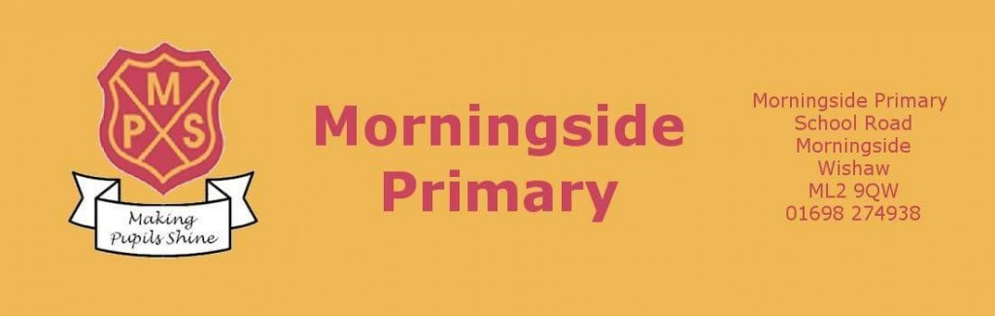

Digital Policy (Updated)
November 2021

Article 29 Your education should help you use and develop your talents and abilities. It should also help you learn to live peacefully, protect the environment and respect other people.
Article 17 You have the right to get information that is important to your well-being, from radio, newspaper, books, computers and other sources. Adults should make sure that the information you are getting is not harmful, and help you find and understand the information you need.
Article 13 You have the right to find out things and share what you think with others, by talking, drawing, writing or in any other way unless it harms or offends other people.

Contents
Page 3
Page 3 - 4
Page 5 - 6
Page 7 - 8
Page 9 – 10
Page 11 – 13
Page 13
Page 14

- Introduction
- Key terms
- Online platforms
- Social Media
- Online user and mobile device agreements
- Online safety/ incidents of misuse
- Device Care
- Digital Leaders

Introduction

Digital technology is already recognised as making a significant contribution to current learning and teaching practices. When used appropriately and with young people being supported, digital technology can enrich learning and teaching, help to raise levels of attainment and close the attainment gap. Online tools and resources have been used in classrooms across North Lanarkshire to enrich children and young people’s experiences. Digital approaches give the ability for learning and feedback to take place remotely as well as in school.

Learning online is still relatively new for many staff and young people, however digital technologies used to enhance teaching and learning is not new. This document provides advice on how to use the digital tools we currently have available to engage learners and deliver a high quality learning experience for all.

Digital approaches to learning have taken on a new significance within our learning environments as teachers and school leaders plan for the recovery of education whilst ensuring Health and Safety guidelines are followed.
There will be occasions when children and young people cannot attend school and this document will outline the approach adopted by MPS in line with NLC and Scottish Government advice.

Key terms

Remote/distance learning - learning that is directed by practitioners and undertaken by children and young people who are not physically with the teacher while instruction is taking place. Remote learning can be delivered in a variety of ways: some high-tech, some low-tech and sometimes requiring no technological solutions.
This might involve teacher led instruction delivered ‘live’ to pupils in real time and may involve interaction with peers as part of the learning experience. It may also include ‘recorded’ learning input from a teacher which the young person has been directed to. There are also approaches that encourage pupils to work independently, sometimes with technology that adapts the content of tasks in order to provide additional challenge or support.

Flipped learning - relates to the combination of learning in-person with a teacher and online away from and out with their normal school environment. Used almost universally within Further and Higher Education, flipped learning involves the combination of online learning and classroom-based learning.

Asynchronous or Synchronous remote learning - relates to the time-based nature of learning. A synchronous learning environment means that students and teachers engage in learning at the same time. Asynchronous means that student learning takes place away from direct contact with teachers. Although these terms may appear new, normal learning environments incorporate both forms. For example, the standard classroom learning environment is an example of a synchronous learning environment. Homework, completed before or after an in-person task, is an example of asynchronous learning.
It is not practical for schools to reproduce the normal school day via ‘live’ online classrooms. As such, a shift towards more asynchronous environments is necessary. Irrespective of the type of learning, virtual learning environments will aid the delivery of education.

Virtual Learning Environments (VLE) - digital platforms that facilitate learning by providing a space to house resources, deliver content and provide instruction/feedback. During social distancing, the use of VLE’s such as Glow are needed to provide learners with materials and resources. Platforms such as Microsoft TEAMs may be used as a virtual learning environment and may be convenient to ensure continued interaction between teacher and pupil.

Online Platforms

The main online platform adopted throughout NLC is Microsoft Teams accessed through Glow (www.rmunify.com). All children at Morningside Primary School will now have been issued their user details for all online platforms and will have a copy of their login details at home and in class. The card will look like this;

The username and password on this card will work for Glow/Teams, Sumdog and ActiveLearn (passwords can only be issued to children and will not be given to parents/carers under any circumstances).
IMPORTANT – When logging into Teams via the desktop app or via a mobile app you will need to include the child’s full email address and not just their username. For example if the username is jsmith you will have to put jsmith@glow.sch.uk.

Teams
This platform is now being used across NLC to issue homework and home learning opportunities. All homework will be issued as an assignment by the class teacher each week, allowing children to submit documents or pictures of their work directly to the teacher. You can check out a number of guides for using Teams and assignment by following the link: https://blogs.glowscotland.org.uk/nl/MorningsideBlog/digital-area/online-guides/ .
Sumdog
Sumdog will be used to issue all Maths and Numeracy homework and may also be used to issue spelling and grammar activities. Information about Tasks to complete etc will be outlined in the homework information presented in the homework assignment on Teams. Children can access Sumdog anytime they wish at home to further challenge themselves.
IMPORTANT – It is important that you do not help your child with questions on Sumdog as it automatically alters the difficulty of questions given to your child based on the way they answer the questions they are given.

ActiveLearn
ActiveLearn is an online Maths and Numeracy resources that is part of the Active Maths, Active Spelling and Phonics and Rapid Reader programmes that we use in school. Your child may be issued with activities to complete on this as part of their homework and this will be outlined in the information sheet they receive on Assignments in Teams.

For guides on how to access and use Sumdog and ActiveLearn please check out the guides on the following link: https://blogs.glowscotland.org.uk/nl/MorningsideBlog/digital-area/online-guides/.

Social Media – Twitter

Morningside Primary’s Twitter account (@morningsideps) is a private account managed by staff for the purpose of:

- communicating information to our families and wider school community
- regular reporting on children’s learning
- sharing and celebrating success and achievements both in and out of school
- modelling responsible and respectful use of social media with children

This is the school’s main Twitter account and will therefore be updated with important information such as school closures, holidays, lunch menus etc. It is recommended that all staff and parents follow the school account to be kept up to date.

To gain access to the school Twitter account you must have children currently at the school. If you would like to request to follow us then you should click follow and then email Mr Stathis at nlstathisg@northlan.org.uk with the name of your child and also your Twitter Handle. Your Twitter handle is the bit under your Twitter name that starts with @ as displayed below.
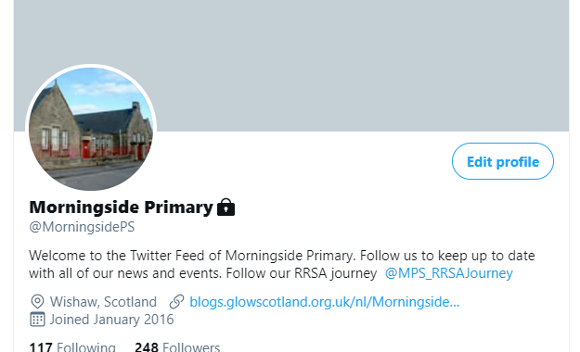
When managing the school Twitter account, SLT will:

- monitor followers and block any who should not have access
- welcome positive comments only
- follow educationally linked accounts. Parental accounts, unless educationally linked, will not be followed back.
- only upload photographs of children in line with this policy. No names of children will appear with photos or videos Tweeted if they could be identified.
As Twitter users must be at least thirteen years old, pupils will not be allowed to use Twitter accounts independently. However, in school they will have the opportunity to contribute to Tweets as part of planned educational activities.
Code of Conduct for parents and the wider school community when interacting with the school Twitter accounts:

- The school should be contacted using formal means of communication only; email or telephone contact to discuss issues or queries.
- If commenting on a photo or video of a child, do not include the child’s name in the Tweet.
- If Tweeting a photo or video of your own child, it is recommended that you do not include their name in the Tweet.
- Seek permission from parents before uploading photos or videos of children other than your own.

Twitter Misuse

Any concerns or issues about the misuse of Twitter should be reported to the Head Teacher immediately.

User Agreements
Pupils will:
- Comply with Digital class charter in line with the UNCRC
- only use their GLOW email address for class communication
- Have an understanding that behaviour and remote learning will be discussed with schools and should your behaviour be inappropriate you will be removed from the learning environment
- submit all assignments on time
- show respect for everyone in the online classroom
- seek to contribute to the class in a positive manner and not be disruptive at any time
- you do not have permission to screen shot or film any virtual leaning. Doing so will result in further actions being taken by schools.
- not share recordings/images of the class out with the class environment
Teachers will:

- ensure that they are logged in to Teams when delivering lessons to have full access to the management console
- issue all homework through the assignments tab on Teams
- provide guidance to children and parents on how to use the relevant features of their class Team
- discuss roles and responsibilities with pupils
- Remove a young person from the Team if their behaviour is inappropriate
- Only communicate with the young people through Glow and Teams. Do not use personal email addresses or social media
- ensure that they keep themselves up to date with all relevant policies and procedures, including Child Protection

Mobile Devices

Mobile technology devices may be school owned or personally owned and might include: smartphone, smartwatch, tablet, notebook / laptop or other technology that usually has the capability of utilising the school’s wireless network. The device then has access to the wider internet which may include the school’s learning platform and other cloud based services such as email and data storage.
All users should understand that the primary purpose of the use of mobile / personal devices
in a school context is educational. The school’s Acceptable Use Agreements for staff and pupils will give consideration to the use of mobile technologies.

The school allows:

 | Personal Devices
 | School owned for single user | School owned for multiple  users | Student owned | Staff owned | Visitor owned
Allowed in school | Yes | Yes | Yes but pupil must hand in to school office upon arrival. | Yes | Yes
Full network | Yes | Yes | no- only | no- only school | no- only
access |  |  | school | devices should | school
 |  |  | devices | be connected to | devices
 |  |  | should be | the school’s | should be
 |  |  | connected | network | connected
 |  |  | to the |  | to the
 |  |  | school’s |  | school’s
 |  |  | network |  | network
 |  |  |  |  | unless
 |  |  |  |  | authorised
 |  |  |  |  | by HT

Responding to incidents of misuse

This guidance is intended for use when staff need to manage incidents that involve the use of online services. It encourages a safe and secure approach to the management of the incident. Incidents might involve illegal or inappropriate activities.

It is hoped that all members of the school community will be responsible users of digital technologies, who understand and follow school policy. However, there may be times when infringements of the policy could take place, through careless or irresponsible or, very rarely, through deliberate misuse.

In the event of suspicion:

- Isolate the computer/device in question as best you can. Any change to its state may hinder a later police investigation.
- Inform Head Teacher immediately

Consequences to Misuse

It is more likely that the school will need to deal with incidents that involve inappropriate rather than illegal misuse. It is important that any incidents are dealt with as soon as possible in a proportionate manner, and that members of the school community are aware that incidents have been dealt with. It is intended that incidents of misuse will be dealt with proportionately. Some examples of possible misuse are listed below; this is not an exhaustive list. Any concerns should be reported to the Head Teacher to seek advice and clarity on next steps.

- Allowing others to access school network by sharing username and passwords
- Unauthorised downloading or uploading of files
- Unauthorised use of non-educational sites during lessons
- Unauthorised / inappropriate use of mobile phone / digital camera other mobile device
- Corrupting or destroying the data of other users
- Sending an email, text or message that is regarded as offensive, harassment or of a bullying nature

Online Safety
We want everyone to be safe, just like being in school, if you see anything in your Teams that you feel is inappropriate then please alert a teacher immediately.
- When communicating with your teacher you should use your glow account only.
- Do not share the URL or code of a Team or meeting publicly.
- When in a Team meeting use the chat for class purposes only.
- Follow normal classroom behaviour agreements!
With increased use of digital technologies, children may be exposed to more risks online. As part of learning and teaching children and young people are taught about online safety. We should also be alert to signs that individuals or groups are using the current crisis as an opportunity for the criminal or sexual exploitation of children.
Further advice and guidance on online safety can be found at the CEOP, thinkuknow website https://www.thinkuknow.co.uk/.

Device Care
Class iPads and Laptops
- Information relating to allocated laptop/iPad numbers and chargers is stored and checked at regular intervals by the ICT co-ordinator
- Faults or damages should be reported as soon as possible to the ICT co- ordinator
- should be charged regularly
- should be stored safely overnight (iPads locked in storage unit)

Classroom desktop computers
- Should be logged off throughout the day when not in use by a pupil or class teacher
- Should be shut down at the end of the school day
- Faults or damages should be reported as soon as possible to the ICT co- ordinator

Promethean Panels
- Only a dry micro-fiber cloth should be used to maintain the panel
- Faults or damage should be reported as soon as possible to the ICT Co- ordinator

Digital Leaders

The development of a Digital Leaders’ team in session 19/20 had a significant impact on digital learning in Morningside Primary School. The Digital Leaders team were trained in a number of areas and:

- are role models for responsible and respectful digital citizenship across the school
- actively seek new technology and resources to trial, review and purchase
- lead learning in classes across the school to model use of innovative technology, programs and resources
- offer regular staff skills sessions to build staff confidence and raise awareness of effective digital approaches to teaching and learning that could be implemented in their classrooms
- support staff delivering lessons with new digital technology and resources
- support staff with technical issues

