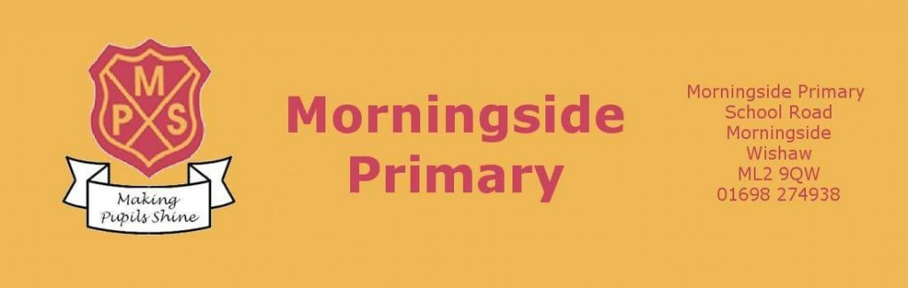

Digital Guide (Version 1)
October 2020

Contents
Page 3
Page 3 - 4
Page 5 - 6
Page 6 - 7
Page 7

- Introduction
- Key terms
- Online platforms
- Online user agreements
- Online safety

Introduction

Digital technology is already recognised as making a significant contribution to current learning and teaching practices. When used appropriately and with young people being supported, digital technology can enrich learning and teaching, help to raise levels of attainment and close the attainment gap. Online tools and resources have been used in classrooms across North Lanarkshire to enrich children and young people’s experiences. Digital approaches give the ability for learning and feedback to take place remotely as well as in school.

Learning online is still relatively new for many staff and young people, however digital technologies used to enhance teaching and learning is not new. This document provides advice on how to use the digital tools we currently have available to engage learners and deliver a high quality learning experience for all.

Digital approaches to learning have taken on a new significance within our learning environments as teachers and school leaders plan for the recovery of education whilst ensuring Health and Safety guidelines are followed.
There will be occasions when children and young people cannot attend school and this document will outline the approach adopted by MPS in line with NLC and Scottish Government advice.

Key terms

Remote/distance learning - learning that is directed by practitioners and undertaken by children and young people who are not physically with the teacher while instruction is taking place. Remote learning can be delivered in a variety of ways: some high-tech, some low-tech and sometimes requiring no technological solutions.
This might involve teacher led instruction delivered ‘live’ to pupils in real time and may involve interaction with peers as part of the learning experience. It may also include ‘recorded’ learning input from a teacher which the young person has been directed to. There are also approaches that encourage pupils to work independently, sometimes with technology that adapts the content of tasks in order to provide additional challenge or support.

Flipped learning - relates to the combination of learning in-person with a teacher and online away from and out with their normal school environment. Used almost universally within Further and Higher Education, flipped learning involves the combination of online learning and classroom-based learning.

Asynchronous or Synchronous remote learning - relates to the time-based nature of learning. A synchronous learning environment means that students and teachers engage in learning at the same time. Asynchronous means that student learning takes place away from direct contact with teachers. Although these terms may appear new, normal learning environments incorporate both forms. For example, the standard classroom learning environment is an example of a synchronous learning environment. Homework, completed before or after an in-person task, is an example of asynchronous learning.
It is not practical for schools to reproduce the normal school day via ‘live’ online classrooms. As such, a shift towards more asynchronous environments is necessary. Irrespective of the type of learning, virtual learning environments will aid the delivery of education.

Virtual Learning Environments (VLE) - digital platforms that facilitate learning by providing a space to house resources, deliver content and provide instruction/feedback. During social distancing, the use of VLE’s such as Glow are needed to provide learners with materials and resources. Platforms such as Microsoft TEAMs may be used as a virtual learning environment and may be convenient to ensure continued interaction between teacher and pupil.

Online Platforms
The main online platform adopted throughout NLC is Microsoft Teams accessed through Glow (www.rmunify.com). All children at Morningside Primary School will now have been issued their user details for all online platforms and will have a copy of their login details at home and in class. The card will look like this;

The username and password on this card will work for Glow/Teams, Sumdog and ActiveLearn.
IMPORTANT – When logging into Teams via the desktop app or via a mobile app you will need to include the childs full email address and not just their username. For example if the username is jsmith you will have to put jsmith@glow.sch.uk.

Teams
This platform is now being used across NLC to issue homework and home learning opportunities. All homework will be issued as an assignment by the class teacher each week, allowing children to submit documents or pictures of their work directly to the teacher. You can check out a number of guides for using Teams and assignment by following the link: https://blogs.glowscotland.org.uk/nl/MorningsideBlog/digital-area/online-guides/ .
Sumdog
Sumdog will be used to issue all Maths and Numeracy homework and may also by used to issue spelling and grammar activities. Information about Tasks to complete etc will be outlined in the homework information presented in the homework assignment on Teams. Children can access Sumdog anytime they wish at home to further challenge themselves.
IMPORTANT – It is important that you do not help your child with questions on Sumdog as it automatically alters the difficulty of questions given to your child based on the way they answer the questions they are given.

ActiveLearn
ActiveLearn is an online Maths and Numeracy resources that is part of the Active Maths, Active Spelling and Phonics and Rapid Reader programmes that we use in school. Your child may be issued with activities to complete on this as part of their homework and this will be outlined in the information sheet they receive on Assignments in Teams.
For guides on how to access and use Sumdog and ActiveLearn please check out the guides on the following link: https://blogs.glowscotland.org.uk/nl/MorningsideBlog/digital-area/online-guides/.

User Agreements
Pupils will:
- only use their GLOW email address for class communication
- Have an understanding that behaviour and remote learning will be discussed with schools and should your behaviour be inappropriate you will be removed from the learning environment
- submit all assignments on time
- show respect for everyone in the online classroom
- seek to contribute to the class in a positive manner and not be disruptive at any time
- you do not have permission to screen shot or film any virtual leaning. Doing so will result in further actions being taken by schools.
- not share recordings/images of the class out with the class environment
Teachers will:

- ensure that they are logged in to Teams when delivering lessons to have full access to the management console
- issue all homework through the assignments tab on Teams
- provide guidance to children and parents on how to use the relevant features of their class Team
- discuss roles and responsibilities with pupils
- Remove a young person from the Team if their behaviour is inappropriate
- Only communicate with the young people through Glow and Teams. Do not use personal email addresses or social media
- ensure that they keep themselves up to date with all relevant policies and procedures, including Child Protection

Online Safety
We want everyone to be safe, just like being in school, if you see anything in your Teams that you feel is inappropriate then please alert a teacher immediately.
- When communicating with your teacher you should use your glow account only.
- Do not share the URL or code of a Team or meeting publicly.
- When in a Team meeting use the chat for class purposes only.
- Follow normal classroom behaviour agreements!
With increased use of digital technologies, children may be exposed to more risks online. As part of learning and teaching children and young people are taught about online safety. We should also be alert to signs that individuals or groups are using the current crisis as an opportunity for the criminal or sexual exploitation of children.
Further advice and guidance on online safety can be found at the CEOP, thinkuknow website https://www.thinkuknow.co.uk/.

