

This is a step by step guide on how to download Office Suite onto as many as 15 devices.

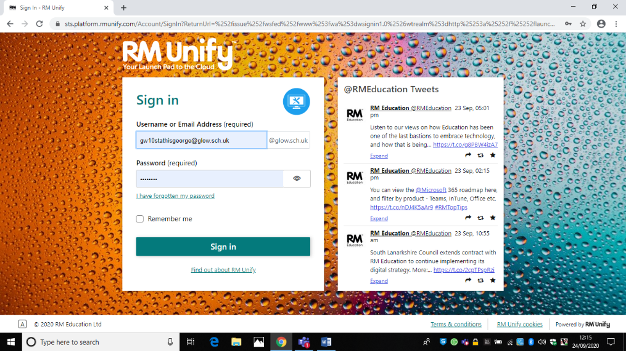

Log in to Glow at [www.rmunify.com](http://www.rmunify.com)

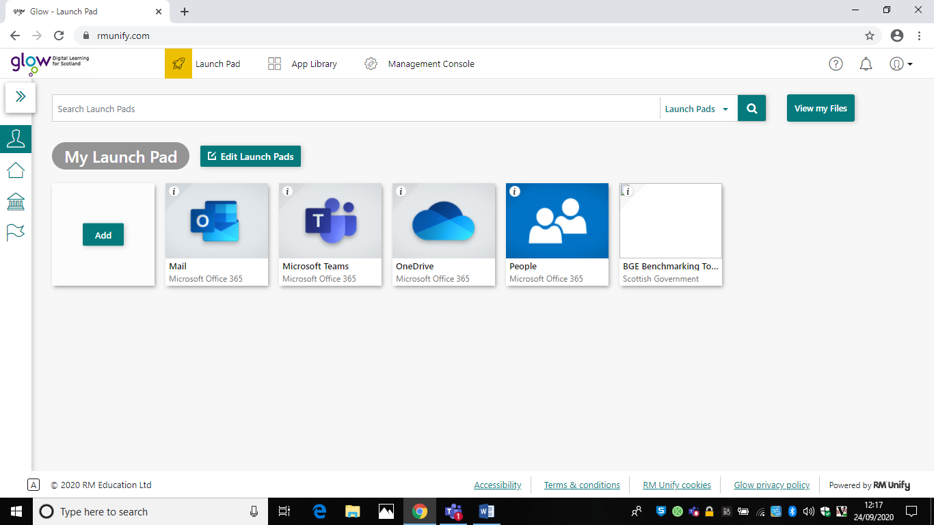Search for ‘office’ using the search bar

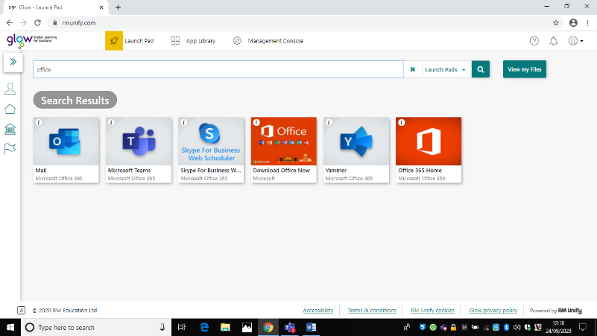Select ‘download office now’ tab

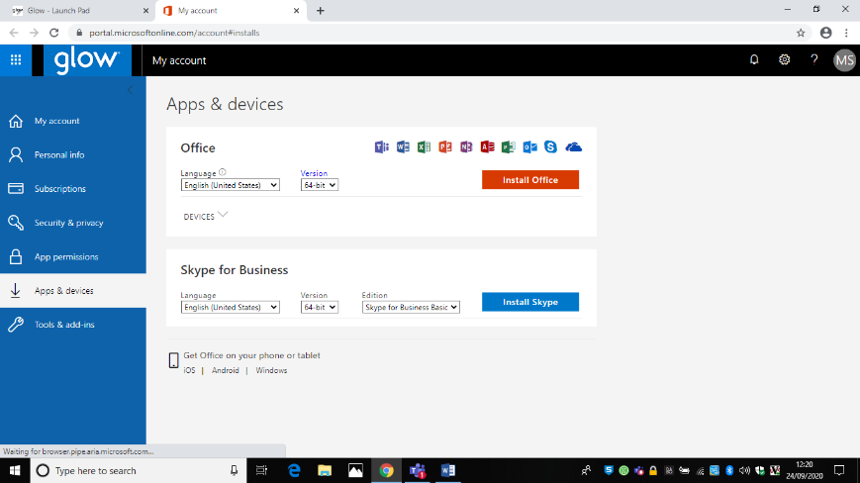Select the deivce you are downloading it on

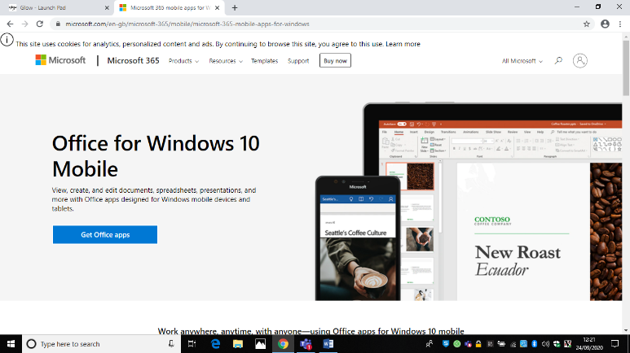Select ‘get office apps’

Once office is downloaded it may ask you to log in. This is your Glow email (your username with @glow.sch.uk on it) and your Glow password.