08
Fall

Glow Blogs: Creating a post

1. Log on to your blog dashboard
Click on Site Admin in the sidebar of your blog.
If you are not logged into glow you will be redirected to the glow logon screen
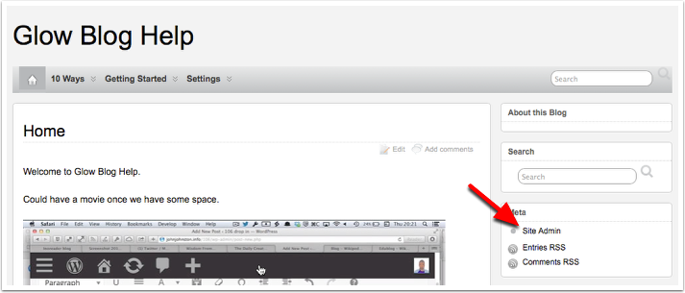

2. Create a new post
Click New Post at the top right of the dashboard.
The button is also a popup button that will allow you to create a new page, upload etc.
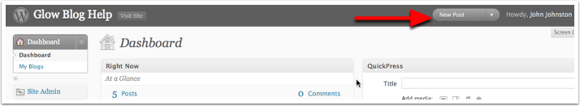

3. Write your post
All a post needs is a title and some body text.
- Fill in the title
- Fill in the body text
- Click Publish
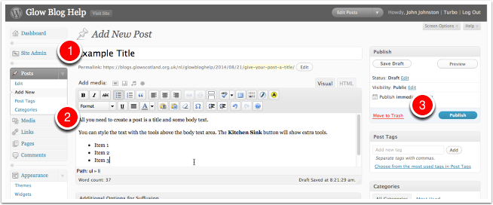

4. View Post
To view your new post click View Post
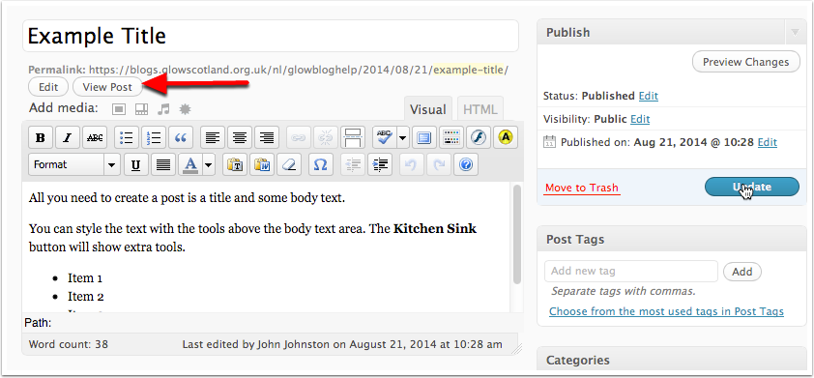

5. Live View
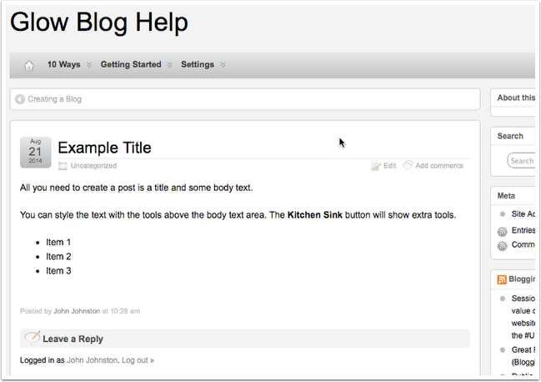

Adding an image to a post

Create a post
- In the dashboard click Add New to create a new post.
- Give your post a title.
- Place the I-bar in the body field where you want the image. (This could be between text)
- Click the Add image button.
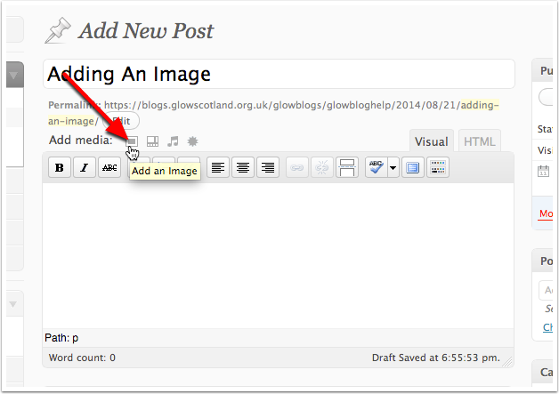

Select the image
A 'lightbox' window opens up.
Click Select Files
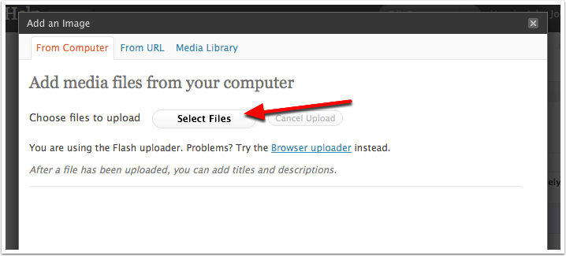

Select file(s) to upload
In the file dialog that opens
- Choose an image
- Click Open
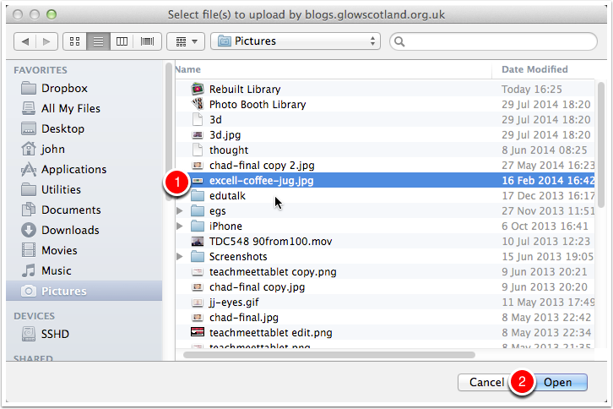

Progress
You will see a progress bar as the image uploads
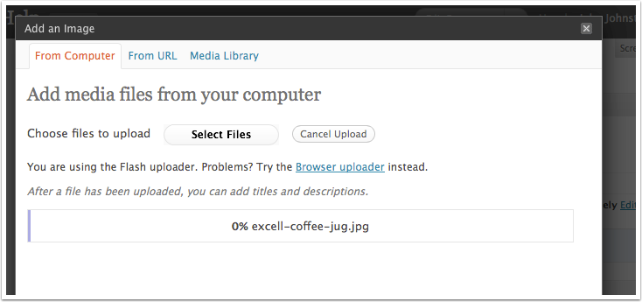

Image Settings
You will see an image thumbnail, and can input the settings.
- Alternative text, caption and description are optional.
- The Link URL will affect what people see when they click the link, the file url will link directly t othe file and is what you want to choose if you are using a Lightbox plugin.
- Choose an alignment and size.
- Click Insert into Post to add the image to your post. Save all changes will close the image editor without inserting it into the post!
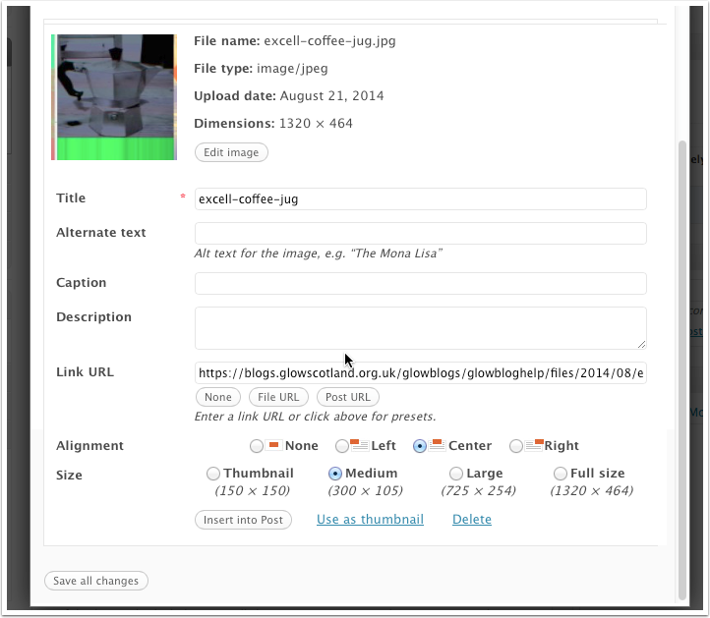

Image in the Editor
When you click Insert into Post in the last step you should see the image in place in the post.
You can finish the post and Publish it.
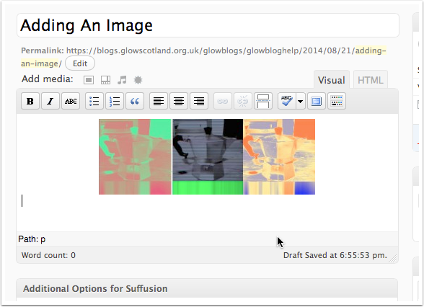

Adding an Image Gallery
Image Galleries allow you to display a grid of photo thumbnails that link to fullsized versions. If used with the lightbox plugin the larger images will be displayed without leaving the webpage and can be browsed through easily with mouse or arrow keys.

Create a post
You start by creating a post in the usual way.
Put the cursor where you want the gallery to appear and click the photo button beside Add Media. This will open the image picker.
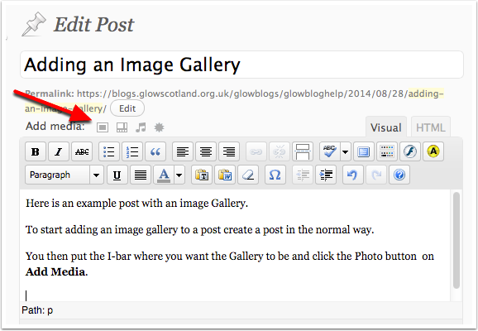

Select Files with the Image picker.
You shoud see a Select Files Button. Click it.
If the Select Files button is not showing you may be using the "Browser uploader" There should be a link to the Flash uploader (in place of the Browser uploader in the screenshot below).
The Select files button will allow multiple images to be picked at once and save a bit of time. If you do not have Flash on your computer you can use the browser upload button multiple times for the same effect.
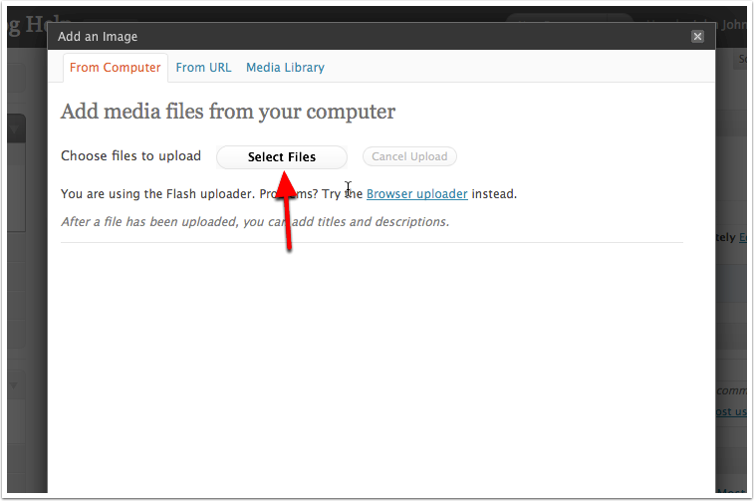

Select file in the standard file browser.
Clicking Select Files in the file browser will open the system file dialog. You can choose multiple images to upload. (Click once on the first image then shift click on another to select all the ones inbetween too).
After selecting files click Open.
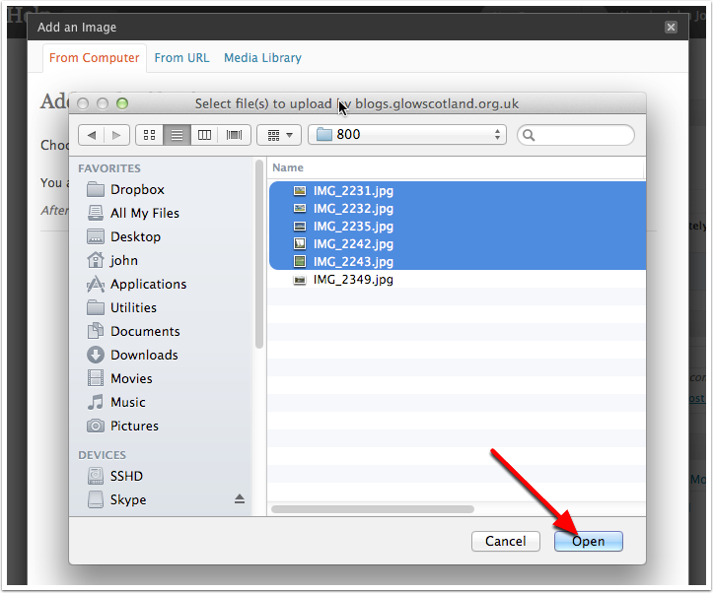

File upload
You will see progress indications of the file upload.
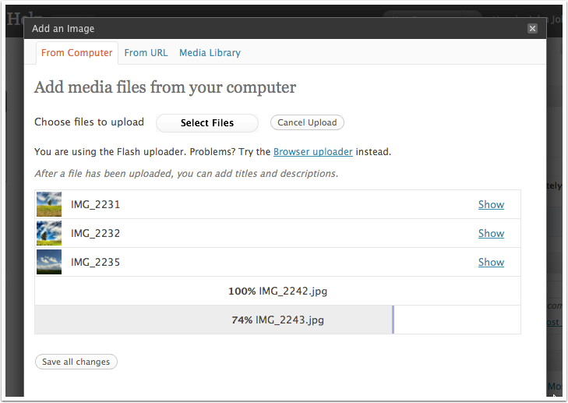

Save the upload
Once the images has uploaded click Save all changes.
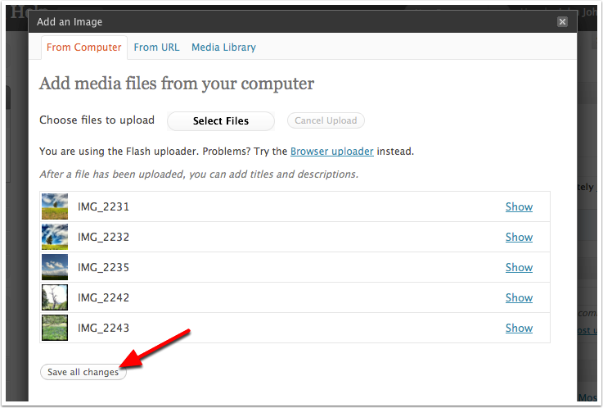

Gallery Settings
You can now change some settings for the gallery.
If you are using the lightbox plugin (recommended), make sure you choose Image File for Link thumbnails to.
Click Insert Gallery to do just that.
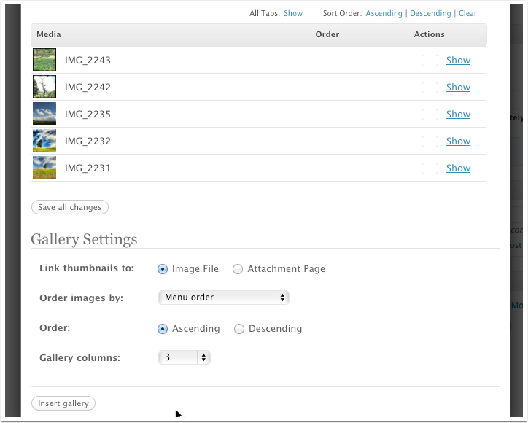

The Gallery is added to the editor
The Gallery is not shown in WYSIWYG fashion but represented by a dotted rectangle with an icon in the middle.

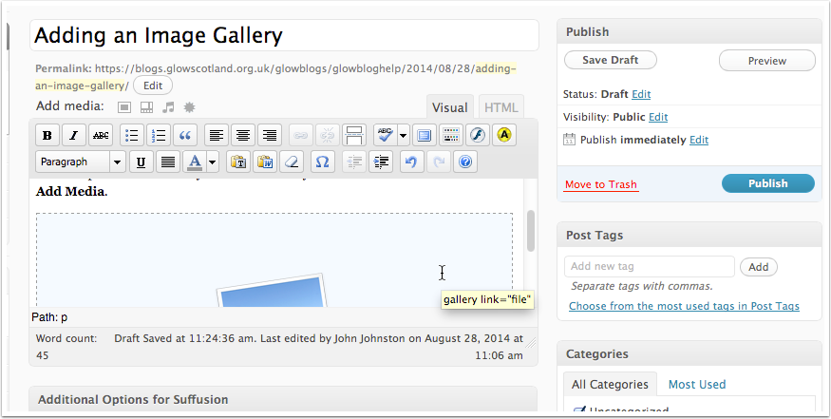

Editing the gallery
Click the gallery once then click on the Edit Gallery button if you need to change settings.
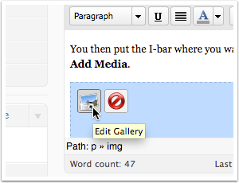

Publish
Publish the post as normal by clicking the Publish button, you can then visit the post and see the gallery.
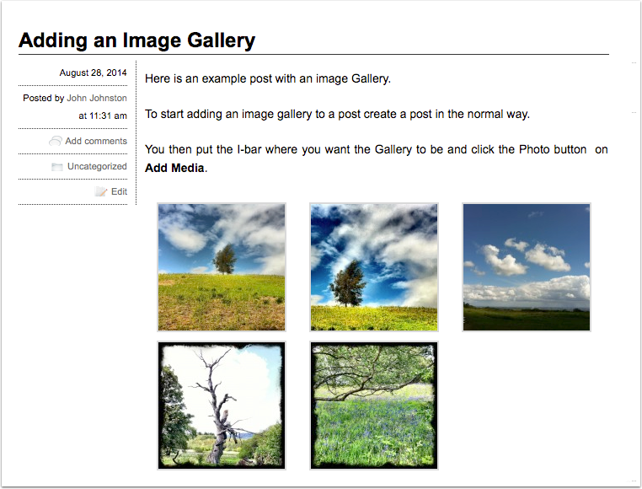

Lightbox

If you have the lightbox installed clicking on an image will open it up in a 'lighbox' window. You can then view other images by clicking on the image or using the arrow keys.
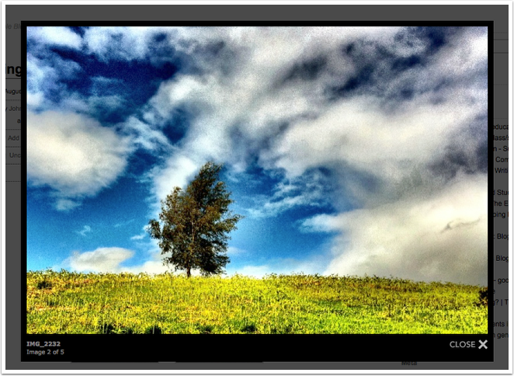

Adding video and audio
Video and audio files can be displayed in players in a blog post or page.
You need to have activated the Anarchy Media player plugin.

Activating the Anarchy Plugin
- On your blog dashboard, click the link to Plugins on the left hand navigation.
- Clcik Activate under Anarchy Media Player.
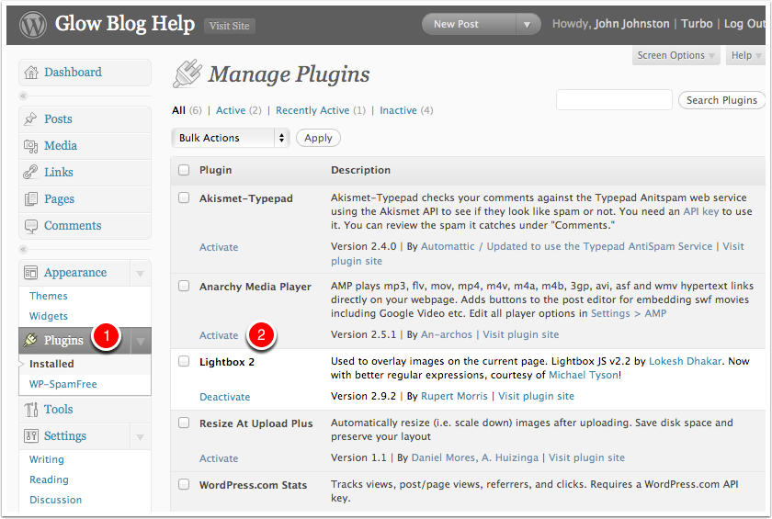

Create a Post or Page
In the normal way create a post.
Place the I-bar where you wish the video to appear and click the Add Video Graphic beside Add Media.
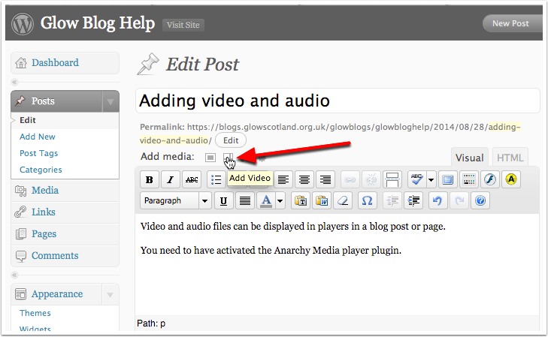

Select Files with the Image picker
You shoud see a Select Files Button. Click it.
If the Select Files button is not showing you may be using the "Browser uploader" you can use the Choose or Broswe button to selcet a file and then upload it.
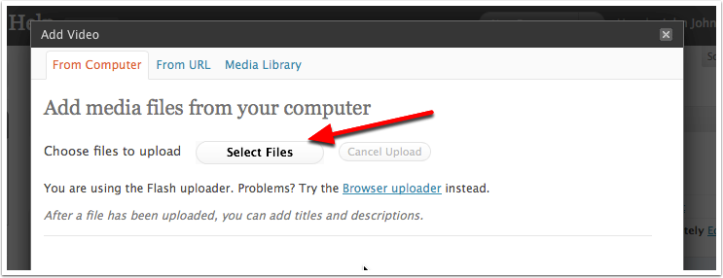

Select file in the standard file browser
Click on a video file and click Open or double click the file.
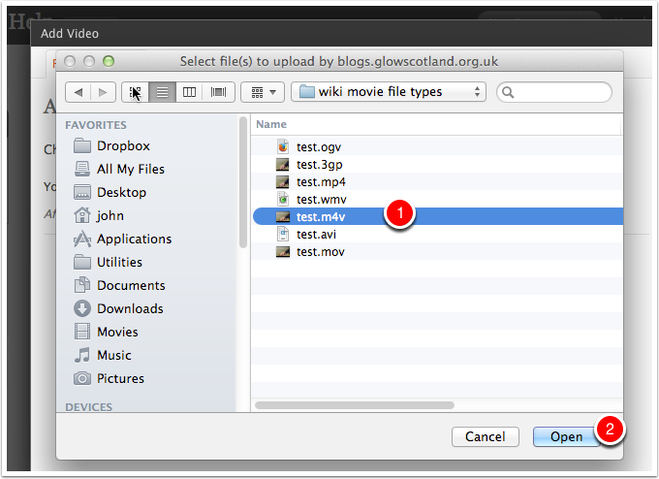

Insert into Post
Once the video is uploaded you will see some information about the file, tyou could add a caption or description if you want.
Click Insert into Post.
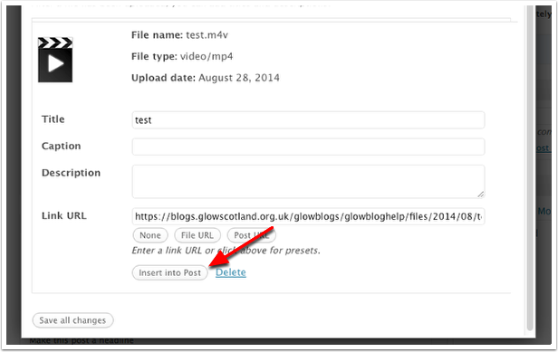

View in Editor and Publish
The inserted video will just look like a link in the editor.
You can publish your post in the usual way buy clicking the Publish button.
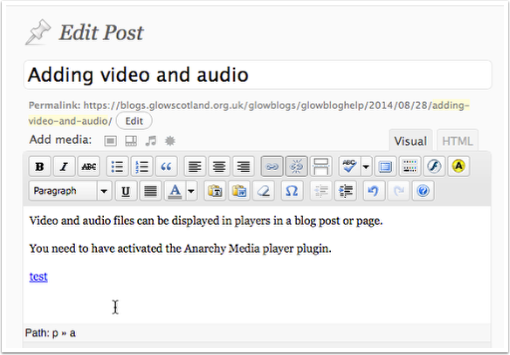

View the post
When you view the post you will see that the link has been replace with a video splash screen.
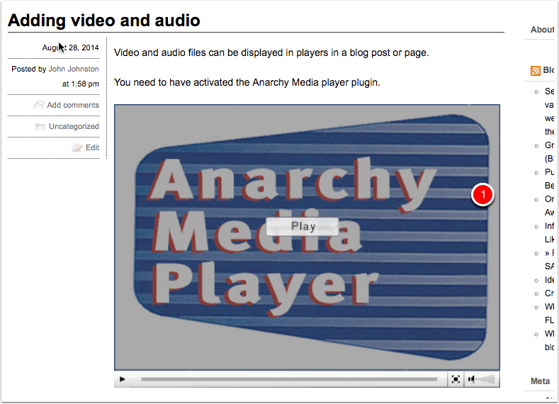

Audio
You can add audio files in exactly the same way.
When the post is published this will insert a flash audio player.
Clicking on the + will change the player to the 2nd view below and play the audio.
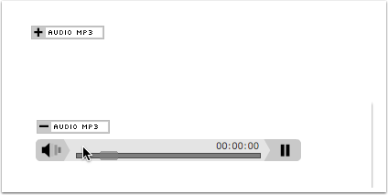

Tips & Factors to note
The playing of audio and video is complex and depends on a matrix of files types and browser capabilities. You may not get the result you expect viewing the media on different browsers.
You can replace the Anarchy media player splash scren shon above with your own. You need to upload a jpg file with the same name as the movie file withthe addition of the .jpg extension.
For example if your movie is called myMovie.mp4 you can upload an image myMovie.mp4.jpg. The Anarchy splash screen will be replaced with your image. The image needs to be in the same place on the server so it is best to upload it at the same time as you upload the video.
Remeber that you might want to add instructions to the viewer on your splash screen (Click to Play or an arrow).

