**Order Form**

|  |  |
| --- | --- |
| **Name of Child/ Adult** |  |
| **Class** |  |

**Upper school and adult umbrella (recommended Primary 4 upwards)**

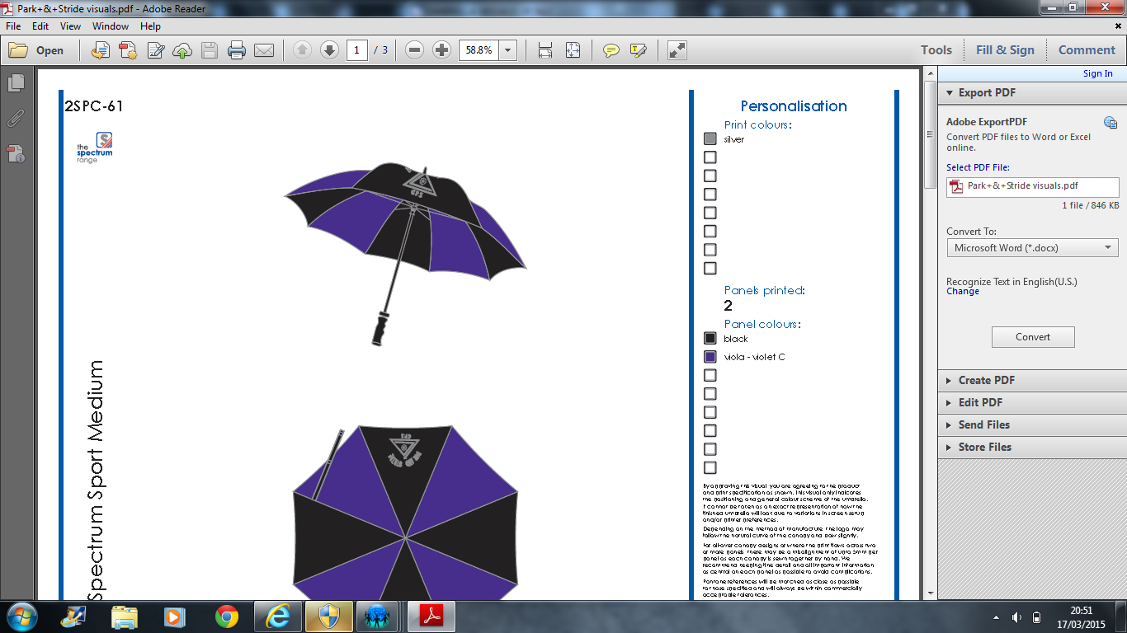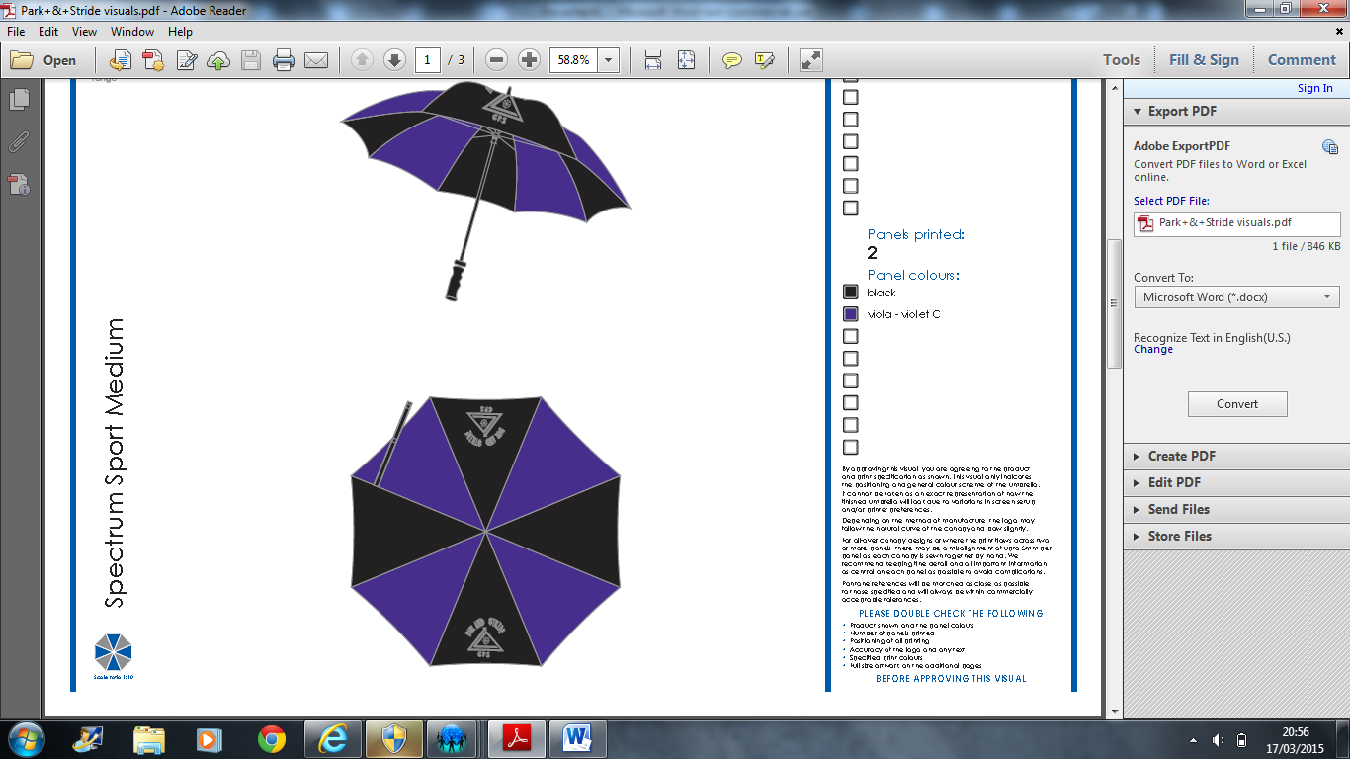

|  |  |
| --- | --- |
| Price | Quantity |
| £13 each | Total £ |

**Lower school umbrella (recommended Primary 1-3)**

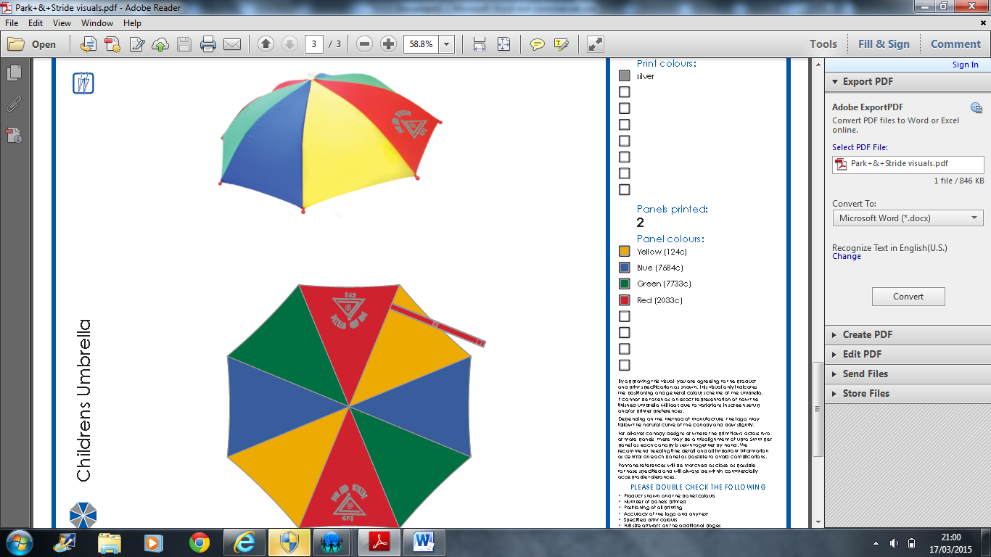 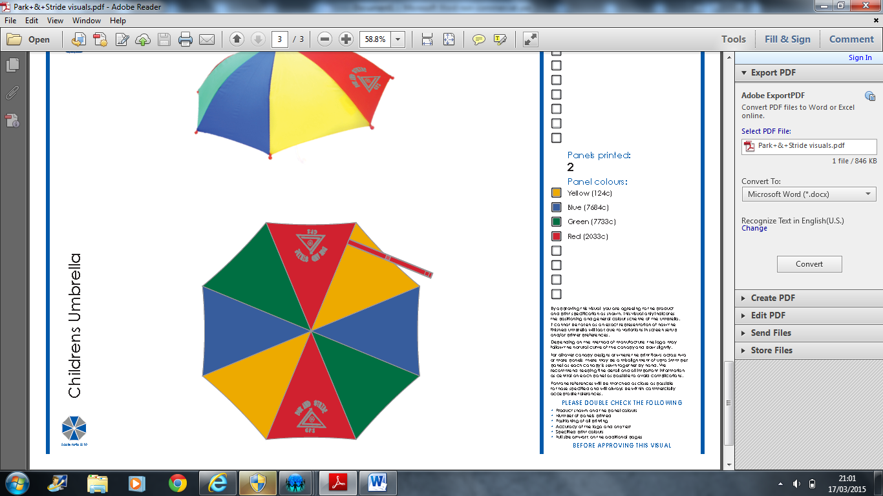

|  |  |
| --- | --- |
| Price | Quantity |
| £5 each | Total £ |