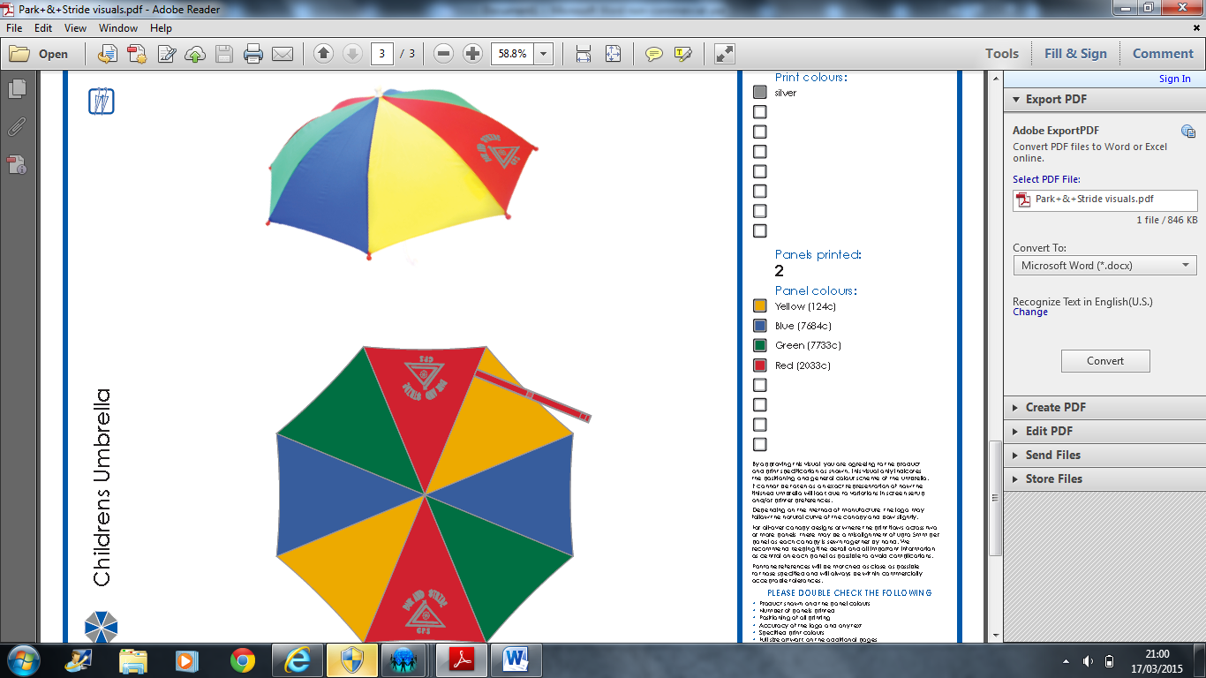School Umbrella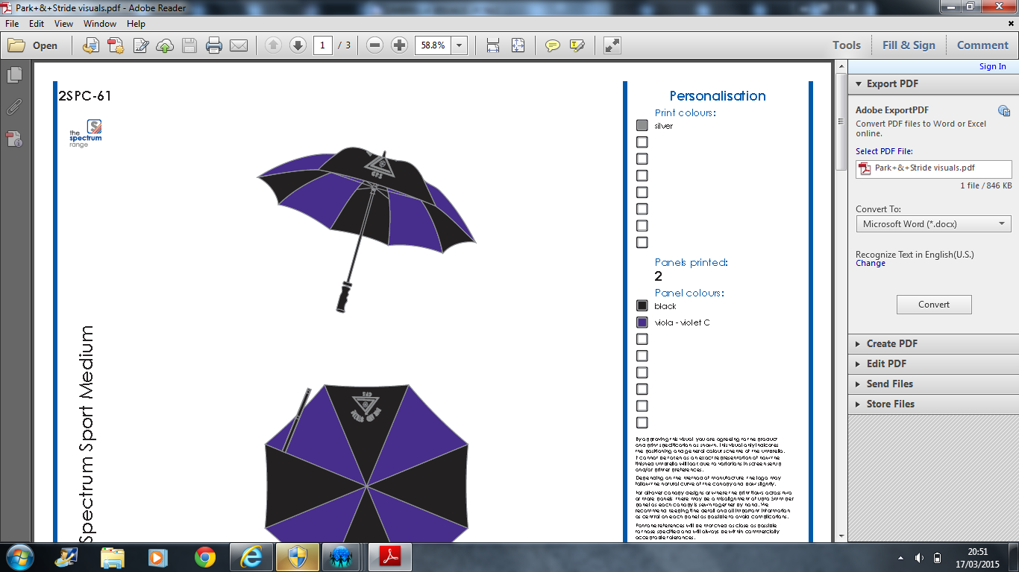

Dear Parents/Carers

We have been working hard this year to try and promote safe parking and drop off around school. Our Parent Council has been very supportive in discussing options with North Lanarkshire Council and police on the best way to manage safety. I’m sure you’ll agree that pupil safety when arriving and leaving school is a huge concern.

Our pupils have been active this term in getting involved with this issue. We have had classes design posters, which have been printed onto an outdoor durable material and will be displayed on the fence at Russell Street. We launched an umbrella design competition to have our own school umbrella produced. The idea behind this being to encourage more people to park a little further away and walk a short distance to school. This will mean fewer cars around the school at pick up and drop off times and a nice bit of exercise first thing in the morning.

The umbrella design has been finalised after looking through excellent entries from pupils. We have kept it simple to keep costs down with the umbrella having our school logo and the Park and Stride slogan on it. We hope to have some press coverage in the Advertiser showing people walking to school with our umbrellas. We will also highlight our signage at this point to promote how we are all taking positive steps towards making improvements to this potentially serious issue.

There are two umbrellas on offer. One is an adult/older pupil umbrella in school colours, with 61cm steel rib length. The second is a smaller children’s umbrella in bright colours with 37cm steel ribs.
I have attached an order form if you or your child would like one of these to help support this campaign. Please return the order form with cash/ cheques made payable to Chapelhall Primary School as soon as possible so we can get the order processed. It takes approximately three weeks for the umbrellas to be produced and returned to school so they should be available just after the Easter holidays.

Thank you for your continued support

Mr Murray

