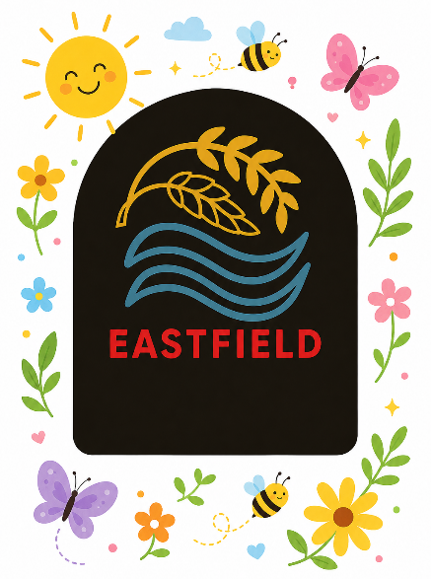
September 2026
Together we will shine!
Dear Parents / Carers,
As we approach our first break of the school year, I am delighted to report that the children have settled well into the school year. They are embracing play and enquiry-based learning opportunities and participating and engaging well in their learning.
MUGA
Our new MUGA is now in the final stages and we are looking forward to accessing it during the school day for PE and break times and out with school hours for use by the wider community.
Annual Calendar
Our Annual Calendar can be found on the school website. This is subject to change as we progress through the school year. Please access it regularly to keep up to date with school events.
Car Park
A huge “Thank you” to parents/carers who are supporting us to keep our children, staff and visitors safe by utilising the car park across the road and walking to school. The children and staff supporting the ESP drop off, NLC taxis, pre and after school care providers and the School Bus are very appreciative of your efforts. Pleased remember that Disabled Parking Spaces are pre-arranged for the use of children with blue badges or school parking permits; further information is available via the School Office should you require one of these.

Meet the Teacher and Parent’s Night
I hope everyone enjoyed our first partnership event of the year and got the opportunity to see you child(ren’s) classroom(s) and “Meet the Teacher(s).”
We look forward to seeing you at our upcoming parent’s night on Thursday 8th October. Further information will be issued next week.
Pupil Equity Funding
This session we have allocated our £33,000 PEF funding to support additional staffing to close the attainment gap. This will be used to support bespoke offerings and deliver interventions to raise attainment, support the curriculum and promote health and wellbeing.
Sports
Congratulations to our rugby team who represented the school at the recent Active Schools Rugby Festival. The team won all of their matches and were praised for their attitude and teamwork. Netball, Football, Rugby and Bikeability experiences are all planned for the coming month.
Curriculum Rationale
We are updating our Curriculum Rationale. Please look out for stakeholder surveys for you to have your say in how we shape our school going forward.
Annual Improvement Report and Annual Improvement Plan
Please see attached for details of our Annual Improvement Report (“AIR”)for Session 2025/26 and our Annual Improvement Plan for Session 2026/27 – “Curriculum Improvement Cycle” and “Digital Learning”. These were shared with the Parent Council at their recent AGM.
Parent Council AGM
The Parent Council held their AGM on Wednesday 16th September. Congratulations to the new elected members. We look forward to working in partnership to further improve our school.
I hope all of our children and families have a lovely September Weekend. School re-opens at 9am on Tuesday 29th October 2026. Thank you for your support.
Kind regards,
Lesley McPhee
Head Teacher

