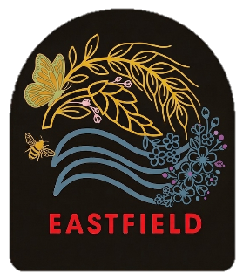
March 2026
Together we will shine!
Dear Parents/Carers,
We have had a great and productive term in school, and it was lovely to see all the parents and carers in the building during parents’ night. A big well done to all members and partners within our school community and we look forward to welcoming you back in our final term of the session.
Pupil Profiles
Our Pupil Profiles officially launch this month and a communication about how to access these has been sent out separately. These will give snapshots of learning and reports from the teachers on your child’s progress and share learning targets.
Muga Update
The latest MUGA indicates that a final design for the MUGA is nearing completion. We expect to get a further update on this after the Easter break where we will have a clearer idea about timescales.
New Playpark
We are delighted that one of our children has won the competition to name the New Eastfield Playpark. The entry was completed in class, all entries were submitted to the New Playpark planning committee who made the decision. A representative group of children are anticipating attending the official opening of the park on Friday 15th May at 1.15pm.
Clyde in the Classroom
Primary 5 completed their Clyde in the Classroom topic and were fortunate to be able to attend the release of their Brown Trout into the Garrell burn. Watching the fish grow and develop by providing an appropriate environment until they are ready to be released into the wild has been wonderful.

Ford Castle
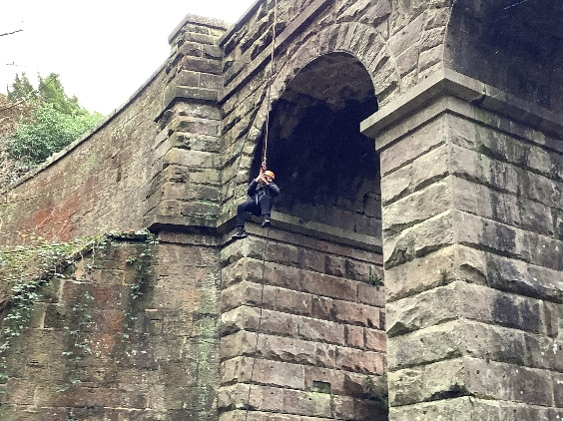
Our Primary 7’s had a wonderful trip top Ford Castle in Northumberland supported by Miss Wilson, Mrs Mills, Miss Nicholson, Mr Miller and Mr Rutherford. The children had a thoroughly wonderful time and enjoyed taking part in a wide range of outdoor activities and pursuits as well as the opportunity to foster independence and build relationships with their peers. We were very proud of the feedback that the staff at Ford Castle gave in relation to the behaviour and manners of our children, a credit to you all.
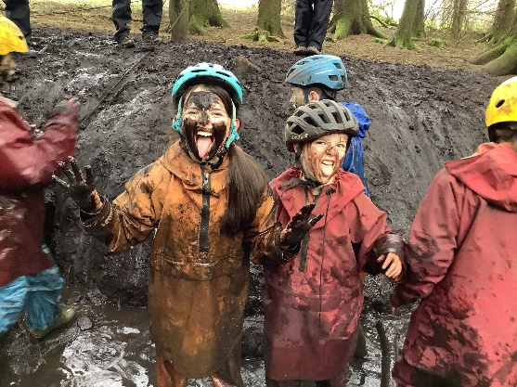
Palacerigg
Our Primary 6 learners enjoyed their outdoor learning week at Palacerigg. The children experienced a wide range of activities and the feedback from children, parents and staff has all been extremely positive. Mrs Steel, Ms Quinn and Mrs Tierney all supported the children in an engaging and exciting week.

Football
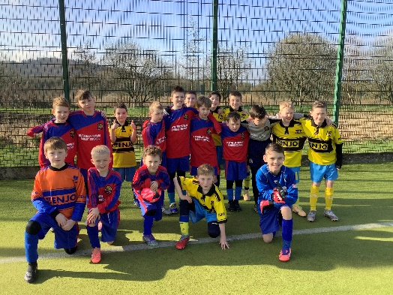
Our P4 and P5 football teams took part in a recent football festival at St. Patricks Primary School. Both teams won all of their games against other schools returning in victorious spirit to Eastfield!
Well done!

Our P6/7 boys football team took part in a festival at Broadwood stadium recently. Winning every game and conceding 0 goals in the process. Special congratulations go to Austin who was our top scorer on the day across the 6 games and to Matthew for scoring the most spectacular goal seen in an Eastfield shirt (rivalling McTominay’s for Scotland v Denmark).
Our P6/7 recently took part in a football festival at Broadwood stadium. With the support from Mrs Mills the girls returned to school undefeated and buoyed by the results. A big well done to our team that included a mix of players from Primary 6 and 7 and where girls played out of position to accommodate other members of the team. Mrs Mills commented particularly on the excellent team spirit and teamwork. Well done!
Thanks to all parents who supported us at these events.
Sports Leaders
Sports Leaders from St. Maurices and Greenfaulds High School have been down supporting a range of classes in Physical Education. It has been lovely to see some former pupils return as part of this.
Athletics
Primary 5 have benefitted from an after-school athletics club organised by Mr Miller. The Primary 5 athletics teams came third in a North Lanarkshire athletics event. A fantastic well done to all who competed!
Cycling
Primary 2 and Primary 3 have been benefitting from the opportunity to develop their riding skills in partnership with Cycling Scotland. Cycling Scotland have been working closely with small groups of children and they have thoroughly enjoyed taking part in the lessons.
Minecraft Build Battles
P6b took part in the North Lanarkshire Minecraft Build Battles and reached the Quarter Finals. A Big well done to Mrs Steel and P6b for their efforts in this.
Mrs Steel and our Digital Leaders will shortly be running an in-house Minecraft Build Battle for P4 – P7. Any children interested in this should indicate this to Mrs Steel.
Parent Consultations
We would like to thank all parents and carers for attending our recent Parents evening. It is always good to share the success stories of the learning that has happened in school and set next steps in advance of the final term.
Transition
Our Transition Tuesdays will begin after the Easter break for our new Primary 1’s. Transition to Greenfaulds has already began and will continue in the final term with a 3 day visit to Greenfaulds High School and transition meetings at Eastfield.

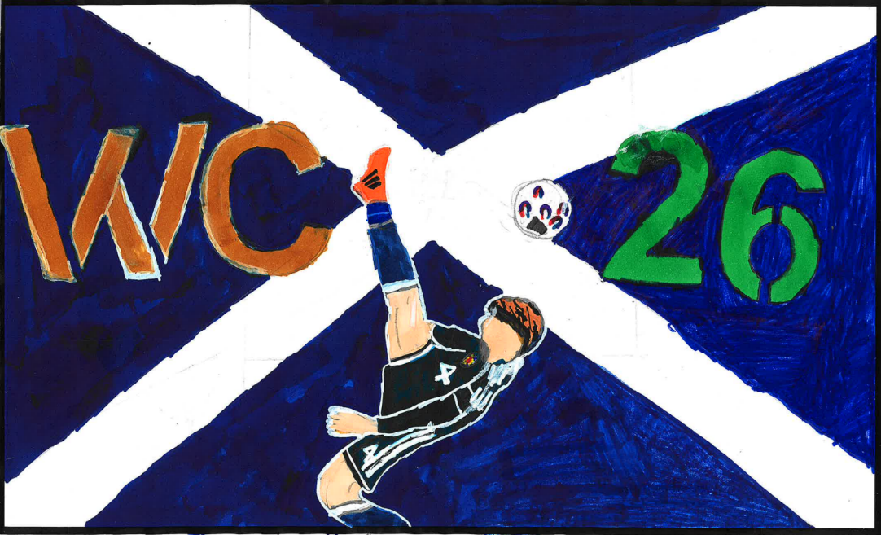
Scotland Flag Competition
Well done to Calum McLaughlin for winning our Scotland Flag design competition. Calum’s design will be submitted into the North Lanarkshire Flag competition.
Class Assemblies
Our final term brings in the last of our class assemblies, P7 will have their leavers assembly expected for the 18th of June (tbc), P5’s class assembly is scheduled for Friday 15th May and P1’s class assembly is scheduled for Friday 29th May
Resident parking / Car Park
The Car Park is for staff only and drop off for children who are in receipt of a parking permit. Please be mindful of residential parking and driveways around the area. We recommend using the car park at the Smiddy and using the crossing patrol to walk across to the school. Should you feel your child would benefit from a parking permit please contact the school.
Upcoming Titanic/trips
Our Titanic trip arrangements have been finalised and confirmed with Dodds of Troon for Wednesday 6th May. We look forward to sharing this learning experience with our Primary 5s and the opportunity to visit Belfast, the Titanic museum and learn more about the area.
Parent Council 2026/Disco’s
Our Parent Council are looking to encourage all families to raise £20.26 this term through a variety of creative enterprises. Please see your child’s class Team for further information.
The Spring Disco’s take part after the Easter Holidays, please see communication from the Parent Council for further information.

World Book Day
Thank you to everyone who supported World Book Day. The children enjoyed dressing down, bringing in their blankets and pillows and reading and listening to books and stories. Thank you to Mrs Dickson for organising this.


School Uniform
We value our uniform and the identity and security that it provides to the school. The vast majority of pupils arrive each day looking smart in their school uniform. We expect all pupils to wear full school uniform when they come to school and details of Eastfield Primary School’s Uniform is outlined on our website. Scan the above QR code to access.
Should your child have any issues wearing a school uniform or a specific part of it, please contact the school who will be happy to discuss this with you.
Pupils get changed for Physical Education throughout each school day; Pupils are not permitted to arrive in school wearing PE clothing - all pupils get changed for Physical Education regardless of when they are timetabled for PE. This not only supports personal hygiene but it allows easy identification of our children in the community should they require assistance on their way to and from school.
We have a wide range of both new and pre-loved uniform items and school resources that can be discretely issued to pupils should they need at any time. We have lots of items and many sizes and would encourage everyone to access it should they wish. Please feel free to contact the school should you wish to access the uniform stores or you wish the school to provide a clothing parcel.
As a school we value your assistance in helping us to safeguard and provide equity for all children by supporting our school uniform standards – we simply cannot do that without your continued partnership.
Senior Leadership Team - Enhanced Support Provision
I would like to extend a warm welcome to our new acting Principal Teacher, Jennifer Nicholson, who has been appointed to support the Senior Leadrership Team in establishing our Enhanced Support Provision. We anticipate that Miss Nicholson will continue in her role as Primary 1/2 teacher until the end of the 2025 / 2026 session.

Police Scotland and Fire and Rescue Services Visit
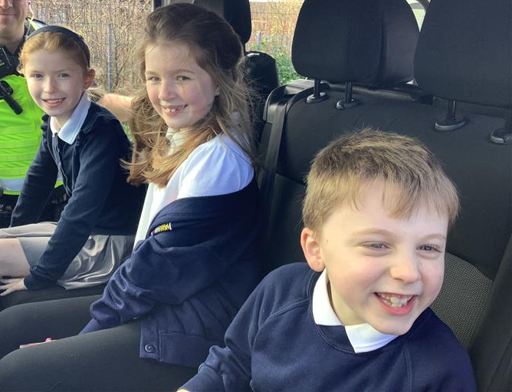
P3/4 had the pleasure of a visit from Cumbernauld Fire and Rescue as part of their learning into our local community and people who help us. We were also delighted to have a visit from Police Scotland, and the children enjoyed the opportunity to see the range of tools and skillsets that both services have.
A special thank you to those that supported us with these visits.
I hope you enjoy the break, make special memories with family and friends, and return refreshed on Monday 20th April ready for the exciting term ahead.

Happy Easter!
Mrs Lesley McPhee
Head Teacher

