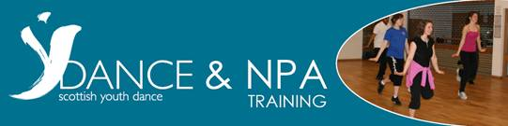

YDance is running a number of training days in 2012 to help teachers develop skills and knowledge to deliver the SQA National Progression Award in Dance - a qualification aimed at S3/S4 pupils. The course is made up of 3 separate units, can be delivered over a number
of years and is an excellent progression into the Higher Dance Practice Course. We offer the following 3 units - Choreography (compulsory unit), Contemporary and Jazz. All the details you need are below so don't miss out - book your place!
___________________________________________________________________________

Tuesday 17 January 2012 or Monday 10 September 2012 CHOREOGRAPHY UNIT (FH5T 11)
We'll give you the skills, knowledge and confidence to make sure your pupils can:
- Demonstrate choreographic skills
- Use stimuli to create movement
- Identify music and design appropriate to choreographic themes

Monday 21 May 2012 – JAZZ UNIT (FH5Y 11) We'll give you the skills, knowledge and confidence to make sure your pupils can:
- Demonstrate skills and techniques of Jazz dance
- Apply skills and techniques to the performance of Jazz dance

Tuesday 22 May 2012 – CONTEMPORARY UNIT (FH5X 11) We'll give you the skills, knowledge and confidence to make sure your pupils can demonstrate:
- Skills & technique in Contemporary dance
- Contemporary dance sequences and phrases
- The ability to recreate Contemporary dance repertoire

Wednesday 11 September 2012 - NPA REFRESHER DAY
For people who have already taken part in one of our NPA Training Days in Contemporary and Jazz, this is the chance to refresh your skills, knowledge and confidence for a new year of students.
___________________________________________________________________________

WHERE
All courses take place at Dance HQ in Glasgow
411 White Studios, Templeton on the Green, Templeton Street, Glasgow, G40 1DA

COST
Book 1 training day for £75, 2 days for £140 or 3 days for £200
(all prices are inclusive of VAT)

